Forward (Light-Based) Ray Tracing for a Sphere with Multiple Point Lights
Idea: Unlike backward ray tracing (rays cast from the eye), forward ray tracing emits rays from each light source, tests them against scene objects, and only rays that eventually reach the eye/image plane contribute to the final image. It's the more "physical" model but wastes many rays that never reach the viewer.
Algorithm (per light Lᵢ):
- Emit ray from light position toward the object.
- Test ray–sphere intersection (closed-form, below).
- If hit → find point P, normal N.
- Compute reflected ray direction; trace toward eye.
- Repeat for every light; sum contributions (illumination is linear/additive).
Ray–sphere intersection math
Ray: P(t) = P₀ + tD (|D| = 1)
Sphere: |P − C|² = r²
Substituting and letting L = P₀ − C:
t² + 2t(D·L) + (|L|² − r²) = 0
Solve as a quadratic (a=1, b=2(D·L), c=|L|²−r²):
t = −(D·L) ± √[(D·L)² − (|L|² − r²)]
- Δ < 0 → no intersection
- Δ = 0 → tangent
- Δ > 0 → two roots; take the smaller positive t (nearest hit)
Hit point: P = P₀ + tD Normal: N = (P − C)/r
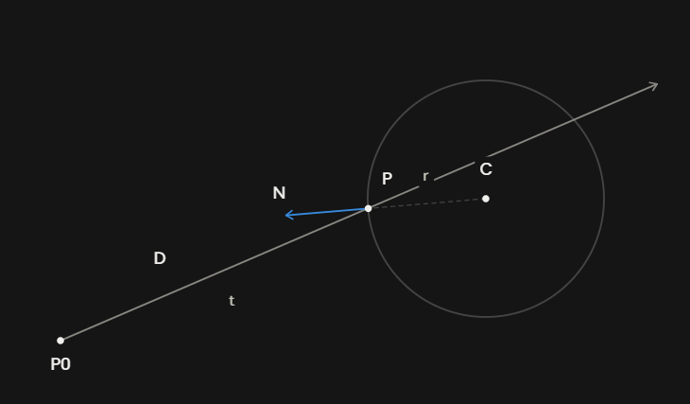
Illumination with n point lights (Phong model):
I = Iₐkₐ + Σᵢ [ I_d,ᵢ·k_d·(N·Lᵢ) + I_s,ᵢ·k_s·(Rᵢ·V)ˢ ]
where Lᵢ = unit vector toward light i, Rᵢ = 2(N·Lᵢ)N − Lᵢ (reflection), V = view direction. Since illumination is additive, all light contributions at one hit point are summed in a single loop — no need to re-trace the whole scene per light.
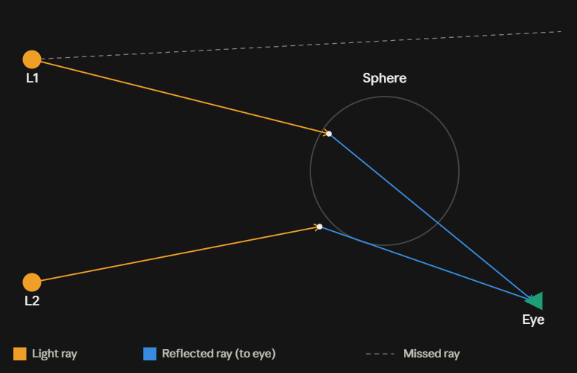
Efficiency improvements to mention in your write-up:
- Early rejection: compute Δ first — if Δ < 0, skip the square root and reject the ray immediately (cheap test before expensive math).
- Closed-form intersection: solving the quadratic directly is O(1) per ray — no iterative root-finding needed.
- Targeted emission: instead of emitting rays from a light in random directions, aim them only within the solid angle subtended by the sphere (importance sampling) — this avoids wasting rays that could never hit the object.
- Single-pass accumulation: since illumination is additive, compute all lights' contributions at one hit point in one loop rather than re-tracing the whole scene per light.
- Reuse of terms: precompute L = P₀ − C once per ray instead of recomputing it for each light/root check.
For your handwritten pages: put the ray-sphere geometry diagram (P₀, D, C, r, P, N) on the page with the intersection derivation, and the multi-light scene diagram (L1, L2, sphere, eye, hit/miss rays) alongside the Phong illumination formula and the efficiency bullet points.

