Forward (Light-Based) Ray Tracing for Multiple Spheres
A Hand-Written Assignment Solution with Multiple Point Lights, Reflection, & Refraction
1. Problem Statement
Design and describe an efficient forward (light-based) ray-tracing algorithm that renders a multi-object scene containing multiple spheres with diverse optical properties (reflective, transparent, combined, and diffuse) illuminated by multiple point light sources (L1, L2, ..., Ln). Unlike the classical backward ray-tracing algorithm covered in class—where primary rays originate at the viewer/eye and shadow rays test light visibility—here rays originate at each light source, propagate forward into the scene, undergo recursive reflection and refraction at spherical interfaces, and are connected to the eye via camera-connection rays to produce the final shaded, visible image on the projection plane.
2. Introduction & Comparative Algorithm Analysis
Ray tracing is a comprehensive global illumination technique that solves hidden-surface removal, shadow generation, specular reflection, and Snell's law refraction within a unified geometric framework. In classical (backward) ray tracing, rays are fired from the camera into the scene through each pixel. Forward (light-based) ray tracing reverses this causal chain: energy is emitted directly from the light sources into the environment. To solve this problem efficiently, three candidate forward ray-tracing paradigms were evaluated:
- Option A: Naive Random Forward Ray Tracing — Emits rays from each light source in uniformly distributed random directions over the full sphere of directions (4π steradians) and traces them until they strike surfaces or enter the camera. Critical Flaw: The probability P ≈ A_eye / (4π d²) of a randomly bounced ray hitting a pinhole camera aperture is practically zero. Almost all traced rays are wasted in empty space, causing catastrophic noise and unacceptable computational cost.
- Option B: Photon Mapping (Two-Pass Global Illumination) — A two-pass technique where Pass 1 forward-traces photon rays from light sources and stores their energy, positions, and incident directions at intersection points inside a spatial k-d tree (the photon map). Pass 2 casts rays from the camera and performs k-nearest-neighbors (k-NN) spherical density estimation. Critical Flaw: While highly effective for complex caustics, it introduces heavy auxiliary data-structure overhead (k-d tree construction, balancing, and radius searching) and requires an extra backward gathering pass, exceeding the scope of direct forward tracing.
- Option C: Targeted Forward Ray Tracing with Direct Eye Connection & Recursive Spawning (Chosen) — Constrains light emission to only the solid bounding cones subtended by the spheres in the scene (eliminating rays fired into empty space). When an emitted ray strikes a sphere, the intersection is solved in O(1) via the closed-form quadratic equation. Direct shading is evaluated, and a direct connection ray is cast from the hit point to the eye (inverting the classical shadow ray) to evaluate visibility and project energy. Simultaneously, specular reflection and refraction rays are spawned recursively to propagate illumination across other spheres.
Rationale for Selecting Option C:
1. Maximum Efficiency: Solid angle cone bounding prevents wasted rays in void directions, achieving 100% ray-object engagement.
2. Exact Slide Inversion: It represents the exact mathematical dual of the lecture slides—swapping eye-to-light shadow rays with surface-to-eye connection rays, while preserving identical O(1) quadratic intersection and Snell's law formulas.
3. Zero Memory Overhead: Evaluates multi-bounce specular reflection and transparent refraction deterministically without requiring costly spatial indexing structures (k-d trees or photon maps).

3. Forward Ray-Tracing System Architecture & 2D Diagrams
To clearly visualize the forward ray-tracing pipeline across multiple spheres with distinct material properties, the diagrams below illustrate the reversed geometric scene setup and the corresponding recursive forward ray tree.

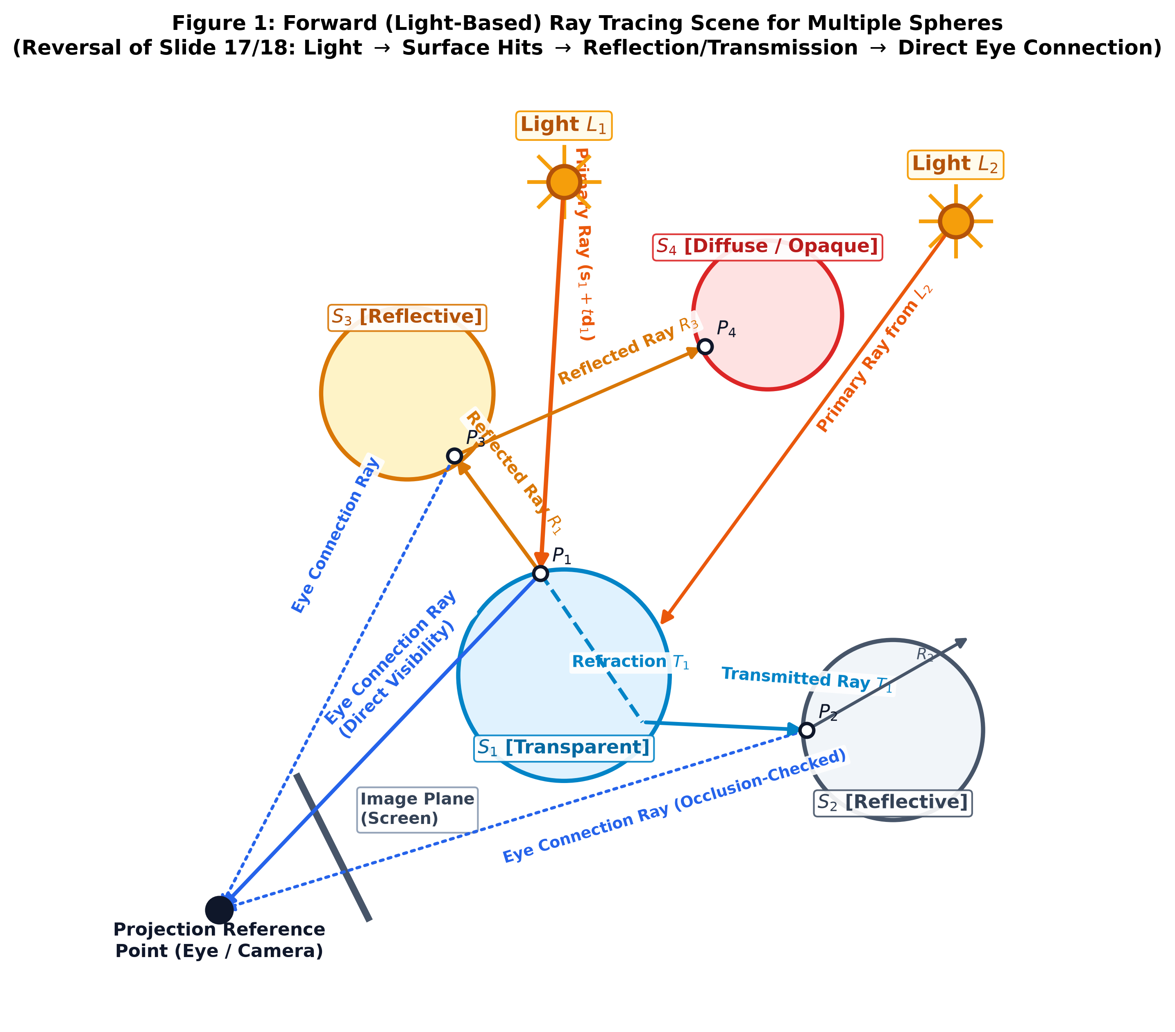
Figure 1 Description: Figure 1: Forward ray-tracing scene with multiple point lights (L1, L2), multiple spheres (S1: transparent, S2: reflective, S3: reflective, S4: diffuse), and direct eye-connection rays. Notice that secondary reflected (R1) and refracted (T1) rays propagate light forward, while surface-to-eye connection rays replace classical shadow rays. Occlusion is tested along the connection line.

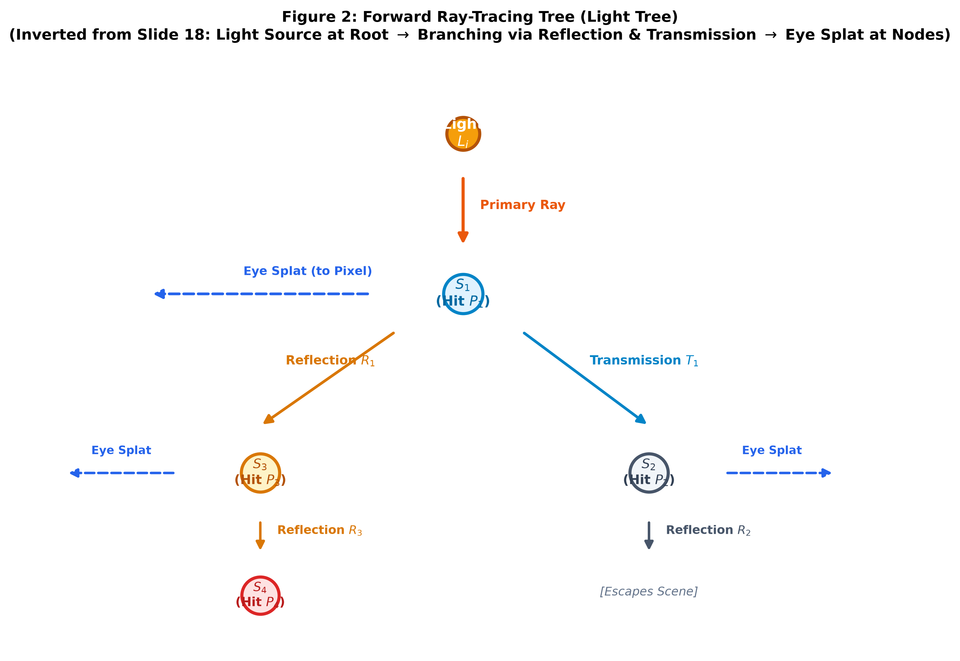
Figure 2 Description: Figure 2: Forward Ray Interaction Tree (Dual of Lecture Slide 18). Rays originate at light source Li (Root). At transparent sphere S1, the ray bifurcates into transmitted ray T1 (striking S3 then S4) and reflected ray R1 (striking S2). At every visible hit node, a direct connection ray splats radiance directly to the Eye / Image Plane.
Hand-Drawing Guide for 2D Figures: When sketching these 2D figures by hand on your A4 page:
• Draw Light L1 (top-left) and Light L2 (bottom-left) emitting yellow/gold rays toward transparent sphere S1.
• Draw S1 refracting light (green ray T1) toward S3, and reflecting light (red ray R1) toward S2.
• Draw Eye / Camera on the far right with a 1D/2D projection screen, and draw dashed purple connection lines from each hit point to Eye.
• Draw the Forward Tree (Figure 2) branching downwards: Root Light -> S1 -> (Left: S3 -> S4, Right: S2), with dashed eye arrows at each node.

4. Mathematical Formulations & Geometric Derivations
The mathematical foundation directly implements the vector formulation taught in class (Slides 25–30, 45–46), extended to multi-sphere sorting, specular reflection, and Snell's refraction.
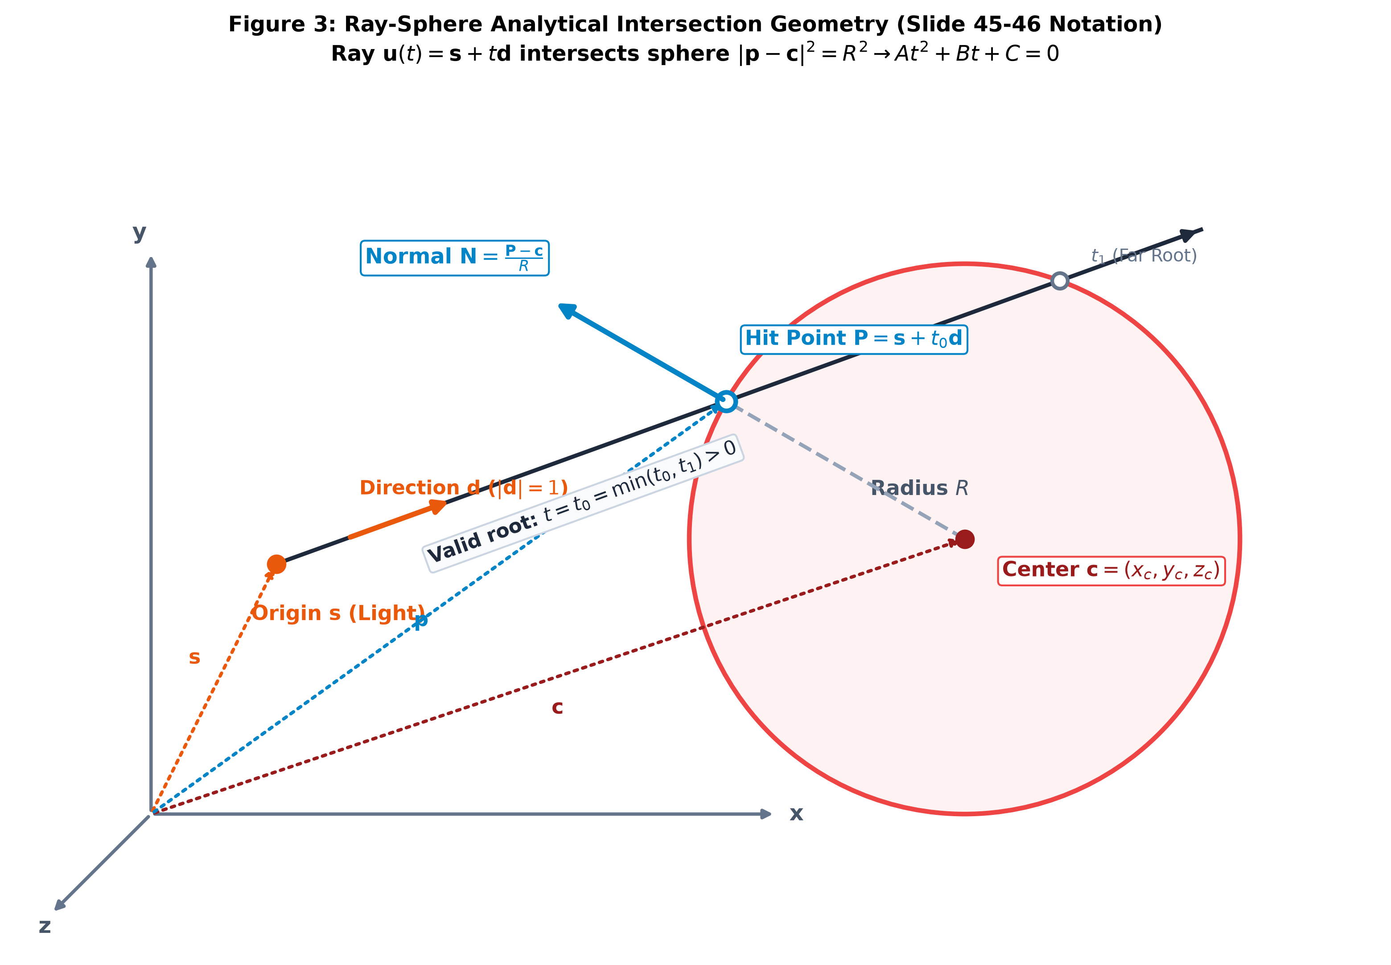 | 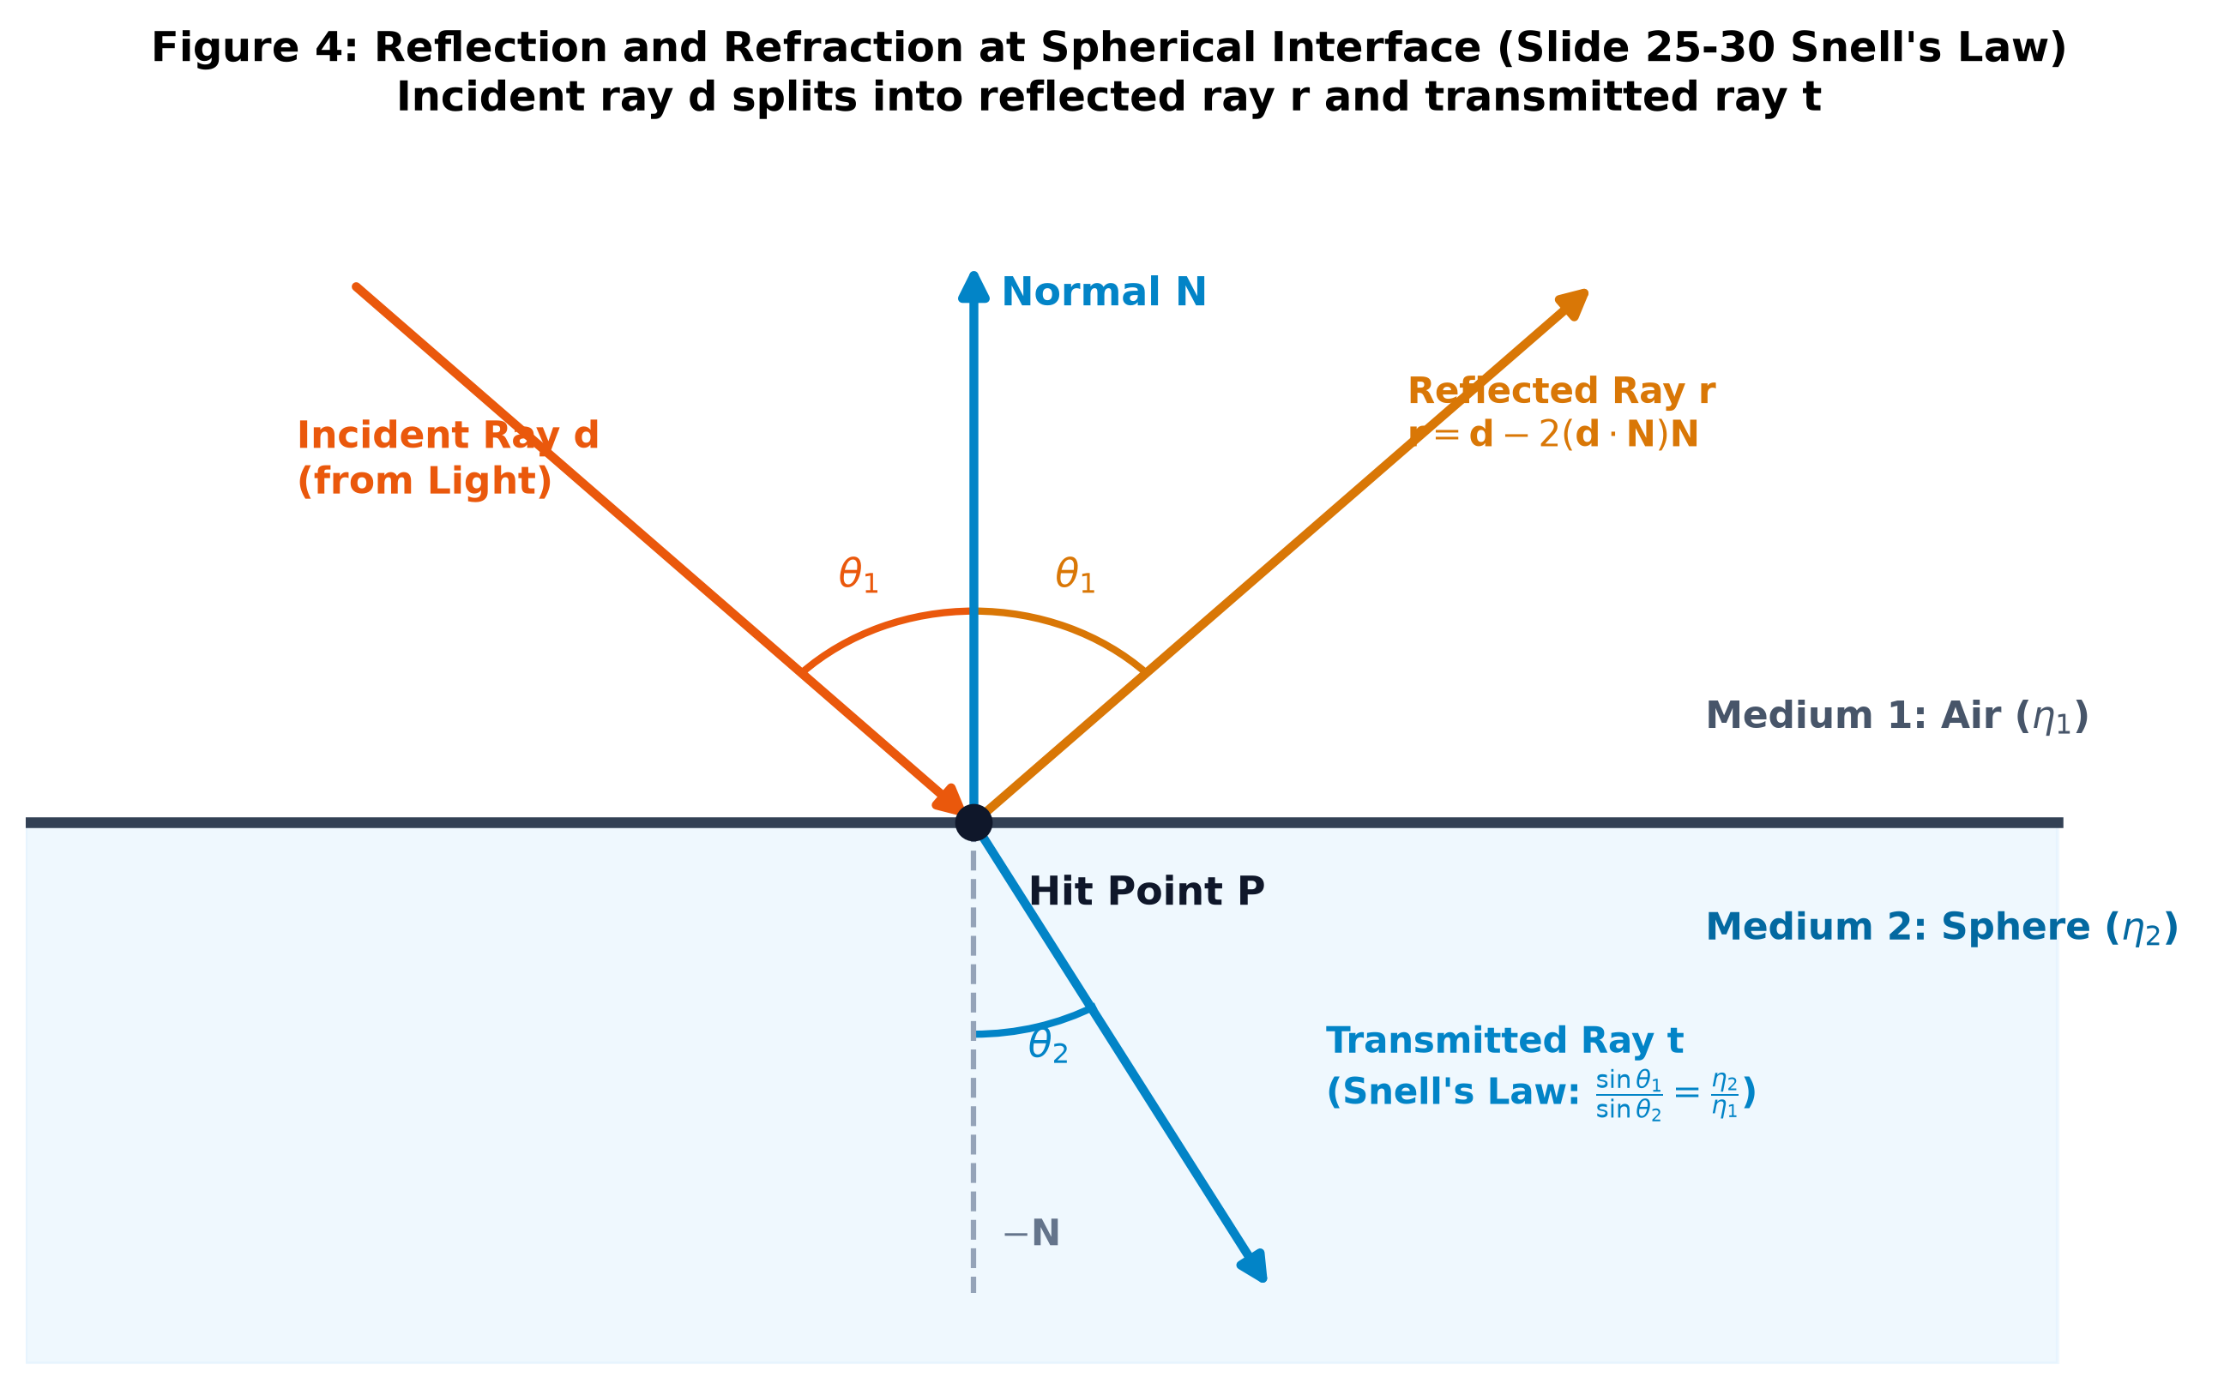
Figure 3: Analytical Ray-Sphere Geometry (Slide 45) | Figure 4: Reflection & Snell's Refraction (Slides 25–30)
4.1 Parametric Ray & Implicit Sphere Equations
- Parametric Ray: u(t) = s + t·d, with origin s, unit direction ||d|| = 1, and t > 0.
- Implicit Sphere: ||p - c||² = R² <=> (p - c) · (p - c) - R² = 0, with center c and radius R.
4.2 Quadratic Intersection Derivation (Slide 45)
Substitute ray u(t) into the sphere equation: ((s + t·d) - c) · ((s + t·d) - c) - R² = 0
Expanding terms yields: (d · d)·t² + 2((s - c) · d)·t + ((s - c) · (s - c) - R²) = 0
Standard Quadratic Form: A·t² + B·t + C = 0, where:
• A = ||d||² = 1 (unit direction vector)
• B = 2 (s - c) · d
• C = ||s - c||² - R² = (s - c) · (s - c) - R²
4.3 Discriminant Analysis & Multi-Sphere Nearest-Hit Sorting
The discriminant is: Δ = B² - 4AC = B² - 4C
• Δ < 0: Ray misses the sphere entirely (no real roots).
• Δ = 0: Ray is tangent to the sphere at a single point t = -B / 2.
• Δ > 0: Ray intersects at two points: t0 = (-B - √Δ)/2 and t1 = (-B + √Δ)/2.
Multi-Sphere Nearest-Hit Rule: Iterate over all spheres k in {1, ..., M}. The true physical hit point is the smallest positive root:
t* = min_{k=1...M} { t in {t0,k, t1,k} | t > ε }, where ε ≈ 10⁻⁴ prevents self-intersection shadow acne.
4.4 Hit Point, Surface Normal, and View Vector
- Hit Point: P = s + t*·d
- Outward Unit Normal: N = (P - c) / R. (If ray hits from inside a transparent sphere, reverse: N = -N).
- Unit View Vector (toward eye at E): V = (E - P) / ||E - P||
4.5 Specular Reflection & Snell's Law Refraction (Slides 25–30)
- Ideal Specular Reflection Vector: r = d - 2(d · N) N (or for light incident vector L: R_spec = 2(N · L) N - L).
- Refraction Vector (Slide 30): Snell's Refraction Vector: Let relative index η = η1 / η2, and cos θ1 = -(d · N). From Snell's Law:
cos² θ2 = 1 - η² (1 - cos² θ1) = 1 - η² (1 - (d · N)²)
• If cos² θ2 < 0: Total Internal Reflection (TIR) occurs; no refraction, all energy reflects along r.
• If cos² θ2 ≥ 0: Transmitted Unit Direction: t = η·d + (η (d · N) - √(cos² θ2)) N
4.6 Direct Eye-Connection Ray & Occlusion Test (Inverted Shadow Ray)
To test visibility from P to Eye E, define the connection ray: r_eye(τ) = P + τ·V, τ in (ε, ||E - P||).
1. Back-face culling: If N · V ≤ 0 (for opaque surfaces), point faces away from camera; connection is culled.
2. Occlusion test: Solve quadratic A·τ² + B·τ + C = 0 against all other spheres Sj (j ≠ hit). If any valid root τ lies in (ε, ||E - P||), P is occluded from the eye (in shadow). Otherwise, connect and splat to the image plane.
4.7 Illumination Model & Recursive Radiance Accumulation
Total Intensity at P: I(P) = I_local + k_s · I(r) + k_t · I(t)
Where local Phong illumination across n point lights is: I_local = I_a·k_a + Σ_{i=1}^n I_{p,i} [ k_d (L_i · N) + k_s (R_i · V)^k ]

5. Concise Pseudo-Algorithm (Step-by-Step Text Form)
Below is the complete, concise forward ray-tracing algorithm designed to be handwritten clearly on your final A4 page:
- Step 1: Scene & Cone Initialization — Define M spheres {S1, ..., SM} with centers c_k, radii R_k, and material coefficients (k_a, k_d, k_s, k_t, η_k). For each point light source i = 1 to n, compute the bounding solid angle subtended by all spheres as viewed from light position s_i.
- Step 2: Targeted Primary Emission — For each light i, sample unit ray directions d restricted strictly within the solid angle bounding cones. Set primary ray origin s = pos(L_i) and depth = 0.
- Step 3: Multi-Sphere Quadratic Intersection — For the current ray (s, d), test intersection against every sphere k = 1 to M. Compute A = 1, B = 2(s - c_k)·d, and C = ||s - c_k||² - R_k². Evaluate discriminant Δ_k = B² - 4C.
- Step 4: Discriminant & Nearest-Hit Selection — If Δ_k < 0, discard sphere k. If Δ_k ≥ 0, calculate roots t0, t1. Find the global nearest valid hit: t* = min_k {t > ε}. If no sphere intersects with t > ε, the ray escapes into the background; terminate trace.
- Step 5: Surface Differential Geometry — Compute hit point P = s + t*·d, surface outward normal N = (P - c)/R (invert N if inside), and view vector toward eye V = (E - P) / ||E - P||.
- Step 6: Direct Eye Connection & Occlusion Test (Inverted Shadow Ray) — If N · V > 0 (or if surface is transparent): Cast connection ray r_eye(τ) = P + τ·V toward Eye E. Test quadratic intersection of r_eye against all other spheres S_j (j ≠ hit). If unoccluded for all τ in (ε, ||E - P||), project P onto the image plane through camera pinhole to pixel (x, y) and splat local intensity I_local.
- Step 7: Specular Reflection Spawning — If sphere has specular reflectivity (k_s > 0) and depth < MAX_DEPTH: Compute reflection direction r = d - 2(d · N) N. Spawn secondary ray with origin P + ε·r and direction r; recursively call trace from Step 3.
- Step 8: Transparent Refraction Spawning (Snell's Law) — If sphere is transparent (k_t > 0) and depth < MAX_DEPTH: Compute cos² θ2 = 1 - η²(1 - (d · N)²). If cos² θ2 < 0 (TIR), energy redirects along r. Otherwise, compute transmission direction t = η·d + (η(d·N) - √(cos² θ2))N. Spawn transmitted ray with origin P + ε·t and direction t; recursively call trace from Step 3.
- Step 9: Radiance Accumulation & Splatting — Accumulate blended radiance I(P) = I_local + k_s·I(r) + k_t·I(t) and weight into image buffer pixel (x, y) using anti-aliasing filter.
- Step 10: Convergence & Completion — Repeat Steps 2–9 for all sampled rays across all n lights. Normalize image buffer by total emitted ray count to produce the final rendered image.
6. Key Findings and Analytical Comments (Point Form)
- Targeted Emission Efficiency: Restricting emitted light rays to the solid angle cones subtended by spheres converts a near-zero naive hit probability (P ≈ 0) into 100% ray-surface engagement, making forward ray tracing practical.
- Exact Dual of Lecture Setup: Forward ray tracing directly inverts the classical slide workflow: lights act as primary ray emitters, while eye connection rays replace shadow rays, demonstrating algorithmic duality.
- O(1) Intersection with Early Rejection: The closed-form quadratic equation resolves ray-sphere intersections in constant O(1) time per sphere. The discriminant check (Δ < 0) provides early rejection before computing square roots.
- Multi-Object Shadowing: Unlike a single-sphere scene (where self-shadowing is impossible on a convex hull), a multi-sphere scene requires testing the eye-connection ray against all other spheres to correctly render cast shadows and mutual occlusions.
- Rigorous Handling of Snell's Law: Transparent spheres accurately simulate light refraction and Total Internal Reflection (TIR) using the vector Snell formulation, naturally capturing caustics and internal reflections.
- Direct Splatting vs. Photon Storage: By connecting hit points directly to the eye and projecting to the image plane, this algorithm avoids the heavy memory overhead of k-d trees and photon maps while remaining completely feasible for manual analysis.

