Theory:Assignment is reverse of this setup
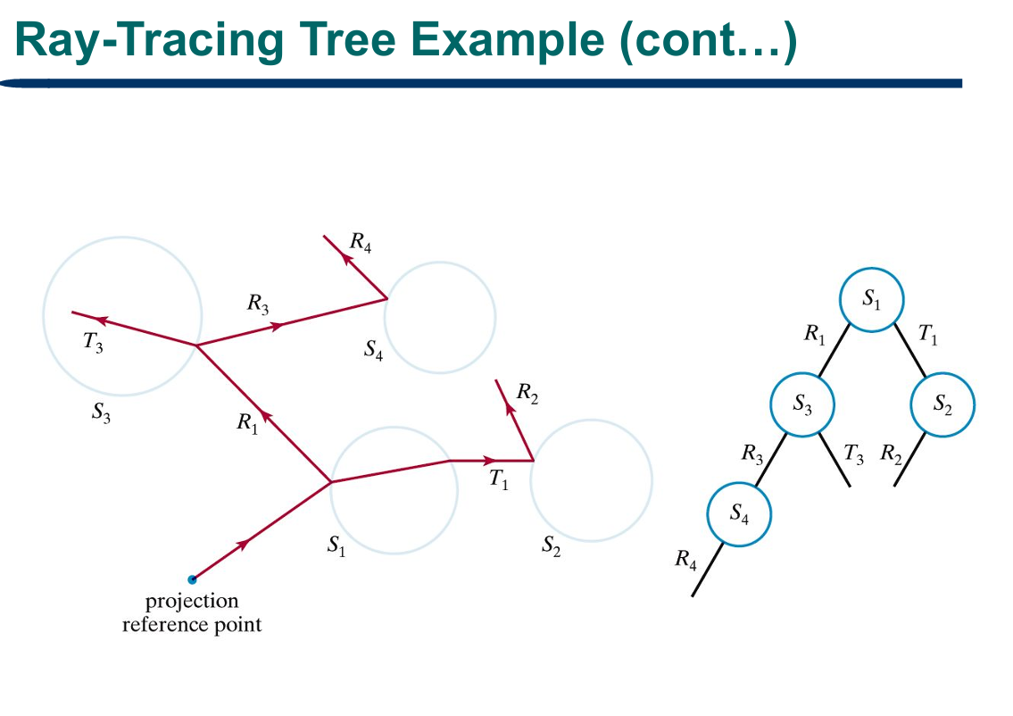
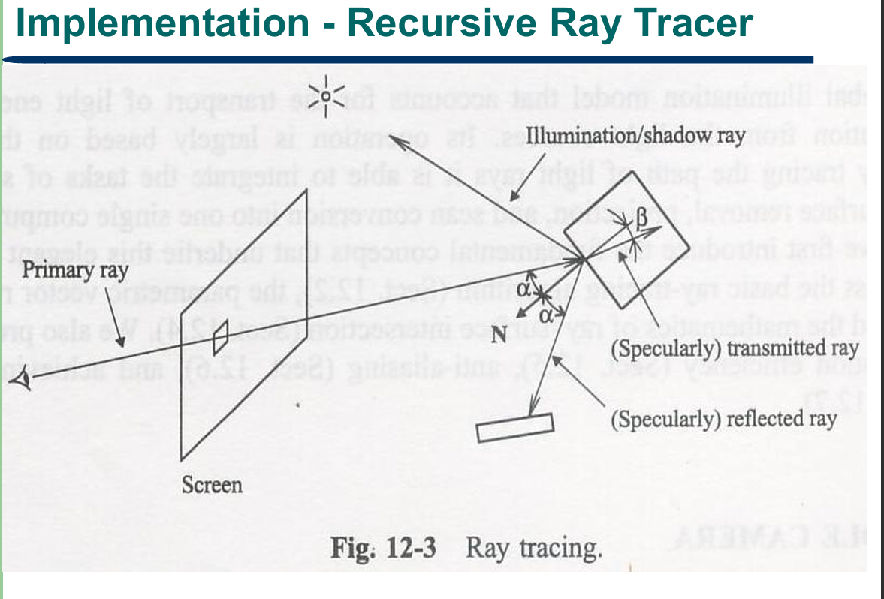
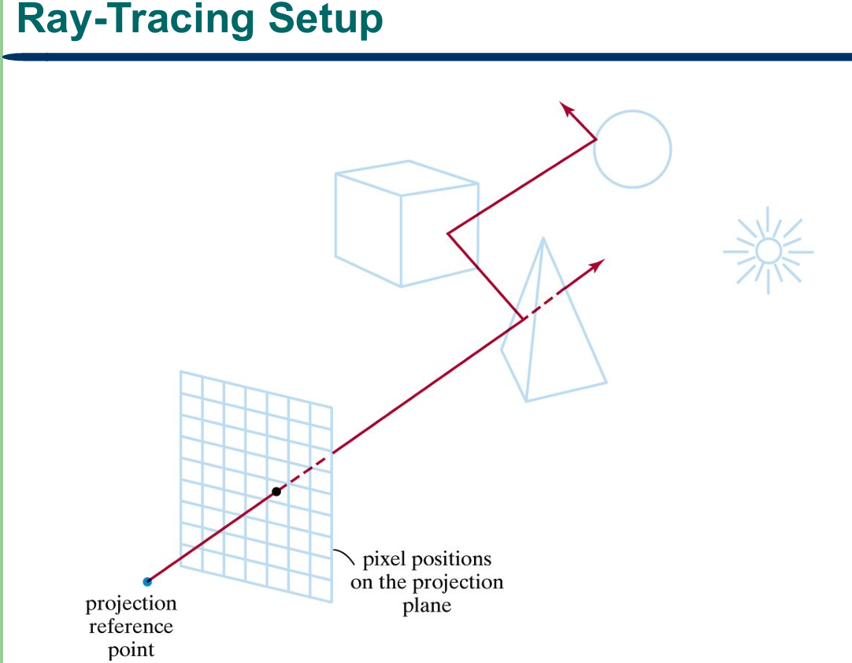
Forward (Light-Based) Ray Tracing for a Sphere with Multiple Point Lights
1. Problem Statement
Design and describe an efficient forward (light-based) ray-tracing algorithm that renders a sphere illuminated by n point light sources. Unlike the classical (backward) ray-tracing algorithm covered in class — where the primary ray originates at the viewer/eye and a shadow ray is sent from the surface to each light — here the ray must originate at each light source, be traced until it strikes the sphere, and then be connected to the eye to produce the final shaded, visible image.
2. Introduction
Ray tracing is a global illumination technique that integrates shading, shadow generation, hidden-surface removal and projection into one process. The classical (backward) algorithm fires a primary ray from the eye through each pixel, finds the nearest surface it hits, and then sends a shadow ray from that surface to each light to test occlusion. Forward (light-based) ray tracing reverses this: rays are emitted from the lights themselves.
Three candidate algorithms were considered:
- A. Naive random forward tracing — emit rays from each light in random directions over the full sphere of directions (4π steradians) and keep only the ones that eventually reach the eye. Problem: the probability of a randomly emitted ray landing on the tiny camera aperture is almost zero, so nearly all traced rays are wasted.
- B. Photon mapping (two-pass) — forward-trace rays and store "photons" at hit points in a spatial map, then gather from the eye in a second pass. Problem: needs a spatial photon-map data structure and a density-estimation gather step — powerful for caustics/global illumination, but unnecessary overhead for one sphere and a few point lights.
- C. Targeted forward tracing with direct eye-connection — restrict each light's emission to only the solid angle actually subtended by the sphere, find the hit using the closed-form ray–sphere quadratic, shade the point, and connect it to the eye with a single ray for visibility/projection.
Chosen algorithm: C. It removes almost all of the wasted rays that make Option A impractical, without the extra data-structure overhead of Option B. It also reuses the exact closed-form ray–sphere intersection formula already taught in class, and it is the most direct reversal of the class algorithm — the roles of "primary ray" and "shadow ray" are simply swapped: the light now emits the primary ray, and what used to be the shadow ray (surface → light) becomes a connection ray (surface → eye).
3. Pseudo Algorithm (text form)
- For each light source i = 1 to n, determine the solid angle subtended by the sphere as seen from that light, and restrict all emitted ray directions d to lie within this cone (targeted emission, not random).
- For each sampled direction d from light i (ray origin s = position of light i), compute B = 2(s−c)·d and C = |s−c|² − R², noting A = |d|² = 1.
- Compute the discriminant Δ = B² − 4C. If Δ is negative, the ray misses the sphere entirely; discard it and move to the next sampled direction.
- Otherwise solve for the two roots t₀ and t₁, and take t as the smaller of the two that is still positive (the nearer valid intersection). If neither root is positive, discard the ray.
- Compute the hit point P = s + td and the outward surface normal N = (P − c)/R.
- Compute the view vector V, the normalized direction from P to the eye. If the dot product N·V is zero or negative, the point faces away from the eye and is invisible from that viewpoint; discard it.
- If the shading at P has not already been computed, evaluate the total intensity there by summing the contribution of every light source j = 1 to n: for each j, find the light vector Lⱼ from P to light j and the reflection vector Rⱼ = 2(N·Lⱼ)N − Lⱼ, then accumulate the ambient term once plus, for every j, the diffuse term k_d(Lⱼ·N) and the specular term k_s(Rⱼ·V)ᵏ, each scaled by that light's intensity. Store the result so a repeated hit at the same point is not recomputed.
- Project P onto the image plane through the eye to determine the corresponding pixel, and assign that pixel the intensity found in step 7.
- Repeat steps 2–8 for every sampled direction of every light source until all lights have been processed; the accumulated pixel values form the rendered image.
Comment: since the sphere is a single convex object, step 7 requires no shadow-ray/occlusion test — a convex surface cannot shadow itself, so this step is simpler here than in the class algorithm.
4. Figures, Formulas and Findings/Comments
Figure 1 (the reversed scene, shown above) illustrates lights L1 and L2 emitting rays that converge at hit point P, with a single connection ray from P to the eye — the mirror image of the class slide, where the eye emitted the primary ray and shadow rays went out to the lights.
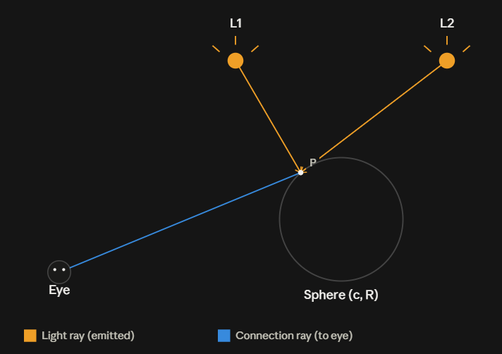
Figure 2 (the intersection geometry, shown above) illustrates the same labels used in class — s, d, c, R, P, N — for the ray–sphere intersection.
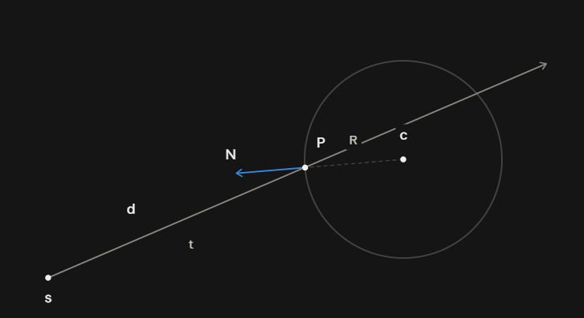
Formulas:
Ray: u(t) = s + t d, |d| = 1
Sphere: |p − c| = R
Quadratic: At² + Bt + C = 0, where A = 1, B = 2(s−c)·d, C = |s−c|² − R²
t = (−B ± √(B² − 4C)) / 2, with:
Δ < 0 → no intersection · Δ = 0 → tangent · Δ > 0 → two roots, take min(t₀, t₁) with t > 0
Hit point: P = s + td Normal: N = (P − c)/R
Illumination (n lights): I = Iₐkₐ + Σᵢ₌₁ⁿ Iₚᵢ(k_d(Lᵢ·N) + k_s(Rᵢ·V)ᵏ)
Findings/comments:
- Restricting emission to the sphere's solid angle is what makes forward tracing practical — it converts an otherwise near-zero hit probability into a targeted, efficient sampling scheme.
- The closed-form quadratic gives the intersection in O(1) per ray, with the discriminant test allowing a cheap early rejection before any square root is computed.
- Because there is only one, convex object, the usual shadow-ray step is unnecessary — a clear simplification over the class algorithm.
- Back-face culling (N·V ≤ 0) substitutes for a full visibility trace when connecting a hit point to the eye.
- The method generalizes to multiple objects by applying min(t₀, t₁) across all spheres to find the true nearest hit (extending the class rule "Return min(t0, t1)"), at which point the eye-connection ray would also need to be checked for occlusion by the other objects.

