**Bangabandhu Sheikh Mujibur Rahman Science and Technology University, Gopalganj-8100**

**Project Requirement Analysis on**

**“Institute Management System”**

**Course Code: CSE 310**

**SUBMITTED GROUP BY**

              M. A. Forhad Aziz, ID: 20CSE007

Mohammad Nimour Hossain, ID: 20CSE010

  Jahid Hasan,   ID: 20CSE037

Session: 2020-21

Department of Computer Science and Engineering

**SUBMITTED TO**

Dr. Syful Islam,

Assistant Professor.

Department of Computer Science and Engineering

**Table of Contents**

**1. INTRODUCTION** 4

***1.1 Purpose of the Institute Management System*** 4

***1.2 Scope of the System*** 4

***1.3 Goals of the Development Team*** 5

***1.4 Development Process Model*** 5

***1.5 Team Roles and Organization*** 6

**2. RESEARCH** 7

***2.1 Literature Survey and Technical Research*** 7

2.1.1 User Interface Design: 7

2.1.2 Data Management: 8

2.1.3 Authentication and Security: 8

2.1.4 Performance and Scalability: 9

***2.2 Technology Stack:*** 10

**3. DESCRIPTION** 11

***3.1 System Modules*** 11

3.1.1 Student Management Module 11

3.1.2 Course Management Module 11

3.1.3 Faculty Management Module 12

3.1.4 Timetable Management Module 12

3.1.5 Examination Management Module 12

3.1.6 Fee Management Module 13

***3.2 User Roles and Permissions*** 13

3.2.1 Admin Role 13

3.2.2 Faculty Role 13

3.2.3 Student Role 14

***3.3 System Workflow*** 14

***3.4 System Security Features*** 14

**4. REQUIREMENTS** 16

***4.1 Functional Requirements*** 16

4.1.1 Menu Requirements 16

4.1.2 In-System Functions 17

***4.2 Structural Requirements*** 18

4.2.1 Database Structure 18

4.2.2 User Interface (UI) 18

4.2.3 Networking 18

4.2.4 Security 19

4.2.5 Integration 19

***4.3 Performance Requirements*** 19

***4.4 Software Requirements*** 19

***4.5 Hardware Requirements*** 20

***4.6 Non-Functional Requirements*** 20

4.6.1 Security 20

4.6.2 Maintainability 20

4.6.3 Portability 20

***4.7 Project Constraints*** 20

**5. SYSTEM ANALYSIS AND MODELING** 21

***5.1 Functional Modeling*** 21

5.1.1 Level 0 of Data Flow Diagram 21

5.1.2 Level 1 of Data Flow Diagram 21

***5.2 Use Case Analysis*** 22

5.2.1 Start Menu Use Case 22

5.2.2 In-System Use Case 23

**6.GANTT CHART** 25

# **1. INTRODUCTION**

The **Institute Management System (IMS)** is designed to improve the efficiency and functionality of administrative tasks in educational institutions. The system will streamline various operational processes such as managing student information, scheduling courses and examinations, tracking fee payments, and handling user roles within the institution. Built on the **MERN stack** (MongoDB, Express, React, and Node.js), the IMS will offer an intuitive, scalable, and secure solution for students, faculty, and administrators, significantly enhancing their interaction with the institution.

## ***1.1 Purpose of the Institute Management System***

The primary purpose of the **Institute Management System (IMS)** is to automate and simplify the administrative processes of an educational institution. It will act as a centralized platform that handles crucial operations in a seamless manner, from student enrollment to examination management. Key objectives include:

* **Student Management:** The IMS will store and manage student data such as enrollment details, attendance records, course registration, grades, and academic progress.
* **Course Management:** It will provide tools for creating and managing courses, assigning instructors, and scheduling lectures or classes for students.
* **Examination Management:** The system will manage examination schedules, monitor exam results, and track assignments, enabling faculty to evaluate students effectively.
* **Fee Management:** The IMS will automate fee collection, track pending fees, generate invoices, and maintain detailed records of all payments made.
* **Role-based User Access:** The system will provide distinct roles for administrators, faculty, and students, ensuring appropriate access levels for each user type.

The **MERN stack** will be employed to ensure that the system is not only secure but also highly scalable and capable of handling the growing demands of educational institutions in the future. The end goal is to create an efficient, user-friendly platform that simplifies institutional management and enhances communication among all stakeholders.

## ***1.2 Scope of the System***

The scope of the Institute Management System is broad, covering a wide range of features aimed at addressing various operational needs of an educational institution:

* **Student Management:** The system will allow the registration of students, maintaining their personal details, attendance records, academic history, and course registration. Students will also be able to track their performance, including grades and assignments.
* **Course Management:** The IMS will allow for the creation and management of courses, assigning instructors, and scheduling classes. It will track which courses students are enrolled in and allow faculty members to access relevant course details.
* **Examination Management:** The system will handle the scheduling of examinations and assignments, including results processing. It will store and display student performance records and help faculty evaluate their students effectively.
* **Fee Management:** A key feature of IMS is the ability to manage fee structures, keep track of payments, generate invoices, and provide students with reminders for pending fees. It will support multiple fee categories (tuition, lab fees, library fees, etc.) and allow admins to manage fee details.
* **User Roles and Permissions:** The system will include role-based access control to manage what information and actions are available to each user. Admins will have complete access, faculty will be able to manage courses and assessments, and students will have access to their academic details and results.
* **Security:** The system will implement security measures such as encryption and secure authentication to protect sensitive data and maintain privacy. Role-based access control ensures that each user can only access what is necessary for their role.
* **Real-Time Communication:** The system will provide real-time communication features such as notifications for assignment deadlines, examination schedules, fee reminders, and general announcements to ensure smooth interaction between students, faculty, and administration.
* **System Integration:** The system will enable online course registration, result viewing, and report generation, making it a comprehensive platform for academic management. It will also support the integration of third-party tools if needed for enhanced functionality.

## ***1.3 Goals of the Development Team***

The development team's primary goals for this project are:

* **Full-Stack Development Mastery:** The team aims to gain in-depth knowledge and hands-on experience in using the **MERN stack** (MongoDB, Express, React, and Node.js) to build a complete, functional system. Mastery of full-stack development is essential for delivering a seamless and efficient system that meets the needs of the educational institution.
* **Effective Documentation and Version Control:** The team will employ proper project documentation practices and use version control systems such as **Git** to ensure that the development process is well-managed and organized. This will help in tracking progress and handling collaborative changes effectively.
* **Efficient Time Management:** The team will focus on managing their time efficiently, dividing the project into well-defined phases and tasks, prioritizing key features, and ensuring timely completion of deliverables.
* **Teamwork and Collaboration:** The project will be a collaborative effort, with the team members sharing responsibilities and contributing equally to both front-end and back-end development. They will engage in regular communication and feedback sessions to ensure smooth project progression and problem-solving.
* **Scalability and Maintainability:** The final IMS should not only solve current problems but also be scalable and maintainable. The team will focus on writing clean, modular code that can be easily expanded with new features in the future.
* **Creating a Robust System:** The team will prioritize the security, performance, and user-friendliness of the IMS. They will ensure that it meets all functional requirements while providing a smooth experience for users.

## ***1.4 Development Process Model***

The project will be developed following the **Agile methodology**, which emphasizes iterative and incremental development. This model allows for continuous feedback and improvement, making it highly suitable for projects with evolving requirements. Specifically, the **Scrum framework** will be used to break the project into multiple **sprints**, each focusing on a specific feature or module of the IMS.

* **Sprint Planning:** At the beginning of each sprint, tasks will be identified, prioritized, and assigned based on their importance and complexity.
* **Daily Stand-ups:** The team will conduct short daily meetings to discuss progress, identify blockers, and plan the next steps.
* **Sprint Review and Retrospective:** At the end of each sprint, the team will present the completed work to stakeholders and review what went well and what could be improved in the next sprint.

This approach allows for greater flexibility and adaptability throughout the development process, ensuring that the final system is both functional and user-centric.

## ***1.5 Team Roles and Organization***

The IMS project is a collaborative effort among three team members who share responsibility for both front-end and back-end development, ensuring a balanced workload and efficient collaboration.

* **Frontend Development:** One of the team members will focus on building the user interface using **React**. They will design a responsive and intuitive interface, ensuring that the system is user-friendly for all stakeholders (students, faculty, and administrators).
* **Backend Development:** Another team member will focus on server-side development, working with **Node.js** and **Express** to handle API development and database management. They will ensure the integrity of data and maintain smooth communication between the front-end and back-end.
* **Database Management and Integration:** The third team member will work on setting up and managing the **MongoDB** database, ensuring efficient data storage and retrieval. They will handle user authentication, data encryption, and implement role-based access control.

The team operates under a flat hierarchy, with all members having equal responsibility and authority over decisions related to the project. The team leader ensures that the project stays on track by managing timelines, delegating tasks, and keeping all members aligned on the overall project goals.

Regular meetings and brainstorming sessions will help the team identify any issues early on and make necessary adjustments. Each member will contribute their expertise, ensuring the successful delivery of the IMS.

# **2. RESEARCH**

The development of the **Institute Management System (IMS)** requires a solid foundation of research to identify suitable technologies, architectural approaches, and design patterns. This section explores the findings from literature surveys and technical research, highlighting the considerations for user interface design, data management, authentication, security, performance, and scalability. Additionally, it elaborates on the chosen technology stack and its relevance to the project.

## ***2.1 Literature Survey and Technical Research***

### 2.1.1 User Interface Design:

For a system like the **Institute Management System**, an intuitive, user-friendly, and responsive interface is essential. The UI must accommodate diverse users, including administrative staff, faculty, and students, each requiring tailored access and interaction points. Modern web development practices emphasize **dynamic and interactive interfaces**, making **React** (a core component of the MERN stack) the ideal choice for building the front-end.

Key considerations for UI design include:

1. **Framework Selection:**
   * **React:** React will enable the creation of reusable components, facilitating consistent design across all pages. Its virtual DOM ensures high performance, even for complex, data-heavy pages like student dashboards and fee management.
   * **Material-UI (MUI):** A React-based library offering pre-designed, customizable UI components such as buttons, tables, and form inputs. It will help maintain a professional, modern aesthetic.
   * **Bootstrap for React:** Bootstrap’s grid system and responsive design features will ensure the application works seamlessly on devices of all sizes, from desktops to smartphones.
2. **UI Features:**
   * **Clear Navigation Paths:** Navigation menus will guide users to features like managing student data, viewing courses, submitting assignments, and processing fee payments. Icons and tooltips will enhance usability.
   * **Real-Time Updates:** React’s state management will provide real-time feedback for actions like form submissions, course registrations, or attendance updates.
   * **Search and Filters:** Powerful search and filtering mechanisms will allow users to quickly access specific student records, courses, or fee payment histories.
   * **Form Validations:** The system will include client-side and server-side validation for all input fields, ensuring data integrity before submission.
   * **Custom Dashboards:** Tailored dashboards for admins, faculty, and students will highlight relevant information, such as course details, fee status, or announcements.

The UI design process will involve wireframing and prototyping to gather feedback and ensure the design aligns with user expectations before full-scale development.

### 2.1.2 Data Management:

Efficient data management is the backbone of the **Institute Management System**, as it involves handling extensive, diverse datasets. These include student records, faculty information, course schedules, fee transactions, and examination results. **MongoDB**, a NoSQL database, was selected for its flexibility and performance in managing large, dynamic datasets.

Key aspects of data management include:

1. **Database Structure:**
   * **Document-Oriented Model:** MongoDB’s JSON-like document structure makes it ideal for storing complex, hierarchical data such as student profiles with nested attributes (e.g., personal details, enrollment history, fee status).
   * **Dynamic Schema:** MongoDB supports schema-less design, allowing the system to adapt to evolving data requirements without major disruptions.
2. **Data Validation and Consistency:**
   * **Mongoose:** This ODM (Object Data Modeling) library for MongoDB will be used to define schemas, enforce data validation, and manage relationships between data entities (e.g., linking students to their enrolled courses).
3. **Sensitive Data Handling:**
   * **Encryption:** Sensitive information, such as passwords and financial records, will be encrypted both at rest and during transmission to prevent unauthorized access.
   * **Data Backup and Recovery:** Regular backups will ensure data safety, and recovery procedures will be established to prevent data loss in case of system failures.
4. **Data Querying and Performance:**
   * Indexing will be implemented to optimize search operations, ensuring that the system can quickly retrieve data, such as searching for a student by name or ID.
   * Aggregation pipelines will process complex queries, such as generating fee summaries for an academic year.

### 2.1.3 Authentication and Security:

Ensuring a secure and reliable authentication mechanism is critical for the **IMS**, as it deals with sensitive personal and institutional data. The system will use **JWT (JSON Web Tokens)** for authentication and session management, paired with robust security practices.

1. **Authentication Approach:**
   * **JWT:** JWTs will provide stateless authentication, allowing secure user sessions without overloading the server with session data. Tokens will be signed with secret keys and validated for every user request.
   * **Role-Based Access Control (RBAC):** Role-based permissions will ensure that each user (admin, faculty, or student) can access only the features and data relevant to their role.
2. **Password Security:**
   * **Bcrypt:** Passwords will be hashed using bcrypt before storage, adding a layer of security against potential data breaches.
3. **Server and Application Security:**
   * **Helmet.js:** This middleware will set secure HTTP headers, protecting the system against common web vulnerabilities like cross-site scripting (XSS) and clickjacking.
   * **Rate Limiting:** To prevent brute force attacks, rate limiting will restrict the number of login attempts from a single IP address.
4. **Audits and Testing:**
   * Regular security audits will identify and mitigate vulnerabilities.
   * Penetration testing will simulate real-world attacks to ensure the system’s defenses are robust.

### 2.1.4 Performance and Scalability:

Performance optimization and scalability are vital for a system expected to handle growing datasets and concurrent user interactions. The IMS will use technologies and practices that ensure smooth performance during peak loads and allow for future growth.

1. **Backend Performance:**
   * **Node.js:** Node.js’s non-blocking, event-driven architecture allows the backend to handle multiple requests concurrently, reducing latency and improving user experience.
   * **Asynchronous Programming:** Asynchronous operations, such as database queries and API calls, will ensure efficient use of resources.
2. **Database Scalability:**
   * **Horizontal Scaling:** MongoDB’s ability to distribute data across multiple servers will allow the system to grow as the institution expands.
   * **Sharding:** Data sharding will distribute datasets across different servers, improving query performance and reducing load on individual nodes.
3. **System Scalability:**
   * **Load Balancing:** Load balancers will distribute traffic evenly across servers, ensuring consistent performance during high-demand periods.
   * **Microservices Architecture:** The system may be modularized into independent microservices (e.g., authentication, fee management) to simplify scaling specific features as needed.

## ***2.2 Technology Stack:***

The **MERN stack** was selected for the IMS due to its comprehensive, JavaScript-based ecosystem, which ensures seamless communication between the front-end and back-end. Each component of the stack contributes to the overall system’s functionality:

1. **MongoDB:**
   * A NoSQL database designed for high performance and scalability.
   * Used for storing all system data, including student records, course schedules, examination results, and fee transactions.
   * Provides flexibility in handling structured and unstructured data.
2. **Express:**
   * A minimalist web application framework for Node.js that simplifies routing and middleware management.
   * Handles backend API development, managing communication between the database and front-end.
3. **React:**
   * A JavaScript library for building the user interface.
   * Enables the creation of reusable, interactive components and ensures a responsive, dynamic front-end.
4. **Node.js:**
   * A runtime environment for executing server-side JavaScript.
   * Manages API requests, authentication, and real-time data exchange between the client and server.

The seamless integration of these technologies ensures the development of a scalable, secure, and user-friendly Institute Management System.

# **3. DESCRIPTION**

The **Institute Management System (IMS)** is a comprehensive platform designed to streamline the administrative, academic, and financial operations of an educational institution. This section provides an in-depth description of the system’s primary modules, the roles and permissions granted to users, the overall workflow of the system, and its security features.

## ***3.1 System Modules***

The IMS consists of several modules, each focusing on a specific aspect of institutional management. These modules are designed to work cohesively, ensuring an efficient and user-friendly system.

### 3.1.1 ****Student Management Module****

This module handles all student-related functionalities, including registration, profile management, academic tracking, and attendance monitoring.

**Key Features:**

* **Student Registration:** Enables administrators to register new students, capturing details such as personal information, contact details, academic history, and enrollment information.
* **Profile Management:** Allows students to view and update their personal details, ensuring their information is accurate and up-to-date.
* **Attendance Tracking:** Facilitates attendance recording for each student, helping faculty monitor class participation and identify irregularities.
* **Progress Tracking:** Provides detailed reports of student performance, including grades, attendance, and participation.
* **Transcripts and Reports:** Automates the generation of academic transcripts and progress reports, which can be downloaded by students or administrators.

### 3.1.2 ****Course Management Module****

This module facilitates the creation, organization, and monitoring of academic courses offered by the institution.

**Key Features:**

* **Course Creation and Updates:** Administrators can create, update, or delete courses, including details like course codes, descriptions, and credits.
* **Instructor Assignment:** Assign faculty members to specific courses based on their expertise and availability.
* **Student Enrollment:** Tracks which students are enrolled in which courses, allowing real-time updates of class rosters.
* **Course Material Distribution:** Faculty can upload course materials, such as lecture notes and assignments, which students can download or access directly from the system.

### 3.1.3 ****Faculty Management Module****

This module manages all faculty-related activities, including profile management, teaching schedules, and performance monitoring.

**Key Features:**

* **Faculty Profiles:** Allows administrators to add and update faculty information, such as qualifications, contact details, and teaching history.
* **Course Assignments:** Ensures that faculty are assigned appropriate courses based on their areas of expertise.
* **Performance Feedback:** Collects feedback from students about faculty performance, which administrators can review to improve teaching quality.
* **Schedule Management:** Faculty can view their teaching schedules, upcoming classes, and assigned duties.

### 3.1.4 ****Timetable Management Module****

This module simplifies the process of scheduling classes, examinations, and faculty availability.

**Key Features:**

* **Class Schedules:** Automates the creation of class timetables, avoiding overlaps and conflicts.
* **Room Allocation:** Assigns classrooms for lectures and examinations, optimizing room usage.
* **Conflict Resolution:** Identifies and resolves timetable conflicts, such as overlapping classes or unavailable faculty members.
* **Dynamic Updates:** Allows administrators to make real-time changes to schedules, notifying affected users instantly.

### 3.1.5 ****Examination Management Module****

This module oversees the entire examination process, from scheduling to result generation.

**Key Features:**

* **Exam Scheduling:** Allows administrators to plan and announce examination dates and venues.
* **Question Paper Management:** Faculty can create, upload, and manage question papers securely.
* **Result Recording and Calculation:** Enables faculty to record exam scores and calculate final grades automatically.
* **Result Distribution:** Students can access their results online, reducing the need for physical report distribution.

### 3.1.6 ****Fee Management Module****

This module handles all financial transactions related to student fees, ensuring accurate and secure processing.

**Key Features:**

* **Fee Tracking:** Monitors fee payments, overdue amounts, and payment histories for each student.
* **Invoice and Receipt Generation:** Automates the creation of invoices and receipts, which can be downloaded by students or sent via email.
* **Payment Integration:** Integrates with online payment gateways to facilitate secure transactions.
* **Fee Types:** Supports multiple fee categories, such as tuition fees, library fines, and extracurricular charges.

## ***3.2 User Roles and Permissions***

The IMS implements a **Role-Based Access Control (RBAC)** system to ensure that users have access only to the features relevant to their roles. The three primary user roles are as follows:

### 3.2.1 ****Admin Role****

The admin has the highest level of access, responsible for managing the entire system.

**Permissions:**

* Full access to all modules and features.
* Create, update, and delete student and faculty records.
* Manage course offerings, timetables, and examination schedules.
* Configure user roles and permissions.
* Perform system-wide operations like backups, performance monitoring, and auditing.

### 3.2.2 ****Faculty Role****

Faculty members have access to academic and course-related functionalities.

**Permissions:**

* Access and manage assigned courses, including uploading materials and monitoring student progress.
* View and update student attendance and grades for courses they teach.
* Participate in timetable creation and provide inputs for exam scheduling.
* Communicate with students via announcements and direct messages.

### 3.2.3 ****Student Role****

Students have access to their personal and academic information.

**Permissions:**

* View personal profiles, course materials, timetables, and examination schedules.
* Submit assignments and view grades or feedback provided by faculty.
* Access fee payment options and download receipts.
* Track attendance and progress in enrolled courses.

## ***3.3 System Workflow***

The system workflow ensures an efficient and seamless user experience for all stakeholders.

1. **Admin Workflow:**
   * Logs in to the system through secure multi-factor authentication.
   * Creates and manages user accounts, courses, and schedules.
   * Monitors system performance and addresses issues promptly.
2. **Faculty Workflow:**
   * Logs in to manage assigned courses and view teaching schedules.
   * Uploads course materials, records attendance, and inputs grades.
   * Communicates with students and collaborates with admins on scheduling.
3. **Student Workflow:**
   * Registers for an account or logs in to access the dashboard.
   * Views course materials, assignments, and exam results.
   * Tracks academic progress, pays fees, and receives important announcements.

## ***3.4 System Security Features***

The IMS places a strong emphasis on security to safeguard sensitive institutional data.

#### ****Data Encryption:****

* All personal, academic, and financial data is encrypted using advanced algorithms.
* Sensitive data (e.g., passwords and payment information) is encrypted both at rest and during transmission.

#### ****User Authentication:****

* Multi-factor authentication (MFA) is mandatory for all users, adding an extra layer of security.
* Passwords are securely hashed using **bcrypt** to prevent unauthorized access.

#### ****Access Control:****

* Role-based access control (RBAC) ensures users can only access the modules and data relevant to their roles.
* Admin-level access is tightly restricted and monitored to prevent misuse.

#### ****Other Security Measures:****

* Regular system audits and penetration tests to identify vulnerabilities.
* Secure API endpoints using HTTPS and proper authentication mechanisms.
* Middleware like **Helmet.js** to protect against common web application vulnerabilities, such as cross-site scripting (XSS) and clickjacking.

# **4. REQUIREMENTS**

This section outlines the functional, structural, performance, software, hardware, non-functional requirements, and project constraints essential for the successful development of the Institute Management System (IMS). These requirements serve as the foundation for designing and implementing the system.

## ***4.1 Functional Requirements***

Functional requirements define the primary behaviors and operations that the IMS must perform. They are categorized by roles to ensure a clear understanding of user privileges and responsibilities.

### 4.1.1 Menu Requirements

The IMS must provide an intuitive, role-specific menu structure to accommodate the following user roles: **Admin**, **Faculty**, and **Student**.

* **Admin Role**:
  + Access all modules, including Student Management, Course Management, Faculty Management, Timetable Management, Examination Management, and Fee Management.
  + Perform CRUD (Create, Read, Update, Delete) operations on student, faculty, and course records.
  + Generate reports such as:
    - Student performance metrics.
    - Faculty workload analysis.
    - System usage statistics.
  + Manage system configurations, such as user permissions and fee structures.
* **Faculty Role**:
  + View assigned courses, upload assignments, and grade students.
  + Monitor student attendance and performance in their courses.
  + Access important updates like announcements, schedules, and departmental notifications.
* **Student Role**:
  + View personal information, including grades, attendance, timetables, and fee details.
  + Enroll in courses and access related content, such as assignments and lecture materials.
  + Interact with faculty via message boards or direct communication for queries and feedback.

The menu must be:

* **Responsive**: Adaptable to various devices (desktop, mobile, tablet).
* **User-Friendly**: Clear labels and intuitive navigation paths for all users.

### 4.1.2 In-System Functions

The IMS’s core functionalities are outlined below:

* **User Registration & Authentication**:
  + Role-based registration (Admin, Faculty, Student).
  + Secure login system with hashed password storage.
  + "Forgot Password" recovery via email.
* **Course Management**:
  + Admin:
    - Add, delete, or modify courses.
    - Assign faculty to courses and schedule classes.
  + Faculty:
    - Upload course materials like assignments and lecture slides.
    - Track and update student performance.
  + Students:
    - Enroll in courses and access related materials.
* **Timetable Management**:
  + Admin:
    - Create and manage timetables for all users.
  + Faculty and Students:
    - View their respective timetables.
    - Receive real-time notifications for class changes.
* **Examination Management**:
  + Admin:
    - Schedule exams and publish results.
  + Faculty:
    - Upload exam questions and results.
    - Monitor student performance through detailed reports.
  + Students:
    - Access exam schedules and view results.
* **Fee Management**:
  + Admin:
    - Configure fee structures and track payments.
  + Students:
    - View payment history and pay fees online.

## ***4.2 Structural Requirements***

### 4.2.1 Database Structure

The system will employ a **MongoDB** database to store and manage all information securely and efficiently.

* **Database Design**:
  + Student records: Name, ID, courses enrolled, grades, attendance.
  + Faculty records: Name, ID, assigned courses, department.
  + Course records: Course ID, name, prerequisites, assigned faculty, schedules.
  + Fee records: Student ID, fee amount, payment status.
* **Normalization**:
  + Data will be normalized to minimize redundancy and maintain consistency.
  + Relationships between data entities (e.g., students and courses) will be represented efficiently using references.
* **Backup and Recovery**:
  + Automated backups will be performed daily to prevent data loss.
  + Recovery protocols will ensure minimal downtime in case of failure.

### 4.2.2 User Interface (UI)

* **Responsive Design**:
  + The UI will adapt seamlessly to devices with varying screen sizes (mobile, tablet, desktop).
* **Modern Principles**:
  + Clean and minimalistic design following UX best practices.
  + Use of Material-UI or Bootstrap for consistency in styling.

### 4.2.3 Networking

* **Web Accessibility**:
  + Accessible through any modern web browser using HTTPS for secure data transfer.
* **Real-Time Communication**:
  + Notifications for events like timetable updates or announcements via WebSocket or similar technologies.

### 4.2.4 Security

* **Authentication**:
  + Passwords will be hashed using bcrypt.
  + Optional Multi-Factor Authentication (MFA) for sensitive operations.
* **Authorization**:
  + Role-Based Access Control (RBAC) to restrict access to specific features.
* **Encryption**:
  + Sensitive data encrypted at rest (AES-256) and in transit (TLS/SSL).

### 4.2.5 Integration

* **Third-Party Services**:
  + Email notifications using services like SendGrid.
  + Online payments via PayPal, Stripe, or Razorpay.
  + SMS alerts for important notifications.

## ***4.3 Performance Requirements***

The IMS must meet the following performance benchmarks:

* **Scalability**:
  + Support at least 1000 concurrent users without performance degradation.
* **Response Time**:
  + Average response time under 2 seconds for core functionalities.
* **System Uptime**:
  + Ensure 99% availability except during scheduled maintenance.

## ***4.4 Software Requirements***

* **Frontend**:
  + React.js for a dynamic, single-page application (SPA).
* **Backend**:
  + Node.js with Express for RESTful API development.
* **Database**:
  + MongoDB as the NoSQL database.
* **Other Tools**:
  + Redux for state management.
  + Axios for API calls.
  + Jest or Mocha for testing.

## ***4.5 Hardware Requirements***

* **Server Specifications**:
  + 16 GB RAM, 500 GB storage, multi-core processor.
  + Cloud hosting options like AWS, Google Cloud, or Azure.
* **Client Devices**:
  + Any modern device with a web browser.

## ***4.6 Non-Functional Requirements***

### 4.6.1 Security

* Conduct regular vulnerability assessments.
* Ensure compliance with GDPR or similar data protection regulations.

### 4.6.2 Maintainability

* Use modular code structures and detailed documentation for future upgrades.

### 4.6.3 Portability

* Ensure compatibility with Windows, macOS, and Linux.

## ***4.7 Project Constraints***

* **Timeline**:
  + Complete development within 6 months.
* **Technology Stack**:
  + MERN (MongoDB, Express, React, Node.js).
* **Scalability**:
  + Designed to handle future expansions, including new modules.

# **5. SYSTEM ANALYSIS AND MODELING**

In this section, we will perform a detailed analysis of the system using **Functional Modeling** and **Use Case Analysis**. These methods will help us understand how the Institute Management System will function, interact with users, and meet the desired objectives.

## ***5.1 Functional Modeling***

Functional modeling is essential for understanding how the system processes data and interacts with different components. We will represent these interactions through **Data Flow Diagrams (DFDs)** to capture the flow of information within the system.

### ****5.1.1 Level 0 of Data Flow Diagram****

A **Level 0 DFD**, also known as a **Context Diagram**, provides a high-level view of the system and its interaction with external entities. For the Institute Management System (IMS), the key external entities would be **Admin**, **Faculty**, **Student**, and **External Systems** (e.g., payment gateways, email servers).

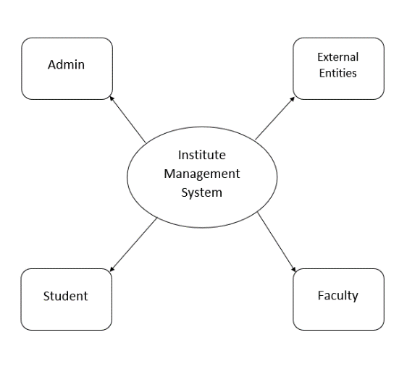In this diagram:

* **Admin**: Interacts with the system to manage students, faculty, courses, and view reports.
* **Faculty**: Interacts to manage courses, grades, schedules, and assignments.
* **Student**: Interacts with the system to enroll in courses, view schedules, grades, and make fee payments.
* **External Systems**: Handles tasks such as email notifications, online fee payment processing, and data storage.

The diagram would include a single process representing the **Institute Management System**, which connects to all the external entities and shows the high-level data flow.

### ****5.1.2 Level 1 of Data Flow Diagram****

The **Level 1 DFD** provides a more detailed look at the internal processes within the Institute Management System. This diagram decomposes the high-level system into functional sub-processes. For the IMS, the following primary processes would be included:

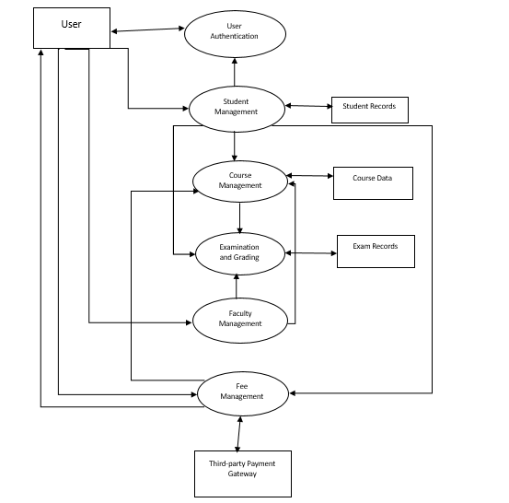

* **User Authentication**:
  + Handles login, role-based access control (Admin, Faculty, Student), and registration.
  + This process validates user credentials and grants access to different functionalities based on the user role.
* **Student Management**:
  + Manages the entire lifecycle of a student, including registration, course enrollment, attendance, performance tracking, and fee management.
  + The process also allows Admins to add or remove student records.
* **Faculty Management**:
  + Manages faculty information such as course assignments, timetables, grading, and performance monitoring.
  + Faculty can upload results, assignments, and course materials.
* **Course Management**:
  + Admin can add, modify, or delete courses.
  + This process also handles course enrollment for students and faculty assignment.
* **Examination and Grading**:
  + Manages exam schedules, question papers, and grade entry.
  + This process calculates and stores student grades for each course.
* **Fee Management**:
  + Admin and students interact with this process to view fee structure, make payments, and generate receipts.
  + Integrates with third-party payment gateways for fee processing.

Each of these sub-processes will have data flows showing how data moves between the processes, data stores (e.g., student records, course data), and external systems.

## ***5.2 Use Case Analysis***

Use Case Analysis is a technique used to identify the different ways in which users interact with the system. It helps in understanding user goals, actions, and system responses. The system will be analyzed for various use cases representing typical interactions for each user role.

### ****5.2.1 Start Menu Use Case****

The **Start Menu Use Case** represents the actions that users take when they first interact with the Institute Management System.

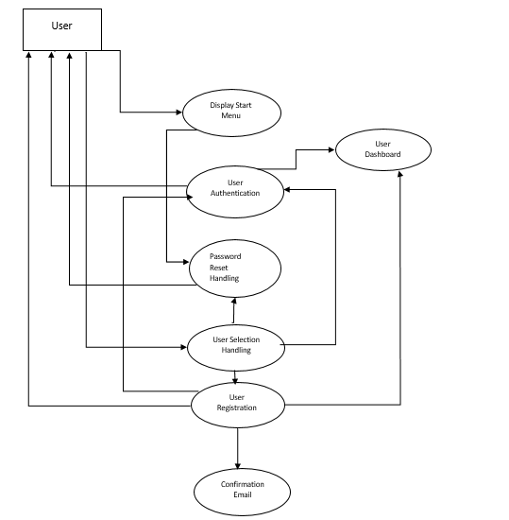

**Actors**:

* **Admin**
* **Faculty**
* **Student**

**Preconditions**:

* The user has an active account in the system.
* The user has access to the appropriate role (Admin, Faculty, Student).

**Main Flow**:

1. The user opens the website and is presented with the **Start Menu**.
2. The user selects an option (Login, Register, Forgot Password).
3. If the user selects **Login**, they are prompted to enter their username and password.
4. After successful authentication, the system directs the user to their respective dashboard (Admin Dashboard, Faculty Dashboard, or Student Dashboard).
5. If the user selects **Register**, they can create a new account by providing their details (name, email, role, etc.).
6. The system validates the registration details and sends a confirmation email.

**Postconditions**:

* User is logged in and redirected to the appropriate dashboard.

**Alternative Flows**:

* If the user forgets their password, they can select the **Forgot Password** option to receive a reset link.

### ****5.2.2 In-System Use Case****

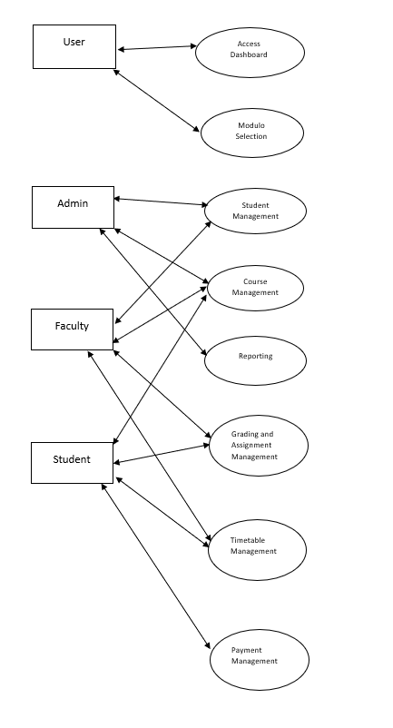The **In-System Use Case** describes the interactions a user has with the Institute Management System once they have logged in. This includes accessing modules like Student Management, Course Management, Timetable Management, etc.

**Actors**:

* **Admin**
* **Faculty**
* **Student**

**Preconditions**:

* User has successfully logged in.
* User’s role has been validated (Admin, Faculty, or Student).

**Main Flow for Admin**:

1. The Admin accesses their dashboard and selects one of the available modules (e.g., Student Management, Faculty Management, Course Management).
2. Admin can add or remove students and faculty members, assign courses, and manage exam schedules.
3. Admin can also view and generate reports for various activities (e.g., course enrollments, student performance).

**Main Flow for Faculty**:

1. Faculty logs into their dashboard, where they can view their assigned courses.
2. They can upload assignments, grade student submissions, and check exam results.
3. Faculty can also manage course schedules and interact with students regarding course-related queries.

**Main Flow for Students**:

1. Students can view available courses and enroll in them.
2. Students can check their timetable, view grades, and interact with faculty.
3. Students can also pay fees and check the status of their payments.

**Postconditions**:

* The user successfully completes their action, whether adding a record, updating a course, or checking their grades.

**Alternative Flows**:

* If a student attempts to enroll in a course without meeting prerequisites, an error message is shown.
* If a faculty member uploads an invalid assignment file, the system rejects the upload and prompts for a valid file format.

# **6.GANTT CHART**

***Milestones:***

|  |  |  |  |
| --- | --- | --- | --- |
| Tasks | Start Date of Task | End Date of Task | Duration |
| Project Selection | 1/12/2024 | 10/12/2024 | 10 days |
| Requirement Analysis | 10/12/2024 | 17/12/2024 | 7 days |
| Upcoming | 0 | 0 | 0 |
| Upcoming | 0 | 0 | 0 |
| Upcoming | 0 | 0 | 0 |
| Upcoming | 0 | 0 | 0 |
| Upcoming | 0 | 0 | 0 |
| Upcoming | 0 | 0 | 0 |
| Upcoming | 0 | 0 | 0 |
| Upcoming | 0 | 0 | 0 |
| Upcoming | 0 | 0 | 0 |
| Upcoming | 0 | 0 | 0 |
| Upcoming | 0 | 0 | 0 |
|  |  |  |  |