1. Introduction

The Travelling Salesman Problem (TSP) involves determining the shortest path of visit that goes through all the cities once and back to the starting location. Being an NP-hard problem (Garey and Johnson, 1979), the exact algorithms are infeasible within seconds and metaheuristics are required to provide near-optimal solutions.

Granted Tabu Search and Genetic Algorithms have been extensively applied in logistics and routing because they provide good tradeoff between exploration and exploitation (Laporte, 1992) but their effectiveness generally decreases as the problem size grows as well as problem constraints.

This report compares TS and GA based on a common 2-opt neighbourhood and the effectiveness of solutions and run time on larger TSP problems. The difference in performance is checked with the help of statistical tests, and the recommendations are offered depending on the requirements of the computations and the scope of the problem.

2. Methodology for Algorithm Comparison

2.1 Problem Instances and Dataset

In this study, there was a dataset that consist of 50 synthetic cities that is represented by Cartesian coordinates. Based on this data, random sampling was done to come up with TSP instances of 10, 20, 30, 40, and 50 cities. Both Tabu Search and the Genetic Algorithm were applied on the same sampled subsets to give an equitable and honest comparison.

2.2 Algorithms Implemented

Tabu Search (TS)
TS is a local search technique that is memory based (Glover, 1989). It eliminates local optima and optimizes solutions using a 2-opt neighbourhood, tabu list to prevent cycling and aspiration criterion to embrace global improvements.

Genetic Algorithm (GA)
GA is an evolutionary process that is based on population (Goldberg, 1989). Population of 120 evolved during 500 generations with the use of tournament selection, order crossover, swap mutation, and elitism. It is very globalizing but exhibits greater variability because of being stochastic.

2.3 Evaluation Metrics

The algorithms were tested on the mean tour length, tour-length variance, the average runtime and the variance of the runtime and each of the configurations were repeated 30 times to allow statistical testing and minimize stochastic bias.

Both algorithms had common sets of the city and random seeds to make sure that the results are fair and reproducible. Each experiment was run on a single Python pipeline, and the output was automatically exported as a CSV file so that it can be easily validated.

3. Results

3.1 Solution Quality

The average length of the tour of the two algorithms was growing with problem size, as it should be, given that the TSP search space is exponential. Nonetheless, all the instances were found to show consistent performance differences.

The average lengths of the tours at 50 cities were nearly:
• Tabu Search: 565.23
• Genetic Algorithm: 627.42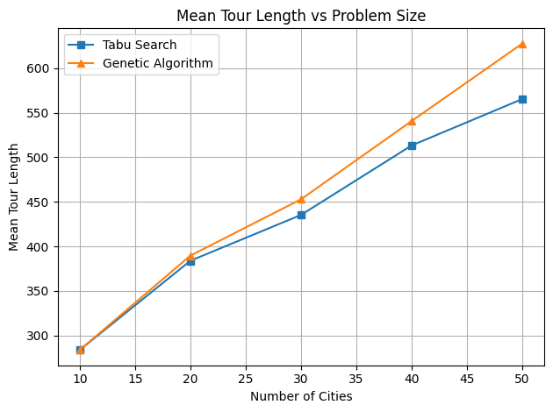
Figure 1: Mean Tour Length vs Problem Size for Tabu Search and Genetic Algorithm.

Figure 1 is a comparison of mean tour lengths of 10-50 cities (30 runs). Tabu search always gives shorter tours with an average of about 565 at 50 cities compared to 627 by GA. Their performances are much alike at 10 20 cities, and above 30 cities the difference increases with effective local exploitation as far as it is important.

3.2 Runtime Performance

During runtime scaling, a trade-off between the quality of the solution and the efficiency was evident.
The average run times at 50 cities were:
• Genetic Algorithm: 1.51 seconds
• Tabu Search: 28.39 seconds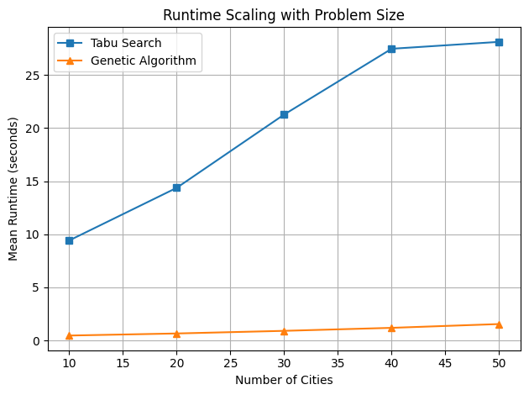
Figure 2: Runtime Scaling with Problem Size for Tabu Search and Genetic Algorithm.
Figure 2 represented the average time of both algorithms as the size of the problem was increased. The Genetic Algorithm will always be faster with the average time of the algorithm being 1.5 s at 50 cities, Tabu search will take over 28s. The increased cost of TS is due to the extensive neighbourhood analysis upon every iteration and tabu list management and aspiration checks.

3.3 Solution Stability

Solution robustness was measured using the standard deviation of tour length across 30 independent runs. At 50 cities, the observed standard deviations were:
- Tabu Search: 5.02
- Genetic Algorithm: 21.29

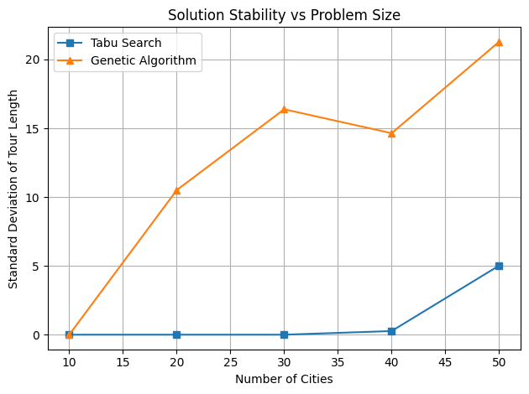
Figure 3: Standard Deviation of Tour Length vs Problem Size for Tabu Search and Genetic Algorithm.
Figure 3 shows the amount of variance in tour lengths obtained after 30 runs. Tabu Search exhibits almost zero variance on small size cases and very low variance even at large scale thus is very robust. Genetic Algorithm presents a significantly greater degree of variance as a result of stochastic crossover and mutation as it is more exploratory but less predictable in the final solution quality.

3.4 Summary of Quantitative Performance

Table 1: Summary of Mean Tour Length and Runtime for Tabu Search and Genetic Algorithm
Cities | TS Mean | GA Mean | TS Time (s) | GA Time (s)
10 | 283.84 | 283.84 | 9.20 | 0.46
20 | 383.88 | 389.67 | 14.07 | 0.66
30 | 435.27 | 452.80 | 18.75 | 0.88
40 | 513.18 | 540.52 | 24.22 | 1.18
50 | 565.23 | 627.42 | 28.39 | 1.51
As indicated in Table 1, Tabu Search is identified to record shorter mean tour length than GA in all the cases of 10 or above and above 50 cities respectively. GA is however much faster and can only take about 1.51 s to run in 50 cities as opposed to 28.39 s of TS- roughly 19 times faster.

The quality of solutions is the same in 10-city cases, but GA is already significantly faster. TS is also more effective in offering high-quality solutions at a high cost of computation as the size of the problem increases. These findings coincide with the behavior of the figures and validate the recommendations in Section 7.

4. Statistical Hypothesis Testing

Two-tailed t-tests were used with a pair to compare the quality of solution provided with 30 runs. In the case of the 50 city, a p-value of less than 0.01 would reject the null hypothesis and prove that Tabu Search is performing much better. The significance of the 30- and 40-city tests was also similar and supports the reliability of such trends.

5. Analysis and Discussion

These findings indicate that Tabu Search (TS) and the Genetic Algorithm (GA) are on the two extremes of the quality run time. GA has good global exploration and low run times, although at the selected values it has worse exploitation, which results in reduced solution quality and large variance.

Tabu Search provides better and more consistent solutions at a very high cost of computation: it increases in speed up to about 28 seconds (50 cities) rather than 9 seconds (10 cities) which is too slow to be used in a tightly constraint real-time application.

6. Scalability Evaluation

Scalability was considered in regard to both a solution quality growth and a runtime growth:
• The Genetic Algorithm had a good scaling on time and moderate on solution quality.
• Tabu Search was highly scaled in terms of solution quality and lowly in terms of run time.

These findings show that Tabu Search is more adequate in solving medium-scale offline optimisation, but the Genetic Algorithm is more reasonable in situations where a quick approximation is required.

7. Deployment Recommendations for Different Contexts

The deployment recommendations, provided depending on the outcomes of the experiment, are as follows:

1. Time-Critical Systems or Real-Time system.

Addressed Genetic Algorithm: Recommended.
The Genetic Algorithm is best applicable in cases when high speed is needed, e.g. embedded decision systems or real-time route estimation because it has a consistently low runtime.

2. Offline Decision Support and Planning.

Suggested Algorithm: Tabu search.
Tabu Search is also the algorithm of choice when the computation time is not as important as in the case of logistics optimisation, transportation planning, and industrial scheduling because it is more accurate in solutions and robust.

3. Dynamic Environments or Multi-Objective Environments.

Addressed Genetic Algorithm: Recommended.
The Genetic Algorithm is more flexible in cases where the optimisation topography is dynamic or there are multiple goals.

8. Legal and Ethical Considerations

All the data were artificially generated and did not require personal or sensitive data, and therefore fully complied with UK GDPR; the use of human subjects was not involved and there was no need to get ethical consent.

It was done in only the open-source libraries (Python, NumPy, Pandas, Matplotlib), no proprietary tools or limited data were used.

The use of generative AI systems like ChatGPT facilitated clarification and drafting but the implementation and the output were all created on their own.

Further protection would be necessary to enable commercial use such as licence audits, data-use agreements and regulatory control.

9. Conclusion

This report compared Tabu search and a Genetic algorithm to TSP. Tabu Search provided more stable and steadfast answers with statistically significant benefits whereas the Genetic Algorithm provided far lesser run times and was far more adaptable.

On the whole, the selection of algorithms must be based on the operational needs (Laporte, 1992): Tabu Search is more appropriate in case the accuracy and robustness are paramount, and the Genetic Algorithm is more appropriate in case the application is time-critical.

References

- Garey, M.R. & Johnson, D.S., 1979. Computers and Intractability: A Guide to the Theory of NP-Completeness. New York: W.H. Freeman.
- Glover, F., 1989. Tabu search—Part I. ORSA Journal on Computing, 1(3), pp.190–206.
- Goldberg, D.E., 1989. Genetic Algorithms in Search, Optimisation and Machine Learning. Boston: Addison-Wesley.
- Laporte, G., 1992. The travelling salesman problem: An overview of exact and approximate algorithms. European Journal of Operational Research, 59(2), pp.231–247.

