Software Requirements Specification (Client Edition)
Executive Project Overview, Feature Catalog, Phased Roadmap & Business Flowcharts

SOFTWARE REQUIREMENTS & PROJECT SPECIFICATION (SRS)
Client & Stakeholder Edition
Project Name: Enterprise Single-Vendor E-Commerce Platform
Target Platform: Web (Ultra-Responsive for Mobile, Tablet & Desktop)
Technology Stack: Laravel, React.js, Tailwind CSS, MySQL
Prepared & Architected By: Jahidul Islam (jahidcse181@gmail.com)
Prepared For: Business Stakeholders & Management
1. EXECUTIVE SUMMARY & BUSINESS VALUE
This Software Requirements Specification outlines the blueprint for a high-performance, modern Single-Vendor E-Commerce platform. The platform is designed from the ground up to solve the three biggest challenges online merchants face:
- Slow Website Speeds & Lost Sales: By combining modern React frontend technology with Laravel's high-speed backend, pages load instantly, ensuring customers do not bounce.
- Inventory & Financial Blindspots: Complete tracking of product costs, supplier purchases, stock adjustments, and real profit margins—eliminating guesswork in business profitability.
- Manual Order Chaos: A centralized control hub with 1-click status updates, instant professional PDF invoice generation, and POS thermal receipt printing for warehouse packing.
2. PHASED ROLLOUT STRATEGY
To get your business online quickly while maintaining software quality, development is divided into two distinct phases:

▲ Visual Flow Diagram #1
3. COMPREHENSIVE FEATURE BREAKDOWN
3.1 Customer Storefront Experience (Converting Visitors to Buyers)
- Ultra-Fast Responsive Design: Fluidly adapts to iPhones, Android devices, tablets, and wide desktop screens.
- Smart Product Discovery:
- Live search with instant suggestions.
- Multi-layer filters (Filter by Category, Brand, Price Range, Color, Size, and In-Stock items).
- Clear category hierarchies and featured product showcases.
- Dynamic Product Detail Page:
- High-definition zoomable image gallery.
- Interactive variant selection (e.g., Selecting "Black" + "XL" instantly displays the accurate price, image, and available stock).
- Low stock alerts (e.g., "Only 3 left in stock - order soon") to increase buyer urgency.
- Frictionless Cart & Single-Page Checkout:
- Slide-out mini cart for instant cart updates without reloading the page.
- Guest checkout support (no mandatory registration required to place an order).
- Promo discount coupon validator with instant price deduction.
- Clear order summary with breakdown of subtotal, tax/VAT, shipping fee, and savings.
- Customer Self-Service Portal:
- Order history with real-time progress timeline (Pending -> Confirmed -> Shipped -> Delivered).
- 1-Click download of official PDF invoices.
- Saved delivery addresses for rapid future checkouts.
3.2 Merchant Admin Backoffice (Your Central Business Control Tower)
- Executive Dashboard & Real-Time Overview:
- Today's revenue, order count, and gross profit at a glance.
- Critical action cards: Pending orders waiting for confirmation, out-of-stock and low-stock alerts.
- Visual sales velocity charts (Daily, Weekly, Monthly, and Annual).
- Catalog & Variant Matrix Management:
- Easily create simple items or complex multi-variant products (e.g. 5 Colors × 4 Sizes = 20 unique SKUs generated automatically).
- Product-level purchase cost vs. selling price configuration.
- Multi-image drag-and-drop upload.
- Inventory & Supplier Purchase Ledger (Stock-In System):
- Supplier Profiles: Maintain supplier directory, contact information, purchase history, and outstanding balance payable.
- Purchase Orders (Stock In): Record new supplier shipments, unit costs, shipping expenses, and amount paid. Automatically updates inventory quantities and adjusts current product cost.
- Stock Movement Audit Log: Every single item added, sold, returned, adjusted, or damaged is permanently logged with who did it, why, and when.
- Low-Stock Notification Center: Highlights products running out of stock before you lose potential sales.
- Order Management & Fulfillment Hub:
- Filter orders by status (Pending, Confirmed, Processing, Shipped, Delivered, Cancelled, Returned).
- Customer detail view with ordered items, delivery addresses, and customer notes.
- Complete status history timeline with internal merchant notes (e.g., "Customer confirmed delivery over phone call").
- Automated inventory restocking if an order is cancelled or returned.
- Invoice & Packing Slip Engine:
- A4 Formal Tax Invoice (PDF): Beautifully branded invoice featuring your company logo, VAT/tax details, itemized totals, and payment status for emailing or printing.
- 80mm POS Thermal Receipt: Direct 1-click printing on standard thermal receipt printers for warehouse packaging and dispatch.
- Business Intelligence, Profit/Loss & Growth Comparisons:
- True Profit & Loss Tracking: Automatically subtracts the actual cost of goods sold (COGS) from sales revenue to show your Real Net Profit.
- Comparative Analytics: Compare this month's revenue vs. last month (MoM) or this year vs. last year (YoY) with percentage growth indicators.
- Top Performing Products: Identifies your highest revenue and most profitable items.
- Dead Stock / Idle Capital Analysis: Identifies items sitting unsold in the warehouse for 60+ days and how much capital is tied up in them.
- Security, Audit Trail & Staff Permissions:
- Role-based permissions (Super Admin, Manager, Inventory Staff).
- Complete activity log tracking which staff member altered a price, updated stock, or changed an order status.
4. VISUAL FLOWCHARTS & BUSINESS PROCESSES
4.1 Customer Order & Checkout Journey

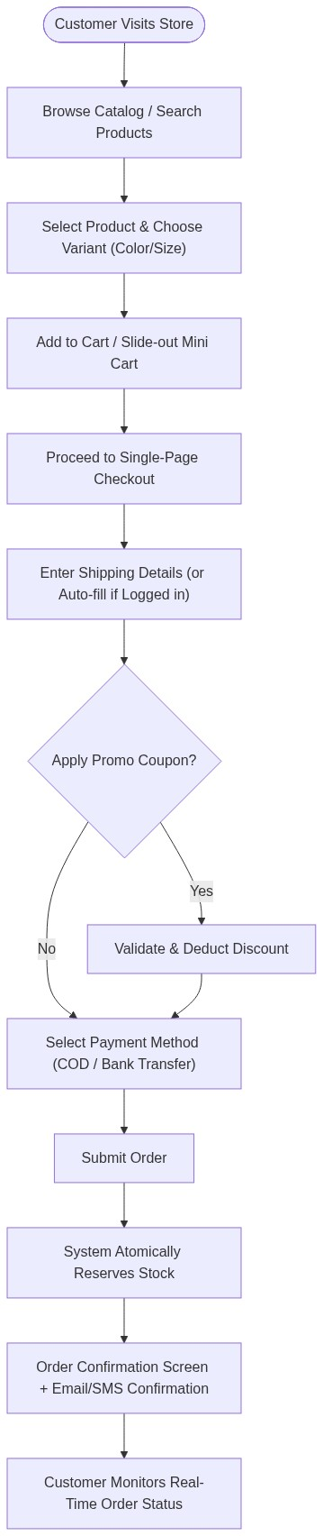
▲ Visual Flow Diagram #2
4.2 Order Fulfillment & Inventory Lifecycle

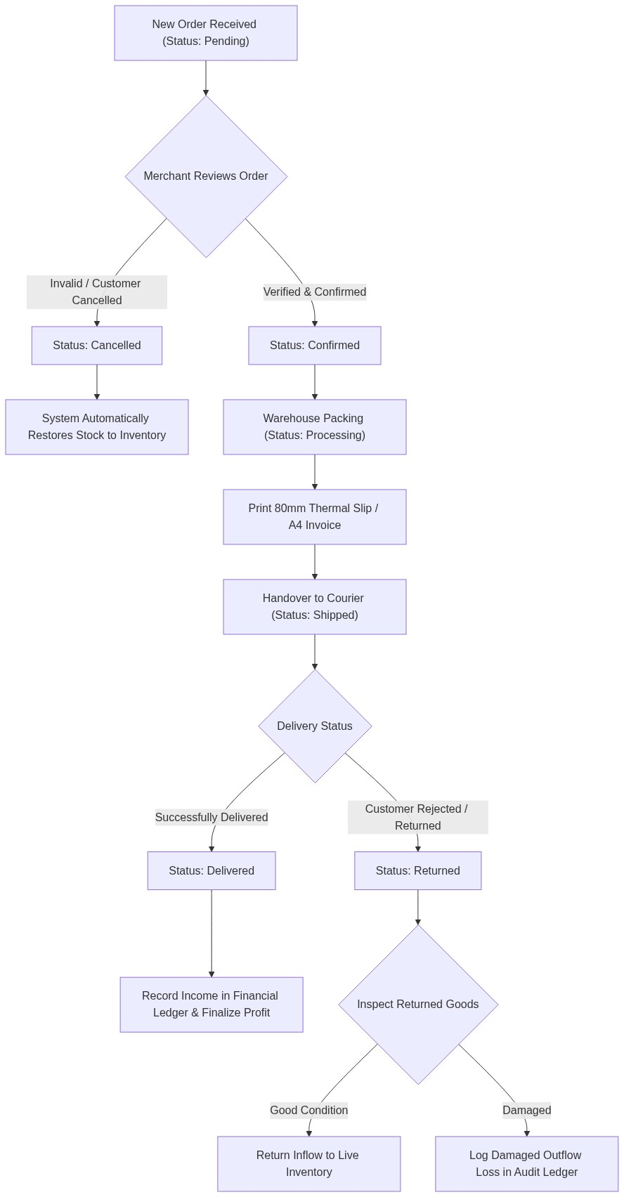
▲ Visual Flow Diagram #3
4.3 Supplier Restocking & Cost Tracking Flow

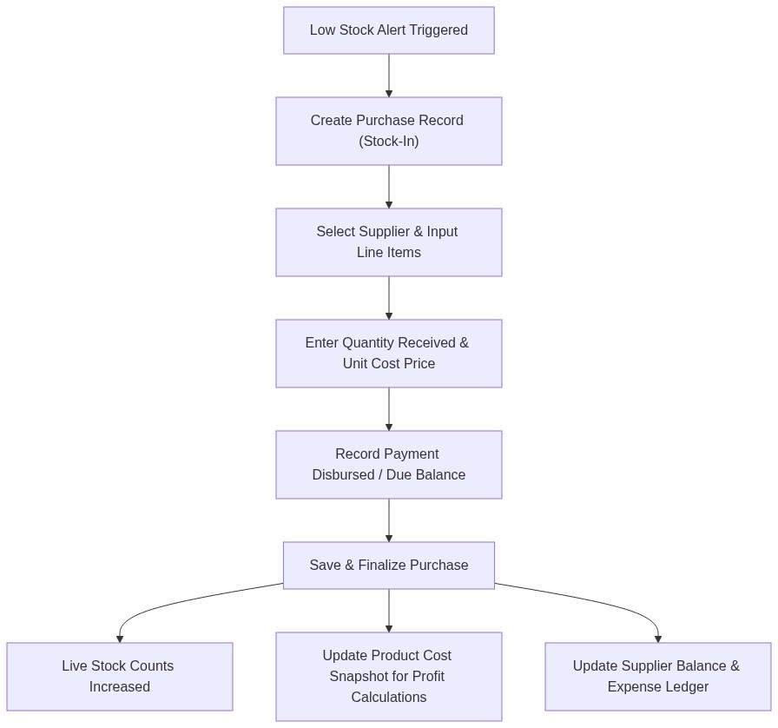
▲ Visual Flow Diagram #4
4.4 Business Intelligence & Profit Calculation Flow

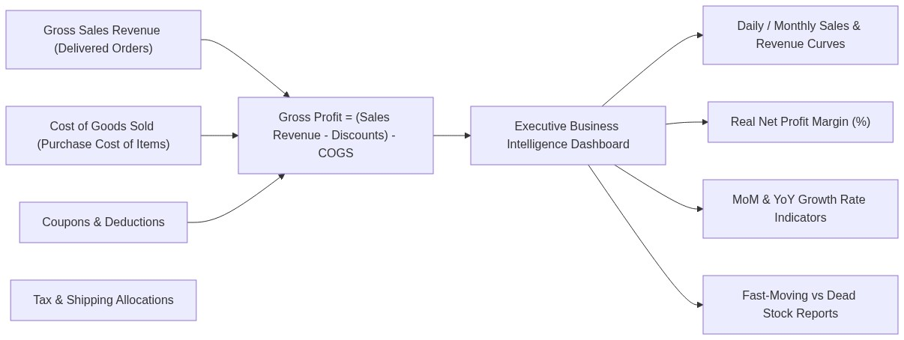
▲ Visual Flow Diagram #5
5. QUALITY, PERFORMANCE & RELIABILITY GUARANTEE
Quality Parameter | What We Build In | Business Benefit to You
Speed & Performance | No unnecessary database queries (Anti-N+1), optimized images, cached settings, React Virtual DOM. | Higher Google search rankings, zero lag, higher checkout conversion rates.
Data Integrity | Atomic database transactions. If an order fails midway, no ghost stock or broken records remain. | 100% accurate inventory and financial reports at all times.
Mobile-First Experience | Responsive UI engineered with Tailwind CSS, touch-friendly navigation, quick tap buttons. | Flawless shopping experience for the 80%+ of customers ordering from smartphones.
Staff Accountability | Immutable audit trail logging every admin action. | Prevents internal discrepancies or unexplained inventory loss.
Future Proofing | Modular driver-ready architecture. | Easy 1-click addition of Phase 2 payment gateways and courier APIs with zero disruption.

6. PROJECT MILESTONES & IMPLEMENTATION TIMELINE

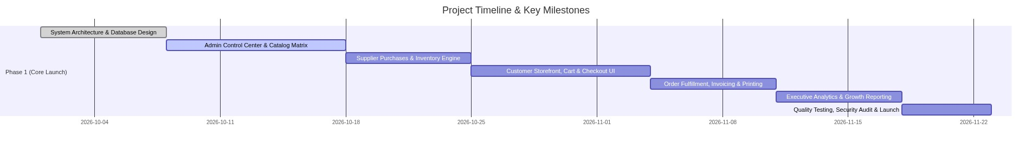
▲ Visual Flow Diagram #6
7. SUMMARY & NEXT STEPS
With this comprehensive specification:
- Developers have an exact technical blueprint for the database, architecture, and performance requirements.
- Business Stakeholders have full clarity on how every single feature contributes to increased sales, efficient warehouse management, and deep financial visibility.
Ready for development kickoff.

