Software Requirements Specification (Developer Edition)
Technical Architecture, Database Schema, Anti-N+1 Strategy, Invoicing & Analytics Engine

SOFTWARE REQUIREMENTS SPECIFICATION (SRS) — DEVELOPER & TECHNICAL EDITION
Enterprise Single-Vendor E-Commerce Platform
Version: 1.0.0
Target Architecture: Laravel 11.x/12.x (MVC + Service/Action Domain Layer) + React 18+ (Inertia.js / SPA Components) + Tailwind CSS 3.4+ + MySQL 8.0
Author & Lead Architect: Jahidul Islam (jahidcse181@gmail.com)
Status: Approved for Implementation
1. SYSTEM OVERVIEW & ARCHITECTURAL FOUNDATION
1.1 Technology Stack Matrix
Layer | Technology | Version / Tooling | Purpose
Backend Core | Laravel Framework | v11.x / 12.x (PHP 8.3+) | Routing, MVC, Eloquent ORM, Auth, Queues, Scheduling
Database | MySQL | v8.0+ (InnoDB, utf8mb4) | Relational Storage, Strict Typing, Foreign Key Constraints, Indexes
Caching & Queues | Redis | v7.0+ | Session storage, Model/Query caching, Async jobs (Invoices, Notifications)
Frontend Framework | React.js | v18.x / 19.x | Component-driven UI, Reactive Storefront & Admin SPA
Glue Layer | Inertia.js | v2.x | Monolithic SPA bridge (Laravel routing + React views without REST boilerplate)
Styling Engine | Tailwind CSS | v3.4+ | JIT utility-first responsive styling, Dark/Light modes
Build Tooling | Vite | v5.x | HMR (Hot Module Replacement), Code-splitting, Asset bundling
PDF Generation | Browsershot / DomPDF | Latest stable | High-fidelity A4 and POS Thermal 80mm Invoice Generation
Charts & BI | ApexCharts / Chart.js | Latest | Interactive financial, growth, and analytics visualizations

1.2 High-Level System Architecture Diagram

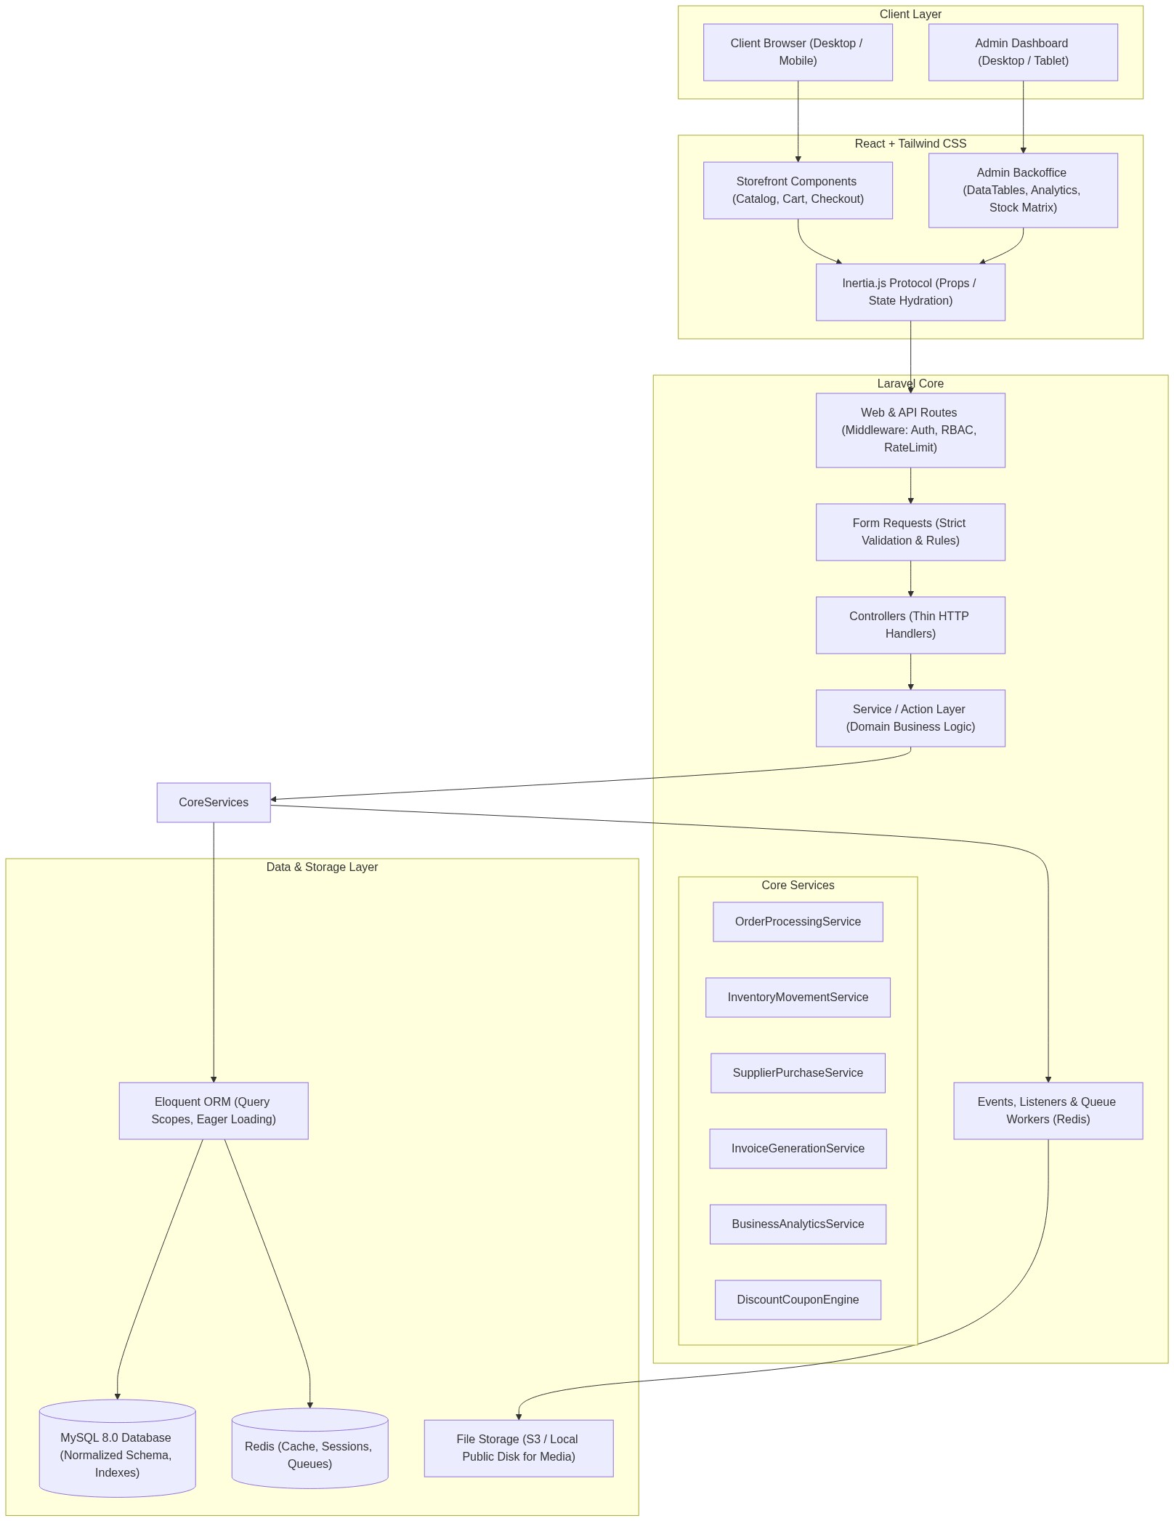
▲ Visual Flow Diagram #1
1.3 Anti-N+1 Query & High-Performance Engineering Directives
To guarantee sub-100ms response times and bulletproof database operations:
- Strict Lazy Loading Prohibition in Development:
[CODE (PHP)]
// app/Providers/AppServiceProvider.php
public function boot(): void
{
Model::preventLazyLoading(! app()->isProduction());
Model::preventSilentlyDiscardingAttributes(! app()->isProduction());
Model::preventAccessingMissingAttributes(! app()->isProduction());
}

- Mandatory Eager Loading Scopes:
- Catalog queries must explicitly specify relationships:
Product::with(['brand:id,name,slug', 'categories:id,name,slug', 'variants.attributeValues', 'media'])
- Order history queries must use:
Order::with(['items.product:id,name', 'items.variant', 'customer:id,name,phone', 'latestStatusHistory'])
- Optimized Pagination & Resource Transformers:
- Always paginate large collections via cursorPaginate() (for infinite scroll) or standard paginate(20) with through() mapping. Never load all records with all().
- Database Indexing Rules:
- Every foreign key must have an explicit B-tree index.
- Composite indexes on query filters: INDEX idx_product_filter (category_id, is_active, base_price)
- Composite index on orders: INDEX idx_order_date_status (order_status, created_at)
- Full-text search index on (name, short_description) for products.
- Atomic Database Transactions:
- Multi-record operations (Checkout, Stock-In, Return, Order Cancellation) must be wrapped in DB::transaction(function() { ... }, 5) to ensure ACID compliance.
2. COMPREHENSIVE DATABASE SCHEMA (DATA DICTIONARY & ERD)

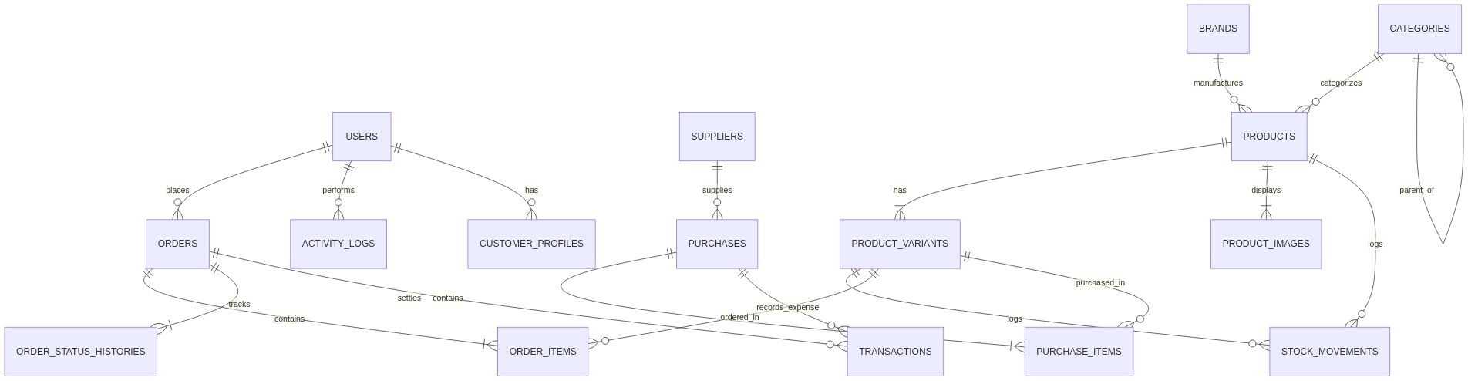
▲ Visual Flow Diagram #2
2.1 Core Tables & Field Definitions
1. `users`
Column | Type | Nullable | Default | Description / Constraints
id | BIGINT UNSIGNED | No | AUTO | Primary Key
name | VARCHAR(120) | No |  | Full Name
email | VARCHAR(191) | No |  | Unique Index
phone | VARCHAR(30) | Yes | NULL | Indexed for customer lookup
password | VARCHAR(255) | No |  | Bcrypted hash
role | ENUM('super_admin','admin','manager','inventory_staff','customer') | No | 'customer' | System role
is_active | BOOLEAN | No | 1 | Account access flag
remember_token | VARCHAR(100) | Yes | NULL
created_at / updated_at | TIMESTAMP | Yes | NULL

2. `customer_profiles`
Column | Type | Nullable | Default | Description / Constraints
id | BIGINT UNSIGNED | No | AUTO | Primary Key
user_id | BIGINT UNSIGNED | No |  | Foreign Key -> users.id (CASCADE)
avatar | VARCHAR(255) | Yes | NULL | Path to image
date_of_birth | DATE | Yes | NULL | Marketing/Loyalty
total_orders_count | INT UNSIGNED | No | 0 | Denormalized counter for quick tier calculation
total_spend_amount | DECIMAL(14,2) | No | 0.00 | Lifetime Customer Value (LTV)
reward_points | INT UNSIGNED | No | 0 | Loyalty point system
default_shipping_address_id | BIGINT UNSIGNED | Yes | NULL | Foreign Key -> addresses.id
default_billing_address_id | BIGINT UNSIGNED | Yes | NULL | Foreign Key -> addresses.id

3. `addresses`
Column | Type | Nullable | Default | Description / Constraints
id | BIGINT UNSIGNED | No | AUTO | Primary Key
user_id | BIGINT UNSIGNED | No |  | Foreign Key -> users.id (CASCADE)
type | ENUM('shipping','billing') | No | 'shipping'
recipient_name | VARCHAR(120) | No |  | Delivery receiver name
phone_number | VARCHAR(30) | No |  | Contact number
street_address | TEXT | No |  | Road, House, Flat details
city | VARCHAR(100) | No |  | City / District
state_division | VARCHAR(100) | Yes | NULL | State / Zone
postal_code | VARCHAR(20) | Yes | NULL
country | VARCHAR(100) | No | 'Bangladesh' | ISO or country string
is_default | BOOLEAN | No | 0 | Default selection flag

4. `categories`
Column | Type | Nullable | Default | Description / Constraints
id | BIGINT UNSIGNED | No | AUTO | Primary Key
parent_id | BIGINT UNSIGNED | Yes | NULL | Foreign Key -> categories.id (Self-referencing tree, SET NULL)
name | VARCHAR(150) | No |  | Category Title
slug | VARCHAR(191) | No |  | Unique Index
image | VARCHAR(255) | Yes | NULL | Category banner/thumbnail
description | TEXT | Yes | NULL | SEO Description
display_order | INT | No | 0 | Sorting sequence in menu
is_active | BOOLEAN | No | 1 | Show/Hide flag
is_featured | BOOLEAN | No | 0 | Home page highlight

5. `brands`
Column | Type | Nullable | Default | Description / Constraints
id | BIGINT UNSIGNED | No | AUTO | Primary Key
name | VARCHAR(150) | No |  | Brand Name
slug | VARCHAR(191) | No |  | Unique Index
logo | VARCHAR(255) | Yes | NULL | Brand Logo URL
is_active | BOOLEAN | No | 1

6. `products`
Column | Type | Nullable | Default | Description / Constraints
id | BIGINT UNSIGNED | No | AUTO | Primary Key
category_id | BIGINT UNSIGNED | No |  | Foreign Key -> categories.id (RESTRICT)
brand_id | BIGINT UNSIGNED | Yes | NULL | Foreign Key -> brands.id (SET NULL)
name | VARCHAR(255) | No |  | Product Title
slug | VARCHAR(255) | No |  | Unique Index
sku_code | VARCHAR(100) | No |  | Base SKU (Unique)
barcode | VARCHAR(100) | Yes | NULL | EAN/UPC Code (Indexed)
has_variants | BOOLEAN | No | 0 | 0 = Single Product, 1 = Configurable
cost_price | DECIMAL(12,2) | No | 0.00 | Base Purchase Cost for COGS computation
selling_price | DECIMAL(12,2) | No | 0.00 | Standard Retail Price
discount_price | DECIMAL(12,2) | Yes | NULL | Promotional Price
discount_start | DATETIME | Yes | NULL | Promo Start
discount_end | DATETIME | Yes | NULL | Promo Expiry
stock_quantity | INT | No | 0 | Sum of variant stocks or simple product stock
low_stock_threshold | INT | No | 5 | Trigger warning in admin when stock <= threshold
short_description | TEXT | Yes | NULL | For preview cards & search snippets
long_description | LONGTEXT | Yes | NULL | Rich HTML format specifications
thumbnail | VARCHAR(255) | Yes | NULL | Primary Catalog Display Image
weight_kg | DECIMAL(8,3) | Yes | NULL | Shipping calculation weight
is_active | BOOLEAN | No | 1 | Indexed
is_featured | BOOLEAN | No | 0 | Indexed
views_count | BIGINT UNSIGNED | No | 0 | Popularity counter
created_at / updated_at | TIMESTAMP | Yes | NULL

7. `product_variants`
Column | Type | Nullable | Default | Description / Constraints
id | BIGINT UNSIGNED | No | AUTO | Primary Key
product_id | BIGINT UNSIGNED | No |  | Foreign Key -> products.id (CASCADE)
sku | VARCHAR(100) | No |  | Unique Variant SKU (e.g. TSHIRT-BLK-XL)
variant_name | VARCHAR(255) | No |  | Human readable (e.g. Color: Black, Size: XL)
attributes_json | JSON | No |  | { "color": "Black", "size": "XL" }
cost_price | DECIMAL(12,2) | No | 0.00 | Variant-specific acquisition cost
selling_price | DECIMAL(12,2) | No | 0.00 | Variant-specific selling price
discount_price | DECIMAL(12,2) | Yes | NULL | Variant-specific promo price
stock_quantity | INT | No | 0 | Live physical stock for this exact variant
low_stock_threshold | INT | No | 3 | Alert level
image | VARCHAR(255) | Yes | NULL | Specific image (e.g., specific color)
is_active | BOOLEAN | No | 1

8. `product_images`
Column | Type | Nullable | Default | Description / Constraints
id | BIGINT UNSIGNED | No | AUTO | Primary Key
product_id | BIGINT UNSIGNED | No |  | Foreign Key -> products.id (CASCADE)
image_path | VARCHAR(255) | No |  | Storage URL/Path
is_primary | BOOLEAN | No | 0 | Featured image flag
sort_order | INT | No | 0 | Display sequence

9. `suppliers`
Column | Type | Nullable | Default | Description / Constraints
id | BIGINT UNSIGNED | No | AUTO | Primary Key
name | VARCHAR(150) | No |  | Contact Person Name
company_name | VARCHAR(150) | No |  | Business / Factory Name
phone | VARCHAR(30) | No |  | Contact Phone (Indexed)
email | VARCHAR(150) | Yes | NULL
address | TEXT | Yes | NULL | Physical address
total_purchased_amount | DECIMAL(14,2) | No | 0.00 | Lifetime purchase volume
total_paid_amount | DECIMAL(14,2) | No | 0.00 | Total paid to supplier
total_due_balance | DECIMAL(14,2) | No | 0.00 | Accounts payable balance
is_active | BOOLEAN | No | 1

10. `purchases` (Stock-In Records)
Column | Type | Nullable | Default | Description / Constraints
id | BIGINT UNSIGNED | No | AUTO | Primary Key
po_number | VARCHAR(50) | No |  | Unique PO Code (e.g., PO-202609-0012)
supplier_id | BIGINT UNSIGNED | No |  | Foreign Key -> suppliers.id (RESTRICT)
purchase_date | DATE | No |  | Transaction Date
subtotal_cost | DECIMAL(14,2) | No | 0.00 | Sum of line items
shipping_cost | DECIMAL(10,2) | No | 0.00 | Freight/Handling costs
tax_amount | DECIMAL(10,2) | No | 0.00 | Incurred tax
discount_amount | DECIMAL(10,2) | No | 0.00 | Supplier discount
grand_total | DECIMAL(14,2) | No | 0.00 | Net total payable
paid_amount | DECIMAL(14,2) | No | 0.00 | Cash/Bank disbursed
due_amount | DECIMAL(14,2) | No | 0.00 | Remaining liability
payment_status | ENUM('paid','partial','unpaid') | No | 'unpaid'
status | ENUM('draft','received','cancelled') | No | 'received' | Only 'received' updates stock
invoice_attachment | VARCHAR(255) | Yes | NULL | Scanned supplier voucher
notes | TEXT | Yes | NULL | Internal remarks
created_by_user_id | BIGINT UNSIGNED | No |  | Foreign Key -> users.id
created_at / updated_at | TIMESTAMP | Yes | NULL

11. `purchase_items`
Column | Type | Nullable | Default | Description / Constraints
id | BIGINT UNSIGNED | No | AUTO | Primary Key
purchase_id | BIGINT UNSIGNED | No |  | Foreign Key -> purchases.id (CASCADE)
product_id | BIGINT UNSIGNED | No |  | Foreign Key -> products.id (RESTRICT)
variant_id | BIGINT UNSIGNED | Yes | NULL | Foreign Key -> product_variants.id (SET NULL)
quantity | INT UNSIGNED | No |  | Units received
unit_cost_price | DECIMAL(12,2) | No |  | Cost per item for this shipment
subtotal | DECIMAL(14,2) | No |  | quantity * unit_cost_price

12. `stock_movements` (Complete Audit Ledger)
Column | Type | Nullable | Default | Description / Constraints
id | BIGINT UNSIGNED | No | AUTO | Primary Key
product_id | BIGINT UNSIGNED | No |  | Foreign Key -> products.id
variant_id | BIGINT UNSIGNED | Yes | NULL | Foreign Key -> product_variants.id
movement_type | ENUM('purchase_in','sale_out','order_cancel_in','return_in','manual_adjustment_in','manual_adjustment_out','damage_out') | No |  | Strict classification
quantity | INT | No |  | Positive (Inflow) or Negative (Outflow)
unit_cost | DECIMAL(12,2) | No | 0.00 | Snapshot unit cost at time of movement
reference_type | VARCHAR(100) | Yes | NULL | Polymorphic (e.g. App\Models\Order, Purchase)
reference_id | BIGINT UNSIGNED | Yes | NULL | ID of reference record
previous_stock | INT | No |  | Stock level immediately before operation
current_stock | INT | No |  | Stock level immediately after operation
user_id | BIGINT UNSIGNED | Yes | NULL | Admin/Staff who performed action
notes | VARCHAR(255) | Yes | NULL | Reason for manual adjust/damage
created_at | TIMESTAMP | No | CURRENT | Timestamp of occurrence

13. `orders`
Column | Type | Nullable | Default | Description / Constraints
id | BIGINT UNSIGNED | No | AUTO | Primary Key
order_number | VARCHAR(40) | No |  | Unique Public Order Identifier (e.g., ORD-20260926-8821)
user_id | BIGINT UNSIGNED | Yes | NULL | Foreign Key -> users.id (NULL for Guest Checkout)
customer_name | VARCHAR(120) | No |  | Snapshot name
customer_phone | VARCHAR(30) | No |  | Snapshot phone
customer_email | VARCHAR(150) | Yes | NULL | Snapshot email
shipping_address_json | JSON | No |  | Immutable snapshot of delivery address
billing_address_json | JSON | Yes | NULL | Immutable snapshot of billing address
subtotal | DECIMAL(12,2) | No |  | Sum of order items
tax_amount | DECIMAL(10,2) | No | 0.00 | Applied VAT/Tax
shipping_cost | DECIMAL(10,2) | No | 0.00 | Delivery charge
discount_amount | DECIMAL(10,2) | No | 0.00 | Total discount applied
coupon_code | VARCHAR(50) | Yes | NULL | Applied promo coupon
grand_total | DECIMAL(12,2) | No |  | subtotal + tax + shipping - discount
total_cost_price | DECIMAL(12,2) | No | 0.00 | Sum of COGS for all items in order (for instant profit calculation)
gross_profit | DECIMAL(12,2) | No | 0.00 | (subtotal - discount) - total_cost_price
payment_method | ENUM('cod','bank_transfer','bkash_manual','stripe_online','sslcommerz_online') | No | 'cod'
payment_status | ENUM('pending','paid','partially_refunded','refunded','failed') | No | 'pending'
order_status | ENUM('pending','confirmed','processing','shipped','delivered','cancelled','returned') | No | 'pending' | Indexed
courier_name | VARCHAR(100) | Yes | NULL | Phase 1 manual / Phase 2 automated
courier_tracking_id | VARCHAR(100) | Yes | NULL | Tracking code
customer_notes | TEXT | Yes | NULL | Special instructions from customer
admin_notes | TEXT | Yes | NULL | Internal admin remarks
delivered_at | DATETIME | Yes | NULL | Timestamp of fulfillment
created_at / updated_at | TIMESTAMP | Yes | NULL | Composite index (order_status, created_at)

14. `order_items`
Column | Type | Nullable | Default | Description / Constraints
id | BIGINT UNSIGNED | No | AUTO | Primary Key
order_id | BIGINT UNSIGNED | No |  | Foreign Key -> orders.id (CASCADE)
product_id | BIGINT UNSIGNED | No |  | Foreign Key -> products.id (RESTRICT)
variant_id | BIGINT UNSIGNED | Yes | NULL | Foreign Key -> product_variants.id (SET NULL)
product_name | VARCHAR(255) | No |  | Snapshot item name at purchase
variant_name | VARCHAR(255) | Yes | NULL | Snapshot variant label
sku | VARCHAR(100) | No |  | Snapshot SKU
unit_cost_price | DECIMAL(12,2) | No | 0.00 | Snapshot product unit cost (COGS)
unit_selling_price | DECIMAL(12,2) | No |  | Unit retail price charged
quantity | INT UNSIGNED | No |  | Item count
subtotal | DECIMAL(12,2) | No |  | quantity * unit_selling_price
total_cost | DECIMAL(12,2) | No | 0.00 | quantity * unit_cost_price

15. `order_status_histories`
Column | Type | Nullable | Default | Description / Constraints
id | BIGINT UNSIGNED | No | AUTO | Primary Key
order_id | BIGINT UNSIGNED | No |  | Foreign Key -> orders.id (CASCADE)
from_status | VARCHAR(50) | Yes | NULL | Prior status
to_status | VARCHAR(50) | No |  | Updated status
changed_by_user_id | BIGINT UNSIGNED | Yes | NULL | User who triggered the state change (or NULL for system)
comment | VARCHAR(255) | Yes | NULL | e.g. "Payment received via Cash on Delivery", "Dispatched with Steadfast"
created_at | TIMESTAMP | No | CURRENT

16. `transactions` (Financial Ledger)
Column | Type | Nullable | Default | Description / Constraints
id | BIGINT UNSIGNED | No | AUTO | Primary Key
transaction_number | VARCHAR(60) | No |  | Unique Code (e.g. TRX-2026-9901)
transaction_type | ENUM('income_sale','expense_purchase','expense_refund','expense_operational') | No |  | Direction of capital
payable_type | VARCHAR(100) | Yes | NULL | Polymorphic (e.g. App\Models\Order, Purchase)
payable_id | BIGINT UNSIGNED | Yes | NULL | Target ID
payment_method | VARCHAR(50) | No |  | 'cash', 'bank', 'bkash', 'card'
amount | DECIMAL(14,2) | No |  | Transaction value
gateway_fee | DECIMAL(10,2) | No | 0.00 | Processing fee deduction
net_amount | DECIMAL(14,2) | No |  | Net settled value
status | ENUM('successful','pending','failed') | No | 'successful'
gateway_reference | VARCHAR(150) | Yes | NULL | External Bank/MFS Transaction ID
recorded_by_user_id | BIGINT UNSIGNED | Yes | NULL | Foreign Key -> users.id
notes | TEXT | Yes | NULL | Transaction memo
created_at | TIMESTAMP | No | CURRENT

17. `coupons`
Column | Type | Nullable | Default | Description / Constraints
id | BIGINT UNSIGNED | No | AUTO | Primary Key
code | VARCHAR(50) | No |  | Unique Promo Code (UPPERCASE)
discount_type | ENUM('percentage','fixed_amount') | No | 'percentage'
discount_value | DECIMAL(10,2) | No |  | Percentage (e.g. 15.00) or Flat Amount (e.g. 500.00)
min_order_amount | DECIMAL(10,2) | No | 0.00 | Threshold to qualify
max_discount_cap | DECIMAL(10,2) | Yes | NULL | For percentage discounts cap
usage_limit_total | INT UNSIGNED | Yes | NULL | Global max usage
usage_limit_per_user | INT UNSIGNED | No | 1 | Max times a single customer can redeem
used_count | INT UNSIGNED | No | 0 | Live counter
start_date | DATETIME | No |  | Validity Start
end_date | DATETIME | No |  | Validity Expiry
is_active | BOOLEAN | No | 1

18. `activity_logs` (System Audit Trail)
Column | Type | Nullable | Default | Description / Constraints
id | BIGINT UNSIGNED | No | AUTO | Primary Key
user_id | BIGINT UNSIGNED | Yes | NULL | Actor ID
action | VARCHAR(100) | No |  | e.g. order.status_updated, product.price_adjusted
subject_type | VARCHAR(100) | Yes | NULL | Polymorphic model
subject_id | BIGINT UNSIGNED | Yes | NULL | Target model ID
old_payload | JSON | Yes | NULL | Previous state snapshot
new_payload | JSON | Yes | NULL | Updated state snapshot
ip_address | VARCHAR(45) | Yes | NULL | Client IP
user_agent | TEXT | Yes | NULL | Device browser info
created_at | TIMESTAMP | No | CURRENT

19. `settings`
Column | Type | Nullable | Default | Description / Constraints
id | BIGINT UNSIGNED | No | AUTO | Primary Key
group | VARCHAR(50) | No | 'general' | 'general','seo','invoice','shipping','social'
key | VARCHAR(100) | No |  | Unique Index
value | LONGTEXT | Yes | NULL | Configuration value (Serialized/JSON/String)
is_public | BOOLEAN | No | 0 | Available to React storefront props

3. CORE BACKEND BUSINESS LOGIC & SERVICE ARCHITECTURE
The application avoids fat controllers by implementing the Action / Service Layer Pattern.
[SPECIFICATION]
app/
├── Actions/
│ ├── Orders/
│ │ ├── CreateOrderAction.php
│ │ ├── UpdateOrderStatusAction.php
│ │ └── CancelOrderAction.php
│ ├── Inventory/
│ │ ├── AdjustStockAction.php
│ │ └── RecordStockMovementAction.php
│ ├── Purchases/
│ │ └── ReceivePurchaseOrderAction.php
│ └── Analytics/
│ ├── CalculateSalesMetricsAction.php
│ └── CalculateGrowthRateAction.php
├── Services/
│ ├── Cart/
│ │ └── CartSessionManager.php
│ ├── Invoicing/
│ │ ├── InvoicePdfGenerator.php
│ │ └── ThermalReceiptFormatter.php
│ └── Discounts/
│ └── CouponValidationService.php

3.1 Order State Machine Implementation
Order status updates must strictly follow valid transitions to prevent stock discrepancies:

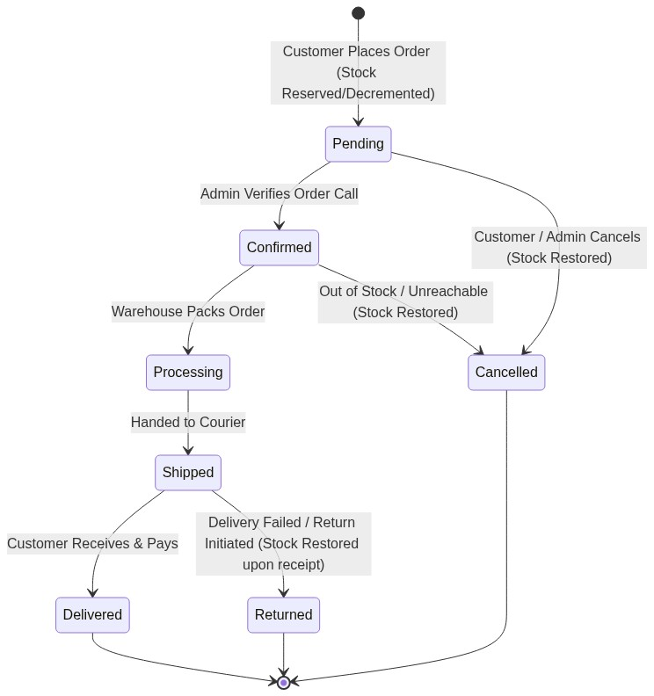
▲ Visual Flow Diagram #3
State Transition Matrix Table
Current Status | Allowed Next Statuses | Stock Action Triggered | Financial Action Triggered
pending | confirmed, cancelled | None (Stock decremented on placement) | None
confirmed | processing, cancelled | If cancelled: Inflow order_cancel_in | Cancel transaction if applicable
processing | shipped, cancelled | If cancelled: Inflow order_cancel_in | Cancel transaction
shipped | delivered, returned | If returned: Inflow return_in (after admin inspection) | Record refund/loss if applicable
delivered | returned (Within return window) | If returned: Inflow return_in | Process refund transaction
cancelled | Terminal State | No further modifications | -

3.2 Automated Profit & Cost-of-Goods-Sold (COGS) Engine
When an order is created, the system calculates the profit margin in real time by snapshotting the product/variant's unit cost price at the exact moment of purchase:
✦ Item Profit = (Unit Selling Price × Quantity) - (Unit Cost Price × Quantity)
✦ Order Gross Profit = (Order Subtotal - Discount Amount) - Σ (Item Unit Cost Price × Quantity)
This enables instant, zero-delay reporting on gross profit margins across days, weeks, months, or per individual SKU.
3.3 Supplier Purchase & Stock-In Workflow

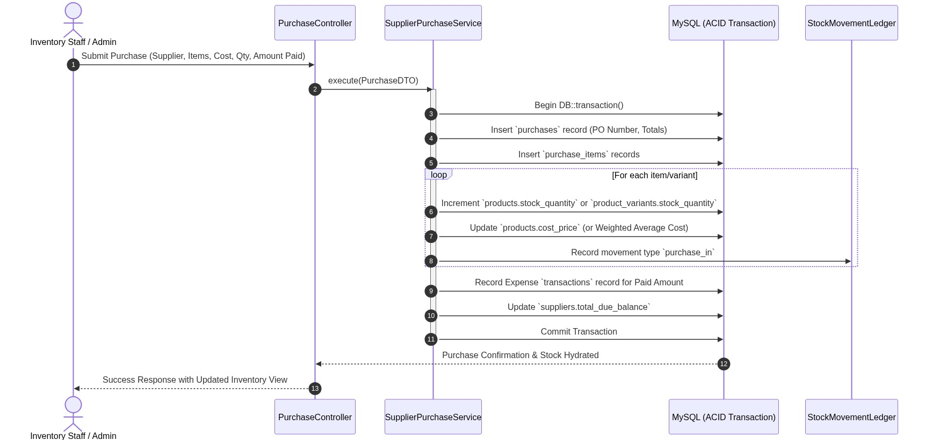
▲ Visual Flow Diagram #4
4. INVOICE GENERATION & PRINT SYSTEM ARCHITECTURE
4.1 Dual Invoicing System Specification
- Full Standard A4 Invoice (PDF Download / Direct Print):
- Built with high-precision vector-styled HTML/Blade templates converted via PDF renderer.
- Includes: Company Logo, Official VAT/BIN Number, Invoice Number, Issue Date, Customer Billing/Shipping Details, Itemized Table with SKU, Unit Price, Qty, Subtotal, Tax Breakdown, Shipping Fee, Coupon Discount, Grand Total in Words, Payment Mode, Terms & Conditions, Authorized Signature placeholder.
- POS 80mm Thermal Receipt (Direct Browser POS Print):
- Compact 80mm width CSS media print layout:
[CODE (CSS)]
@media print {
@page { size: 80mm auto; margin: 0; }
body { width: 78mm; font-family: 'Courier New', monospace; font-size: 11px; }
.no-print { display: none !important; }
}

- Includes store title, contact number, order barcode/QR code for courier scanning, item summary, total, and thank you note.
5. ANALYTICS, COMPARISONS & BUSINESS INTELLIGENCE (BI) ENGINE
The analytics engine provides pre-aggregated queries and caching for high-speed executive dashboards:
5.1 Analytics Metrics Formulas & SQL Aggregations
- Gross Sales vs Net Sales:
✦ Gross Sales = Σ (Order Item Subtotals)
✦ Net Sales = Gross Sales - Discount Discounts - Returned Order Amounts
- Average Order Value (AOV):
✦ AOV = Net Sales{Total Completed Orders Count
- Period-over-Period Growth Rate (MoM / YoY):
✦ Growth Rate (\%) = ( Current Period Value - Previous Period Value{Previous Period Value ) × 100
- Top 10 High-Velocity Products:
[CODE (SQL)]
SELECT oi.product_id, oi.product_name, SUM(oi.quantity) as total_sold, SUM(oi.subtotal) as total_revenue, SUM(oi.subtotal - oi.total_cost) as total_profit
FROM order_items oi
INNER JOIN orders o ON o.id = oi.order_id
WHERE o.order_status = 'delivered' AND o.created_at BETWEEN :start_date AND :end_date
GROUP BY oi.product_id, oi.product_name
ORDER BY total_sold DESC
LIMIT 10;

- Dead Stock / Aging Inventory Report:
[CODE (SQL)]
SELECT p.id, p.name, p.sku_code, p.stock_quantity, p.cost_price, (p.stock_quantity * p.cost_price) as locked_capital, MAX(o.created_at) as last_ordered_at
FROM products p
LEFT JOIN order_items oi ON p.id = oi.product_id
LEFT JOIN orders o ON oi.order_id = o.id
WHERE p.stock_quantity > 0 AND p.is_active = 1
GROUP BY p.id, p.name, p.sku_code, p.stock_quantity, p.cost_price
HAVING last_ordered_at < DATE_SUB(NOW(), INTERVAL 60 DAY) OR last_ordered_at IS NULL
ORDER BY locked_capital DESC;

6. FRONTEND ARCHITECTURE & COMPONENT SPECIFICATION
6.1 React Component Hierarchy
[SPECIFICATION]
resources/js/
├── Components/
│ ├── Common/
│ │ ├── Button.jsx
│ │ ├── Modal.jsx
│ │ ├── DataTable.jsx # Sortable, Filterable, Server-side paginated
│ │ ├── FormInput.jsx
│ │ ├── Badge.jsx
│ │ └── Toast.jsx
│ ├── Storefront/
│ │ ├── Header/Navbar.jsx
│ │ ├── ProductCard.jsx
│ │ ├── VariantSelector.jsx # Real-time stock & price sync
│ │ ├── MiniCartDrawer.jsx
│ │ ├── CheckoutForm.jsx
│ │ └── TrackingTimeline.jsx
│ └── Admin/
│ ├── Sidebar.jsx
│ ├── TopNav.jsx
│ ├── StatCard.jsx # Value, Trend Icon (+12.5%), Sparkline
│ ├── GrowthComparisonChart.jsx
│ ├── StockMatrixBuilder.jsx # Cartesian Product variant creator
│ └── PrintInvoiceModal.jsx
├── Pages/
│ ├── Store/
│ │ ├── Home.jsx
│ │ ├── Shop.jsx # Multi-facet filters, query params sync
│ │ ├── ProductDetails.jsx
│ │ ├── Cart.jsx
│ │ ├── Checkout.jsx
│ │ └── Customer/Orders.jsx
│ └── Admin/
│ ├── Dashboard.jsx
│ ├── Products/Index.jsx, Create.jsx, Edit.jsx
│ ├── Inventory/StockList.jsx, StockAdjustment.jsx
│ ├── Purchases/Index.jsx, Create.jsx
│ ├── Orders/Index.jsx, Show.jsx
│ ├── Reports/Sales.jsx, ProfitLoss.jsx, Growth.jsx
│ └── Settings/Index.jsx

7. PHASE 1 VS PHASE 2 ARCHITECTURAL ROADMAP

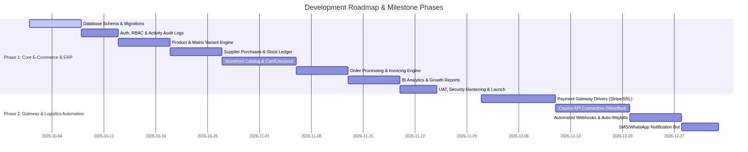
▲ Visual Flow Diagram #5
7.1 Phase 1 Deliverables (Core Solid Foundation)
- Fully functional, highly-optimized Single Vendor Storefront.
- Cart & Single-Page Checkout supporting Cash on Delivery (COD) and Manual Banking/MFS verification.
- Complete Catalog, Brand, Category, Attribute, and Variant Matrix Management.
- Supplier Management, Purchase Invoicing (Stock-In), and Continuous Inventory Movement Tracking.
- Order Management with full lifecycle state machine, order edit/modification, and automated stock restoration on cancellation.
- Complete Invoicing System: A4 PDF Generator and 80mm POS Thermal Receipt direct printer.
- Executive Analytics: Real-time Sales, Revenue, Gross Profit (COGS), MoM/YoY Growth Comparison Charts, and Dead Stock tracking.
- Role-based permissions and detailed audit logging of every admin action.
7.2 Phase 2 Deliverables (Integration & Automation)
- Payment Gateway Integration: Modular driver-based architecture (Stripe, SSLCommerz, bKash, Nagad) with cryptographic webhook signature validation and auto-settlement.
- Courier API Automation: Real-time sync with courier APIs (e.g. Steadfast, Pathao, RedX, DHL) for 1-click booking, instant waybill barcode generation, and automated delivery status webhooks.
- Automated Messaging: Automated SMS and WhatsApp order confirmation and parcel dispatch notifications.
8. SECURITY, CODING STANDARDS & DEPLOYMENT
- Security Measures:
- Strict CSRF verification on all state-mutating requests.
- Content Security Policy (CSP) and sanitization on all user-submitted rich text.
- Rate limiting: throttle:10,1 on checkout and authentication routes to prevent bot floods.
- Encrypted customer data snapshots in orders to maintain historical accuracy regardless of profile modifications.
- Code Quality Standards:
- Strict PHP types (declare(strict_types=1);).
- PSR-12 coding compliance enforced via Laravel Pint.
- ESLint and Prettier for clean React & Tailwind components.
- Automated Testing Matrix:
- Feature tests covering Cart calculations, Coupon rules, Stock movements, and Order status state transitions.
- Zero tolerance for untracked inventory changes.

