ORIO STYLE
SOFTWARE REQUIREMENTS & PROJECT SPECIFICATION (SRS)
Executive Project Overview, Feature Catalog & Business Flowcharts

Project Name: Enterprise Single-Vendor E-Commerce Platform – ORIO Style
Target Platform: Web (Ultra-Responsive for Mobile, Tablet & Desktop)
Technology Stack: Laravel, React.js, Tailwind CSS, MySQL
Prepared For: Business Stakeholders & Management
Prepared By/Developer: Jahidul Islam, jahidcse181@gmail.com

1. EXECUTIVE SUMMARY & BUSINESS VALUE
This Software Requirements Specification outlines the blueprint for a high-performance, modern Single-Vendor E-Commerce platform. The platform is designed from the ground up to solve the three biggest challenges online merchants face:
- Slow Website Speeds & Lost Sales: By combining modern React frontend technology with Laravel's high-speed backend, pages load instantly, ensuring customers do not bounce.
- Inventory & Financial Blindspots: Complete tracking of product costs, supplier purchases, stock adjustments, and real profit margins—eliminating guesswork in business profitability.
- Manual Order Chaos: A centralized control hub with 1-click status updates, instant professional PDF invoice generation, and POS thermal receipt printing for warehouse packing.

2. COMPREHENSIVE FEATURE BREAKDOWN
2.1 Customer Storefront Experience (Converting Visitors to Buyers)
- Ultra-Fast Responsive Design: Fluidly adapts to iPhones, Android devices, tablets, and wide desktop screens.
- Smart Product Discovery:
- Live search with instant suggestions.
- Multi-layer filters (Filter by Category, Brand, Price Range, Color, Size, and In-Stock items).
- Clear category hierarchies and featured product showcases.
- Dynamic Product Detail Page:
- High-definition zoomable image gallery.
- Interactive variant selection (e.g., Selecting "Black" + "XL" instantly displays the accurate price, image, and available stock).
- Low stock alerts (e.g., "Only 3 left in stock - order soon") to increase buyer urgency.
- Frictionless Cart & Single-Page Checkout:
- Slide-out mini cart for instant cart updates without reloading the page.
- Guest checkout support (no mandatory registration required to place an order).
- Promo discount coupon validator with instant price deduction.
- Clear order summary with breakdown of subtotal, tax/VAT, shipping fee, and savings.
- Customer Self-Service Portal:
- Order history with real-time progress timeline (Pending -> Confirmed -> Shipped -> Delivered).
- 1-Click download of official PDF invoices.
- Saved delivery addresses for rapid future checkouts.
2.2 Merchant Admin Backoffice (Your Central Business Control Tower)
- Executive Dashboard & Real-Time Overview:
- Today's revenue, order count, and gross profit at a glance.
- Critical action cards: Pending orders waiting for confirmation, out-of-stock and low-stock alerts.
- Visual sales velocity charts (Daily, Weekly, Monthly, and Annual).
- Catalog & Variant Matrix Management:
- Easily create simple items or complex multi-variant products (e.g. 5 Colors × 4 Sizes = 20 unique SKUs generated automatically).
- Product-level purchase cost vs. selling price configuration.
- Multi-image drag-and-drop upload.
- Inventory & Supplier Purchase Ledger (Stock-In System):
- Supplier Profiles: Maintain supplier directory, contact information, purchase history, and outstanding balance payable.
- Purchase Orders (Stock In): Record new supplier shipments, unit costs, shipping expenses, and amount paid. Automatically updates inventory quantities and adjusts current product cost.
- Stock Movement Audit Log: Every single item added, sold, returned, adjusted, or damaged is permanently logged with who did it, why, and when.
- Low-Stock Notification Center: Highlights products running out of stock before you lose potential sales.
- Order Management & Fulfillment Hub:
- Filter orders by status (Pending, Confirmed, Processing, Shipped, Delivered, Cancelled, Returned).
- Customer detail view with ordered items, delivery addresses, and customer notes.
- Complete status history timeline with internal merchant notes (e.g., "Customer confirmed delivery over phone call").
- Automated inventory restocking if an order is cancelled or returned.
- Invoice & Packing Slip Engine:
- A4 Formal Tax Invoice (PDF): Beautifully branded invoice featuring your company logo, VAT/tax details, itemized totals, and payment status for emailing or printing.
- 80mm POS Thermal Receipt: Direct 1-click printing on standard thermal receipt printers for warehouse packaging and dispatch.
- Business Intelligence, Profit/Loss & Growth Comparisons:
- True Profit & Loss Tracking: Automatically subtracts the actual cost of goods sold (COGS) from sales revenue to show your Real Net Profit.
- Comparative Analytics: Compare this month's revenue vs. last month (MoM) or this year vs. last year (YoY) with percentage growth indicators.
- Top Performing Products: Identifies your highest revenue and most profitable items.
- Dead Stock / Idle Capital Analysis: Identifies items sitting unsold in the warehouse for 60+ days and how much capital is tied up in them.
- Security, Audit Trail & Staff Permissions:
- Role-based permissions (Super Admin, Manager, Inventory Staff).
- Complete activity log tracking which staff member altered a price, updated stock, or changed an order status.
3. VISUAL FLOWCHARTS & BUSINESS PROCESSES
3.1 Customer Order & Checkout Journey
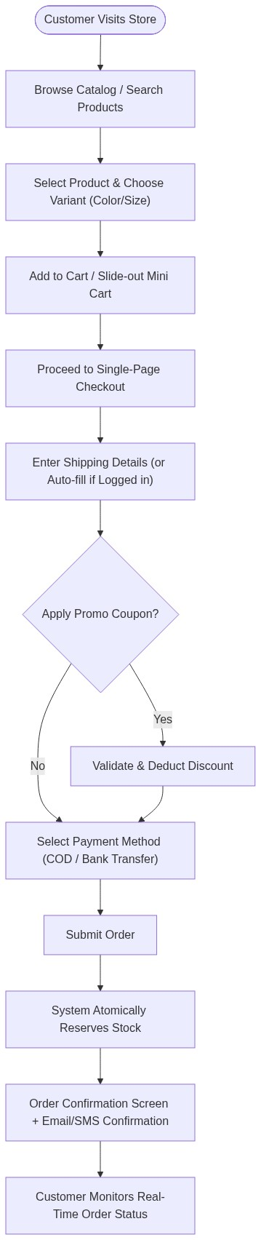

3.2 Order Fulfillment & Inventory Lifecycle
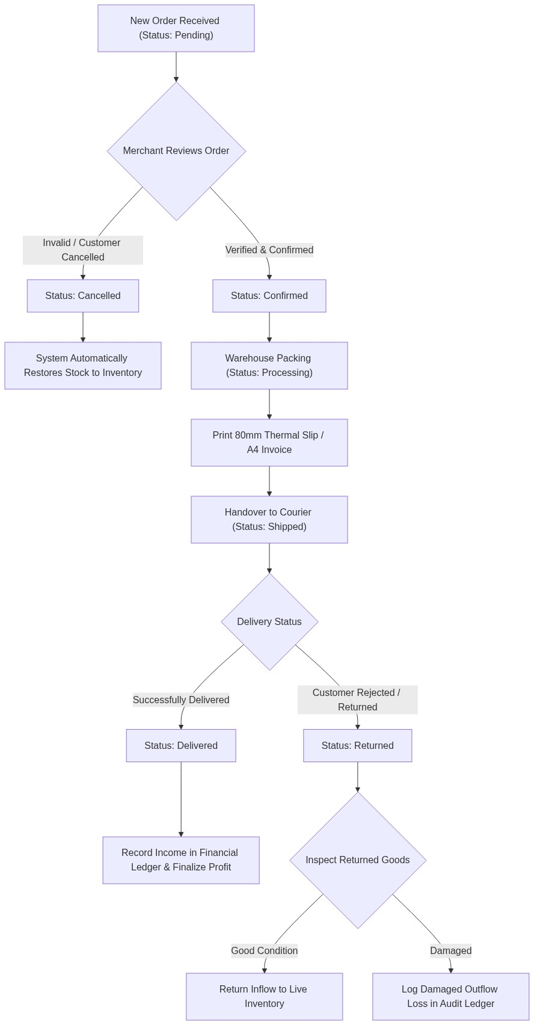

▲ Visual Flow Diagram #3
3.3 Supplier Restocking & Cost Tracking Flow

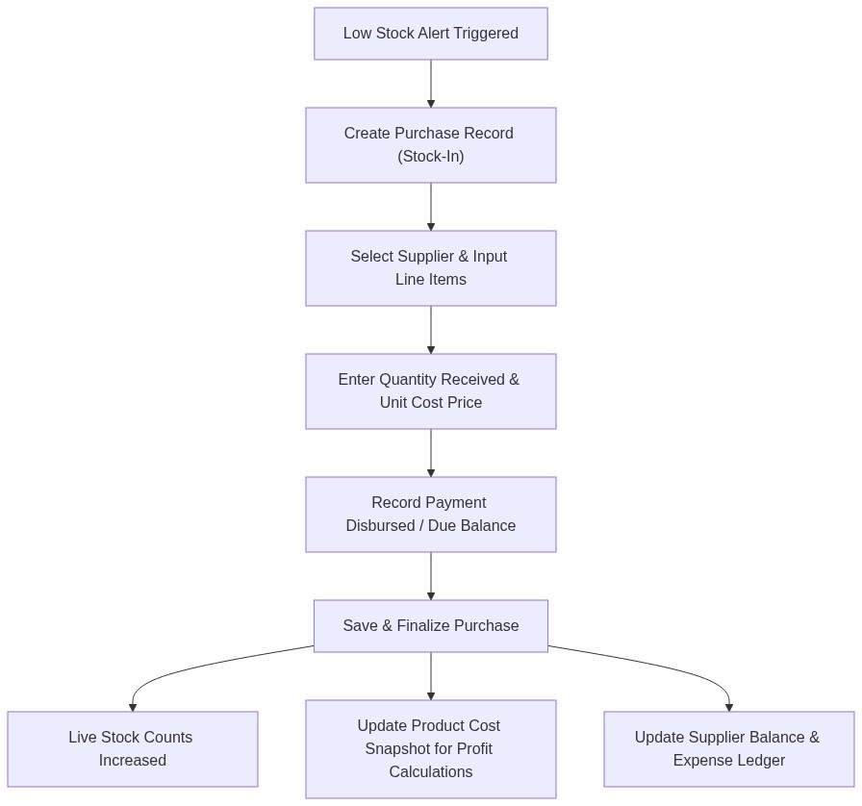
▲ Visual Flow Diagram #4
3.4 Business Intelligence & Profit Calculation Flow

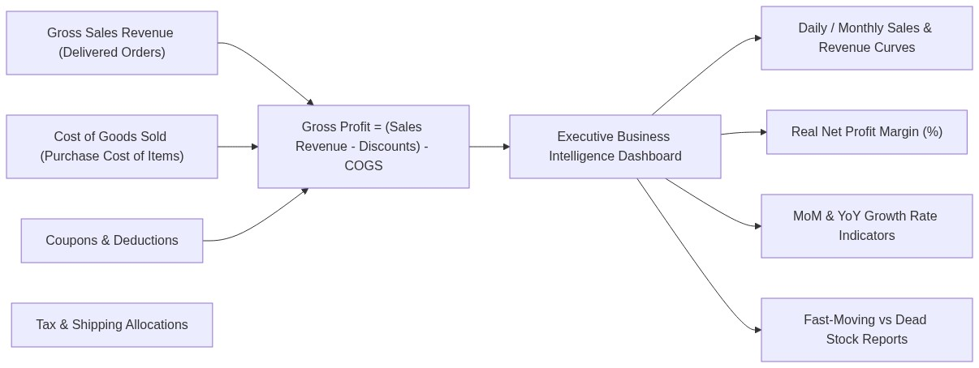
▲ Visual Flow Diagram #5
4. QUALITY, PERFORMANCE & RELIABILITY GUARANTEE
Quality Parameter | What We Build In | Business Benefit to You
Speed & Performance | No unnecessary database queries (Anti-N+1), optimized images, cached settings, React Virtual DOM. | Higher Google search rankings, zero lag, higher checkout conversion rates.
Data Integrity | Atomic database transactions. If an order fails midway, no ghost stock or broken records remain. | 100% accurate inventory and financial reports at all times.
Mobile-First Experience | Responsive UI engineered with Tailwind CSS, touch-friendly navigation, quick tap buttons. | Flawless shopping experience for the 80%+ of customers ordering from smartphones.
Staff Accountability | Immutable audit trail logging every admin action. | Prevents internal discrepancies or unexplained inventory loss.
Future Proofing | Modular driver-ready architecture. | Easy addition of Phase 2 payment gateways and courier APIs with zero disruption.

