|  |
| --- |
| **Software Requirements Specification**  **Content Management System** |

**Chowdhury, Jahiruddin 15-28397-1**

**Tamanna Tamannur Khondokar 14-27403-2**

**Table of Contents**

1. Introduction ........................................................................................................................................... 3

1.1 Purpose ................................................................................................................................................ 3

1.2 Scope .................................................................................................................................................... 3

1.3 Definitions, acronyms, and abbreviations ............................................................................................ 3

1.4 References ............................................................................................................................................ 3

2. Overall description ................................................................................................................................. 4

2.1 Product perspective ............................................................................................................................. 4

2.2 Product functions ................................................................................................................................. 4

2.3 User classes and characteristics............................................................................................................ 4

2.4 Operating Environment ........................................................................................................................ 4

2.5 Assumptions and dependencies ........................................................................................................... 4

3. Specific requirements.............................................................................................................................. 5

3.1 External interface requirements………………………………………………….……………………………………..……………. 5

3.1.1 User interfaces ................................................................................................................................... 5

3.1.2 Hardware interfaces .......................................................................................................................... 6

3.1.3 Software interfaces ........................................................................................................................... 6

3.1.4 Communications interfaces ............................................................................................................... 6

3.2 Functional requirements ...................................................................................................................... 7

3.3 Non-functional requirements................................................................................................................ 9

3.4 System requirements........................................................................................................................... 10

3.5 User requirements............................................................................................................................... 10

4. Prioritization and Release Plan .............................................................................................................. 12

4.1 Choice of prioritization method .......................................................................................................... 12

Appendix A: Analysis Models ..................................................................................................................... 16

**1. Introduction**

This section gives a scope description and overview of everything included in this SRS document. Also, the purpose for this document is described and a list of abbreviations and definitions is provided.

**1.1 Purpose**

The purpose of this document is to give a detailed description of the requirements for the “Content Management System” software. It will illustrate the purpose and complete declaration for the development of system. It will also explain system constraints, interface and interactions with other external applications. This document is primarily intended to be proposed to a customer for its approval and a reference for developing the first version of the system for the development team.

**1.2 Scope**

The “Content Management System” is a web based site that allows the readers and writers to meet each other. This website provides the features of blogging all at one place. The main idea behind blogging is to share your thoughts with all your friends which can be read by all the users using the website. Authors will be able to choose from the default themes and create their own.

**1.3 Definitions, acronyms, and abbreviations**

|  |  |
| --- | --- |
| **Term** | **Definition** |
| User | Someone who interacts with the system. |
| Admin/Administrator | System administrator who is given specific permission for managing and controlling the system |

**1.4 References**

<https://managewp.com/blog/wordpress-content-management-complete-guide>

<https://www.drupal.org/docs/user_guide/en/understanding-drupal.html>

<https://www.joomla.org/about-joomla.html>

# Overall Description

## 2.1 Product Perspective

This education sharing platform will allow writers to write from their profile. The writers will be able to choose from the provided themes for their article publishing environment. Readers will be able to choose their interest. According to their interest area suggested articles will be shown to their homepage.

## 2.2 Product Function

* Login: This provide facilities for user to log in into the website.
* Logout: This provide facility for user to logout from the website after successful logged in
* Change Password: This provide facility for user to change the password
* Forget Password: This provide facility for user to get new password when they forget
* Create profile: This provide facility for user to create their own profile
* Update Profile: This provide facility for user to update their information

## 2.3 User Classes and Characteristics

Author: General users of the software they will be

## 2.4 Operating Environment

HARDWARE REQUIREMENTS:

* Pentium-IV (Processor) and later.
* 256 MB Ram minimum
* 512 KB Cache Memory minimum
* Hard disk 10 GB minimum
* Microsoft Compatible 101 or more Key Board

SOFTWARE REQUIREMENTS:

* Operating System: ALL
* Front-End: JavaScript, HTML, CSS.
* Back-End: MySQL, PHP
* Web Server:

## Assumptions and Dependencies

1. There will be availability of Internet via 3G, 4G, 5G or Wi-Fi.

2. The user of the site should be well acquainted with English or Bangla language.

3. The user should have a valid email address in order to register into the website.

4. Central server of the system must be able to handle all the incoming requests simultaneously.

5. The user ha basic knowledge of computers and Internet.

**3. Specific Requirements**

This section contains all of the functional and quality requirements of the system. It gives a detailed description of the system and all its features.

# External Interface Requirements

## 3.1.1 User Interfaces

Standard users will use the web browser to use the website. Hence, it shall have a login page for users to login into the site. For those who are first time users, they will have to fill up registration details. After logging into the system, the user will be shown his profile and the wall containing the posts shared by user’s friends. User is given options to log out, search people and change any of his personal settings on his home page. A daily advertisement page will be shown alongside the wall.

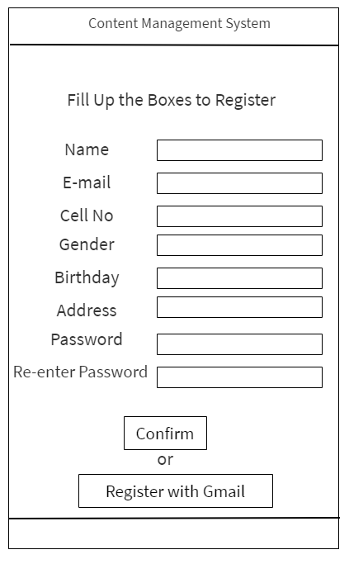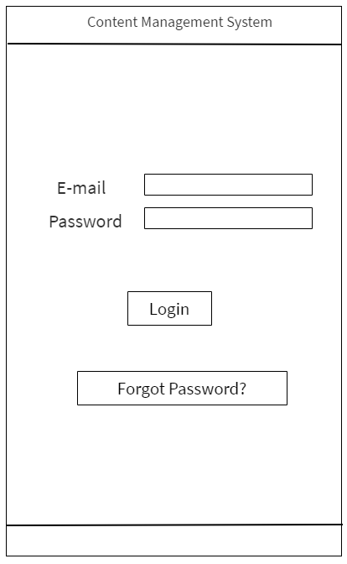

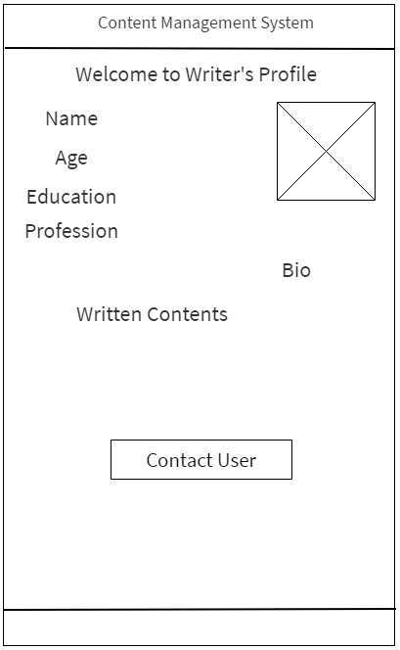

## 3.1.2 Hardware Interfaces

The users need to have access to a keyboard, monitor, and a computer to view and manage our CMS. Users are highly recommended to have a mouse, and speakers for full functionality.

## 3.1.3 Software Interfaces

The users need to have a functional operating system that includes an up to date Internet browser with JavaScript enabled, such as Internet Explorer, Google Chrome, Firefox, Opera or Safari. In addition to a functional operating system, and Internet browser, users need an up-to-date version of Adobe Flash Player.

## 3.1.4 Communication Interfaces

The users need to have access to unrestricted Internet via broadband, dial-up or wire.

# Functional Requirements

**Functional Requirement 01:**

**Title:** Sign up in the system.

**Description:** A user shall be able to sign up in the system through ‘Sign Up’ button.

**Dependency:** None

**Functional Requirement 02:**

**Title**: Sign up through google account.

**Description:** A user shall be able to sign up through google account with ‘Sign up with Google’ button where all public information will be filled up automatically.

**Dependency:** None.

**Functional Requirement 03:**

**Title:** Login to the system.

**Description:** A user shall be able to login to the system by clicking ‘Login’ button.

**Dependency:** FR 01/ FR 02

**Functional Requirement 04:**

**Title:** Change passwords.

**Description:** A user shall be able to change his/her password of the account.

**Dependency:** FR 03.

**Functional Requirement 05:**

**Title:** Give users new password when they forget.

**Description:** A user shall be able to recover his/her account with the help of google account when they forget their password.

**Dependency:** FR 02.

**Functional Requirement 06:**

**Title:** Profile creation.

**Description:** A user shall be able to create his/ her profile.

**Dependency:** FR 03.

**Functional Requirement 07:**

**Title:** Edit/Update profile.

**Description:** A user shall be able to edit or update his/her created profile.

**Dependency:** FR 06.

**Functional Requirement 08:**

**Title:** Logout from the account.

**Description:** A user shall be able to logout of his/her profile.

**Dependency:** FR 03.

**Functional Requirement 09:**

**Title:** Search content.

**Description:** A user shall be able to search any written content with keywords.

**Dependency:** FR 03.

**Functional Requirement 10:**

**Title:** Seek content (Reader).

**Description:** A user(Reader) shall be able to seek content about any topic from writers and post it in ‘Seeking Bar’.

**Dependency:** FR 03.

**Functional Requirement 11:**

**Title:** Post content.

**Description:** A writer shall be able to post his/her written content in public bar or reply to any seeking post in Seeking bar.

**Dependency:** FR 03.

**Functional Requirement 12:**

**Title:** View profile.

**Description:** A user shall be able to view other user’s profile and view his/her written contents and viewed contents.

**Dependency:** FR 03.

# Non-functional Requirements

**Non-functional Requirement 01:**

**Requirement:** Passwords shall never be viewable at the point of entry or at any other time.

**Type:** Security.

**Non-functional Requirement 02:**

**Requirement:** Each unsuccessful attempt by a user to access an item of data shall be recorded on an audit trail

**Type:** Security.

**Non-functional Requirement 03:**

**Requirement:** The System shall be available for use 24 hours.

**Type:** Availability

**Non-functional Requirement 04:**

**Requirement:** The System shall achieve 100 hours MTBF (mean time between failure).

**Type:** Availability

**Non-functional Requirement 05:**

**Requirement:** Unless the system is non‐operational, the system shall present a user with notification informing them that the system is unavailable.

**Type:** Availability

**Non-functional Requirement 06:**

**Requirement:** At least 20 percent of the processor capacity and storage space available to the system shall be unused at peak load seasonal periods.

**Type:** Efficiency.

**Non-functional Requirement 07:**

**Requirement:** The system restart cycle must execute completely in less than 60 seconds.

**Type:** Efficiency.

**Non-functional Requirement 08:**

**Requirement:** Any interface between a user and the automated system shall have a maximum response time of two seconds.

**Type:** Efficiency.

# System Requirements

**System Requirement 01:**

**Title:** User Registration.

**Description:** Given that a user has downloaded application, then the user should be able to register through the application. The user must provide user-name, password and e-mail address. The user can choose to provide a regularly used phone number.

**System Requirement 02:**

**Title:** User Login.

**Description:** Given that a user has registered, then the user should be able to log in to the application. The log-in information will be stored on the device and in the future the user should be logged in automatically.

**System Requirement 03:**

**Title:** Retrieve Password.

**Description:** Given that a user has registered, then the user should be able to retrieve his/her password by e-mail.

**System Requirement 04:**

**Title:** Profile Page.

**Description:** A user should have a profile page. On the profile page a user can edit his/her information, which includes the password, -mail address and phone number.

# User Requirements

**User Requirement 01:**

**Title**: Signup.

**User Story:** As a user, I want to sign up to the system.

**Dependency:** None.

**User Requirement 02:**

**Title**: Signup with google.

**User Story:** As a user, I want to sign up into the system with my google account where all my public info will be filled automatically from my google account.

**Dependency:** None.

**User Requirement 03:**

**Title:** Login.

**User Story:** As a user, I want to login to the system with my username and password.

**Dependency:** Signup.

**User Requirement 04:**

**Title:** Change Password.

**User Story:** As a user, I want to change my password if needed.

**Dependency:** Login.

**User Requirement 05:**

**Title:** Recover account.

**User Story:** As a user, I want to system to recover my account with my google account if in any case I forget my password.

**Dependency:** Signup.

**User Requirement 06:**

**Title:** Create profile.

**User Story:** As a user, I want to create my profile.

**Dependency:** Login.

**User Requirement 07:**

**Title:** Edit profile.

**User Story:** As a user, I want to able to edit and update my profile.

**Dependency:** Login.

**User Requirement 08:**

**Title:** Logout.

**User Story:** As a user, I want to be able to logout from the system whenever I like.

**Dependency:** Login.

**User Requirement 09:**

**Title:** Search content.

**User Story:** As a user, I want to search the contents with title and keywords of my topics of interest.

**Dependency:** Login.

**User Requirement 10:**

**Title:** Seek content.

**User Story:** As a user(reader), I want the option to post a topic of which I’m interested in and willing to read contents related to it.

**Dependency:** Login.

**User Requirement 11:**

**Title:** Publish content.

**User Story:** As a user(writer), I want to post my written contents publicly or in reply to any seeking post.

**Dependency:** Login.

**User Requirement 12:**

**Title:** View other profiles.

**User Story:** As a user, I want to view any user’s profile and read his/her pubic contents and view the contents they’ve read.

**Dependency:** Login.

**4. Prioritization and Release Plan**

In order to get a view of how to divide the requirements into different releases and what requirements should be included in which release, a prioritization of the requirements is needed. This section discusses the choice of prioritization methods and gives a suggestion of how the release plan for these requirements could look like.

**4.1 Choice of prioritization method**

The prioritization technique that was used to classify the requirements was ‘Three Level Scale’.

Which divides the requirements into 3 levels of priority.

High-priority requirements are both important (customers need the capability) and urgent (customers need it in the next release).

Medium-priority requirements are important (customers need the capability) but not urgent (they can wait for a later release).

Low-priority requirements are neither important (customers can live without the capability if necessary) nor urgent (customers can wait, perhaps forever).

**Functional Requirement prioritization:**

|  |  |
| --- | --- |
| **ID** | 01 |
| **Title** | Sign up in the system |
| **Description** | A user shall be able to sign up in the system through ‘Sign Up’ button |
| **Priority** | High |

|  |  |
| --- | --- |
| **ID** | 02 |
| **Title** | Title: Sign up through google account. |
| **Description** | A user shall be able to sign up through google account with ‘Sign up with Google’ button where all public information will be filled up automatically. |
| **Priority** | High |

|  |  |
| --- | --- |
| **ID** | 03 |
| **Title** | Login to the system |
| **Description** | A user shall be able to login to the system by clicking ‘Login’ button |
| **Priority** | High |

|  |  |
| --- | --- |
| **ID** | 04 |
| **Title** | Change passwords. |
| **Description** | A user shall be able to change his/her password of the account. |
| **Priority** | High |

|  |  |
| --- | --- |
| **ID** | 05 |
| **Title** | Give users new password when they forget. |
| **Description** | A user shall be able to recover his/her account with the help of google account when they forget their password |
| **Priority** | High |

|  |  |
| --- | --- |
| **ID** | 06 |
| **Title** | Profile creation |
| **Description** | A user shall be able to create his/ her profile. |
| **Priority** | High |

|  |  |
| --- | --- |
| **ID** | 07 |
| **Title** | Edit/Update profile |
| **Description** | A user shall be able to edit or update his/her created profile |
| **Priority** | Medium |

|  |  |
| --- | --- |
| **ID** | 08 |
| **Title** | Logout from the account. |
| **Description** | A user shall be able to logout of his/her profile. |
| **Priority** | High |

|  |  |
| --- | --- |
| **ID** | 09 |
| **Title** | Search content. |
| **Description** | A user shall be able to search any written content with keywords |
| **Priority** | High |

|  |  |
| --- | --- |
| **ID** | 10 |
| **Title** | Seek content (Reader). |
| **Description** | A user(Reader) shall be able to seek content about any topic from writers and post it in ‘Seeking Bar’. |
| **Priority** | Low |

|  |  |
| --- | --- |
| **ID** | 11 |
| **Title** | Post content. |
| **Description** | A writer shall be able to post his/her written content in public bar or reply to any seeking post in Seeking bar. |
| **Priority** | High |

|  |  |
| --- | --- |
| **ID** | 12 |
| **Title** | View profile |
| **Description** | A user shall be able to view other user’s profile and view his/her written contents and viewed contents |
| **Priority** | Medium |

**4.2 Release Plan**

The requirements were divided into three releases based on the prioritization and their dependencies. The three different releases were assembled so that each would work as a fully functional application. In the first release the requirements that build up the foundation of the application were included, together with the most highly prioritized requirements and their dependencies.

The second release also includes important requirements. However, these requirements are not vital for a functional application. They are more suited to act as additional features that can contribute to making the software product more attractive.

The third release includes the requirements that can be afforded to discard if the project gets delayed or overruns the budget.

Appendix A: Analysis Models

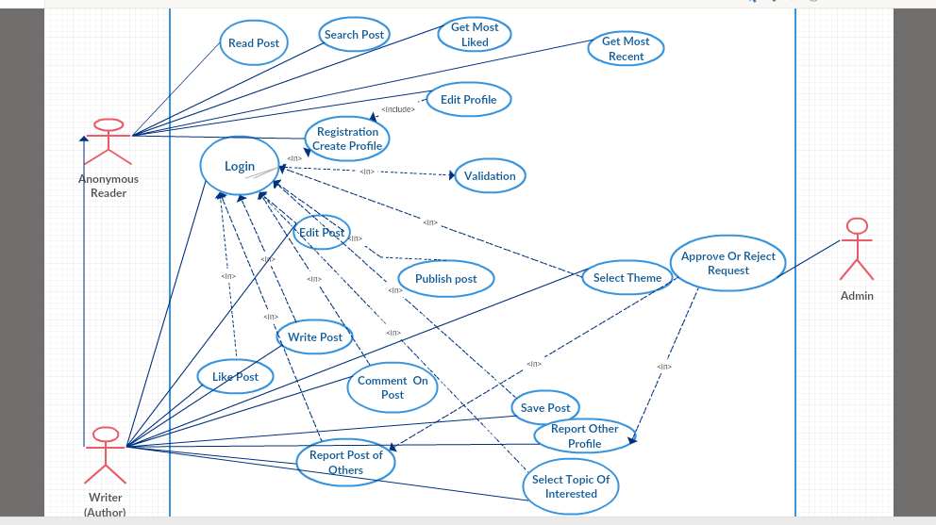

Fig: Use case Diagram.