Title of Contribution

Presenting Author¹, Second Author², Other Authors^{1,2}

¹Department, University/Institute, City, Country
²Department, University/Institute, City, Country

The body of the abstract should start on this line and should be clearly written, self-contained and, when possible, abbreviations and complicated equations will be avoided. The abstract will be limited to a single page. The text will be justified and written using 14pt Times New Roman fonts with 17pt linespacing. A figure may be added between the main text of the abstract and the references. A single line will separate the figure from the main text of the abstract and another one the caption from the bibliography. Please refrain from using headers or footnotes and/or modifying the format of this file. References [1] will use square brackets [1,2].

The file will be saved in .doc format, named following the convention “presentingauthorfamilyname_presentingauthorfirstname .doc” and sent to garciapa@unican.es. Please indicate the kind of contribution (oral/poster) you prefer in the body of the email. Soon after the deadline for abstract submission (30th of April 2018) you will receive confirmation of the acceptance of your contribution as an oral or poster presentation.

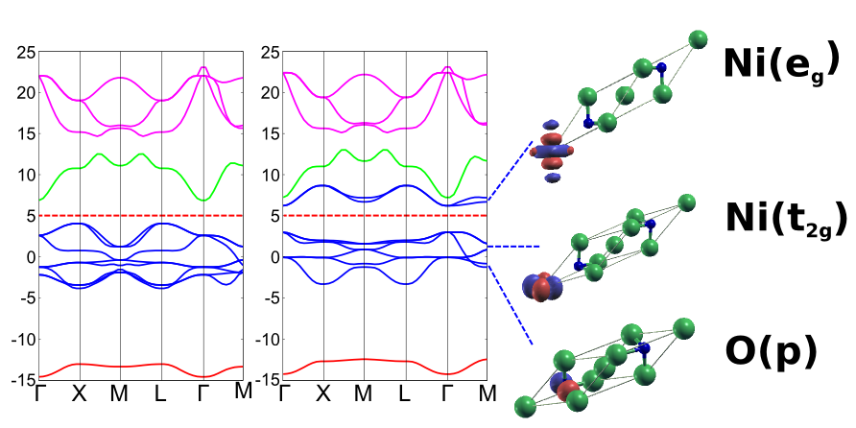

Figure caption, in this case we observe NiO bands in the ferromagnetic phase.

[1] F. Author; S. Author; Journal Volume FirstPage (Year)
[2] F. Author, et al.: Book Title (Publishing Company, Place, Year) 230-235.

