HYBRID TELECOM STREAM PROCESSING FRAMEWORK
MPI-Based Multi-DES Communication for Distributed Telecom Packet Processing

Summer Internship Project Report

by
Pathi Jahnavi(Team Lead)
Malaviya National Institute of Technology (MNIT), Jaipur
Katta Sreeja Meharani
G. Narayanamma Institute of Technology and Science (GNITS), Hyderabad

Project Guidance
by
Dr. V. C. V. Rao
MPPLAB (NSM Project) Staff,
Centre for Development of Advanced Computing (C-DAC), Pune

May – July 2026

Contents

1. Objective
2. Background and Introduction
2.1 C-DAC and MPPLAB
2.2 Motivation and Problem Statement3
3. Description of Present Work
4. Team Members and Institutions
5. Computing Systems, Programming Environment and Tools Used
6. Methodology and Implementation
6.1 Communication Layer — MPI Multi-DES Design
6.2 Multi-DES Packet Lifecycle
6.3 Processing, Storage, Graph, and Monitoring Layers
7. Project Evolution
8. Results and Discussion
8.1 Throughput Under Increasing DES Count and Load
8.2 Correctness and Graph Construction Results
9. Testing and Validation
10. Software Developed
10.1 Build and Run Instructions
10.2 Consolidated Public API Reference
10.3 Sample Execution Output
11. Conclusions and Future Directions
11.1 Conclusions
11.2 Future Directions

1. Objective
The objective of this internship project was to design, implement, and evaluate a Hybrid Telecom Stream Processing Framework capable of ingesting telecom traffic from multiple, concurrently active Data Extraction Servers (DES), using the Message Passing Interface (MPI) as the primary communication mechanism between the DES clients and a central processing node.
The project's central focus was the MPI-based communication layer: establishing a reliable client–server architecture in which an arbitrary number of DES processes can transmit telecom packets concurrently to a single server without modification to the server's core receive logic, and validating this multi-DES communication pattern under increasing client counts and traffic volumes.
In support of this communication-centric goal, the project additionally integrated a small set of complementary layers — concurrent packet processing using POSIX threads, persistent storage using Berkeley DB, communication-graph construction, and runtime monitoring — so that packets received over MPI could be fully processed, stored, and observed end to end.
The project followed an incremental development methodology in which POSIX Threads, TCP socket communication, socket–thread integration, and MPI-based communication were each independently designed, implemented, tested, and documented prior to their combination into the final hybrid framework.

2. Background and Introduction

2.1 C-DAC and MPPLAB
The Centre for Development of Advanced Computing (C-DAC) is a premier research and development organisation under the Ministry of Electronics and Information Technology (MeitY), Government of India, engaged in advanced computing, communication, and information technology solutions. C-DAC Pune houses the Multi-Petaflop Parallel Laboratory (MPPLAB), within which this project was undertaken.
MPPLAB's broader objective is developing parallel and distributed computing techniques for high-productivity computing across several application domains, one of which is tele-traffic engineering. This requires an interface between telecom infrastructure and the underlying computing platform so that traffic data can be extracted from the network and supplied to analysis algorithms; the framework developed during this internship addresses precisely this class of problem from the communication and data-ingestion end.

2.2 Motivation and Problem Statement
Telecom networks generate continuous, high-velocity streams of call and traffic data across geographically distributed exchanges and towers. This multi-source extraction scenario is modelled through the Data Extraction Server (DES): a process that generates and transmits telecom packets to a central processing server, operating as an independent MPI client, with no fixed upper bound on the number of concurrently active DES processes.
The problem addressed may be stated as follows: given telecom packet traffic generated concurrently by an arbitrary number of Data Extraction Servers, design and implement a communication layer that can reliably transport all generated packets to a central processing node without loss, together with the supporting processing, storage, graph-construction, and monitoring capabilities needed to act on that traffic once received — with each layer independently developed, tested, and reasoned about, while remaining composable into a single integrated system.

3. Description of Present Work
The work delivered under this internship is a single, integrated software artefact — the Hybrid Telecom Stream Processing Framework — together with the complete set of intermediate implementations from which it was built. The final framework accepts telecom packets from multiple Data Extraction Servers over MPI, buffers and processes them concurrently using a pool of POSIX worker threads, persists processed packets to a Berkeley DB database, constructs a communication graph from the observed traffic, and continuously reports monitoring statistics describing the internal state of every layer. The system was implemented entirely in C, targeting Ubuntu Linux, and built using GNU Make.
The framework is organised into five layers. The Communication Layer, the primary focus of this project, establishes MPI-based connections between DES clients and the central server and handles reliable serialisation, transmission, and reception of telecom packets across process boundaries, supporting an arbitrary number of concurrently active DES clients. The remaining four supporting layers are built around this core: the Processing Layer buffers and concurrently processes incoming packets using a POSIX worker thread pool; the Storage Layer persists every processed packet to Berkeley DB; the Graph Construction Layer models communication relationships between telecom endpoints as a weighted graph; and the Monitoring Layer aggregates and reports runtime statistics from every other layer.
The project repository preserves the complete development history of the project rather than containing only the final integrated system, as summarised in Table 3.1.
Directory | Description
src/ | Source code for all project phases and the final hybrid implementation.
docs/ | Architecture, design, implementation, testing, and workflow documentation.
diagrams/ | System architecture and project evolution diagrams.
tests_and_reports/ | Testing artefacts, validation reports, and phase-wise documentation.
logs/ | Development and execution logs generated during implementation and testing.
Table 3.1: Repository Directory Organisation
Development followed an incremental software engineering methodology, in which each module or phase was carried through a consistent cycle of design, implementation, testing, validation, and documentation before being considered complete or integrated with other modules — applied uniformly across all five phases summarised in Chapter 6.

4. Team Members and Institutions
Name | Institution | Role
Pathi Jahnavi | Malaviya National Institute of Technology (MNIT), Jaipur | Team Lead
Katta Sreeja Meharani | G. Narayanamma Institute of Technology and Science (GNITS), Hyderabad | Team Member
Project Guidance: Dr. V. C. V. Rao, MPPLAB (NSM Project) Staff, Centre for Development of Advanced Computing (C-DAC), Pune.

5. Computing Systems, Programming Environment and Tools Used
The framework was implemented entirely in the C programming language and targets the Ubuntu Linux operating system, a natural fit given C's low-level control over memory layout, process and thread management, and its first-class support in MPI, POSIX Threads, and Berkeley DB toolchains. All development, building, and testing was carried out on a single physical machine running Ubuntu Linux, with DES client processes and the server process co-located and distinguished only by their MPI rank; this single-node configuration was sufficient to exercise and validate the multi-DES communication pattern that is the focus of this report.
OpenMPI was selected as the MPI implementation on account of its wide adoption, mature tooling, and straightforward availability through the standard Ubuntu package repositories. Berkeley DB was selected as the embedded storage engine on account of its lightweight footprint, well-documented C API, and suitability for high-throughput key-value storage without the operational overhead of a standalone database server process.
Category | Tools / Technologies
Programming Language | C
Parallel Programming | POSIX Threads (Pthreads)
Distributed Communication | MPI (OpenMPI) — primary focus
Networking (early phase) | TCP Socket Programming
Database | Berkeley DB
Synchronisation | Mutexes, Condition Variables
Data Structures | Circular Queue, Graph
Build System | GNU Make
Operating System | Ubuntu Linux
Version Control | Git and GitHub
Debugging / Verification | gdb, Valgrind (Helgrind), strace
Table 5.1: Technology and Tool Stack
Each of the five source directories under src/ is built independently using its own GNU Make Makefile, consistent with the modular, phase-wise organisation of the repository. The MPI phases are compiled using the mpicc compiler wrapper and launched using the mpirun process manager; the POSIX Threads and TCP socket phases are compiled with gcc directly, and the hybrid framework additionally links against the Berkeley DB client library.

6. Methodology and Implementation
This chapter presents the design and implementation of the Hybrid Telecom Stream Processing Framework. Consistent with the project's objective, the MPI-based Communication Layer and its multi-DES design are discussed first and in the greatest depth, followed by the supporting layers built around it.
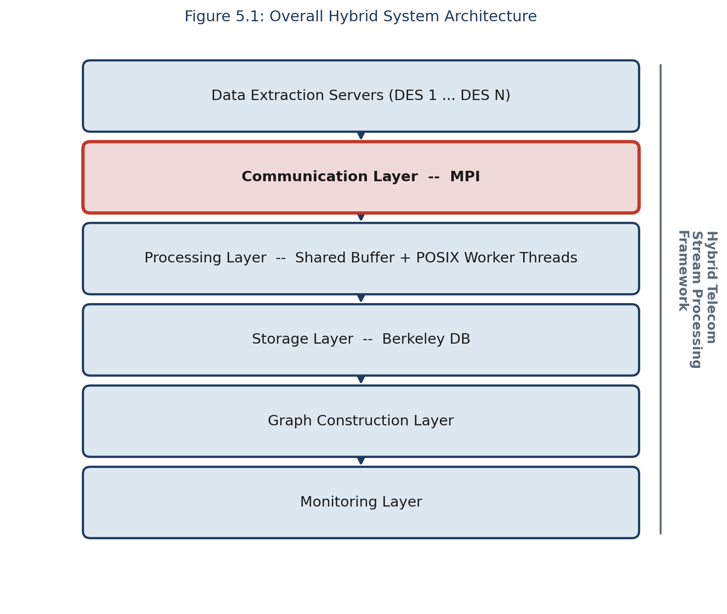
Figure 6.1: Overall Hybrid System Architecture

6.1 Communication Layer — MPI Multi-DES Design
The Communication Layer is implemented using the Message Passing Interface in a client–server configuration and is the architectural centrepiece of the framework. Each Data Extraction Server is realised as an independent MPI client process, which repeatedly generates telecom packets and transmits them to a single central server process using MPI point-to-point send operations. The server process, initialised via initialize_server(), receives packets from any connected client using receive_packet(), and hands each received packet to the processing layer for concurrent handling.
Because MPI clients operate as independent processes rather than threads sharing a server's address space, the communication layer naturally supports an arbitrary number of concurrently active Data Extraction Servers without any modification to the server's core receive logic. This property is the single most important design decision in the framework: scaling the number of DES clients from one to three, as reported in Chapter 8, required no change whatsoever to the server implementation, only to the number of client processes launched via mpirun.
The central data structure of the communication layer is the TelecomPacket, a fixed-layout structure comprising a source identifier, destination identifier, traffic type, timestamp, and payload field, serialised as a contiguous block for transmission via MPI and deserialised identically at the receiving end. This design allows each packet to be transmitted using a single MPI send and receive operation, without the additional complexity of a multi-message serialisation protocol.
The decision to replace an earlier phase-two TCP socket implementation with MPI was driven specifically by the multi-DES requirement. A raw TCP socket server must explicitly accept() each incoming client connection and maintain a table of open file descriptors; adding a new DES client therefore requires the server's connection-handling logic to correctly manage an additional, dynamically arriving file descriptor. MPI, by contrast, establishes the communicator across all participating processes at start-up time through mpirun, so that receive_packet() can accept a message from any source without the server ever needing to manage connection state explicitly.
Concern | TCP Sockets | MPI (adopted)
Adding a new DES client | Server must accept() a new connection and track a new file descriptor | New client simply joins the communicator at mpirun launch time
Multi-client receive logic | Requires select()/poll() or one thread per connection | A single receive_packet() call accepts from any source
Message framing | Application must delimit message boundaries over a byte stream | MPI preserves message boundaries natively
Table 6.1: TCP Sockets vs MPI for Multi-DES Communication

6.2 Multi-DES Packet Lifecycle
Figure 6.2 traces a single telecom packet from generation at a DES client, through MPI transmission, concurrent processing, persistent storage, and graph construction, to its final representation in the monitoring dashboard.
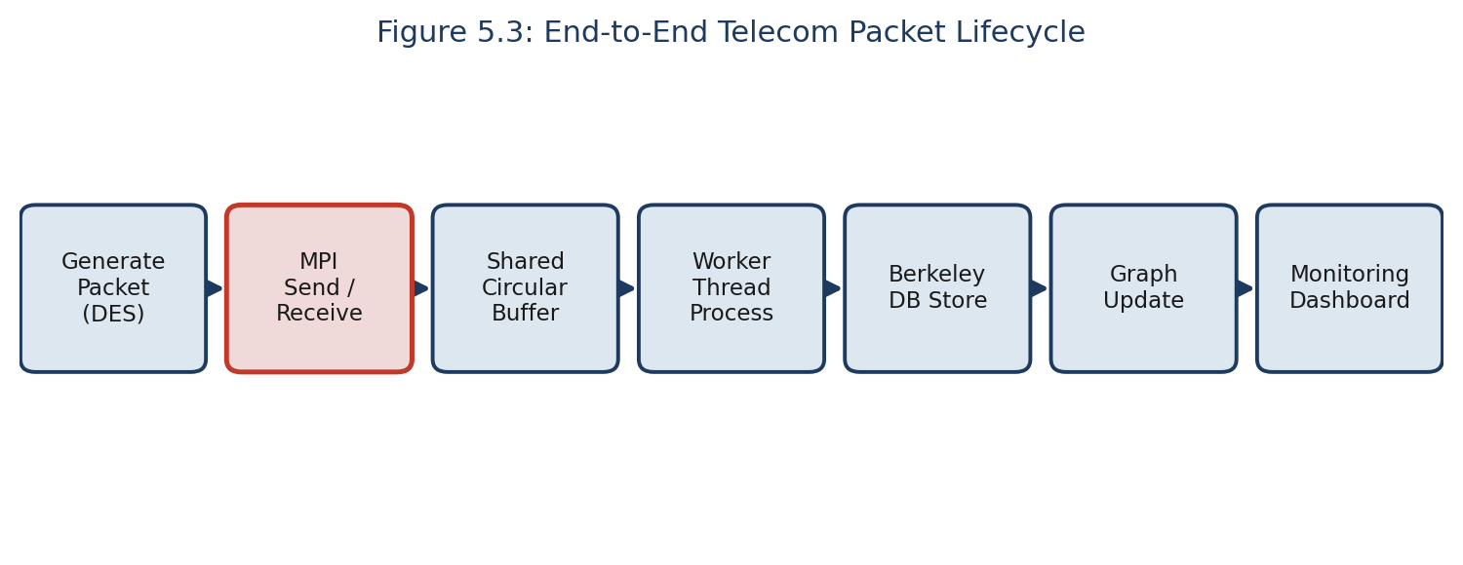
Figure 6.2: End-to-End Telecom Packet Lifecycle
Because receive_packet() is implemented using MPI_ANY_SOURCE, the server services whichever connected DES client has a message ready without favouring any one client, giving fair, order-preserving delivery across all concurrently active clients.

6.3 Processing, Storage, Graph, and Monitoring Layers
The Processing Layer implements a Producer–Consumer architecture around a shared circular buffer, protected by a mutex and two condition variables, and a configurable pool of POSIX worker threads that concurrently dequeue and process packets. The Storage Layer persists every processed packet to a Berkeley DB database, providing simple key-based storage and retrieval. The Graph Construction Layer models tower-to-tower communication as a weighted graph, adding a vertex for each distinct telecom endpoint and an edge — or incrementing an existing edge's weight — for each observed communication, enabling identification of the most active communication link. The Monitoring Layer aggregates and periodically reports live statistics — packet counts, queue occupancy, throughput, and graph statistics — from every other layer.
These four layers were each implemented and independently tested in their own right, even though the communication layer remained the project's central focus, as reflected in the consolidated API reference in Chapter 10.

7. Project Evolution
The final hybrid framework was not implemented directly; it was arrived at through a sequence of independently designed, implemented, tested, and documented phases, each introducing a distinct concurrency or communication capability before those capabilities were combined.
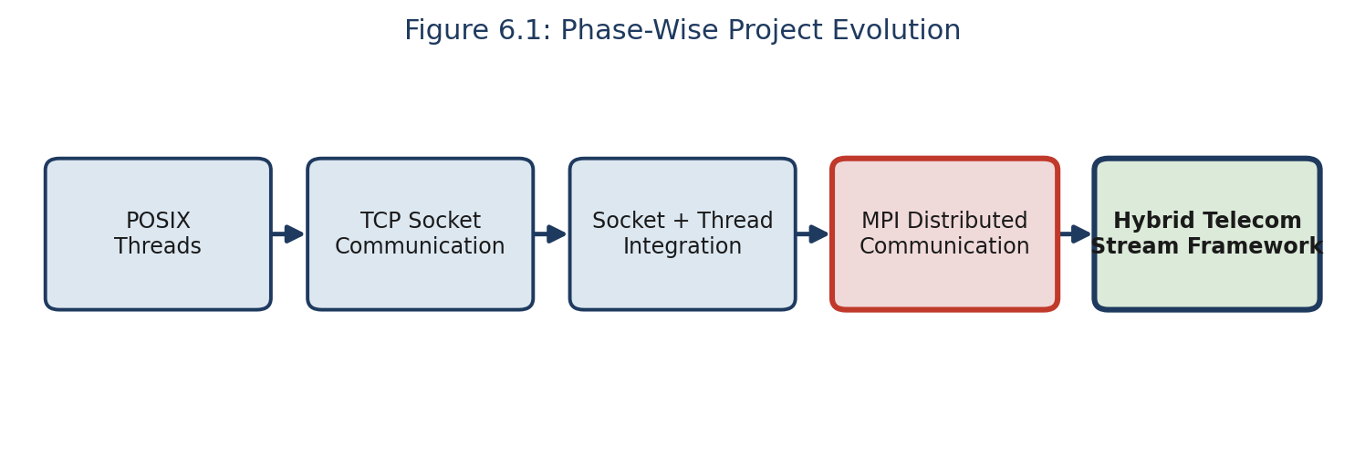
Figure 7.1: Phase-Wise Project Evolution
Phase | Capability Introduced | Status
1 | POSIX Threads (shared buffer, worker pool) | Superseded by hybrid integration
2 | TCP Socket communication (single client) | Superseded by MPI
3 | Socket + Thread integration | Superseded by hybrid integration
4 | MPI distributed communication, multi-DES | Adopted as final communication layer
5 | Full hybrid integration (MPI + processing + storage + graph + monitoring) | Final delivered framework
Table 7.1: Phase-Wise Development Status
Each phase contributed a specific, transferable lesson that directly informed the design of the final communication layer. Phase 1 established a synchronisation discipline for the shared circular buffer that was carried forward unchanged into the final processing layer. Phase 2 exposed the connection-management burden of raw sockets, directly motivating the search for a mechanism better suited to a growing number of concurrent clients. Phase 3 validated that a network communication layer and a POSIX-threaded processing layer could be composed without new synchronisation hazards. Phase 4 confirmed, in isolation, that MPI_ANY_SOURCE together with a fixed server-side receive loop could accept traffic from an arbitrary, dynamically sized set of DES clients without server-side code changes — the single design property the entire project is built around. Phase 5 confirmed that all four previously validated mechanisms could be combined without modification, the strongest practical evidence that the incremental methodology succeeded in reducing integration risk.

8. Results and Discussion
This chapter presents the quantitative results obtained from the performance evaluation and graph validation activities, with particular attention to how the MPI communication layer performed as the number of concurrently active DES clients and the total traffic volume were scaled.

8.1 Throughput Under Increasing DES Count and Load
DES | Packets/DES | Total Pkts | Exec. Time (s) | Avg Time/Pkt (ms) | Throughput (pkts/s)
1 | 10 | 10 | 0.000072 | 0.007201 | 138,877.32
3 | 10 | 30 | 0.000240 | 0.008008 | 124,870.97
3 | 25 | 75 | 0.000549 | 0.007317 | 136,673.01
3 | 100 | 300 | 0.005964 | 0.019881 | 50,299.99
3 | 1000 | 3000 | 0.061620 | 0.020540 | 48,685.29
Table 8.1: Performance Evaluation Results Across DES Counts and Loads
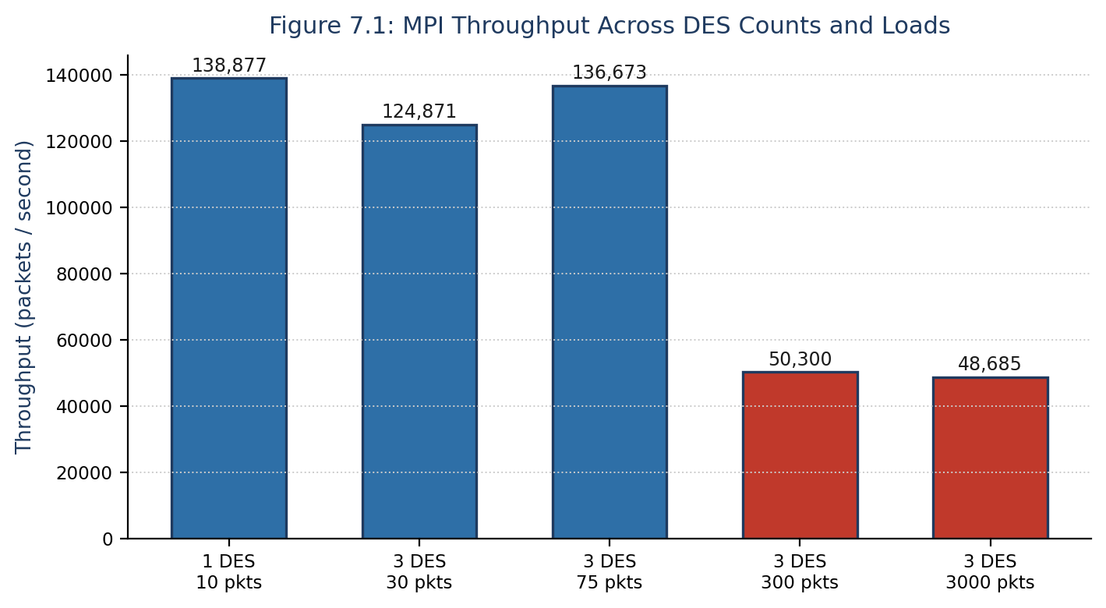
Figure 8.1: MPI Throughput Across DES Counts and Loads
Two distinct performance regimes are visible. For the three smallest configurations (10 to 75 total packets), throughput is very high, 124,900 to 138,900 packets per second, reflecting fixed per-execution overheads such as MPI process start-up dominating the measured time. For the two larger, sustained-load configurations (300 and 3,000 packets), throughput settles to a stable 48,700 to 50,300 packets per second, differing by less than four percent despite a tenfold increase in workload — strong evidence that the multi-DES MPI communication layer sustains stable throughput without degradation as load increases a further order of magnitude.

8.2 Correctness and Graph Construction Results
Across every test configuration, from a single DES client to three concurrently active DES clients, the number of packets received over MPI was equal to the number processed, enqueued equal to dequeued, and stored equal to the total volume generated by all DES clients combined, with no instance of packet loss, deadlock, or race condition observed.
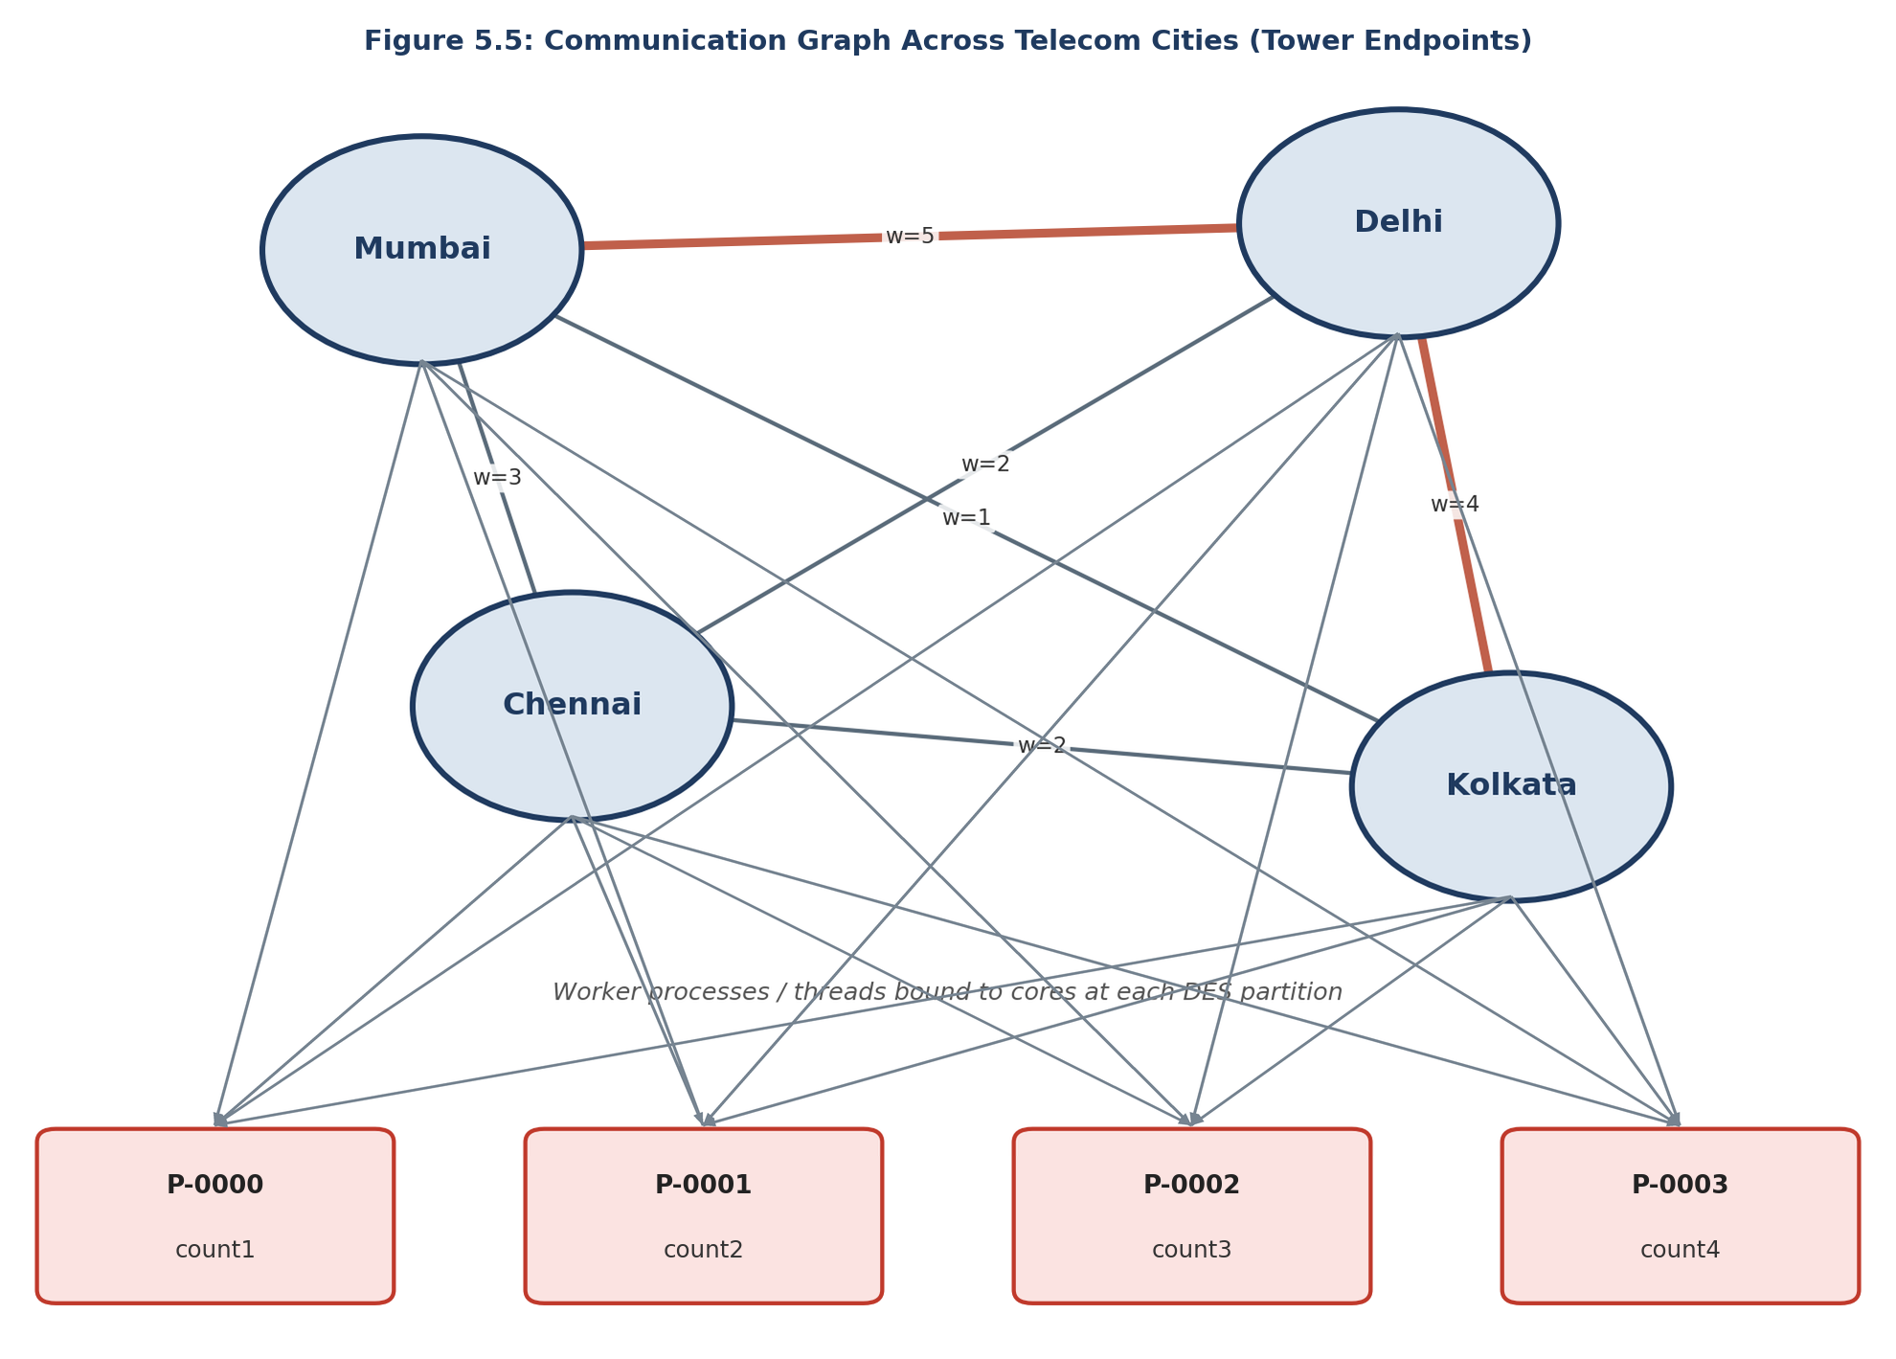
Figure 8.2: Communication Graph Across Telecom Endpoints
The vertex count remained bounded at nine or ten across all configurations, confirming that add_vertex() correctly avoids duplicate vertices, while the edge count grew from nine at a communication volume of ten packets to one hundred at three thousand packets, showing that increasing multi-DES traffic volume produces an increasingly complete picture of pairwise tower communication. Considered together, the throughput and graph results demonstrate that the framework scales gracefully across a three-hundred-fold increase in total packet volume and a threefold increase in concurrently active DES clients, with no degradation in correctness observed at any scale tested.

9. Testing and Validation
Testing was conducted at two levels. At the module level, each of the four independently developed phases — POSIX Threads, TCP sockets, socket–thread integration, and MPI communication — was independently tested and validated prior to integration. At the system level, following integration into the final hybrid framework, a comprehensive final testing programme covered functional validation, system-component validation, and performance and graph validation across five test configurations of increasing scale.
Component | Result | Component | Result
MPI Communication | PASS | Berkeley DB Storage | PASS
Packet Reception | PASS | Telecom Graph Construction | PASS
Shared Circular Buffer | PASS | Graph Analytics | PASS
Producer–Consumer Sync. | PASS | Monitoring Dashboard | PASS
Worker Thread Processing | PASS
Table 9.1: System Component Validation Summary
For every workload tested, four internal consistency invariants were verified directly from the monitoring dashboard's reported statistics: packets received equal to packets processed; packets enqueued equal to dequeued; packets stored equal to the total generated; and communication volume recorded by the graph layer equal to total packets generated. The simultaneous satisfaction of all four invariants across all five configurations demonstrates complete end-to-end correctness.
All test configurations were executed on a single physical node, with DES client and server processes co-located rather than distributed across a networked cluster; the measured performance figures therefore reflect local inter-process MPI communication rather than communication over a network, and may not directly generalise to a genuinely distributed, multi-node deployment.

10. Software Developed
The deliverable is the complete telecom-stream-processing-framework repository, comprising five standalone phase implementations and the final integrated hybrid framework, all implemented in C for Ubuntu Linux. It comprises:
- An MPI-based client–server communication module supporting an arbitrary number of concurrently connected DES clients — the primary deliverable — together with a TelecomPacket data module and a traffic-generation module used by every DES client during testing.
- A POSIX-threaded processing module (shared circular buffer and configurable worker thread pool), a Berkeley DB storage module, a graph construction module modelling tower-to-tower communication, and a monitoring module aggregating live statistics from every other layer.
- Standalone, independently buildable implementations of each development phase, preserved alongside the final hybrid/ implementation.

10.1 Build and Run Instructions
Step | Command
Update package index | sudo apt update
Install build essentials | sudo apt install build-essential
Install OpenMPI | sudo apt install openmpi-bin libopenmpi-dev
Install Berkeley DB | sudo apt install libdb-dev
Build hybrid framework | cd src/hybrid && make
Run hybrid framework | mpirun -np 4 ./hybrid
Table 10.1: Build and Run Instructions
The command mpirun -np 4 ./hybrid launches one server process and three DES client processes, matching the multi-DES configuration evaluated in Chapter 8. Increasing the -np argument increases the number of concurrently connected DES clients without any change to the source code, directly exercising the multi-DES design. While running, monitoring_print_dashboard() periodically prints packet counts, queue occupancy, throughput, and graph statistics to the terminal; on completion, processed packets are persisted in telecom.db.

10.2 Consolidated Public API Reference
Module | Function | Description
Communication | initialize_server() / initialize_client() | Set up the MPI server and DES client roles respectively.
Communication | send_packet() / receive_packet() | Transmit and receive a single TelecomPacket over MPI.
Telecom Packet | initialize_packet(), clear_packet(), validate_packet(), print_packet() | Create, reset, validate, and display a packet.
Traffic Generation | generate_packet(), generate_source(), generate_destination(), generate_traffic_type(), generate_timestamp(), generate_payload() | Synthesise realistic telecom packets for testing.
Processing | buffer_init(), enqueue(), dequeue(), process_telecom_packet() | Shared-buffer producer–consumer packet processing.
Storage | db_initialize(), db_store_packet(), db_get_packet(), db_close() | Persist and retrieve packets via Berkeley DB.
Graph Construction | initialize_graph(), add_vertex(), add_edge(), print_graph_statistics(), get_top_communication_link() | Build and query the tower communication graph.
Monitoring | monitoring_initialize(), monitoring_get_statistics(), monitoring_print_dashboard() | Aggregate and display runtime statistics.
Table 10.2: Consolidated Public API Reference

10.3 Sample Execution Output
Figure 10.1 shows representative terminal output captured from a live run of the hybrid framework (a single DES client generating 1,000 packets), illustrating the performance summary reported on completion, an interactive Berkeley DB packet-retrieval query, and the final system monitoring dashboard aggregating communication, processing, database, graph, and performance statistics across every layer.
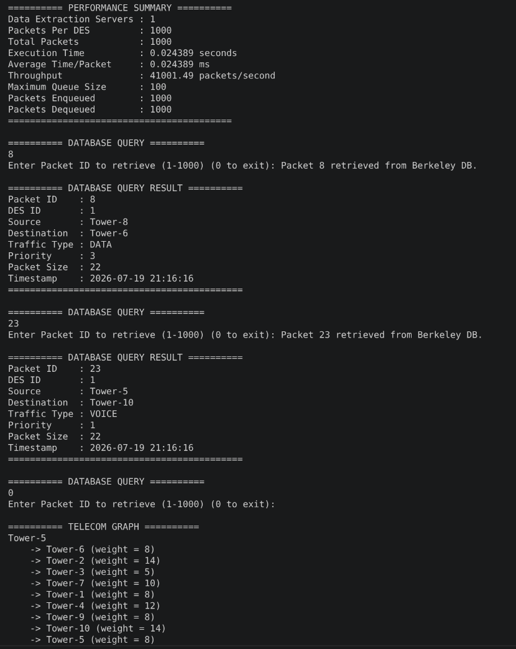  Performance summary and Berkeley DB packet query | 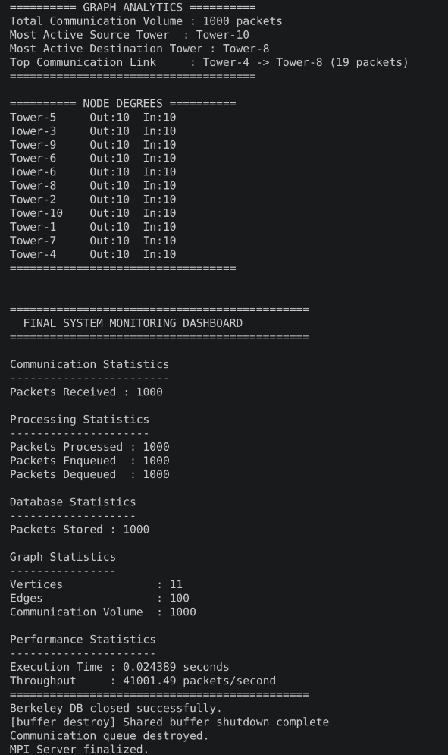  Graph analytics and final monitoring dashboard
Figure 10.1: Representative Terminal Output from a Live Execution Run

11. Conclusions and Future Directions

11.1 Conclusions
This report has presented the design, implementation, and evaluation of the Hybrid Telecom Stream Processing Framework, developed during a summer internship at MPPLAB, C-DAC Pune, under the guidance of Dr. V. C. V. Rao. The project's central achievement is an MPI-based communication layer that supports an arbitrary number of concurrently active Data Extraction Servers without modification to the server's core logic, validated across configurations ranging from one to three concurrent DES clients and from ten to three thousand packets.
Across every test configuration, the framework demonstrated complete correctness, with no packet loss, deadlock, or synchronisation failure observed, and sustained a stable throughput of approximately 48,000 to 50,000 packets per second under load. The supporting processing, storage, graph construction, and monitoring layers built around this communication core were likewise shown to correctly and consistently handle the traffic delivered by the MPI layer. The incremental development methodology, in which POSIX Threads, TCP sockets, socket–thread integration, and MPI were each independently validated before combination, substantially reduced integration risk. From an internship-learning perspective, the project provided direct, hands-on experience with the practical differences between socket-based and message-passing-based distributed communication models, thread synchronisation using mutexes and condition variables, and validating a distributed system incrementally.

11.2 Future Directions
- Distributed cluster deployment to a genuinely multi-node MPI configuration, and dynamic load balancing of worker threads building on the existing monitoring statistics.
- Fault tolerance and recovery for DES client, server, or storage-layer failure, and cloud-native deployment/containerisation using Docker.
- Advanced telecom traffic analytics connecting the communication graph to broader tele-traffic modelling work, and web-based, interactive graph visualisation.
Collectively, these directions chart a path from the present internship-scope proof-of-concept towards a production-capable, MPI-based telecom data extraction and processing platform.

