Report

# Topic: Key Controlled AR Figurine

This report provides an overview of the development and key components of a basic 2D game using Unity, a versatile and widely- used game development platform. Unity supports both 2D and 3D game creation, offering robust tools and a user-friendly interface for developers to create games for various platforms, including PC, mobile, and consoles. The report outlines the fundamental components of Unity, such as game objects, scenes, and scripts, and provides a detailed overview of a basic 2D game's features and controls. This information serves as a foundational guide for understanding game development with Unity.

## Introduction to Unity

Unity is a powerful and widely-used game development platform. It supports both 2D and 3D game creation, providing robust tools and a user-friendly interface. Developers can create games for multiple platforms, including PC, mobile, and consoles.

## Components in Unity

Unity's key components include:

* - Game Objects
* - Components
* - Scenes
* - Prefabs
* - Scripts
* - Assets
* - Physics
* - Lighting

## Unity Editor View

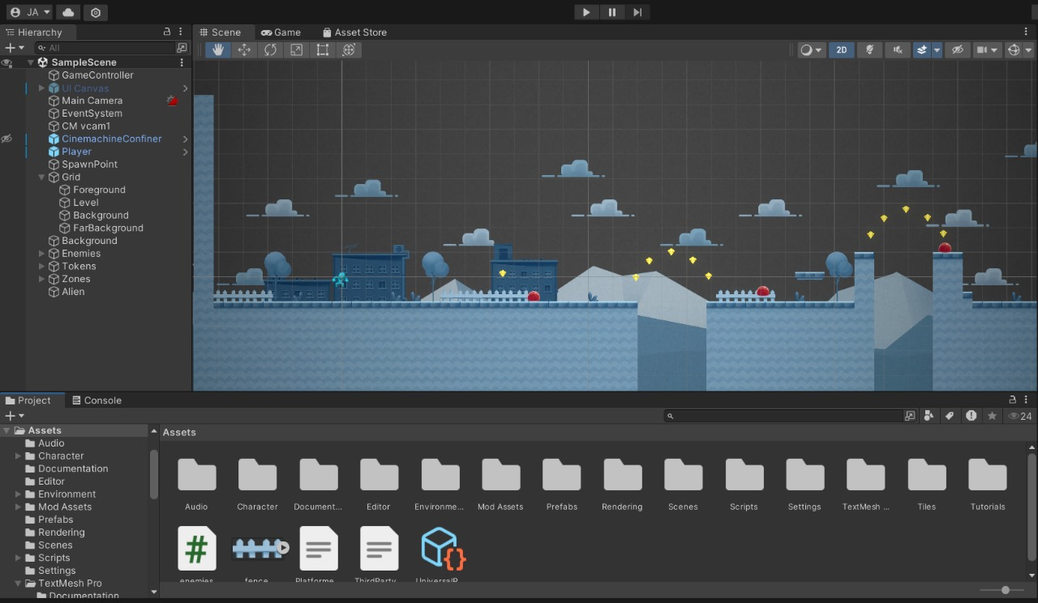

## Game View

## Basic 2D Game Overview

This basic 2D game features:

* - A player character controlled by keyboard
* - Platforms, enemies, and collectibles
* - Simple physics-based interactions
* - Scrolling background and parallax effect

## Basic Gameplay Controls

The game is controlled using the following keyboard keys:

* - Arrow Keys: Move left and right
* - Spacebar: Jump
* - 'P' Key: Pause/Unpause the game