ASSIGNMENT

1)COMPOSITE

import java.util.*;

class count{

public static void main(String args[])

{

try{

int i,j,m=0,flag=0,prime=0,composite=0,n,count;

Scanner s= new Scanner(System.in);

System.out.println("enter how many numbers");

count=s.nextInt();

System.out.println("enter numbers:");

for(j=0;j<count;j++)

{

n=s.nextInt();

m=n/2;

if(n==0||n==1){

prime=prime+1 ;

}

else

{

for(i=2;i<=m;i++)

{

if(n%i==0){

composite=composite+1 ;

flag=1;

break;

}

}

if(flag==0)

{

prime=prime+1;

}

}

}

System.out.println("number of composite:"+composite);

}

catch(Exception e){

System.out.println("invalid input");

}

}

}

OUTPUT:

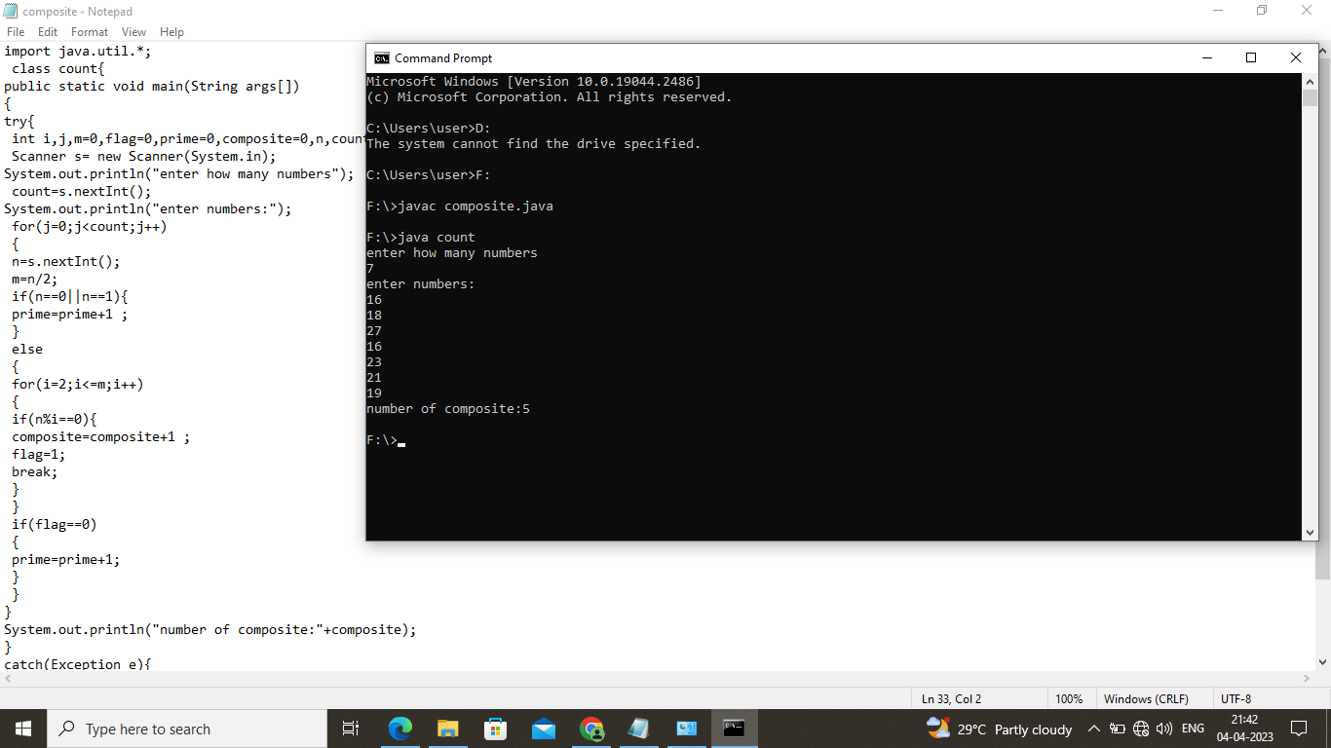

2)MATRIX ADDITION

import java.util.Scanner;

class AddMatrix

{

public static void main(String[] args)

{

int p, q, m, n;

Scanner s = new Scanner(System.in);

System.out.print("Enter number of rows in first matrix:");

p = s.nextInt();

System.out.print("Enter number of columns in first matrix:");

q = s.nextInt();

System.out.print("Enter number of rows in second matrix:");

m = s.nextInt();

System.out.print("Enter number of columns in second matrix:");

n = s.nextInt();

if (p == m && q == n)

{

int a[][] = new int[p][q];

int b[][] = new int[m][n];

int c[][] = new int[m][n];

System.out.println("Enter all the elements of first matrix:");

for (int i = 0; i < p; i++)

{

for (int j = 0; j < q; j++)

{

a[i][j] = s.nextInt();

}

}

System.out.println("Enter all the elements of second matrix:");

for (int i = 0; i < m; i++)

{

for (int j = 0; j < n; j++)

{

b[i][j] = s.nextInt();

}

}

System.out.println("First Matrix:");

for (int i = 0; i < p; i++)

{

for (int j = 0; j < q; j++)

{

System.out.print(a[i][j]+" ");

}

System.out.println("");

}

System.out.println("Second Matrix:");

for (int i = 0; i < m; i++)

{

for (int j = 0; j < n; j++)

{

System.out.print(b[i][j]+" ");

}

System.out.println("");

}

for (int i = 0; i < p; i++)

{

for (int j = 0; j < n; j++)

{

for (int k = 0; k < q; k++)

{

c[i][j] = a[i][j] + b[i][j];

}

}

}

System.out.println("Matrix after addition:");

for (int i = 0; i < p; i++)

{

for (int j = 0; j < n; j++)

{

System.out.print(c[i][j]+" ");

}

System.out.println("");

}

}

else

{

System.out.println("Addition would not be possible");

}

}

}

OUTPUT:

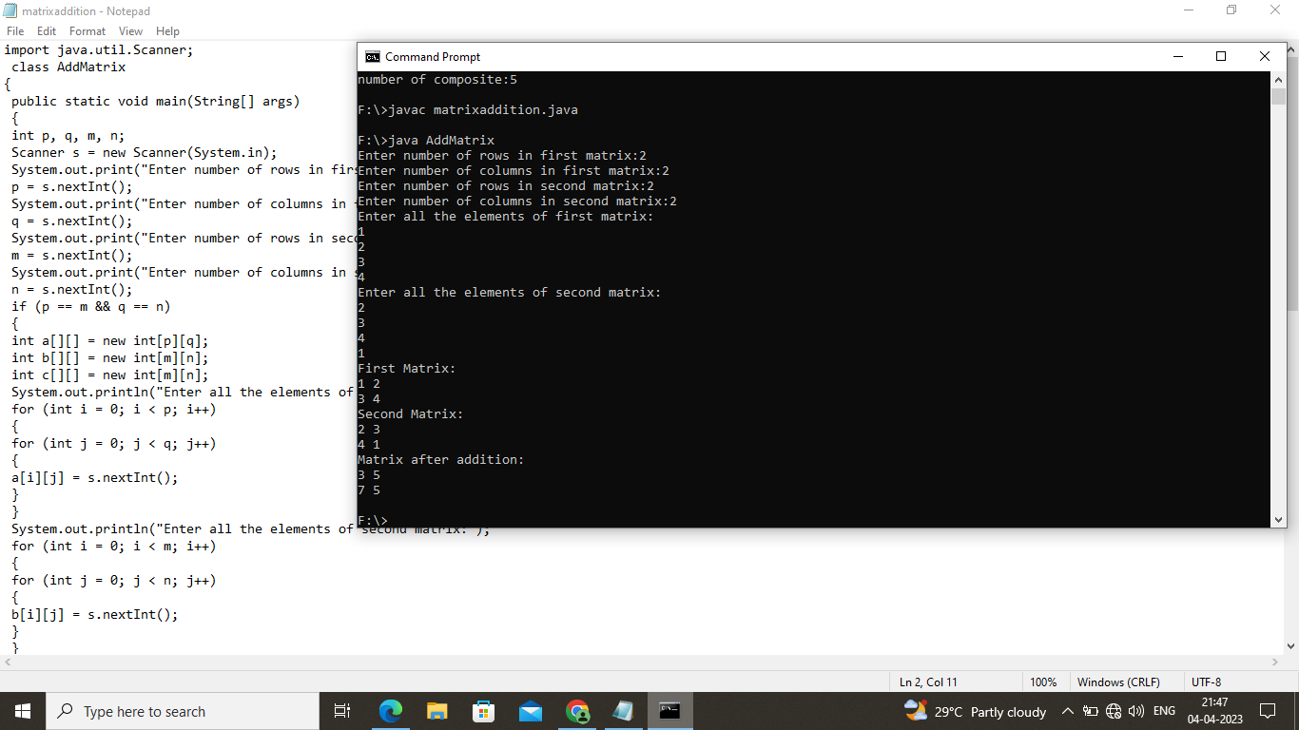

4)PALINDROME

import java.util.Scanner;

class palindrome

{

public static void main(String args[])

{

Scanner in= new Scanner(System.in);

System.out.println("enter the number");

int num=in.nextInt();

int temp=num;

int rev=0,digit;

while(temp>0){

digit=temp%10;

rev=rev*10+digit;

temp=temp/10;

}

if(rev==num){

System.out.println("true");

}

else{

System.out.println("false");

}

}

}

OUTPUT:

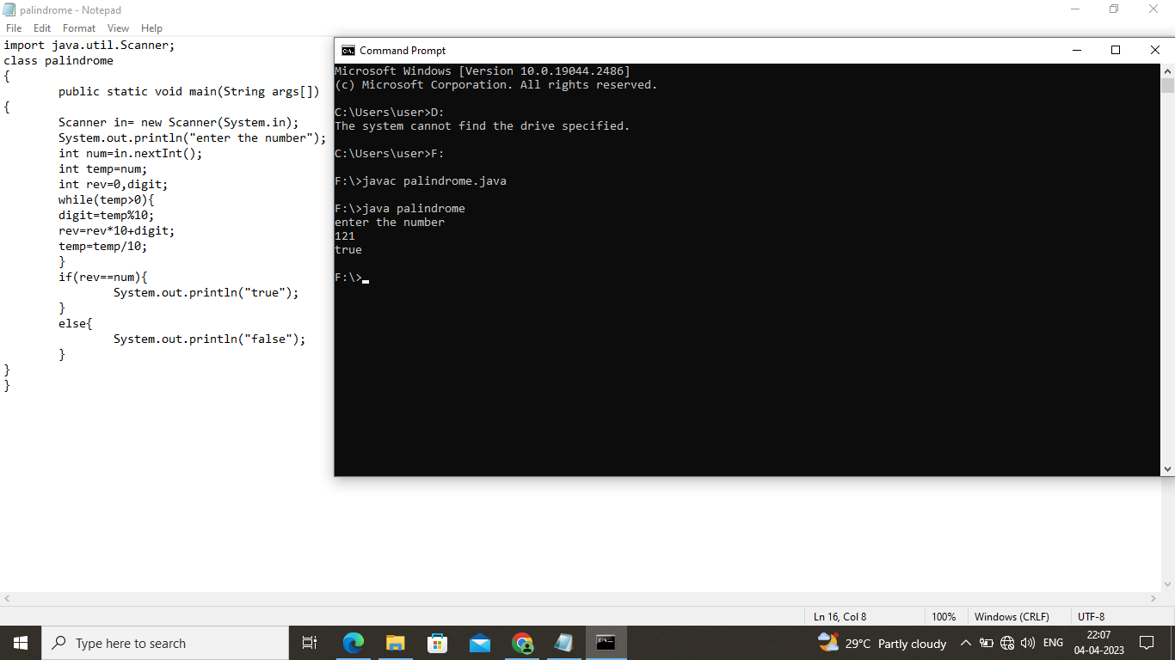

5)VOTE

import java.util.Scanner;

class age{

public static void main(String args[]){

Scanner scan =new Scanner(System.in);

System.out.println("Enter the age of person");

int user_age=scan.nextInt();

System.out.println("The age of person is "+user_age);

if(user_age>18)

{

System.out.println("You are eligible to Vote");

}

else{

System.out.println("You are not eligible to vote and for you" +(18-user_age)+ "years are left to be eligible");

}

}

}

OUTPUT:

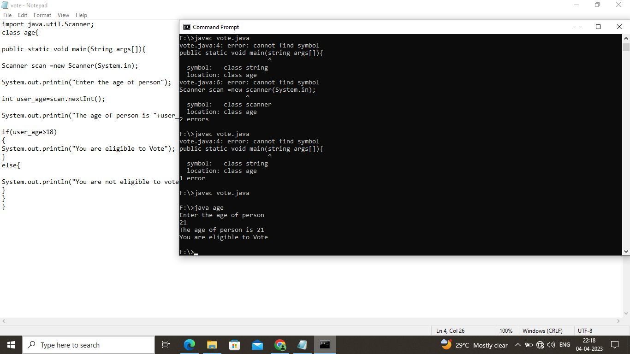

3)SQUARE ROOT

import java.util.Scanner;

class square{

public static int sqrt(int x) {

if (x < 0) {

throw new IllegalArgumentException("Cannot calculate square root of negative number.");

}

if (x == 0) {

return 0;

}

int left = 1;

int right = x;

while (left <= right) {

int mid = left + (right - left) / 2;

if (mid > x / mid) {

right = mid - 1;

} else {

left = mid + 1;

}

}

return right;

}