**Program 1**

**Arithmetic Exception**

public class MultipleCatchBlock1 { public static void main(String[] args) {

try{

int a[]=new int[5]; a[5]=30/0; }

catch(ArithmeticException e) {

System.out.println("Arithmetic Exception occurs");

}

catch(ArrayIndexOutOfBoundsException e)

{

System.out.println("ArrayIndexOutOfBounds Exception occurs");

}

catch(Exception e) {

System.out.println("Parent Exception occurs");

}

System.out.println("rest of the code");

}

}

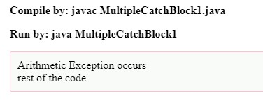

**Array Index out of Bounds**

public class MultipleCatchBlock2 {

public static void main(String[] args) {

try{

int a[]=new int[5];

System.out.println(a[10]);

}

catch(ArithmeticException e)

{

System.out.println("Arithmetic Exception occurs");

}

catch(ArrayIndexOutOfBoundsException e)

{

System.out.println("ArrayIndexOutOfBounds Exception occurs");

}

catch(Exception e)

{

System.out.println("Parent Exception occurs");

}

System.out.println("rest of the code");

}

}

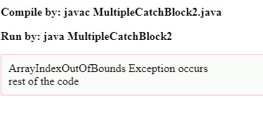

**Null pointer Exception**

import java.io.*;class ne

{

public static void main (String[] args)

{

// Initializing String variable with null value

String ptr = null;

// Checking if ptr.equals null or works fine.

try

{

if (ptr.equals("gfg"))

System.out.print("Same");

else

System.out.print("Not Same");

}

catch(NullPointerException e)

{

System.out.print("NullPointerException Caught");

}

}

}

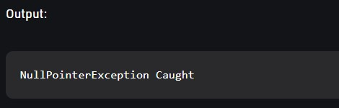

**Program 2**

**class**

**Table**

**{**

**void printTable(int n)**

**{**

**synchronized(this)**

**{**

**for(int i=1;i<=5;i++)**

**{**

**System.out.println(+n+"*"+i+"="+(n*i));**

**try**

**{**

**Thread.sleep(400);**

**}**

**catch(Exception e)**

**{**

**System.out.println(e);**

**}**

**}**

**}**

**}**

**}**

**class Mythread1 extends Thread**

**{**

**Table t;**

**Mythread1(Table t)**

**{**

**this.t=t;**

**}**

**public void run()**

**{**

**t.printTable(5);**

**}**

**}**

**class Mythread2 extends Thread**

**{**

**Table t;**

**Mythread2(Table t)**

**{**

**this.t=t;**

**}**

**public void run()**

**{**

**t.printTable(100);**

**}**

**}**

**class Use**

**{**

**public static void main(String args[])**

**{**

**Table obj = new Table();**

**Mythread1 th1 = new Mythread1(obj);**

**Mythread2 th2 = new Mythread2(obj);**

**th1.start();  th2.start();**

**}**

**}**

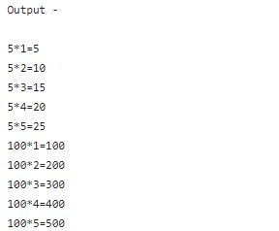

**Program 3**

import java.util.*; import java.io.*; public class ugly {

public static void main(String args[]) {

int inputNumber;

Scanner sc=new Scanner(System.in); System.out.println("Enter the number :"); inputNumber=sc.nextInt();

boolean check = true;

for(int i = 2; i<=inputNumber; i++) {

if(i!=2&&i!=3&&i!=5) {

if(inputNumber%i==0&&checkPrime(i)) {

check = false; break;

}

}

}

if(check) {

System.out.println(inputNumber+" is an ugly number");

} else {

System.out.println(inputNumber+" is Not an ugly number");

}

}

static boolean checkPrime(int number) {

boolean flag = true; for(int i = 2; i<=number/2; i++) { if(number%i==0) { flag = false; break;

}

}

return flag;

}

}

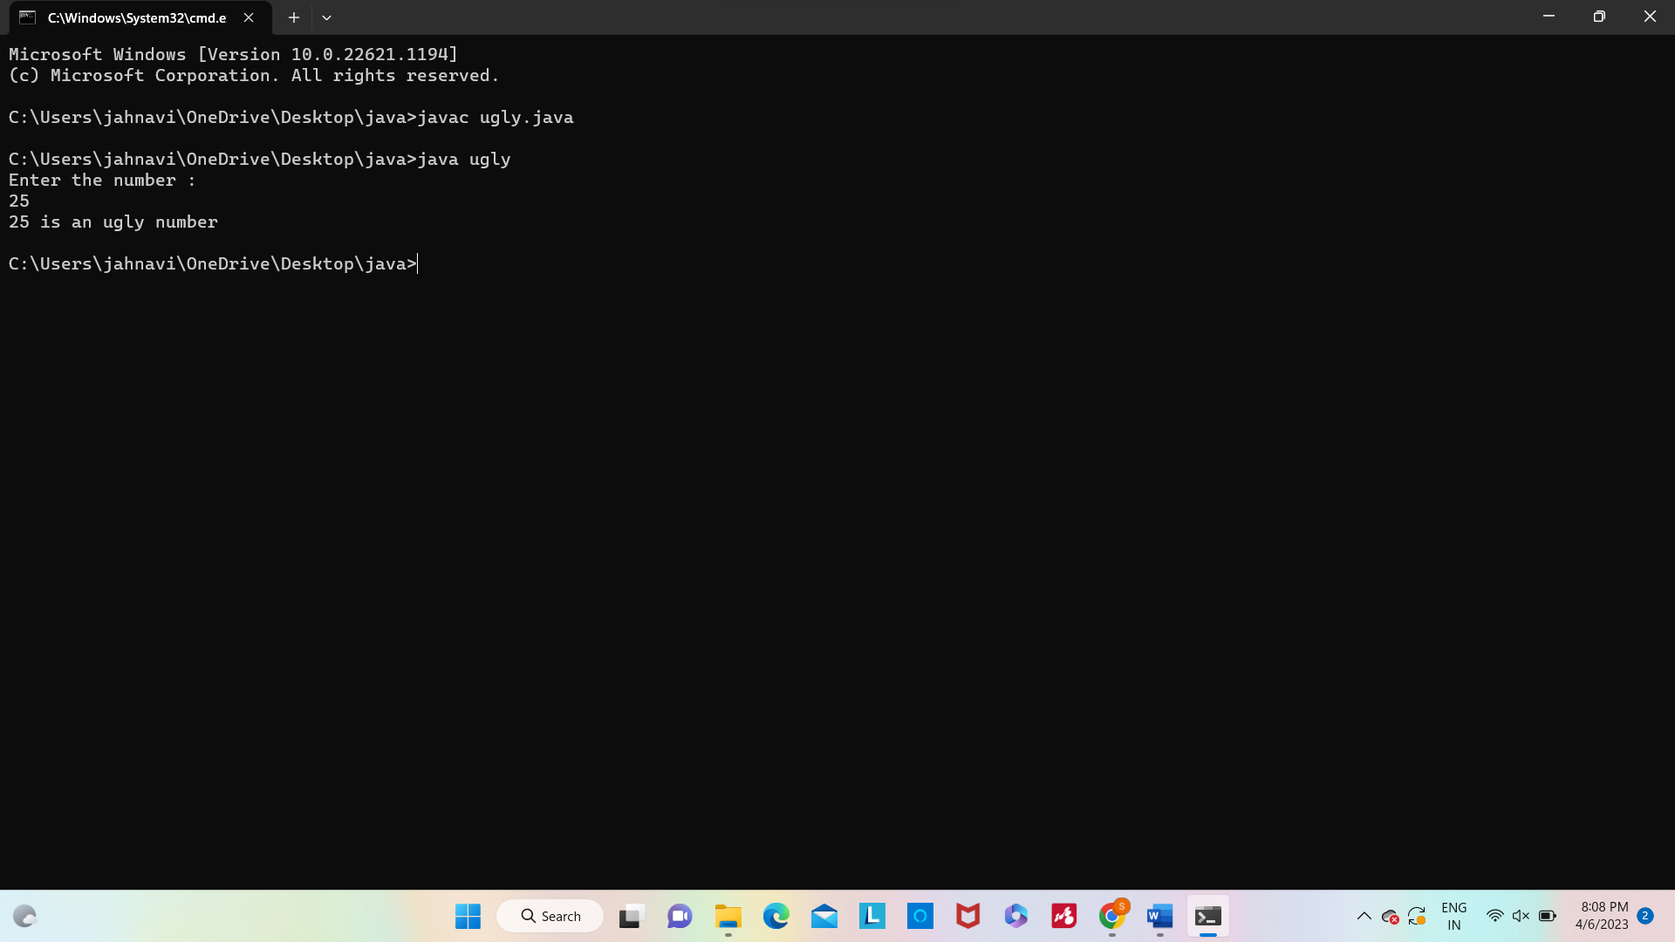

**Program 4**

import java.io.*; import java.util.*; class fibo {

static int fib(int n)

{

if (n==0||n==1) return 0; else if(n==2)

return 1;

return fib(n - 1) + fib(n - 2);

}

public static void main(String args[])

{

int n;

Scanner sc=new Scanner(System.in);

System.out.println("Enter the value of n : "); n=sc.nextInt();

System.out.println(fib(n));

}

}

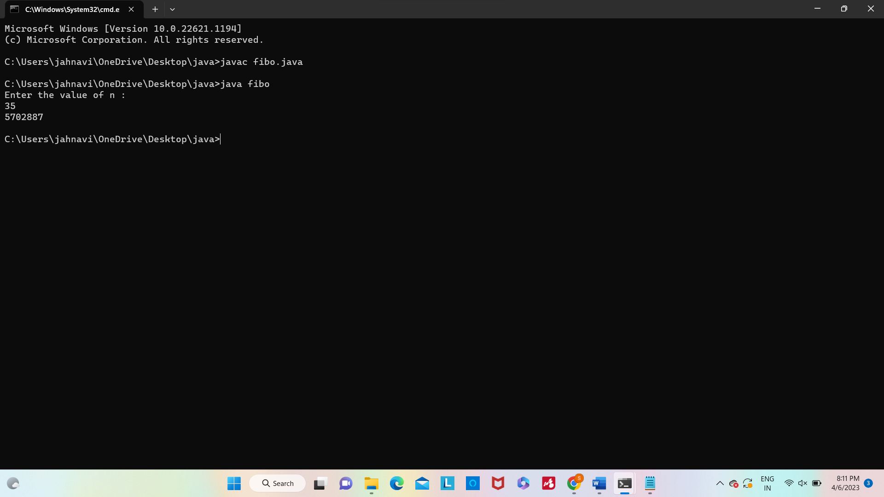

**Program 5 import java.io.*; import java.util.*;**

**class duplicate {**

**static int removeDuplicates(int arr[], int n) { if (n == 0 || n == 1) return n; int[] temp = new int[n];**

**int j = 0;**

**for (int i = 0; i < n-1; i++) {**

**if (arr[i] != arr[i+1]) temp[j++] = arr[i];**

**}**

**temp[j++] = arr[n-1]; for (int i = 0; i < j; i++) { arr[i] = temp[i];**

**}**

**return j;**

**}**

**public static void main(String[] args) { int arr[] = {10, 20, 20, 30, 40, 40, 40, 50, 50}; int n = arr.length; n = removeDuplicates(arr, n); for (int i = 0; i < n; i++) {**

**System.out.print(arr[i]+" ");**

**}**

**}**

**}**

