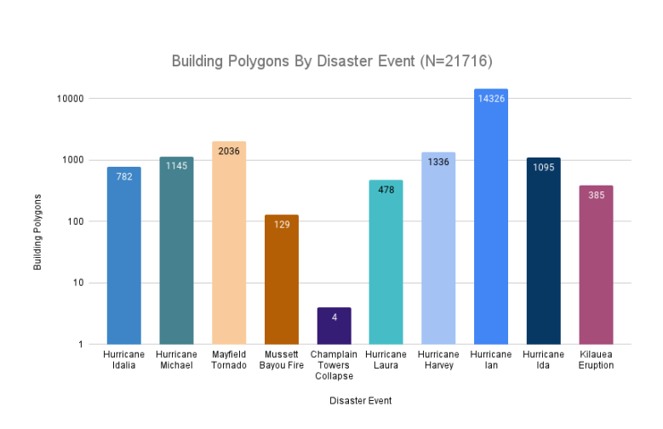

Model0
Used bce+dice loss for model training

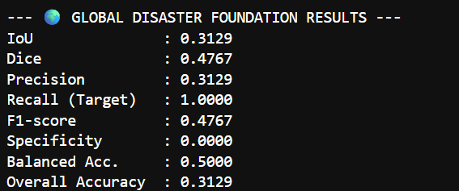

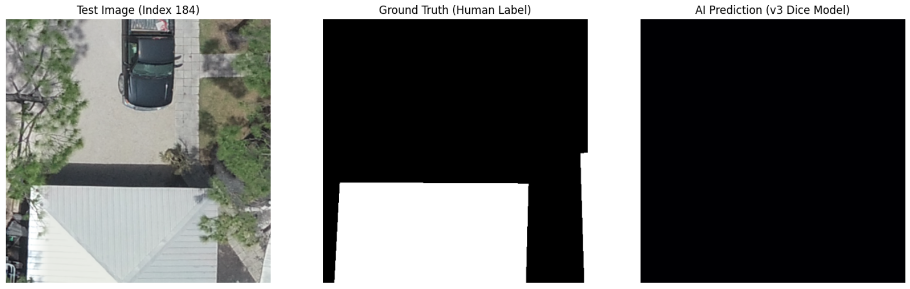
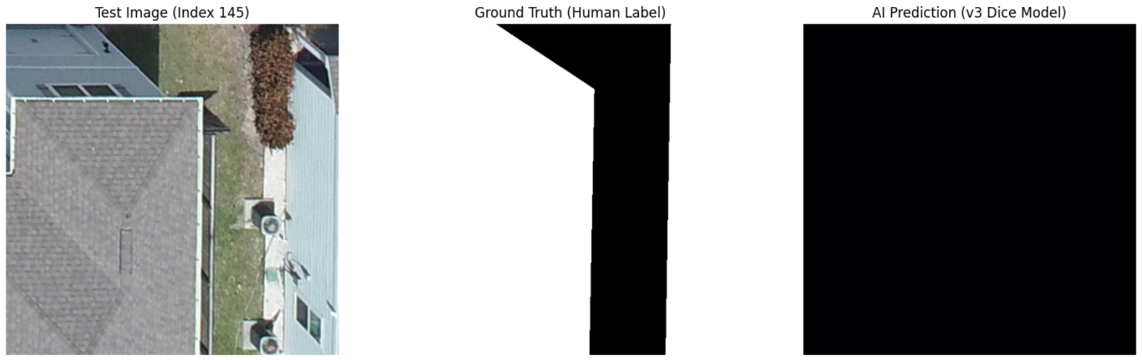

Later on, Switched to tversky loss

Model-1
Random sampling for train and test.
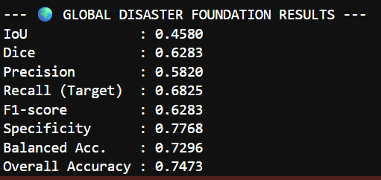

Spatial splits
Model-2 - Seen disaster

Train : Musset(3,4,5)
Test : Musset(1,2)
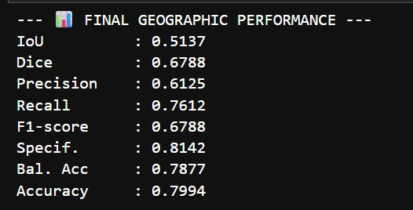

Train : Musset(3,4,5), Laura(1), Eruption(1,3)
Test : Musset(1,2), Laura(2), Eruption(2)
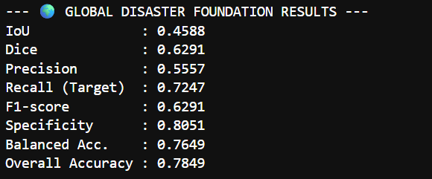

Model-3
Unseen same disaster
Train : Hurricane Ian(part of Ian), Hurricane Laura
Test : Hurricane Micheal, Hurricane Idlia

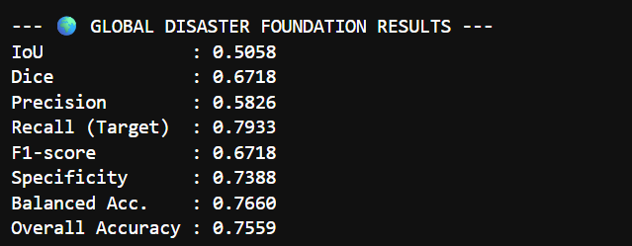
Encoder : Resnet50

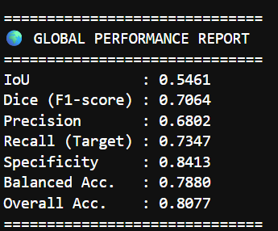
Encoder : EfficientNet-B4
Loss : Focal+Tversky

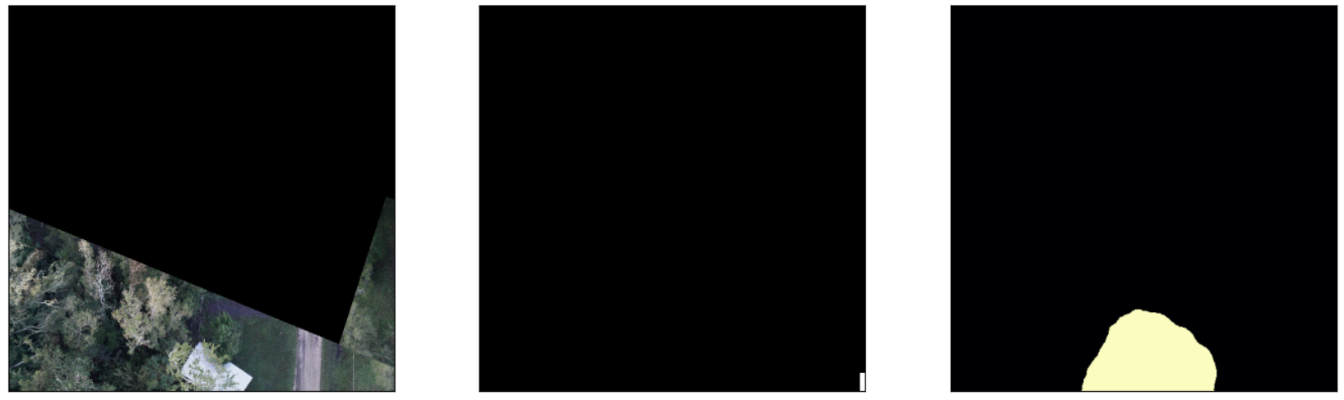

Model-4
Unseen Cross disasters

Phase1 - Train : Musset, Hurricane Laura.
Test : Volcanic eruption
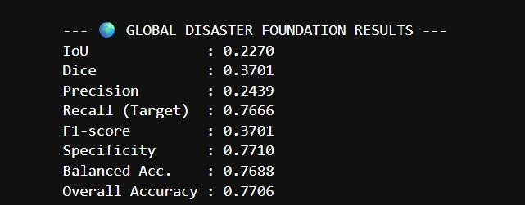
Phase2 - Train : Hurricane Ian, Hurricane Laura, Volcanic Eruption
Test : Hurricane Micheal, Hurricane Idlia, Musset

