**# Loops:**

class Ltts:

def __init__(jahnavi, a, b):

jahnavi.a = a

jahnavi.b = b

def func(jahnavi):

if jahnavi.a > jahnavi.b:

print("a is greater")

else:

jahnavi.a < jahnavi.b

print("b is greater")

x = Ltts(2, 3)

x.func()

**Output:**

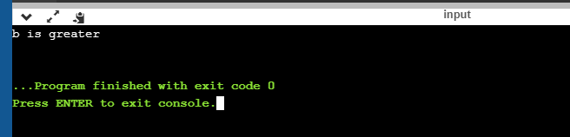

**# Loops(with inheritance):**

class Ltts:

def __init__(jahnavi, a, b):

jahnavi.a = a

jahnavi.b = b

def func(jahnavi):

if jahnavi.a > jahnavi.b:

print("a is greater")

else:

jahnavi.a < jahnavi.b

print("b is greater")

class Ltts1(Ltts):

def __init__(jahnavi, a, b, c):

jahnavi.c = c

def func1(jahnavi):

y = jahnavi.a+jahnavi.b+jahnavi.c

print(y)

x = Ltts1(2, 3, 5)

x.func1()

**Output:**

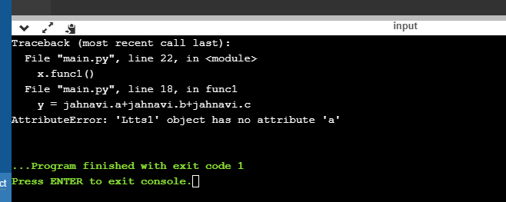

**# Loops(with inheritance):**

class Ltts:

def __init__(jahnavi, a, b):

jahnavi.a = a

jahnavi.b = b

def func(jahnavi):

if jahnavi.a > jahnavi.b:

print("a is greater")

else:

jahnavi.a < jahnavi.b

print("b is greater")

class Ltts1(Ltts):

def __init__(jahnavi, a, b, c):

super().__init__(a, b)

jahnavi.c = c

def func1(jahnavi):

y = jahnavi.a+jahnavi.b+jahnavi.c

print(y)

x = Ltts1(2, 3, 5)

x.func1()

x.func()

**Output:**

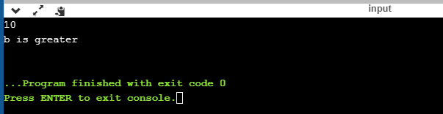

**# Array:**

x = array([11, 22, 33, 44])

print(x)

**Output:**

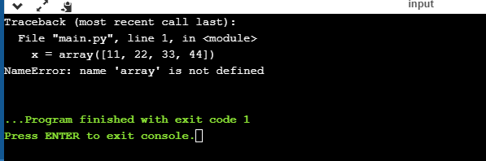

**# List:**

x = list([11, 22, 33, 44])

print(x)

**Output:**

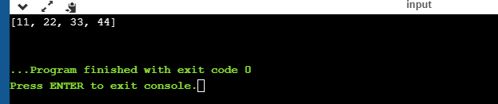

**# List(with methods):**

class Ltts:

def __init__(jahnavi, a, b, c):

jahnavi.a = a

jahnavi.b = b

jahnavi.c = c

list = []

list.append(Ltts("Sunil", "IS", "Bangalore"))

list.append(Ltts("Swapna", "Mentor", "Bangalore"))

list.append(Ltts("Jahnavi", "Trainee", "Mysore"))

for x in list:

print(x.a, x.b, x.c)

print(list[0].a)

print(list[1].a)

print(list[2].a)

**Output:**

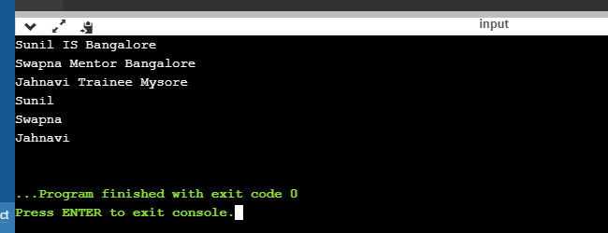

**# While loop:**

class Ltts:

def __init__(jahnavi, a):

jahnavi.a = a

def func(jahnavi):

i = 0

while i < jahnavi.a:

print(i)

i += 1

x = Ltts(10)

x.func()

Output:

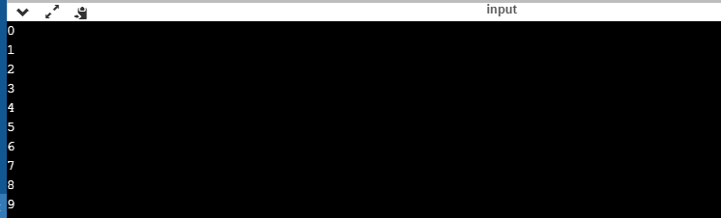

**# While loop:**

class Ltts:

def __init__(jahnavi, a):

jahnavi.a = a

def func(jahnavi):

i = 0

while i < jahnavi.a:

i += 1

print(i)

x = Ltts(10)

x.func()

**Output:**

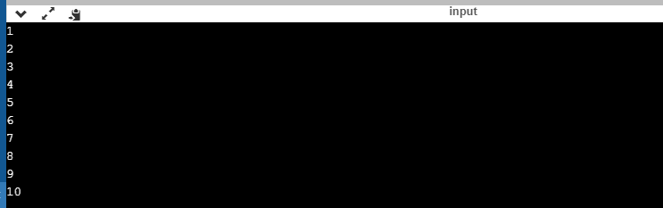

**# if-else loop:**

x = 10

y = 5

if x == y:

print("x is equal to y")

elif x > y:

print("x greater than y")

elif x < y:

print("x less than y")

else:

print("error")

**Output:**

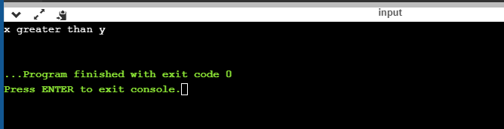

#**nested if-else loop:**

x = 10

y = 5

if x > y:

if x == 10:

print("true")

else:

print("false")

else:

print("x less than y")

**Output:**

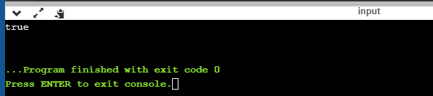

**#list(methods):**

list = [1, 2, 3, 4, 5, 6, 7, 8]

print(list)

print(len(list))

list.append(9)

print(list)

list.remove(3)

print(list)

list.pop()

print(list)

list.insert(3, "three")

print(list)

list1= [11, 12, 13, 14, 15, 16, 17, 18]

list3 = list + list1

print(list3)

list4 = list.copy()

print(list4)

print(list4.count(3))

list.clear()

print(list)

**Output:**

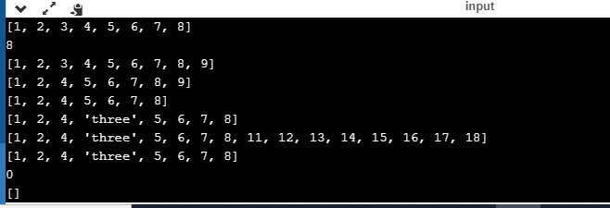

**# Traversing through list:**

list = [1, 2, 3, 4, 5, 6, 7, 8]

for x in list:

print(x)

**Output:**

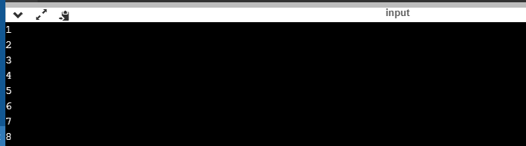

**# list(with class and method):**

class Ltts:

def __init__(jahnavi, list):

jahnavi.list = list

def func(jahnavi):

print(jahnavi.list)

x = Ltts([2, 2, 2])

x.func()

**Output:**

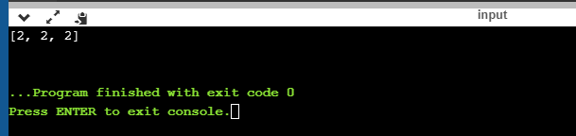

**# list(with class and method):**

class Ltts:

def __init__(jahnavi, list):

jahnavi.list = list

def func(jahnavi):

print(jahnavi.list)

class Ltts1(Ltts):

def __init__(jahnavi, list):

def func1(jahnavi):

print(jahnavi.list)

x = Ltts1([1, 1, 'one'])

x.func()

x.func1()

**Output:**

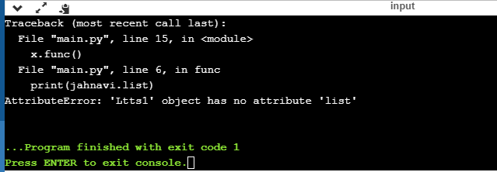

**# list(with class and method):**

class Ltts:

def __init__(jahnavi, list):

jahnavi.list = list

def func(jahnavi):

print(jahnavi.list)

class Ltts1(Ltts):

def __init__(jahnavi, list):

super().__init__(list)

def func1(jahnavi):

print(jahnavi.list)

x = Ltts1([1, 1, 'one'])

x.func()

x.func1()

**Output:**

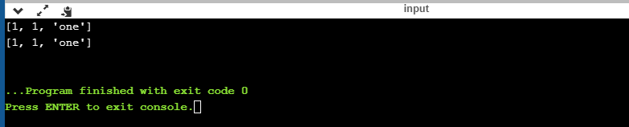

**# list(with class, loops and method):**

class Ltts:

def __init__(jahnavi, list):

jahnavi.list = list

def func(jahnavi):

if len(jahnavi.list) > 1:

print("Big list")

else:

print("Small list")

print(jahnavi.list)

class Ltts1(Ltts):

def __init__(jahnavi, list):

super().__init__(list)

def func1(jahnavi):

print(jahnavi.list)

x = Ltts1([1, 1, 'one'])

x.func()

x.func1()

Output:

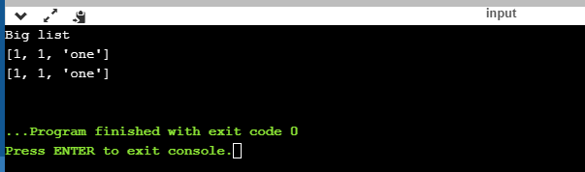

**# list(with class, loops and method):**

class Ltts:

def __init__(jahnavi, list):

jahnavi.list = list

def func(jahnavi):

for a in jahnavi.list:

if len(jahnavi.list) > 1:

print("Big list")

else:

print("Small list")

print(jahnavi.list)

class Ltts1(Ltts):

def __init__(jahnavi, list):

super().__init__(list)

def func1(jahnavi):

print(jahnavi.list)

x = Ltts1([1, 1, 'one'])

x.func()

x.func1()

Output:

