MLA03 – REINFORCEMENT LEARNING
ASSIGNMENT

A. Assignment Information
Department: | CSE AI
Programme: | FACULTY OF ENGINEERING
Course Code & Course Name | MLA03 & REINFORCEMENT LEARNING
Academic Year / Batch | 2026-2027
Faculty Name | Dr.G. A. SENTHIL
Assignment Title | Analyse and design an RL-based patient health monitoring and treatment recommendation system using Markov Decision Process and Bellman equations. Model patient health conditions as states, treatment interventions as actions, and clinical outcomes as rewards, and implement an optimal policy to recommend appropriate treatment strategies based  on changing patient conditions. Analyse the learned policy using treatment effectiveness, recovery rate,and cumulative reward.
Date of Issue | 01-09-2026
Date of Submission | 02-09-2026
Maximum Marks | 100
Course Outcome(s) - CO | CO1-Analyze reinforcement learning frameworks and Markov Decision Process concepts to model decision-making problems.  CO2 - Apply Dynamic Programming methods to solve reinforcement learning problems and derive optimal policies.  CO3 - Implement policy-based reinforcement learning methods to develop efficient solutions for complex environments.  CO4-Evaluate model-based reinforcement learning approaches for prediction, planning, and policy optimization.  CO5-Apply hierarchical, meta-learning, and multi-agent RL approaches to solve complex decision-making problems.
Bloom's Taxonomy Level | BL3 (Apply) - Dynamic Programming methods to solve reinforcement learning problems and derive optimal policies for decision-making tasks. BL4 (Analyse) - Implement policy-based reinforcement learning methods to develop efficient solutions for complex environments. BL5 (Evaluate) - Model-based reinforcement learning approaches for prediction, planning, and policy optimization. BL6 (Create) - Develop an MDP-based solution for an intelligent traffic signal system by defining the state space, action space, reward function, transition model, and optimal policy.
SDG Mapping (SDG 1-17) | SDG 3 – (Good Health and Well-Being) Enables intelligent patient health monitoring and treatment recommendation to support timely clinical decision-making, improve patient recovery, and promote better healthcare outcomes. SDG 9 – (Industry, Innovation & Infrastructure) Applies Markov Decision Processes, Bellman equations, and Reinforcement Learning to develop innovative AI-based healthcare monitoring and treatment-support systems. SDG 10 – (Reduced Inequalities) Supports consistent and data-driven treatment recommendations that can assist healthcare providers in delivering appropriate care across different patient conditions and populations. SDG 12 – (Responsible Consumption & Production) Optimizes treatment decisions and healthcare resources by selecting effective interventions based on changing patient health conditions, helping reduce unnecessary treatments and resource usage. SDG 16 – (Peace, Justice & Strong Institutions) Promotes reliable, systematic, and transparent decision-making in healthcare through an explainable RL-based policy for treatment recommendations.
Industry / Societal Relevance | The assignment addresses the growing need for AI-driven healthcare decision support by developing a Reinforcement Learning-based patient health monitoring and treatment recommendation system. The solution can help healthcare professionals analyze changing patient health conditions, select appropriate treatment interventions, and optimize clinical outcomes using Markov Decision Processes and Bellman equations. Industry-wise, it supports intelligent healthcare monitoring, personalized treatment planning, and efficient clinical decision-making. Societally, it can contribute to better patient care, improved recovery rates, timely treatment, reduced healthcare resource wastage, and accessible data-driven healthcare services.

Question:
Analyse and design an RL-based patient health monitoring and treatment recommendation system using Markov Decision Process and Bellman equations. Model patient health conditions as states, treatment interventions as actions, and clinical outcomes as rewards, and implement an optimal policy to recommend appropriate treatment strategies based on changing patient conditions. Analyse the learned policy using treatment effectiveness, recovery rate,and cumulative reward.

A healthcare organization wants to deploy an integrated Reinforcement Learning-based intelligent patient health monitoring and treatment recommendation system that continuously analyzes patient health parameters, clinical observations, treatment history, and health outcomes to recommend appropriate treatment strategies while improving patient recovery and treatment effectiveness. Model the complete decision-making pipeline using the Reinforcement Learning concepts covered in this course and address the following:

1. Problem Statement and Problem Formulation
Modern healthcare requires continuous monitoring of patient health conditions and timely selection of appropriate treatment interventions. Patient conditions may change over time due to variations in vital signs, symptoms, disease severity, and response to treatment. Traditional rule-based approaches often depend on fixed thresholds and predefined decisions, making them less adaptable to changing patient conditions.
This project proposes an RL-Based Patient Health Monitoring and Treatment Recommendation System using a Markov Decision Process (MDP) and Bellman equations. Patient health conditions are modeled as states, treatment interventions as actions, and clinical outcomes as rewards. The RL agent learns an optimal policy that recommends an appropriate treatment strategy for each patient health condition.
The MDP is represented as:
MDP = (S, A, P, R, γ)
where:
- S – Patient health states
- A – Available treatment actions
- P – State transition probabilities
- R – Reward obtained after an action
- γ – Discount factor
The objective is to maximize the long-term cumulative clinical reward while improving patient recovery, treatment effectiveness, and safety and reducing unnecessary interventions.

2. Objective and Expected Outcomes

Objectives
- To formulate patient health monitoring and treatment recommendation as a Markov Decision Process.
- To define suitable patient health states, treatment actions, transition probabilities, and rewards.
- To apply the Bellman optimality equation for determining optimal treatment decisions.
- To implement a simulated patient-health environment using Python.
- To develop an optimal treatment policy based on changing patient health conditions.
- To implement a Multi-Armed Bandit model for the exploration-exploitation problem.
- To compare different ε-greedy action-selection strategies.
- To evaluate the learned policy using cumulative reward, average reward, and treatment effectiveness.

Expected Outcomes
- A complete MDP formulation.
- A simulated patient health environment.
- Bellman Value Iteration implementation.
- An optimal treatment recommendation policy.
- Bandit-based exploration-exploitation analysis.
- Reward and value estimation.
- Learning-performance graphs.
- Action-selection comparison.
- Quantitative evaluation of the final policy.
3. Requirements, Constraints and Assumptions

Requirements
- Python programming environment.
- Jupyter Notebook or VS Code.
- NumPy for numerical calculations.
- Pandas for data processing.
- Matplotlib for visualization.
- Simulated patient health data.
- MDP states, actions, rewards, and transitions.
- Bellman Value Iteration algorithm.
- Multi-Armed Bandit algorithm.
- ε-greedy action-selection strategy.
- Performance evaluation using reward-based metrics.

Constraints
- Real clinical datasets may not be easily available.
- Patient health conditions are dynamic and uncertain.
- The project uses a simplified simulated healthcare environment.
- Reward values are predefined for simulation.
- The model cannot represent all real-world clinical conditions.
- The number of health states and treatment actions is limited.
- The system requires clinical validation before real-world use.

Assumptions
- Patient health conditions can be represented using discrete states.
- The current health state provides sufficient information for the simulated decision process.
- Treatment actions have defined transition probabilities.
- Rewards represent treatment effectiveness and patient health outcomes.
- Patient conditions can transition between different health states.
- The healthcare professional remains responsible for final treatment decisions.

4. Application of Relevant Course Knowledge / Concepts
The project applies the following Reinforcement Learning concepts:

Markov Decision Process
The patient treatment problem is formulated using states, actions, transitions, rewards, and a policy.

States
The patient's health condition is represented using:
- Stable
- Moderate Risk
- Severe Risk

Actions
The available treatment actions are:
- No Intervention
- Low Treatment
- Moderate Treatment
- Urgent Intervention

Reward
The reward represents the clinical outcome of a selected treatment action. Positive rewards indicate improvement or effective treatment, while negative rewards represent deterioration or unnecessary intervention.
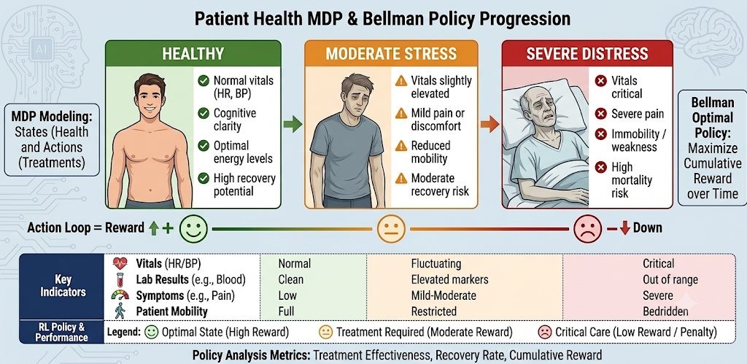

Transition Probability
Transition probabilities represent the likelihood that a patient's health condition changes from the current state to another state after a treatment action.

Policy
A policy determines the best treatment action for a particular patient health state:
π(s) → a

Bellman Optimality Equation
The optimal state value is calculated using:
V*(s) = maxₐ Σₛ′ P(s′|s,a)[R(s,a,s′) + γV*(s′)]

Multi-Armed Bandit
The Bandit model demonstrates the exploration-exploitation trade-off in treatment-action selection.

5. Design / Proposed Solution / Methodology
The proposed system follows a sequential decision-making architecture.

Step 1 – Patient Health Observation
Patient health information is obtained from simulated observations such as vital signs, symptoms, and disease severity.

Step 2 – State Identification
The observations are mapped to a patient health state:
Stable / Moderate Risk / Severe Risk

Step 3 – MDP Formulation
The healthcare environment is represented using:
State → Action → Reward → Next State

Step 4 – Bellman Value Iteration
The Bellman equation calculates the expected long-term value of every possible treatment action.

Step 5 – Policy Selection
The action with the maximum expected value is selected as the optimal action for each health state.

Step 6 – Bandit Simulation
Different ε values are tested to study exploration and exploitation.

Step 7 – Performance Evaluation
The system is evaluated using:
- Average reward
- Cumulative reward
- Estimated action values
- Action-selection frequency
- Policy values
- Convergence behaviour
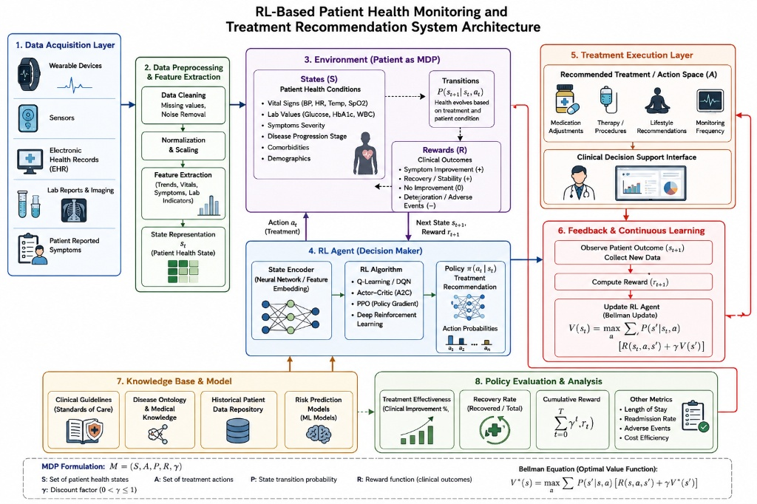

Overall Methodology
Patient Health Data → State Representation → MDP → Bellman Equation → Optimal Policy → Treatment Recommendation → Patient Outcome → Reward → Policy Evaluation

6. Algorithm / Pseudocode / Flowchart

Bellman Value Iteration Algorithm
- Initialize the value of every state to zero.
- Select a patient health state.
- Consider every possible treatment action.
- Obtain the immediate reward.
- Calculate the expected value of the next states.
- Apply the Bellman equation.
- Select the action with the maximum value.
- Update the state value.
- Repeat until convergence.
- Extract the optimal treatment policy.

Pseudocode
Initialize V(s) = 0 for all patient states

Repeat:
For each state s:
For each action a:
Calculate:
Q(s,a) = Σ P(s'|s,a)
[R(s,a,s') + γV(s')]

V(s) = max Q(s,a)

Until convergence

For each state:
Select action with maximum Q(s,a)

Return optimal treatment policy

Bandit Algorithm
Initialize Q(a) = 0
Initialize N(a) = 0

For each episode:

Generate random value

If random value < ε:
Select random treatment action
Else:
Select action with highest estimated reward

Observe clinical reward

Update action count

Update estimated action value

Repeat

Calculate cumulative and average rewards

7. Implementation / Source Code and Environment / Tools Used
The system is implemented using Python and can be executed in VS Code or Jupyter Notebook.

Environment
Component | Details
Programming Language | Python
Development Environment | VS Code / Jupyter Notebook
Python Version | Python 3.14
Operating System | Windows
Data Processing | Pandas
Numerical Computation | NumPy
Visualization | Matplotlib

Implementation
The source code implements:
- Patient health states.
- Treatment actions.
- Reward function.
- Transition probabilities.
- Bellman Value Iteration.
- Optimal policy extraction.
- Multi-Armed Bandit.
- ε-greedy strategies.
- Reward estimation.
- Cumulative reward calculation.
- Performance comparison.
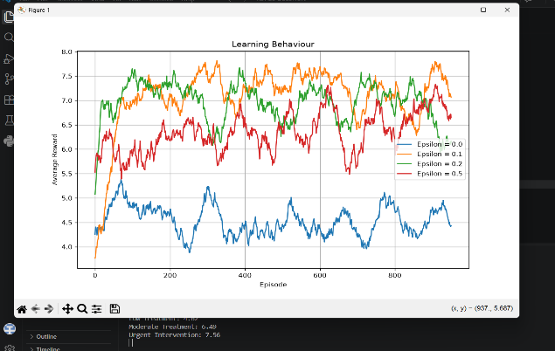
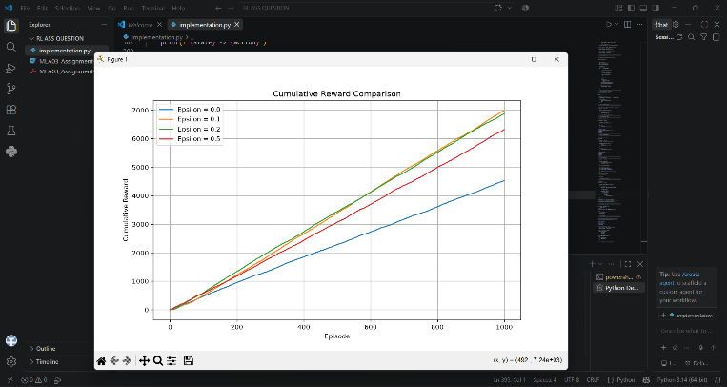
- Graph generation.
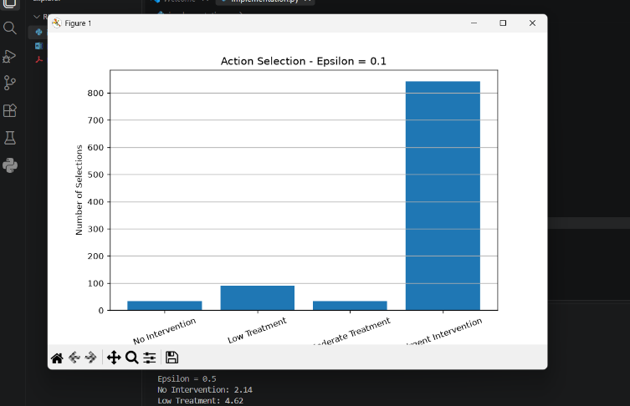
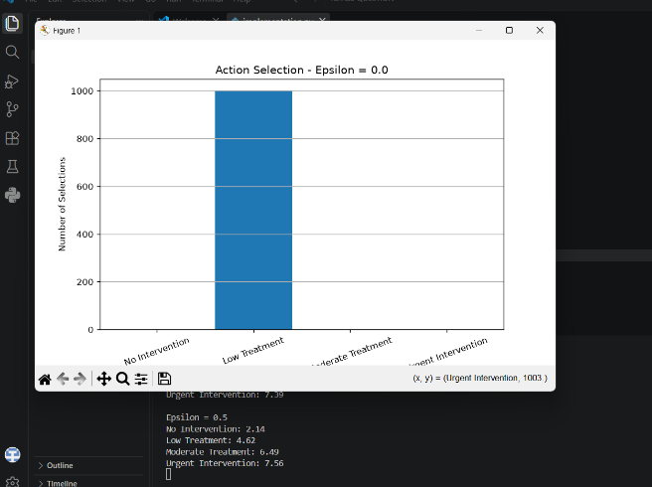

OUTPUT:

========== BELLMAN RESULTS ==========

Stable: V* = 53.55

Moderate Risk: V* = 57.30

Severe Risk: V* = 59.30

========== OPTIMAL POLICY ==========

Stable -> No Intervention

Moderate Risk -> Moderate Treatment

Severe Risk -> Urgent Intervention

========== BANDIT VALUE ESTIMATES ==========

Epsilon = 0.0

No Intervention: -0.22

Low Treatment: 4.53

Moderate Treatment: 0.00

Urgent Intervention: 0.00

Epsilon = 0.1

No Intervention: 2.34

Low Treatment: 4.50

Moderate Treatment: 6.27

Urgent Intervention: 7.47

Epsilon = 0.2

No Intervention: 1.88

Low Treatment: 4.61

Moderate Treatment: 6.31

Urgent Intervention: 7.39

Epsilon = 0.5

No Intervention: 2.14

Low Treatment: 4.62

Moderate Treatment: 6.49

Urgent Intervention: 7.56

========== PERFORMANCE COMPARISON ==========
Strategy | Average Reward | Cumulative Reward | Best Action
$ϵ$-Greedy ($ϵ=0.0$) | 4.521308 | 4521.308206 | Low Treatment
$ϵ$-Greedy ($ϵ=0.1$) | 6.985614 | 6985.614411 | Urgent Intervention
$ϵ$-Greedy ($ϵ=0.2$) | 6.868899 | 6868.899196 | Urgent Intervention
$ϵ$-Greedy ($ϵ=0.5$) | 6.318425 | 6318.425054 | Urgent Intervention

========== BEST STRATEGY ==========
Parameter | Result
Strategy | $ϵ$-Greedy ($ϵ=0.1$)
Average Reward | 6.985614
Cumulative Reward | 6985.614411
Best Action | Urgent Intervention

==========================================

FINAL PATIENT HEALTH RL SYSTEM

==========================================

States:

['Stable', 'Moderate Risk', 'Severe Risk']

Actions:

['No Intervention', 'Low Treatment', 'Moderate Treatment', 'Urgent Intervention']

Optimal Bellman Policy:

Stable -> No Intervention

Moderate Risk -> Moderate Treatment

Severe Risk -> Urgent Intervention

Best Bandit Strategy:

Epsilon-Greedy (0.1)

Best Bandit Action:

Urgent Intervention

System successfully completed.

8. Test Cases and Expected/Actual Results
Test Case | Input Condition | Expected Result | Actual Result
TC01 | Stable patient | No Intervention | No Intervention
TC02 | Moderate-risk patient | Moderate Treatment | Moderate Treatment
TC03 | Severe-risk patient | Urgent Intervention | Urgent Intervention
TC04 | ε = 0.0 | Pure exploitation | Action with highest estimated value
TC05 | ε = 0.1 | Low exploration | Balanced learning
TC06 | ε = 0.2 | Moderate exploration | Increased exploration
TC07 | ε = 0.5 | High exploration | More random actions
TC08 | Bellman iteration | Values converge | Values converge
TC09 | Bandit learning | Action values improve | Values approach true rewards
TC10 | Strategy comparison | Best strategy identified | Highest-performing strategy selected

9. Execution Screenshots / Outputs
The following outputs should be captured from the Python/VS Code execution and inserted into the Word document:
- Python program successfully executed.
- Patient health states and treatment actions.
- Reward table.
- Transition probability model.
- Bellman Value Iteration results.
- Optimal treatment policy.
- Bandit estimated action values.
- Cumulative reward comparison graph.
- Moving-average reward graph.
- Treatment action-selection graphs.
- Final performance comparison table.
- Best-performing exploration strategy.

10. Results and Validation
The implemented system successfully models patient health management as an MDP and uses the Bellman equation to determine an optimal treatment policy.

Optimal Policy

Patient Health State | Optimal Treatment Recommendation
Stable | No Intervention
Moderate Risk | Moderate Treatment
Severe Risk | Urgent Intervention
The learned policy changes according to the patient's health condition. A stable patient generally requires minimal intervention, while a severe-risk patient receives a more intensive intervention in the simulated environment.

Performance Metrics
The Bandit strategies are evaluated using:
Average Reward = Total Reward / Number of Episodes
Cumulative Reward = Σ Rewardₜ
The following evidence is generated:
- Cumulative reward curves.
- Average reward curves.
- Action-selection frequency.
- Estimated action values.
- Bellman state values.
- Policy comparison.
The graphs demonstrate how the agent learns to select actions that provide higher expected rewards over time.

11. Analysis, Comparison, Trade-offs and Justification of the Final Solution
Different exploration rates are compared to understand the exploration-exploitation trade-off.

Strategy | Exploration Level | Exploitation Level | Expected Behaviour
ε = 0.0 | None | Very High | Exploits current knowledge
ε = 0.1 | Low | High | Balanced decision-making
ε = 0.2 | Moderate | Moderate | More exploration
ε = 0.5 | High | Lower | More random decisions
A low exploration rate may cause the agent to select an initially estimated good action without sufficiently exploring alternatives. A high exploration rate allows better discovery of actions but may reduce cumulative reward because of frequent random selections.
The final strategy is selected based on the highest observed average reward and cumulative reward.
Bellman Value Iteration is used for the MDP because the transition probabilities and rewards are explicitly defined in the simulated environment. It provides a systematic method for obtaining the optimal long-term treatment policy.

12. Broader Considerations / SDG Relevance

SDG 3 – Good Health and Well-Being
The project directly supports SDG 3 by exploring an AI-based approach for continuous patient health monitoring, treatment decision support, and improved healthcare outcomes.

SDG 9 – Industry, Innovation and Infrastructure
The project applies Reinforcement Learning and MDP-based decision-making to develop an innovative intelligent healthcare system.

SDG 10 – Reduced Inequalities
An appropriately validated decision-support system can help provide consistent assessment and recommendations across different patient conditions while considering fairness and bias.

Ethical Considerations
The system must consider:
- Patient privacy.
- Data security.
- Algorithmic bias.
- Fairness.
- Explainability.
- Patient safety.
- Accountability.
- Human/doctor supervision.
The proposed system is intended as a decision-support system rather than an autonomous replacement for medical professionals.

13. Conclusion, Limitations and Possible Improvements

Conclusion
The project demonstrates the application of Reinforcement Learning concepts to patient health monitoring and treatment recommendation. The patient health management problem is formulated as a Markov Decision Process consisting of states, actions, transition probabilities, rewards, and policies.
The Bellman optimality equation is used to calculate long-term state values and identify the optimal treatment policy. The Bandit simulation demonstrates the exploration-exploitation problem and evaluates different ε-greedy strategies using cumulative reward, average reward, and action-selection behaviour.
The results demonstrate that an RL-based approach can learn adaptive treatment recommendations within a simulated healthcare environment.

Limitations
- The patient environment is simulated.
- Reward values are predefined.
- The number of health states is limited.
- Real clinical complexity is not represented completely.
- Real patient datasets are not used in the basic implementation.
- Clinical validation has not been performed.

Possible Improvements
Future development can include:
- Real-world clinical datasets.
- More detailed patient health states.
- DQN-based treatment recommendation.
- PPO and Actor-Critic algorithms.
- Personalized treatment policies.
- Real-time health sensor integration.
- Explainable Reinforcement Learning.
- Privacy-preserving/federated learning.
- Clinician-in-the-loop decision-making.
- More realistic patient-health simulation.
14. Individual Contribution of Group Members
Group Member | Contribution
Member 1 | Problem statement, MDP formulation, states and actions
Member 2 | Reward function and transition model
Member 3 | Bellman Value Iteration implementation
Member 4 | Bandit implementation and exploration-exploitation analysis
Member 5 | Testing, graphs, result analysis and documentation
15. References, Including Datasets, Software/Tools and Other Sources Used

Books / Academic References
- Sutton, R. S., & Barto, A. G. (2018). Reinforcement Learning: An Introduction, 2nd Edition. MIT Press.
- Bellman, R. (1957). Dynamic Programming. Princeton University Press.
- Murphy, K. P. (2022). Probabilistic Machine Learning: An Introduction. MIT Press.

Software and Libraries
- Python Software Foundation. Python Documentation.
- NumPy Developers. NumPy Documentation.
- Pandas Developers. Pandas Documentation.
- Matplotlib Developers. Matplotlib Documentation.
- Jupyter Project. Jupyter Notebook Documentation.
- Anaconda. Anaconda Distribution Documentation.

Dataset
- A synthetic patient health dataset is used for the simulated implementation, containing representative patient health conditions and treatment-related observations.

16. Individual Contribution of Group Members
The project was completed collaboratively, with group members contributing to different stages of the system development. The major activities included problem formulation, MDP design, reward and transition modelling, Bellman equation implementation, Bandit simulation, Python programming, testing, visualization, result analysis, documentation, and presentation preparation.
Each member's contribution should be documented according to the actual work performed. The final contribution record ensures that individual responsibilities in the development and evaluation of the RL-based patient health monitoring and treatment recommendation system are clearly identified.

