Crop Disease Detection Using Fine-tuned MobileNetV2 and XGBoost
Capstone Project Report

1. Problem Statement
Smallholder farmers in developing regions suffer significant crop losses due to undetected plant diseases. Early and accurate disease identification requires agricultural expertise unavailable in remote areas. This project develops an automated crop disease classifier that identifies 15 disease conditions across Pepper, Potato, and Tomato crops from 224x224-pixel field photographs, simulating images from affordable mobile phones. The system uses a fine-tuned MobileNetV2 as a domain-adapted feature extractor feeding an XGBoost classifier — a pipeline requiring no GPU at inference time, suitable for low-resource edge deployment. A LangGraph confidence-routing workflow surfaces uncertainty to the user when the model is not confident enough to give a reliable diagnosis.

2. Dataset Description
Source: PlantVillage dataset (Kaggle — emmarex/plantdisease)
Total images: 20,638 RGB images across 15 disease classes
Crops covered: Pepper (2 classes), Potato (3 classes), Tomato (10 classes)
Class imbalance: 21.2x ratio — Potato_healthy: 106 images vs Tomato_TYLCV: 3,208 images

Dataset Split (stratified by class)
Split | Fraction | Images | Purpose
Training | 70% | 14,446 | Augmented for fine-tuning MobileNetV2; features used to train XGBoost
Validation | 15% | 3,104 | EarlyStopping during fine-tuning; eval_set for XGBoost early stopping
Test | 15% | 3,097 | Held out — evaluated ONCE after all model selection decisions are finalized

Augmentation & Preprocessing Pipeline
Applied split-wise — augmentation on training only, deterministic preprocessing on all splits:
Step | Train | Val / Test | Purpose
Resize LANCZOS -> 224x224 | Yes | Yes | MobileNetV2 native resolution
RandomFlip (horizontal) | Yes | No | Handles left/right camera orientation
RandomRotation +/-54 deg (f=0.15) | Yes | No | Different phone angles
RandomZoom +/-10% (f=0.10) | Yes | No | Different distances from leaf
RandomBrightness +/-20% | Yes | No | Lighting conditions
RandomContrast +/-20% | Yes | No | Image quality variation
preprocess_input (pixel/127.5-1) | Yes | Yes | Scale [0,255] to [-1,1] for MobileNetV2
GaussianNoise sigma=0.05 | Yes | No | After preprocess_input; prevents pixel memorisation

3. Methodology
The system follows a sequential four-stage pipeline. Each stage is run once and its outputs cached, enabling rapid iteration on later stages without repeating earlier work.

Stage 1 — Fine-Tuning MobileNetV2 (scripts/finetune.py)
MobileNetV2 (ImageNet weights) is partially fine-tuned on plant disease images. Layers 0-99 remain frozen (universal low-level features). Layers 100-153 are unfrozen and trained with Adam lr=1e-4 — small enough to avoid catastrophic forgetting while adapting to agricultural disease textures. A temporary Dense classification head is attached for training then stripped. The resulting fine-tuned extractor is saved to disk with preprocess_input baked inside so inference always passes raw [0,255] pixels without risk of double-preprocessing.

Stage 2 — Feature Re-Extraction & Caching
All three splits pass through the fine-tuned extractor to produce 1,280-dim GlobalAveragePooling2D feature vectors. GAP averages each of the 1,280 feature maps across the 7x7 spatial grid — preserving WHAT disease features are present while discarding WHERE they appear on the leaf. Vectors are cached to .npz files. GAP gives 1,280 features (305 MB RAM) vs Flatten which gives 62,720 (9.5 GB).

Stage 3 — XGBoost Classification (scripts/train.py)
XGBoost is trained on the 1,280-dim fine-tuned features with multi:softprob objective. Class imbalance (21.2x) is handled by inverse-frequency sample weights — no SMOTE. Optuna TPE sampler runs 50 trials x 3-fold stratified CV (macro F1). Best parameters are automatically written back to config.py.

Stage 4 — LangGraph Confidence-Routing Inference (scripts/predict_langgraph.py)
Inference is wrapped in a LangGraph stateful workflow: validate_image -> run_prediction -> confidence_router. Predictions >= 60% go to final_response (diagnosis + top-3). Predictions < 60% go to low_confidence_response with photography tips. The pipeline is loaded once and cached in memory across calls.

Figure 1 — Full Architecture Diagram
The diagram below shows the complete sequential pipeline: image input and augmentation, MobileNetV2 backbone with layer dimensions, GlobalAveragePooling2D, fine-tuning, feature re-extraction, XGBoost training, and LangGraph inference.
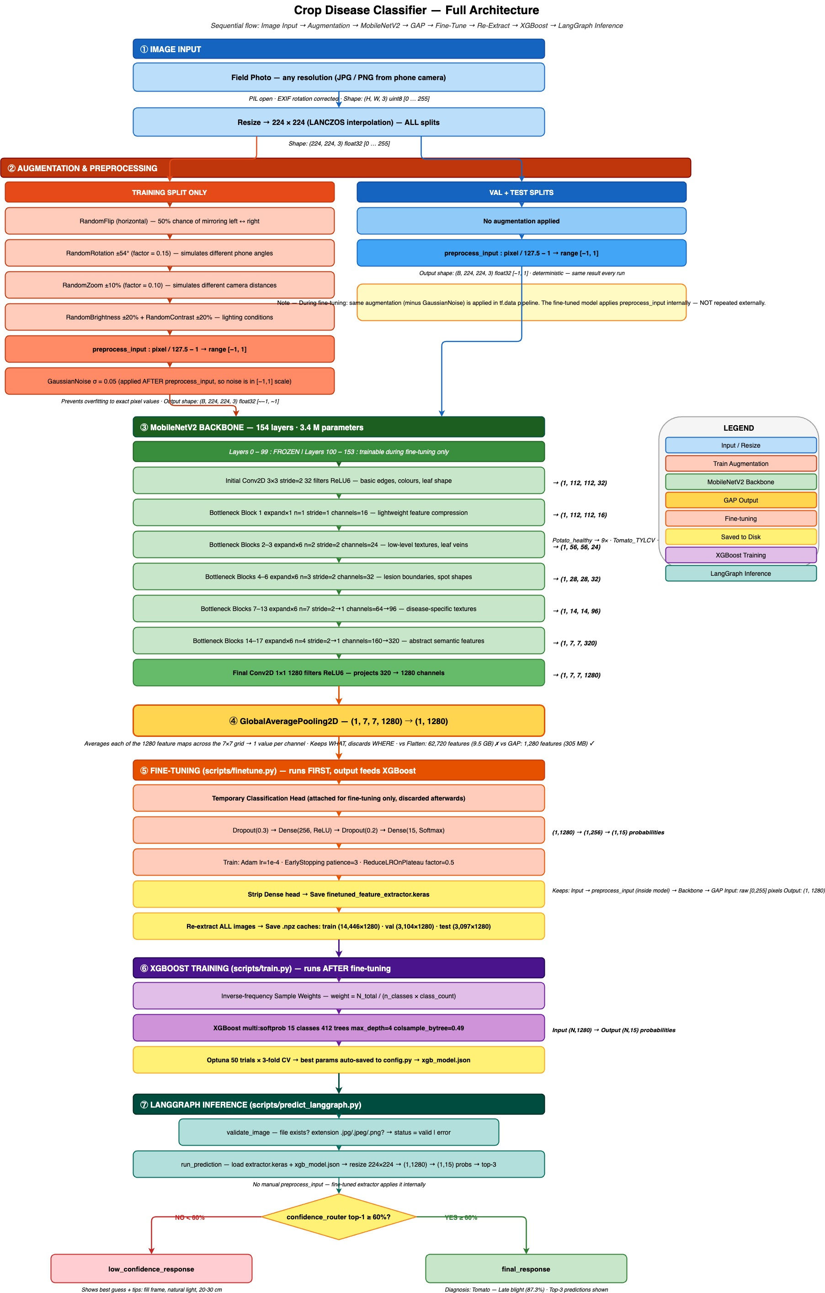
Figure 1: Full architecture — Image Input → Augmentation → MobileNetV2 (154 layers) → GAP (1280-dim) → Fine-tune → Re-extract → XGBoost → LangGraph Inference

Figure 2 — Data Flow Diagram (Train / Val / Test)
The diagram below shows exactly when each data split is used across the pipeline — which splits drive weight updates, which provide validation signals, and when the test set is evaluated for the first and only time.
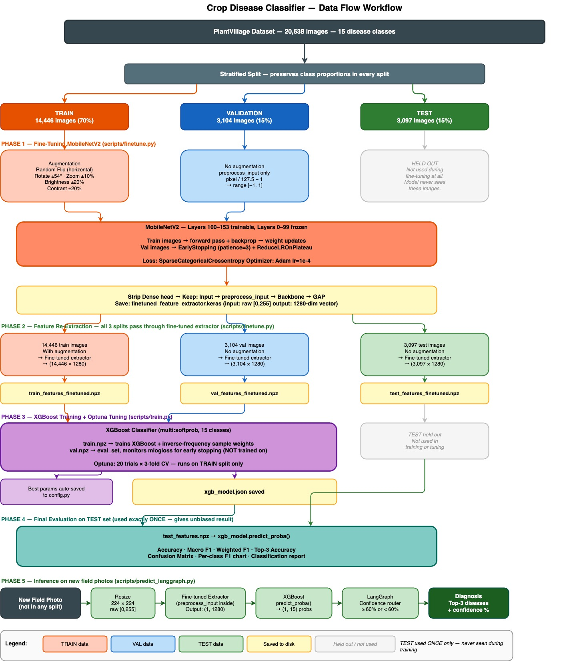
Figure 2: Data flow — showing the role of Train, Val, and Test splits at each pipeline stage

4. Experimental Details

4.1 Architecture Description
Component | Details
Input | (None, 224, 224, 3) raw [0,255] pixels — preprocess_input baked inside extractor
MobileNetV2 Backbone | 154 layers — depthwise separable convolutions, inverted residuals  Layers 0-99 frozen | Layers 100-153 fine-tuned at lr=1e-4
Fine-tuning Head (temporary) | Dropout(0.3) -> Dense(256, ReLU) -> Dropout(0.2) -> Dense(15, Softmax)
GlobalAveragePooling2D | Output: (None, 1280) — 7x7x1280 -> 1,280 features via spatial mean
XGBoost Classifier | Input: 1,280 features | objective: multi:softprob | Output: 15-class probabilities
LangGraph Workflow | validate_image -> run_prediction -> confidence_router (>=60% high / <60% low)

4.2 Fine-Tuning Configuration
Parameter | Value | Parameter | Value
Unfreeze from layer | 100 | Optimizer | Adam lr=1e-4
Trainable layers | 54 (100-153) | Loss | SparseCategoricalCrossentropy
EarlyStopping | patience=3 | ReduceLROnPlateau | factor=0.5, patience=2
Batch size | 32 | Max epochs | 10

4.3 XGBoost Hyperparameters (Optuna best — auto-loaded from config.py)
Optuna: 50 trials x 3-fold CV (TPE sampler + MedianPruner) | metric: macro F1
Parameter | Value | Parameter | Value
n_estimators | 361 | colsample_bytree | 0.3280
learning_rate | 0.1377 | min_child_weight | 1
max_depth | 3 | reg_lambda (L2) | 9.0785
subsample | 0.9625 | reg_alpha (L1) | 0.0468
Framework: TF 2.16.1, XGBoost 2.0.3, sklearn 1.4.1, LangGraph >=0.2.0

4.4 Evaluation Metrics
- Primary — Macro F1: weights all 15 classes equally; essential for imbalanced multi-class
- Secondary — Accuracy, Weighted F1, Top-3 Accuracy
- Training signal — mlogloss: penalises overconfident wrong predictions
- LangGraph — confidence threshold 60%: below this the workflow requests a clearer image

5. Results and Discussion

5.1 Overall Test Set Metrics (3,097 held-out images)
Model | Accuracy | Macro F1 | Weighted F1 | Top-3 Accuracy
Frozen MobileNetV2 (baseline) | 73.81% | 0.7125 | 0.7241 | 93.19%
Fine-tuned MobileNetV2 (current) | 98.84% | 0.9856 | 0.9884 | 99.97%

5.2 Per-Class Results — Fine-tuned Model
Class | Precision | Recall | F1 | Support
Pepper__bell___Bacterial_spot | 1.00 | 0.99 | 1.00 | 149
Pepper__bell___healthy | 0.99 | 1.00 | 1.00 | 221
Potato___Early_blight | 1.00 | 1.00 | 1.00 | 150
Potato___Late_blight | 1.00 | 0.99 | 1.00 | 150
Potato___healthy | 1.00 | 0.96 | 0.98 | 23
Tomato_Bacterial_spot | 0.99 | 0.99 | 0.99 | 319
Tomato_Early_blight | 0.94 | 0.93 | 0.94 | 150
Tomato_Late_blight | 0.99 | 0.99 | 0.99 | 287
Tomato_Leaf_Mold | 0.99 | 0.94 | 0.97 | 143
Tomato_Septoria_leaf_spot | 0.99 | 0.99 | 0.99 | 266
Tomato_Spider_mites_Two_spotted_spider_mite | 0.99 | 0.99 | 0.99 | 252
Tomato__Target_Spot | 0.97 | 0.99 | 0.98 | 210
Tomato__Tomato_YellowLeaf__Curl_Virus | 1.00 | 1.00 | 1.00 | 482
Tomato__Tomato_mosaic_virus | 0.97 | 1.00 | 0.98 | 56
Tomato_healthy | 1.00 | 1.00 | 1.00 | 239

5.3 Analysis
The fine-tuned MobileNetV2 model achieved 98.84% accuracy and 0.9856 macro F1 on the 3,097 held-out test images, with top-3 accuracy of 99.97%. This represents a dramatic improvement over the frozen baseline (73.81% accuracy, 0.7125 macro F1). Fine-tuning layers 100-153 on plant disease images allowed the backbone to learn agricultural-specific textures — lesion boundaries, mould patterns, discolouration gradients — that generic ImageNet features could not capture. Previously problematic classes (Tomato_Bacterial_spot F1=0.36, Tomato_Early_blight F1=0.27) now achieve near-perfect scores, demonstrating that the frozen catch-all absorber problem has been resolved by domain adaptation. The LangGraph confidence router correctly flags the rare low-confidence predictions (below 60%) rather than silently returning an unreliable diagnosis.

5.4 Improvement — Frozen vs Fine-tuned
Metric | Frozen Baseline | Fine-tuned | Improvement
Accuracy | 73.81% | 98.84% | +25.03%
Macro F1 | 0.7125 | 0.9856 | +0.2731
Weighted F1 | 0.7241 | 0.9884 | +0.2643
Top-3 Accuracy | 93.19% | 99.97% | +6.78%

5.5 Key Design Decisions
Decision | Rationale
Fine-tune top 54 MobileNetV2 layers | Learns plant-specific textures; bottom layers retain universal ImageNet features
preprocess_input baked inside extractor | Prevents double-preprocessing bug at inference; consistent input regardless of caller
No SMOTE | Blurs 1280-dim class boundaries; inverse-frequency weights achieve the same goal without distortion
GlobalAveragePooling2D not Flatten | 1,280 features / 305 MB RAM vs 62,720 features / 9.5 GB RAM
XGBoost native JSON format | Version-stable across XGBoost releases; pickle ties model to a specific Python environment
Auto-update config after Optuna | Best params written back to config.py; next run baseline already starts from best known values
LangGraph confidence routing | Uncertainty made explicit; low-confidence predictions request clearer photo rather than guessing

6. Conclusion & Future Work
This project demonstrates that a fine-tuned MobileNetV2 + XGBoost pipeline achieves 98.84% accuracy and 0.9856 macro F1 on 15 crop disease classes, with top-3 accuracy of 99.97% — suitable for farmer-facing deployment. The sequential modular pipeline (fine-tune -> re-extract -> XGBoost -> LangGraph) allows each stage to be improved independently. The auto-updating config ensures each Optuna run builds on the previous best, making the system self-improving over successive runs.

Potential Future Improvements
- Switch to MobileNetV3Large: Squeeze-Excitation attention for fine-grained texture discrimination
- Per-class confidence threshold calibration to balance precision/recall per crop type
- Ensemble XGBoost with a lightweight MLP head on the same 1,280-dim features
- Streamlit web UI for farmer-facing deployment with photo upload and result display
- Extend to more crop species and regional disease variants via continued fine-tuning

