Applications of Machine Learning Algorithms in Agriculture

OBJECTIVE:

The main objective of this application is to predict the rainfall and the recommended crop for the farmers. It will be helpful to the farmers in agricultural field.

ABSTRACT:
Rainfall prediction is important in Indian civilization and it plays major role in human life to a great extent. It is demanding responsibility of meteorological department to predict the frequency of rainfall with uncertainty. It is complicated to predict the rainfall accurately with changing climatic conditions. It is challenging to forecast the rainfall for both summer and rainy seasons. Researchers in all over the world have developed various models to predict the rain fall mostly using random numbers and they are similar to the climate data. In general, agriculture is the backbone of India and also plays an important role in Indian economy by providing a certain percentage of domestic product to ensure the food security. But now-a-days, food production and prediction is getting depleted due to unnatural climatic changes, which will adversely affect the economy of farmers by getting a poor yield and also help the farmers to remain less familiar in forecasting the future crops For this project we use 5 different algorithms they are XG Boost, Decision Tree, AdaBoost, Support vector machine and Random Forest Apart from these algorithms Decision Tree algorithms gives better accuracy compared to remaining algorithms.
Keywords: AdaBoost, Random forest, XGBoost , performance Analyses, SVM, Decision Tree.

EXISTING SYSTEM:
Where as in the case of the existing system means that what is previous system says a Manual human intervention is not that much applicable and error-prone. Legacy and Conventional Data Mining Algorithms can’t deal with huge volumes of data, slower and inaccurate.
DISADVANTAGES:
- Late process
- Its more time
- No accurate result

PROPOSED SYSTEM:
Here in our proposed method we are going to predict the rainfall with the crop recommendation. In rain fall prediction we are going to predict whether it is going to rain or not and in crop recommendation we are going to recommend the crop name based on the environment condition. And to do this we are going to implement some machine learning algorithm mentioned in abstract section.

FLOW CHART:

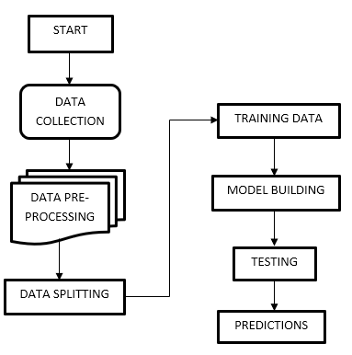

ADVANTAGES:
- High accuracy.
- Low complexities.
- High reliability.

SYSTEM SPECIFICATIONS:

H/W SPECIFICATIONS:

Processor : I3/Intel Processor
- RAM : 4GB (min)
- Hard Disk : 128 GB
- Key Board : Standard Windows Keyboard
- Mouse : Two or Three Button Mouse
- Monitor : Any
S/W SPECIFICATIONS:
- Operating System : Windows 7+
- Server-side Script : Python 3.6+
- IDE : PyCharm.
- Framework : Flask
- Libraries Used : Pandas, Numpy, Matplotlib, OS.

