**AVLSI PROJECT REPORT**

**Name:** V Jahnavika reddy

**Roll no:** S20210020330

**Introduction:**

The current challenges in embedded systems and nano-scale circuits include issues with CMOS transistors and high energy consumption in binary circuits. To address these challenges, CNTFET transistors are proposed as an alternative to CMOS, offering higher performance. Similarly, MVL circuits are suggested to reduce energy consumption by accommodating multiple data states, with the ternary system showing promising results.Despite the advantages of MVL circuits, implementing ternary circuits faces hurdles in efficiently obtaining the logical state 1 (Vdd/2) from a single power supply. Previous solutions involving resistors or diode-connected transistors have drawbacks like increased circuit size and power dissipation. This paper proposes a direct use of (Vdd/2) in designs to eliminate the need for additional components. By utilizing ternary unary operators, CNTFET transistors, transmission gates, and dual-voltages (Vdd, Vdd/2), the proposed designs aim to decrease the Power-Delay Product (PDP) and save battery consumption in nano-scale embedded systems and IoT devices.

Graphene Nanoribbon Field-Effect Transistors (GNRFETs) represent a cutting-edge alternative to traditional CMOS transistors in the realm of nano-scale circuitry. Unlike CNTFETs, which utilize carbon nanotubes, GNRFETs leverage graphene, an atomically thin material renowned for its exceptional electrical properties.In comparison to CNTFETs, GNRFETs offer several distinct advantages. Firstly, graphene's high carrier mobility surpasses that of carbon nanotubes, promising enhanced transistor performance. Additionally, GNRFETs boast superior mechanical strength and thermal conductivity, contributing to their reliability and suitability for demanding applications. Moreover, graphene's tunable bandgap facilitates precise control over device characteristics, providing versatility in circuit design.

**Abstract:**

Novel ternary combinational digital circuits designed for 32 nm CNTFET technology, with the goal of minimizing energy consumption in low-power nano-scale embedded systems and IoT devices. The circuits, including ternary half adder (THA) and multiplier (TMUL), utilize unique ternary unary operator circuits and implement dual power supplies (Vdd and Vdd/2) without the need for ternary decoders, basic logic gates, or encoders. Through extensive simulations examining PVT variations, noise effects, and scalability studies using the HSPICE simulator, the effectiveness of the proposed designs is demonstrated. It Indicates superior performance and robustness of the proposed circuits.

**Background :**

*CNFET-Based Ternary Logic*

In ternary logic circuit design, three logic levels are utilized.

These three logic values, 0, 1, and 2, correspond to voltage levels of 0, Vdd/2, and Vdd, respectively. Within this context, a function f(X) is defined as a ternary logic function, mapping {0, 1, 2} to {0, 1, 2}, where X is composed of X1, X2,..., Xn. For {Xi, Xj} ∈ {0, 1, 2}, the fundamental ternary logic operations are defined as follows:

Xi + Xj = max{Xi, Xj} (1)

Xi·Xj = min{Xi, Xj} (2)

Equations (1) and (2) represent the OR and AND functions of ternary logic, respectively.

**Circuit Diagram: Ternary half adder**

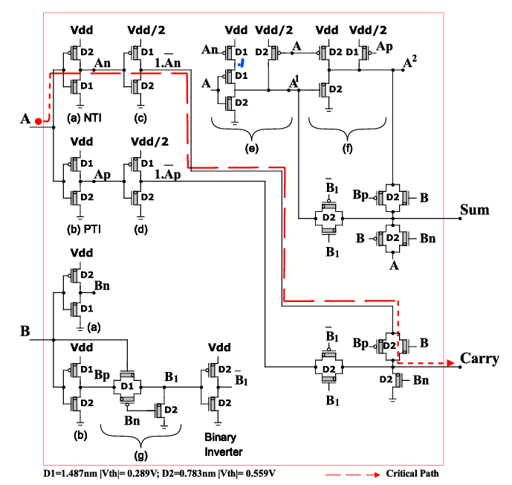

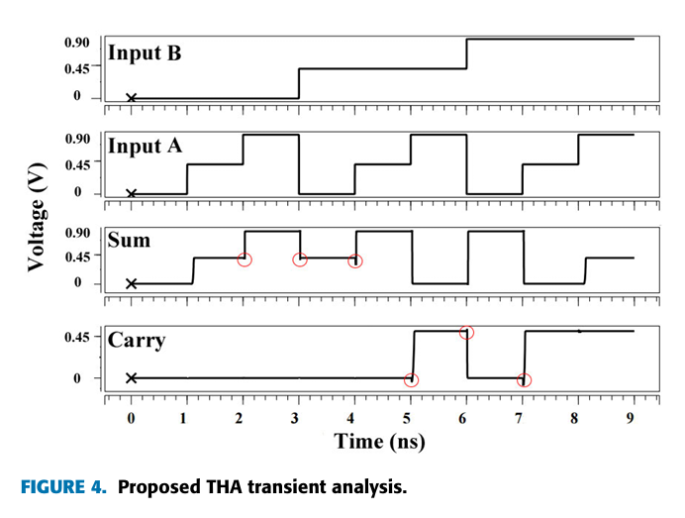

**Implementation:**

**CNTFET:**

THA Transient analysis **(CARRY)**

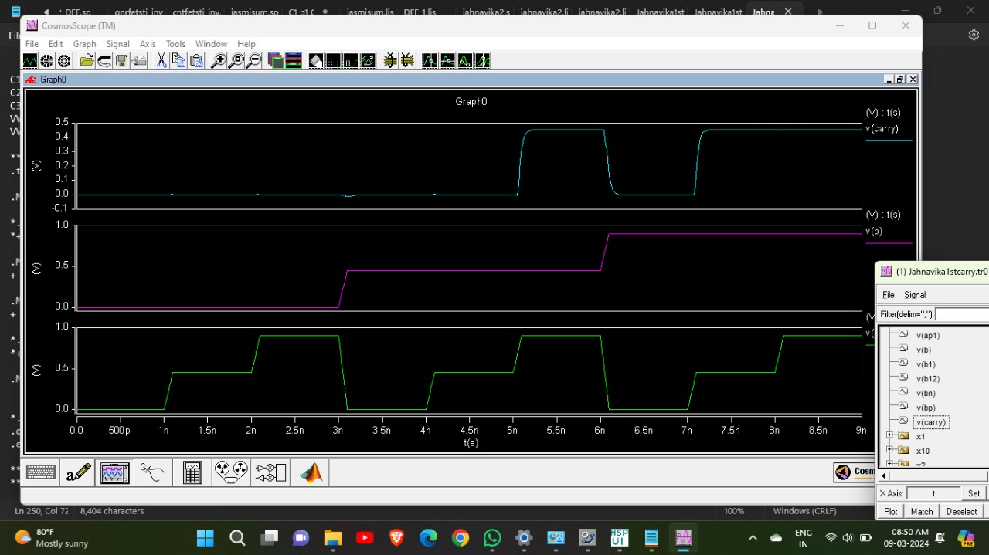

THA Transient analysis **(Sum)**

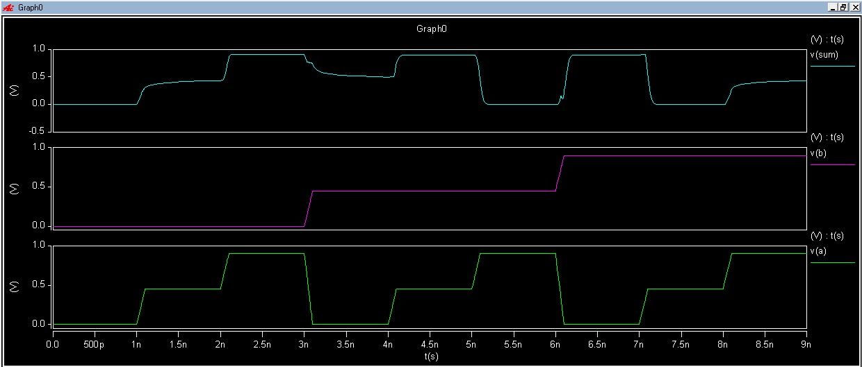

**GNRFET:**

THA Transient analysis **(Sum)**

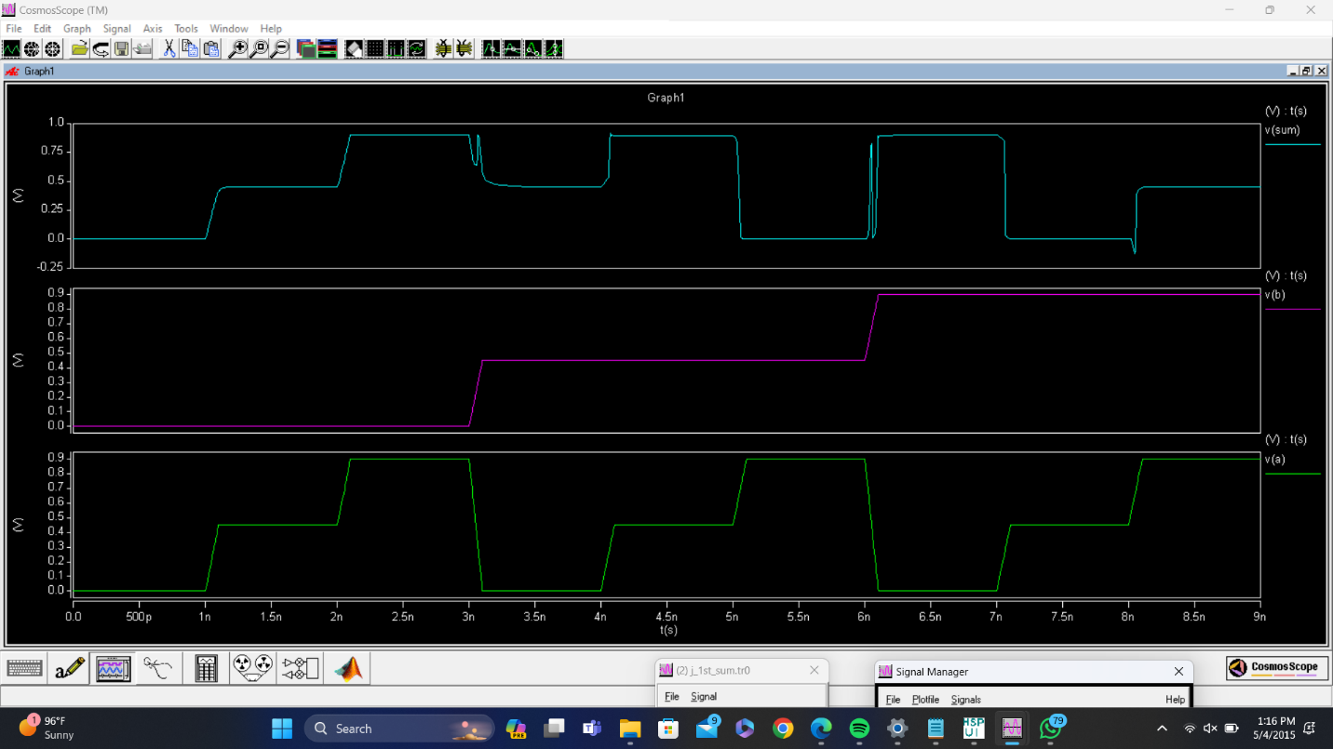

THA Transient analysis **(CARRY)**

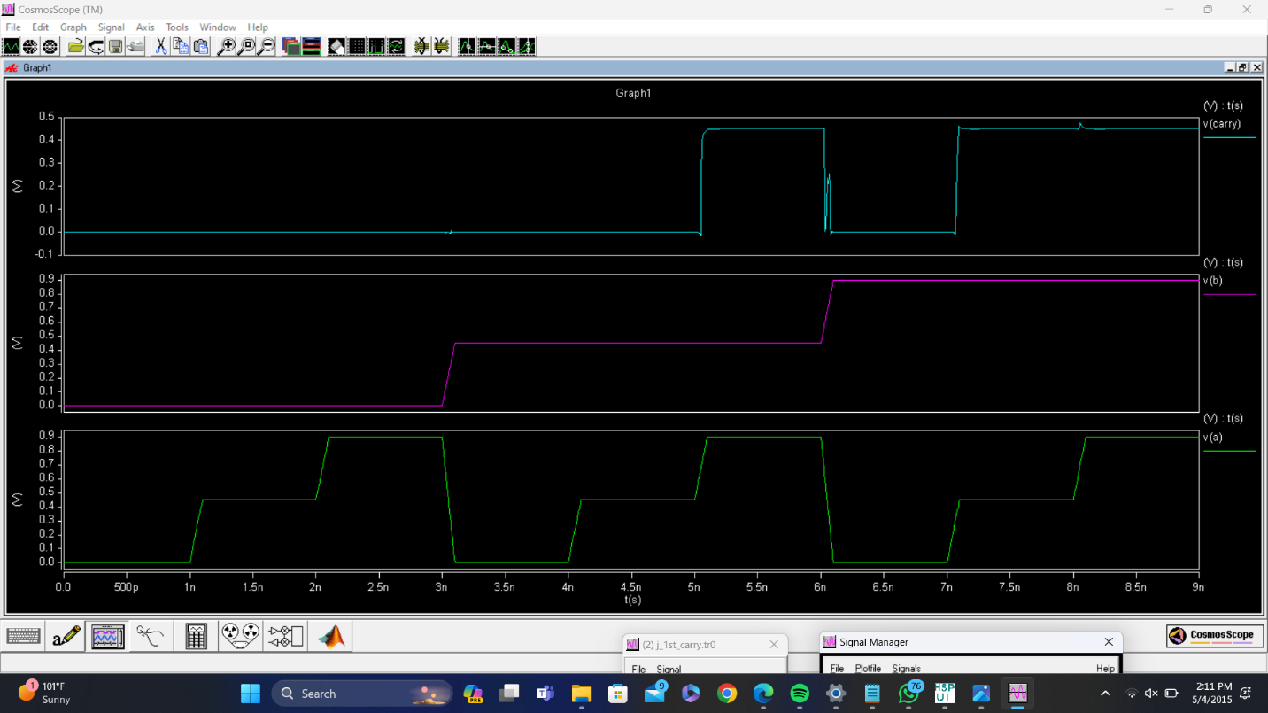

**Ternary Multiplier:**

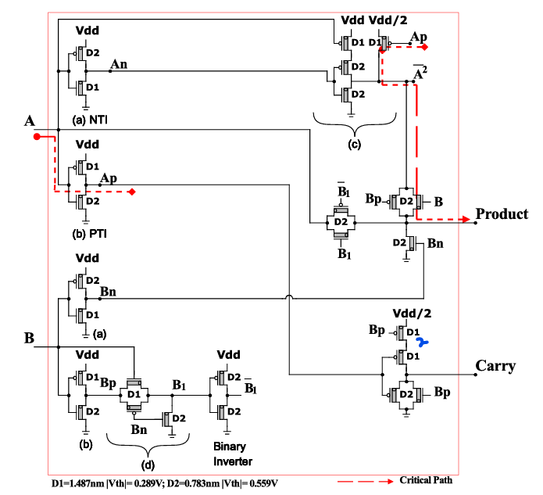

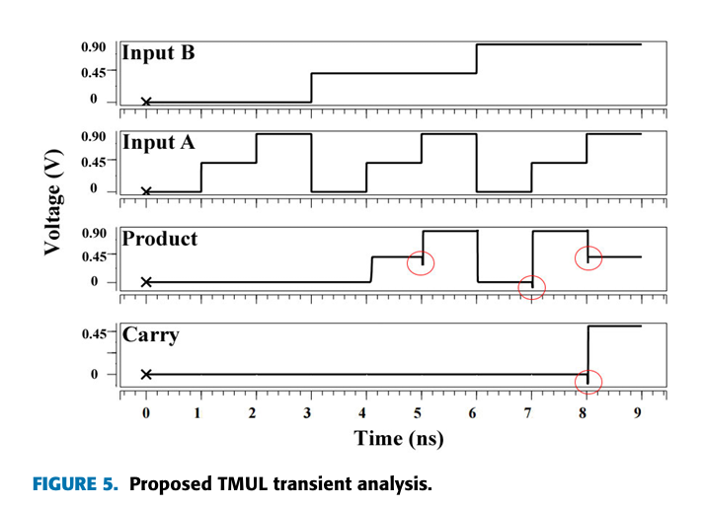

**Implementation:**

**CNTFET:**

**TMUL Transient analysis:**

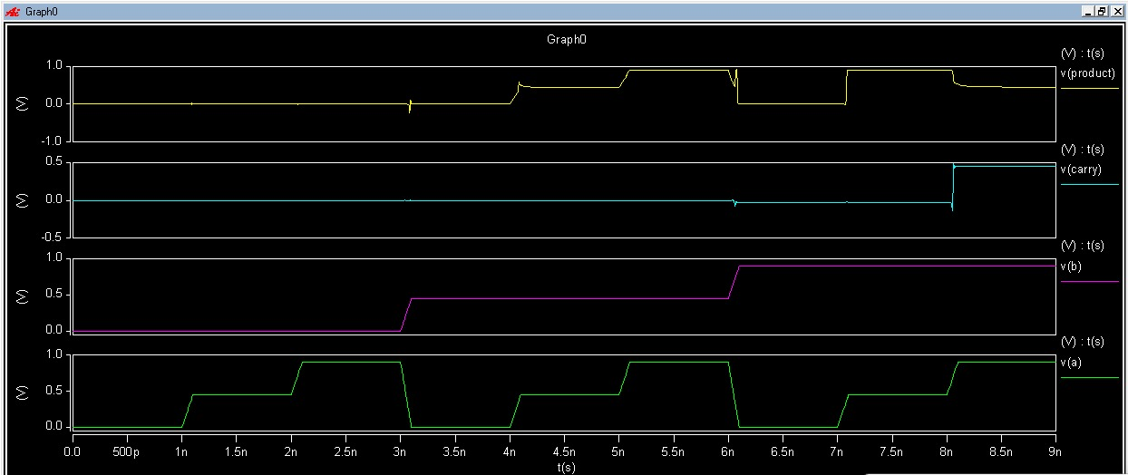

**GNRFET:**

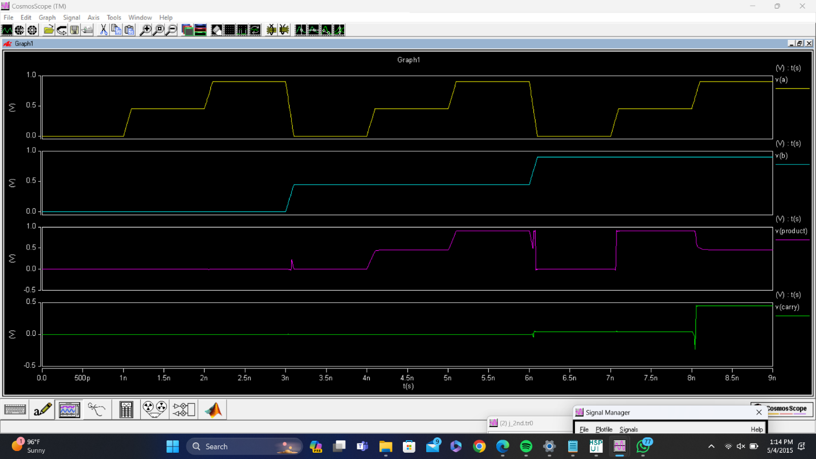

**Conclusion:**

The implementation results underscore the superiority of Graphene Nanoribbon Field-Effect Transistors (GNRFETs) over Carbon Nanotube Field-Effect Transistors (CNTFETs) in nano-scale circuit applications. GNRFETs demonstrate enhanced performance metrics, including higher carrier mobility, mechanical strength, and thermal conductivity compared to CNTFETs. These attributes translate into superior efficiency, reliability, and scalability in circuit designs.

By leveraging GNRFETs, researchers can effectively address the challenges of high energy consumption and limited scalability inherent in nano-scale circuits. The integration of GNRFETs into Multi-Valued Logic (MVL) circuitry offers promising avenues for reducing power dissipation and improving overall circuit efficiency. Moreover, GNRFET-based designs, utilizing innovative strategies and dual-voltage configurations, have the potential to revolutionize embedded systems and IoT devices, paving the way for sustainable and high-performance technologies in the future.