**PRACTICE ASSIGNMENT**

1)

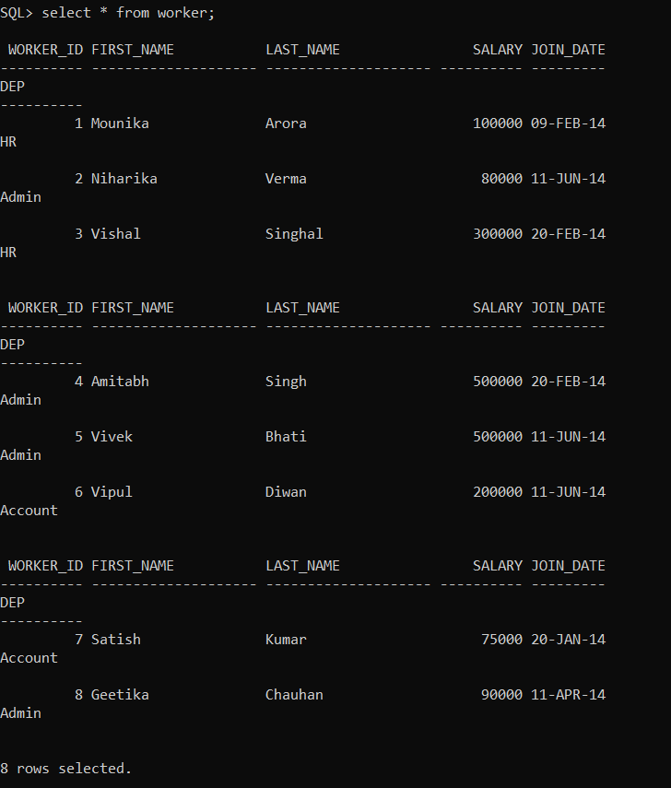

Q-1. Write an SQL query to fetch “FIRST_NAME” from the Worker table using the alias name <WORKER_NAME>.

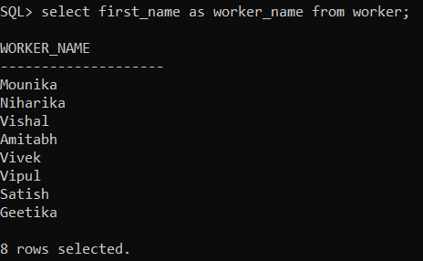

**Q-2. Write an SQL query to find the position of the alphabet (‘a’) in the first name column ‘Amitabh’ from the Worker table.**

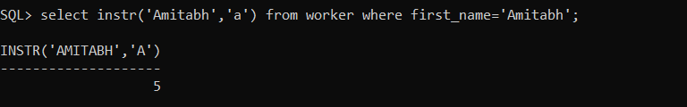

**Q-3. Write an SQL query to print the FIRST_NAME from the Worker table after replacing ‘a’ with ‘A’.**

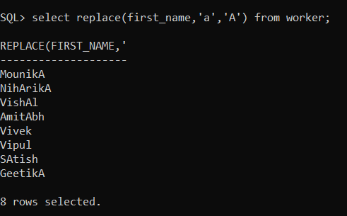

**Q-4. Write an SQL query to print all Worker details from the Worker table order by FIRST_NAME Ascending.**

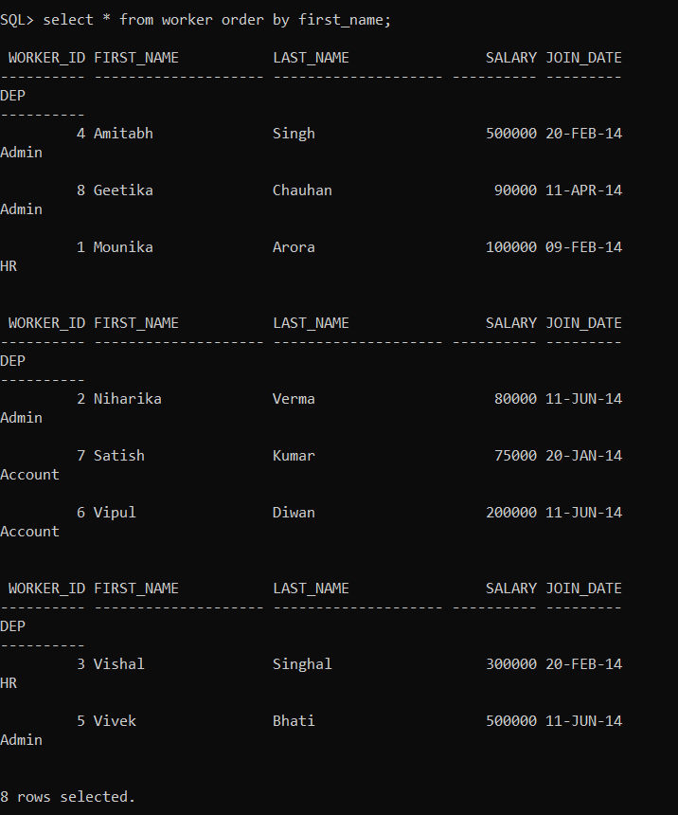

**Q-5. Write an SQL query to print all Worker details from the Worker table order by FIRST_NAME Ascending and DEPARTMENT Descending.**

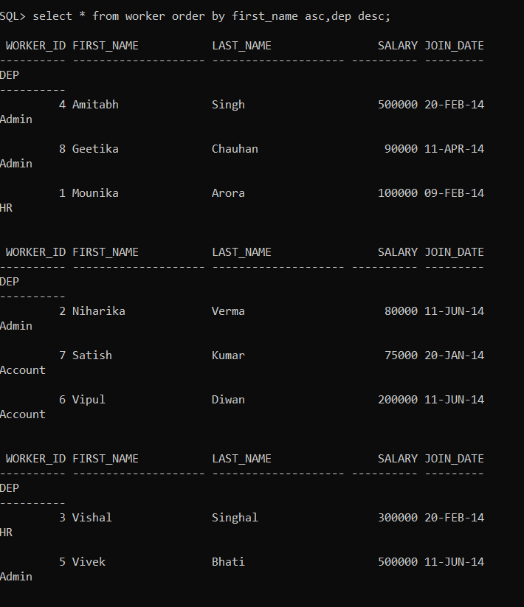

**Q-6. Write an SQL query to print details for Workers with the first name as “Vipul” and “Satish” from the Worker table.**

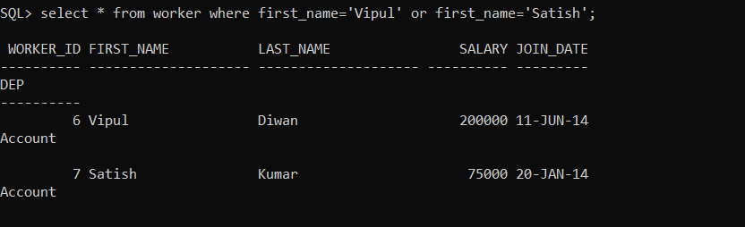

**Q-7. Write an SQL query to print details of Workers with DEPARTMENT name as “Admin”**

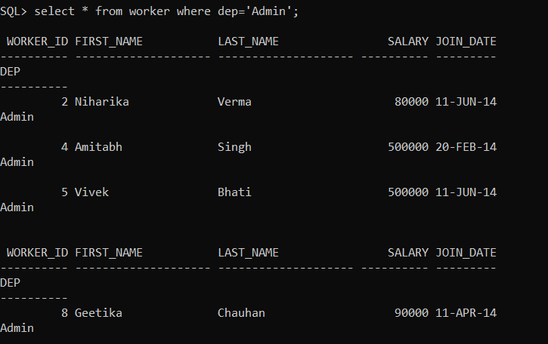

**Q-8. Write an SQL query to print details of the Workers whose FIRST_NAME contains ‘a’**

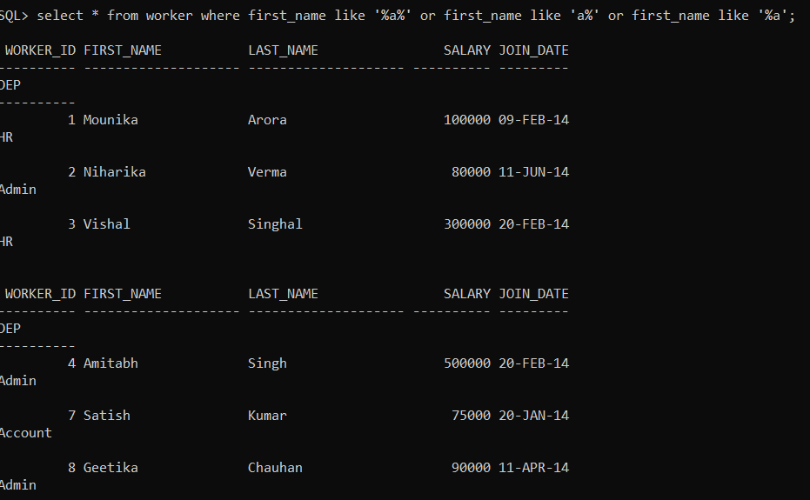

**Task 2: (Skill Mapping – Intermediate)**

###### ****Q-9. Write an SQL query to print details of the Workers whose SALARY lies between 100000 and 50.****

###### 

###### ****Q-10. Write an SQL query to print details of the Workers whose FIRST_NAME ends with ‘h’ and contains six alphabets**.**

###### 

**Q-11. Write an SQL query to print details of the Workers who have joined in Feb’2014.**

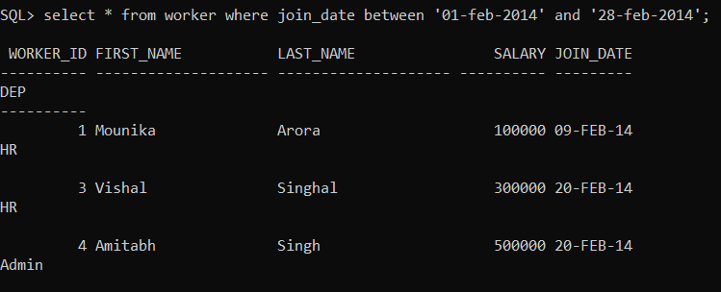

**Q-12. Write an SQL query to fetch worker names with salaries >= 50000 and <= 100000.**

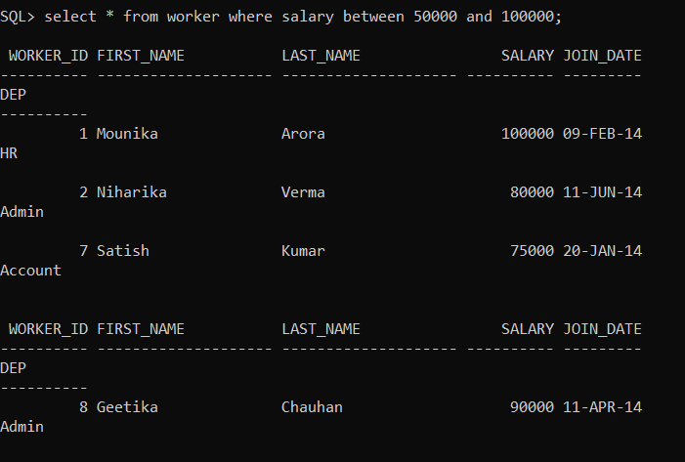

**Task 3**

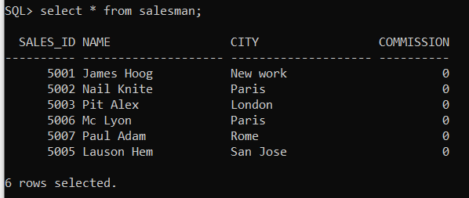

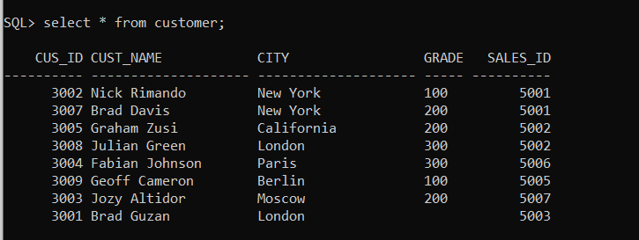

###### ****Q-13. Write a SQL query to find the salesperson and customer who reside in the same city. Return Salesman, cust_name, and city****

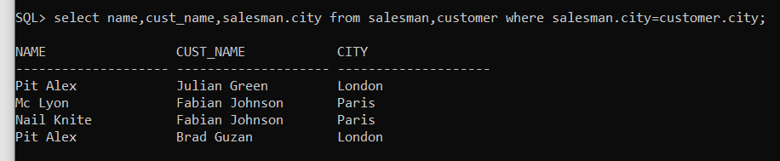

**Q-14. Write a SQL query to find the salesperson(s) and the customer(s) he represents. Return Customer Name, city, Salesman, and commission.**

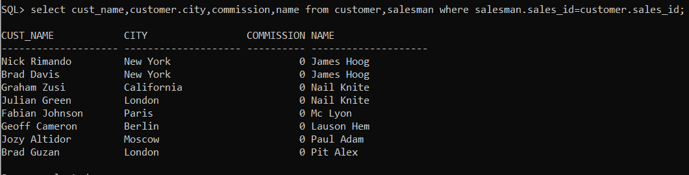

**Q-15. Write a SQL query to find salespeople who received commissions of more than 12 percent from the company. Return Customer Name, customer city, Salesman, and commission.**

