**Ed Me**-School Registration System

**Nandipati Jahnika**

**22BBS0192**

**ABOUT THE PROJECT:**

**EdMe** is a school admission management platform designed to simplify the school selection and application process for students and parents. This part of the project focuses on developing the **admin backend system** using **Node.js, Express.js, and MongoDB**, allowing administrators to efficiently manage school data.

The admin module empowers authorized personnel to perform **CRUD (Create, Read, Update, Delete)** operations on school records in the database. This backend service ensures the data is structured, up-to-date, and accessible for integration with a front-end interface or third-party applications.

**SCREENSHOTS OF A WORKING MODEL:**

**EdMe – Admin Backend (MongoDB + Node.js)**

**MongoDB Compass – Admin Data Inserted**

This screenshot shows the admins collection within the edme database in MongoDB Compass. It contains documents created via the **admin signup API**, with fields such as username, email, and a bcrypt-hashed password. This proves that the backend is successfully storing admin data securely. The presence of multiple documents also shows that multiple signups are functioning as expected.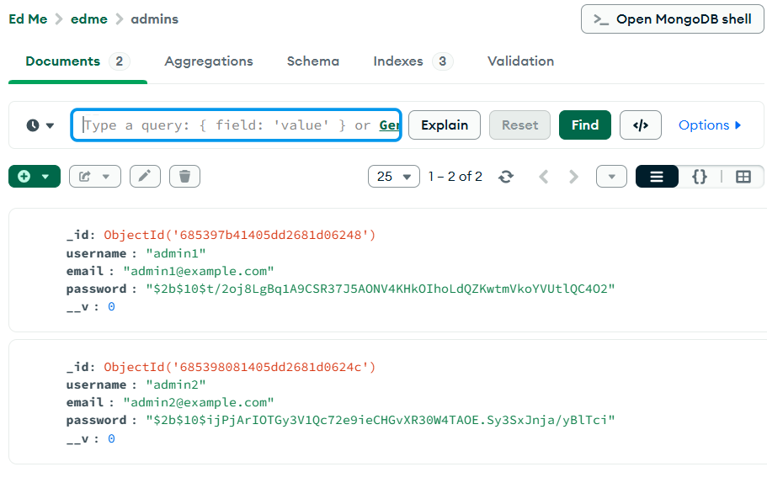

**Postman – Admin Signup API Success**

This is a successful **POST** request to the /api/admin/signup endpoint using Postman. The request body contains username, email, and password. The API returns a 201 Created status and confirms the new admin was added to the database. This confirms the signup functionality works correctly.

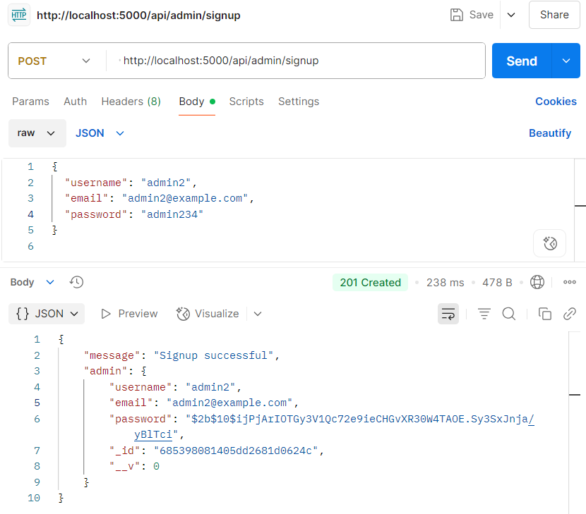

**Postman – Admin Login API Success**

This screenshot shows a **POST** request to the /api/admin/login endpoint. A valid email and password are sent, and the API returns a **JWT token**, confirming successful authentication. This proves the login route and password checking logic are working.

**Postman – Existing Admin Signup API Success**

This screenshot shows a **POST** request to the /api/admin/signup endpoint using Postman. The request attempts to create a new admin account with the username admin2 and email admin2@example.com. However, the API returns a **400 Bad Request** response with the message "Admin already exists".

This confirms that the backend includes **duplicate check validation**, preventing users from signing up with an already registered email. It’s an essential part of data integrity and authentication logic.

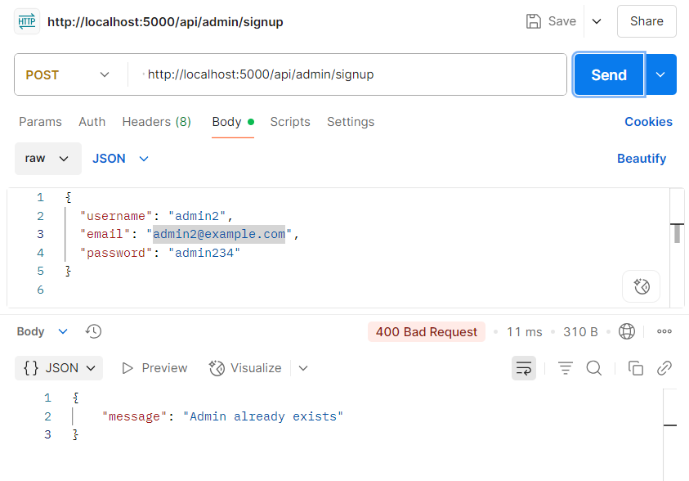

**Compass – School Collection with Sample Data**

This screenshot shows the contents of the schools collection inside the edme database, viewed in **MongoDB Compass**. It lists multiple school records that were added through the backend API.

This screenshot serves as proof that the **Create (POST)** functionality of the backend is working correctly and that school data is being stored successfully in the MongoDB database.

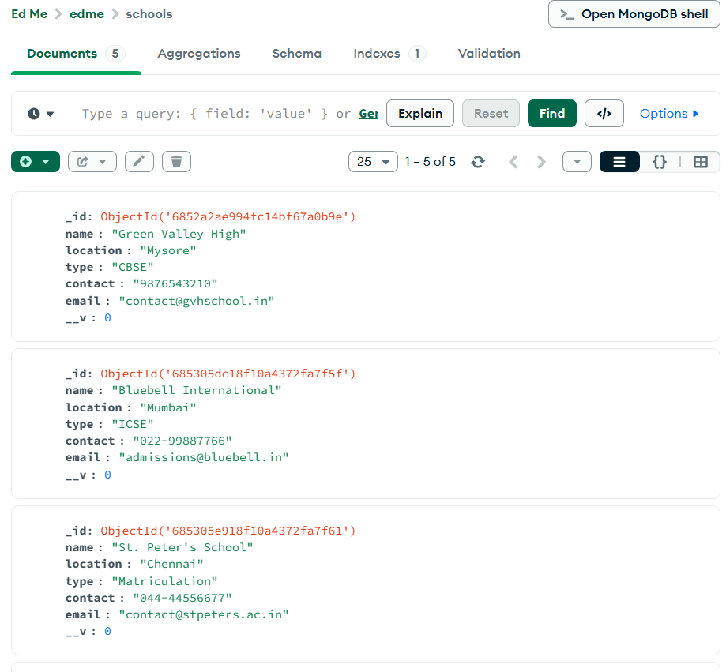

**Tech Stack Used**

| **Layer** | **Technology** |
| --- | --- |
| Language | JavaScript (Node.js) |
| Framework | Express.js |
| Database | MongoDB |
| ORM/ODM | Mongoose |
| Authentication | bcrypt, JWT |
| Testing Tool | Postman |