**Calculate Trip Cost**

CalculateTripCost_ Hackathon zipped file contains the following folder:

1. CalculateTripCost

CalculateTripCost contains the following folders:

1. Drivers folder contains the Chrome driver, Firefox driver, and Edge driver.
2. SRC folder contains the following packages::
   1. Main/java

Functionalities:

* + 1. DriverSetup
    2. HotelDetails
    3. Languages
    4. LaunchedYear
    5. PassengersAndCrew
    6. SearchDestination
    7. CruiseDetails
    8. SetDates

ReadExcel

* + 1. ReadCruiseDetails
    2. ReadUserDetails

WriteExcel

* + 1. WriteCruiseDetails
    2. WriteHotelDetails

3.Test/java

* + 1. ExtentReport
    2. CalculateTripCost
  1. Excel_Input (Excel Input)
  2. Excel_Output (Excel output)
  3. Error_Screenshots
  4. Pom.xml
  5. testng.xml
  6. CruiseTestNG.xml
  7. HotelTestNG.xml
  8. HTML_Report (Extended Report)
  9. Test-output
  10. Target
  11. Documentation folder

# MAVEN Implementation:

Console Output after Maven Implementation(BUILD SUCCESS)

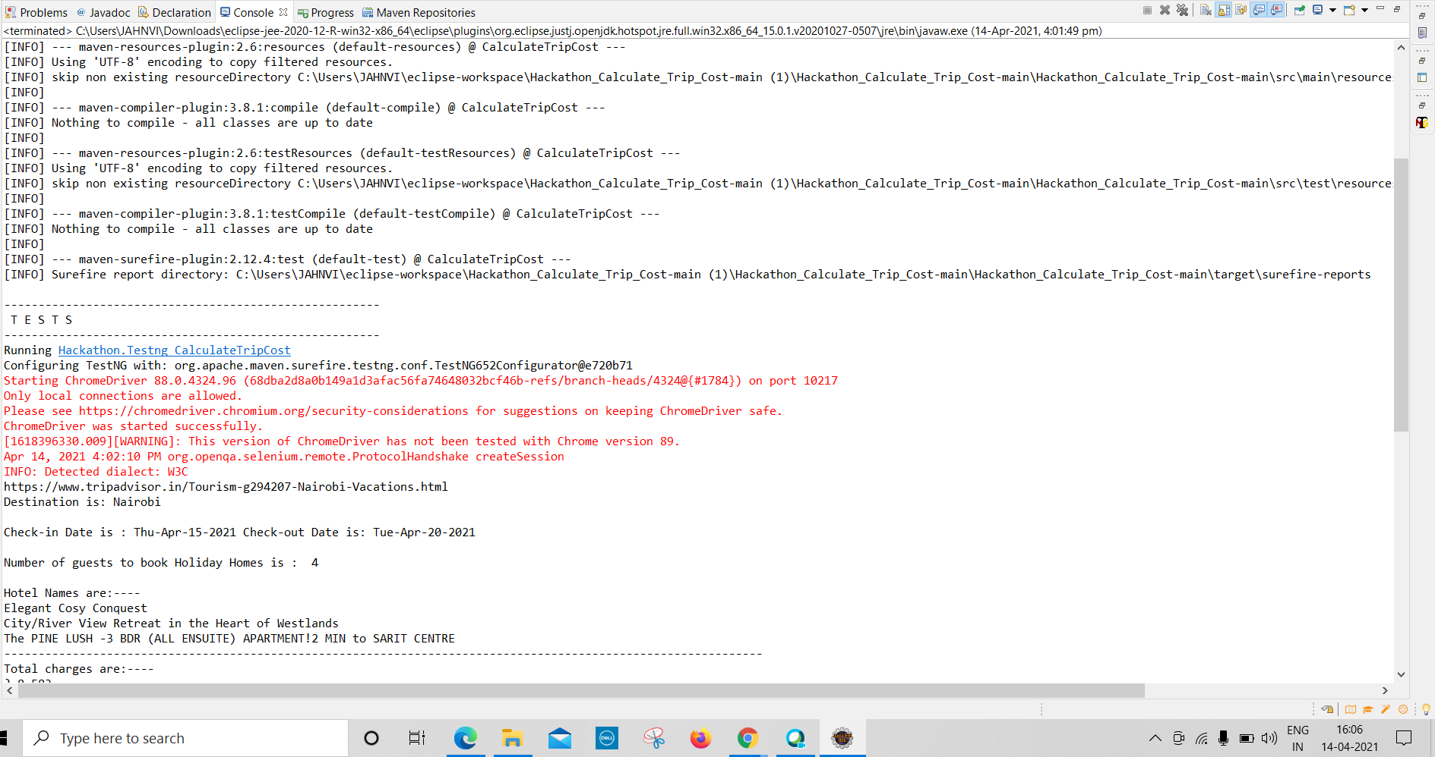

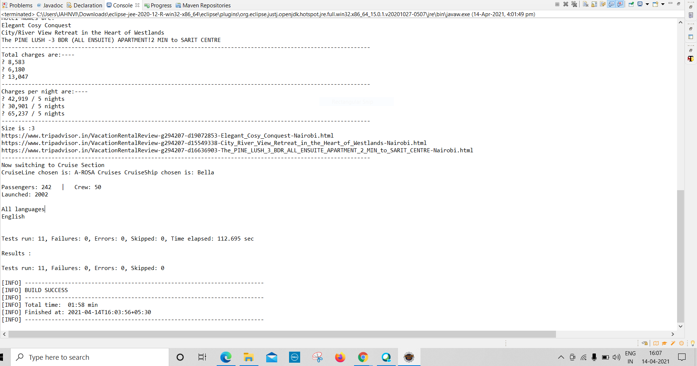

# Test Report:

# 

# 

# 

**JENKINS Implementation:**

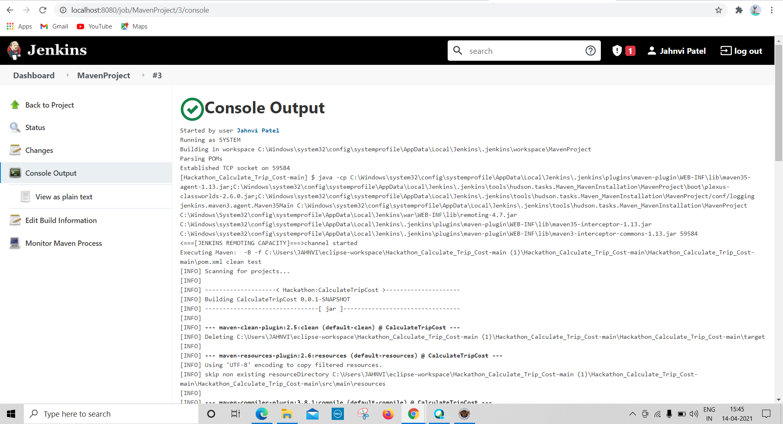

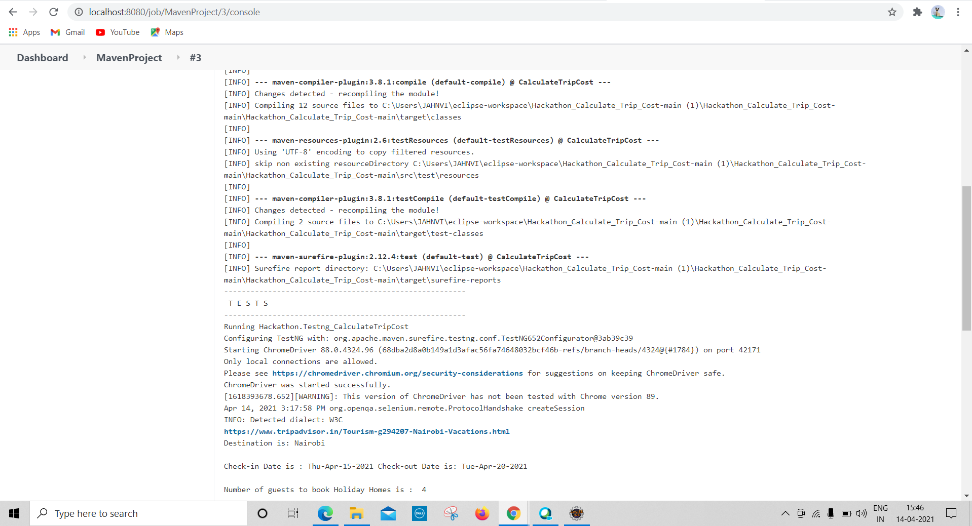

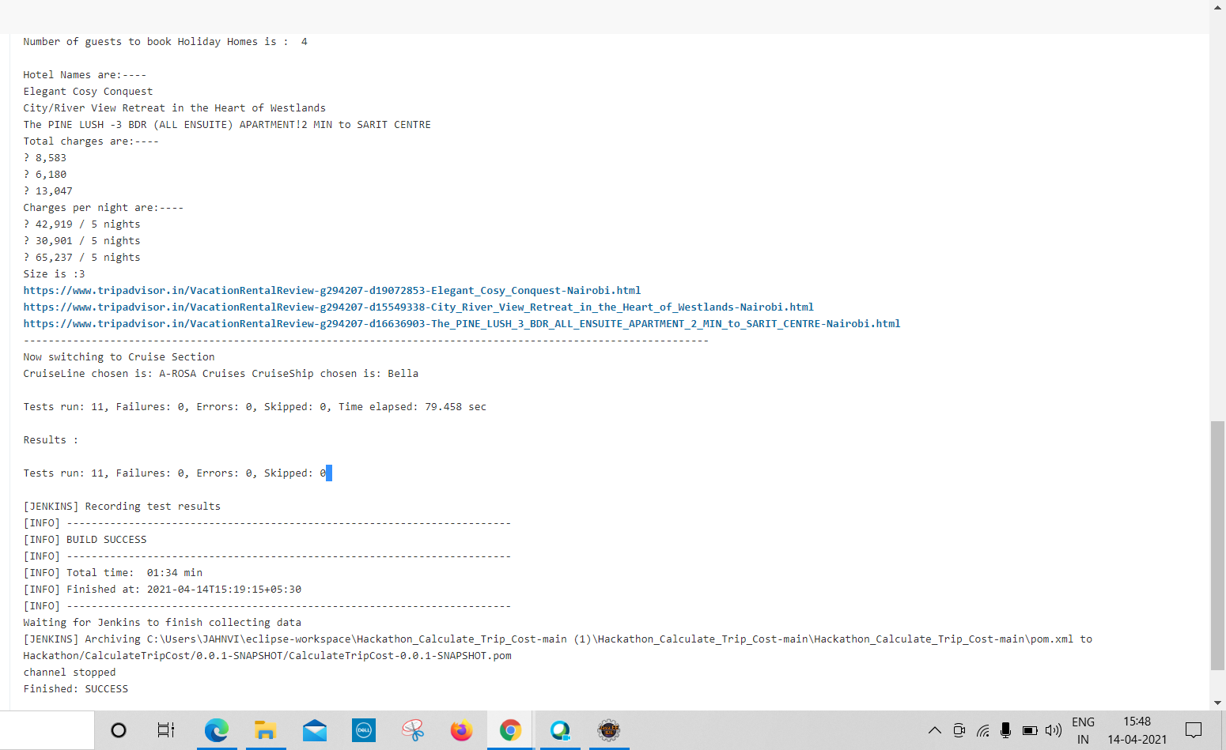

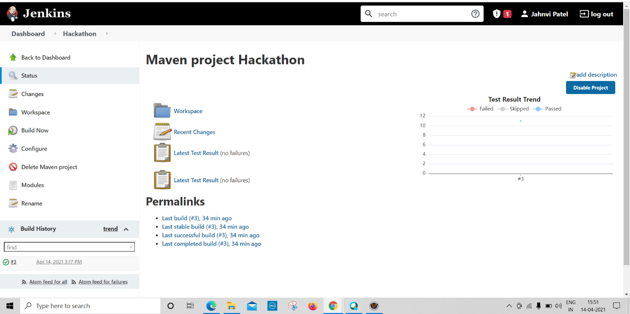

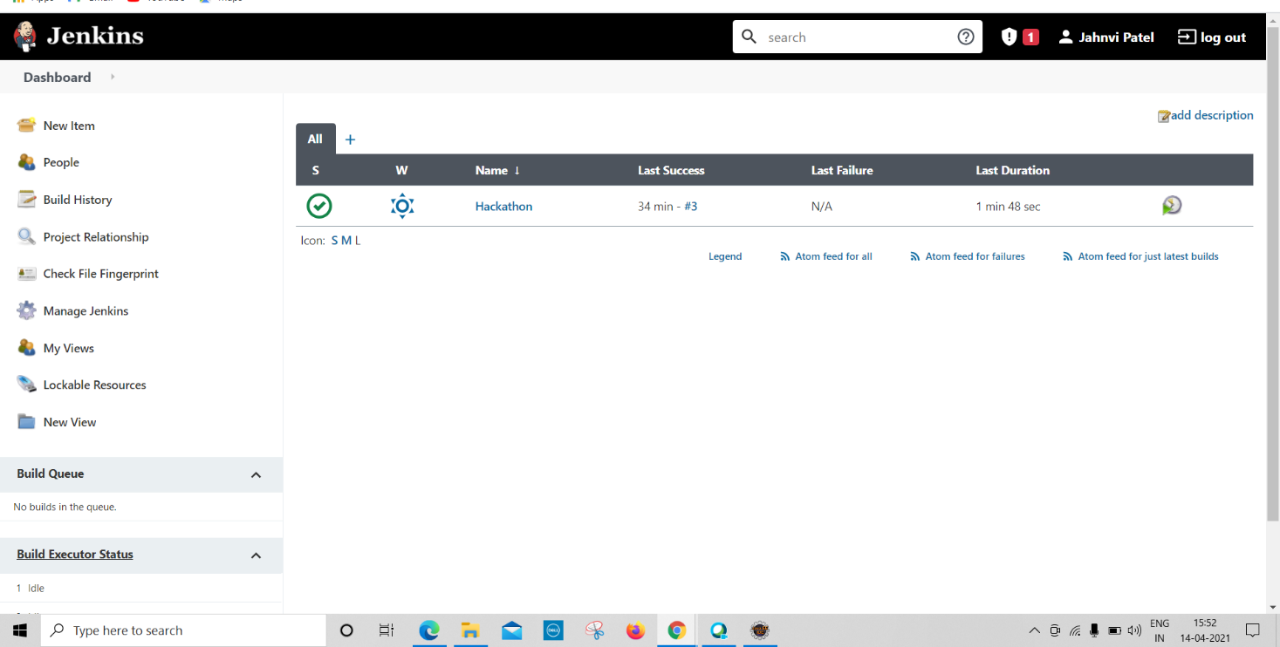

**Submitted By:**

Vankadari Samhitha (899612)

Jahnvi Patel (899504)

Barbie Garg (899717)

Mounika Chandra Ragula (899627)

Jaya Prakash Pediredla (899175)