A Synopsis On

NAGRIKSETU
(A Public complaint portal for efficient citizen government interaction)

Submitted to
IILM UNIVERSITY

In Partial Fulfilment for the award of the degree of
B.TECH
In
COMPUTER SCIENCE AND ENGINEERING

By
JAHNVI ARYA
CS-2341384
Class: 3CSE8

Under the guidance of Ms. Parul Saini Assistant Professor

IILM UNIVERSITY, 16-18, Knowledge Park II,
Greater Noida, Uttar Pradesh 201306 March 2026
PROJECT DETAILS

Title of the Research Proposal | NagrikSetu: A public complaint portal for efficient government-citizen interaction
Name of the Student(s) | Jahnvi Arya | Roll No: CS-2341384 | Class: 3CSE8
Name & Designation of the Guide | Ms. Parul Saini, Assistant Professor, IILM University
Place of Work | IILM University, Greater Noida, Uttar Pradesh
Area / Domain | Web application development and E-governance systems
Co-Domain | Complaint Management, E-governance systems, Web Development
Application Area | Government Complaint Portal, Civic-Issue Reporting System, Public-Serving Platform.
Usefulness | NagrikSetu is a web-based complaint management portal designed to bridge the gap between citizens and government authorities. It enables users to easily register complaints, track their status, and receive timely updates.The system aims to improve transparency, accountability, and efficiency in handling public grievances.
Tech Stack | HTML, CSS, Node.js, express.js, MongoDB, leaflet.js

Table of Contents

PROJECT DETAILS 1
Statement of the proposal 2
Problem Statement 2
Background 2
Motivation/need for the research 2
Objective 2
Sub-Objectives 3
Mode of achieving objective 3
Proposed Methodology 4
Theoretical framework 5
Sources of data – Primary or secondary data: 6
Schematic flow Diagram 7-8
Review of literature 9
Research Gaps 10
Key Bibliography 11

Statement of the Proposal

NagrikSetu is a web-based platform designed to bridge the communication gap between citizens and government authorities. It allows users to report local issues and track their complaint status in real time. The system provides a map-based interface for better visualization and efficient issue management. It ensures secure access with role-based authentication for admins and users.

Problem Statement

In many regions, citizens face difficulties in reporting local civic issues such as poor road conditions, water supply problems, and sanitation concerns. Existing systems are often slow, unresponsive, or lack transparency, making it hard for users to trust the process. As a result, many complaints go unreported or unresolved for long periods.
Another major challenge is the lack of a centralized platform where citizens can easily submit complaints and track their progress. Without real-time updates or proper communication channels, users remain unaware of the status of their issues. This leads to frustration and reduced public engagement in governance.
Additionally, authorities often struggle with managing and organizing a large number of complaints efficiently. Without proper tools for visualization and prioritization, resolving issues becomes time-consuming and less effective. This highlights the need for a structured, secure, and user-friendly system like NagrikSetu.

Background

With the rapid growth of urbanization and population, cities and towns are facing increasing civic challenges such as infrastructure damage, waste management issues, and water supply problems. Citizens encounter these issues daily, but often lack an effective and reliable way to report them to the concerned authorities.
Traditional methods of complaint registration, such as visiting government offices or making phone calls, are time-consuming and inefficient. These processes often involve delays, lack proper documentation, and do not provide any mechanism for tracking the status of complaints, leading to dissatisfaction among citizens.
Although some digital platforms exist, many of them are either not user-friendly or do not provide real-time updates. In several cases, these systems lack transparency, which reduces public trust. Citizens are often left uncertain about whether their complaints are being addressed or ignored.
On the other hand, government authorities face challenges in handling a large volume of complaints without proper digital tools. The absence of a centralized and organized system makes it difficult to prioritize issues, allocate resources, and ensure timely resolution.
Therefore, there is a need for a modern, secure, and efficient platform like NagrikSetu that can streamline complaint management, increase transparency, and strengthen the connection between citizens and governance systems.

Motivation / Need for the Research
The following specific observations motivated the development of NagrikSetu as a B.Tech final year project:
- There is a growing need to improve communication between citizens and government authorities. Many existing systems fail to provide a smooth and reliable way for users to report issues. This creates a gap that affects effective governance.
- Citizens often feel discouraged from reporting problems due to complex processes and lack of response. This reduces public participation in maintaining civic infrastructure. A better system can encourage more active involvement.
- Transparency is another major concern in current complaint systems. Users are usually unaware of the status of their complaints. This lack of visibility leads to frustration and loss of trust.
- From the authorities’ perspective, managing numerous complaints without proper tools is challenging. There is a need for a structured system that helps in organizing and prioritizing issues efficiently. This can improve overall service delivery.
- Modern technologies like web applications and map-based visualization can enhance user experience. These tools make it easier to report, track, and manage issues in a more interactive way. Research is needed to integrate these technologies effectively.
- Therefore, developing a platform like NagrikSetu is important to address these challenges. It aims to create a transparent, user-friendly, and efficient system that benefits both citizens and authorities.

Objective
The objective of NagrikSetu is to develop a user-friendly web platform that enables citizens to easily report civic issues and track their resolution status. It aims to improve transparency and communication between users and authorities through real-time updates. The system also focuses on efficient complaint management using a centralized and organized approach. Additionally, it ensures secure access with role-based authentication for better control and reliability.

Sub-Objectives

- To design a simple and intuitive interface that allows users to easily submit complaints without technical difficulty. It ensures accessibility for all types of users.
- To implement a location-based system using maps for accurate issue reporting and visualization. This helps authorities identify problem areas quickly.
- To develop a secure authentication system with role-based access (Admin and User). It ensures data privacy and controlled system usage.
- To create a centralized database for storing and managing all complaints efficiently. This improves organization and retrieval of information.
- To enable real-time tracking of complaint status for users. It increases transparency and keeps users informed.
- To provide an admin dashboard for managing, updating, and resolving complaints effectively. This enhances decision-making and workflow.
Mode of Achieving Objective

NagrikSetu is built using a phased, milestone-driven development approach structured across 30 working days at
1.5 hours per day, organised into 7 sequential build phases:
- Phase 1: Requirement Analysis & Planning (Day 1–2)
Understand the complete project idea, target users, and features like complaint submission, tracking, and admin control. Finalize project structure, workflow, and basic system architecture.
- Phase 2: UI/UX Design (Day 3–6)
Design layouts for landing page, complaint page, and admin dashboard. Create wireframes and start building basic UI using HTML and CSS.
- Phase 3: Frontend Development (Day 7–14)
Develop all pages fully with proper styling and responsiveness. Add JavaScript functionality and integrate Leaflet.js for map-based complaint location.
- Phase 4: Backend Development (Day 15–20)
Set up Node.js and Express.js server. Create APIs for handling complaints and user actions.
- Phase 5: Database Integration (Day 21–23)
Connect MongoDB and design schemas for users and complaints. Ensure proper data storage and retrieval.
- Phase 6: Authentication & Security (Day 24–26)
Implement JWT-based login system with role-based access (Admin/User). Secure routes and protect data.
- Phase 7: Testing & Finalization (Day 27–30)
Test complete project, fix bugs, improve UI, and ensure everything works smoothly. Prepare project for presentation/demo.
Development follows an alternating backend/frontend daily schedule (Mon: Backend, Tue: Frontend, Wed: Backend, Thu: Frontend, Fri: Backend, Sat: Frontend, Sun: Review) to prevent context overload and ensure consistent weekly progress.

Proposed Methodology

Theoretical Framework

NagrikSetu is grounded in five foundational theoretical and engineering pillars:
- NagrikSetu is based on the concept of e-governance, which focuses on using digital platforms to improve interaction between citizens and government authorities. It aims to enhance transparency, accountability, and efficiency in public service delivery through technology.
- The system follows a client-server architecture, where the frontend (HTML, CSS, JavaScript) acts as the client interface and the backend (Node.js, Express.js) handles business logic and communication with the database. This separation ensures scalability and maintainability of the application.
- A key component is the use of RESTful APIs, which enable smooth data exchange between the frontend and backend. These APIs handle operations like complaint submission, retrieval, and status updates in a structured manner.
- The project also incorporates database management principles using MongoDB to store user and complaint data. Proper schema design ensures efficient data storage, retrieval, and consistency.
- For security, the system uses JWT-based authentication and role-based access control (RBAC). This ensures that only authorized users can access specific functionalities, maintaining data privacy and system integrity.

Sources of Data – Primary or Secondary
Primary Data Sources:
  - Live MongoDB database — Complaint records, user data, and status updates created and managed by the application during development and testing.
  - User submissions — Complaint details including issue type, description, images (if any), and location data entered through the platform.
  - Map interaction data — Location coordinates selected via Leaflet.js used to accurately mark and validate reported issues.
  - User activity logs — Complaint status tracking, updates, and interaction timestamps recorded to monitor system usage and performance.
Secondary Data Sources:
  - Node.js and Express.js documentation — Backend development, routing, and API creation reference.
  - MongoDB documentation (mongodb.com/docs) — Schema design, data modeling, and query operations.
  - Leaflet.js documentation (leafletjs.com) — Map integration, markers, and location-based features reference.
  - JWT documentation and RFC 7519 — Authentication mechanism, token structure, and security implementation.
  - Academic and industry literature on e-governance and complaint management systems — Concepts related to citizen engagement, transparency, and public service efficiency.

Schematic Flow Diagram
The following diagrams present the system workflow, architecture, and project development timeline for the NagrikSetu - A public complaint portal.

Figure 1: Workflow Diagram – Full System Component and Data Flow

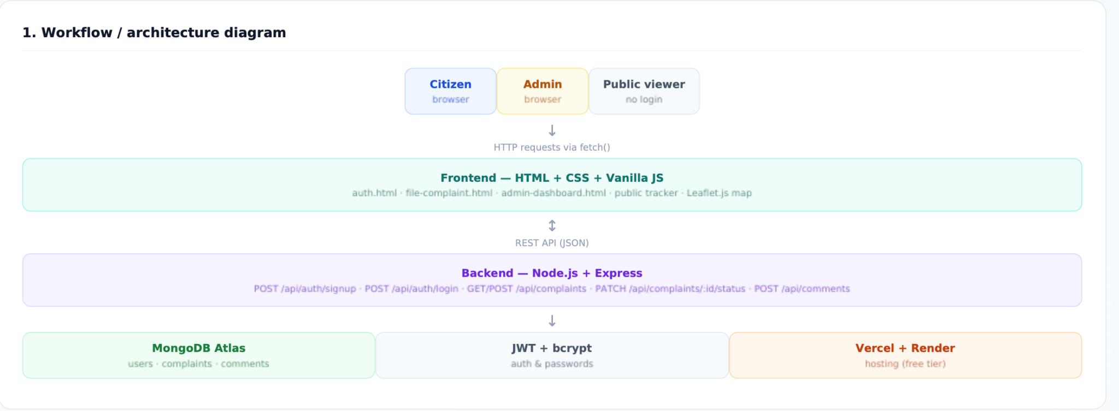
Figure 1: Workflow Diagram – Step-by-step execution flow of NagrikSetu

Figure 2: Schematic Flow Diagram – System Architecture

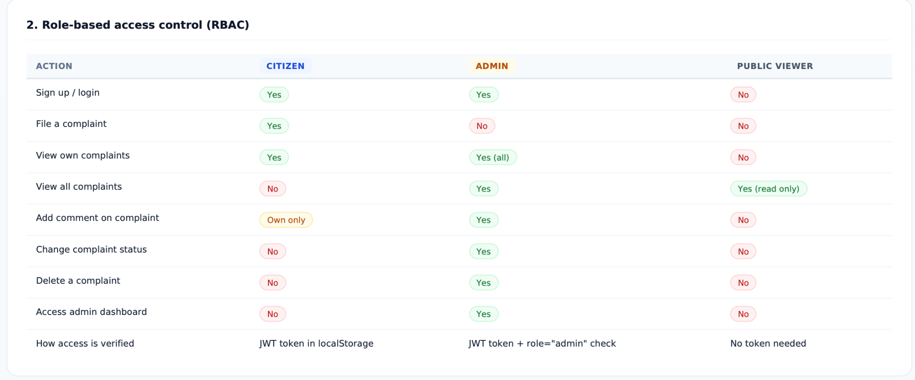
Figure 2: Role-Based Access Control(RBAC) for NagrikSetu

Figure 3: Project Gantt Chart – 12-Week B.Tech Final Year Development Timeline
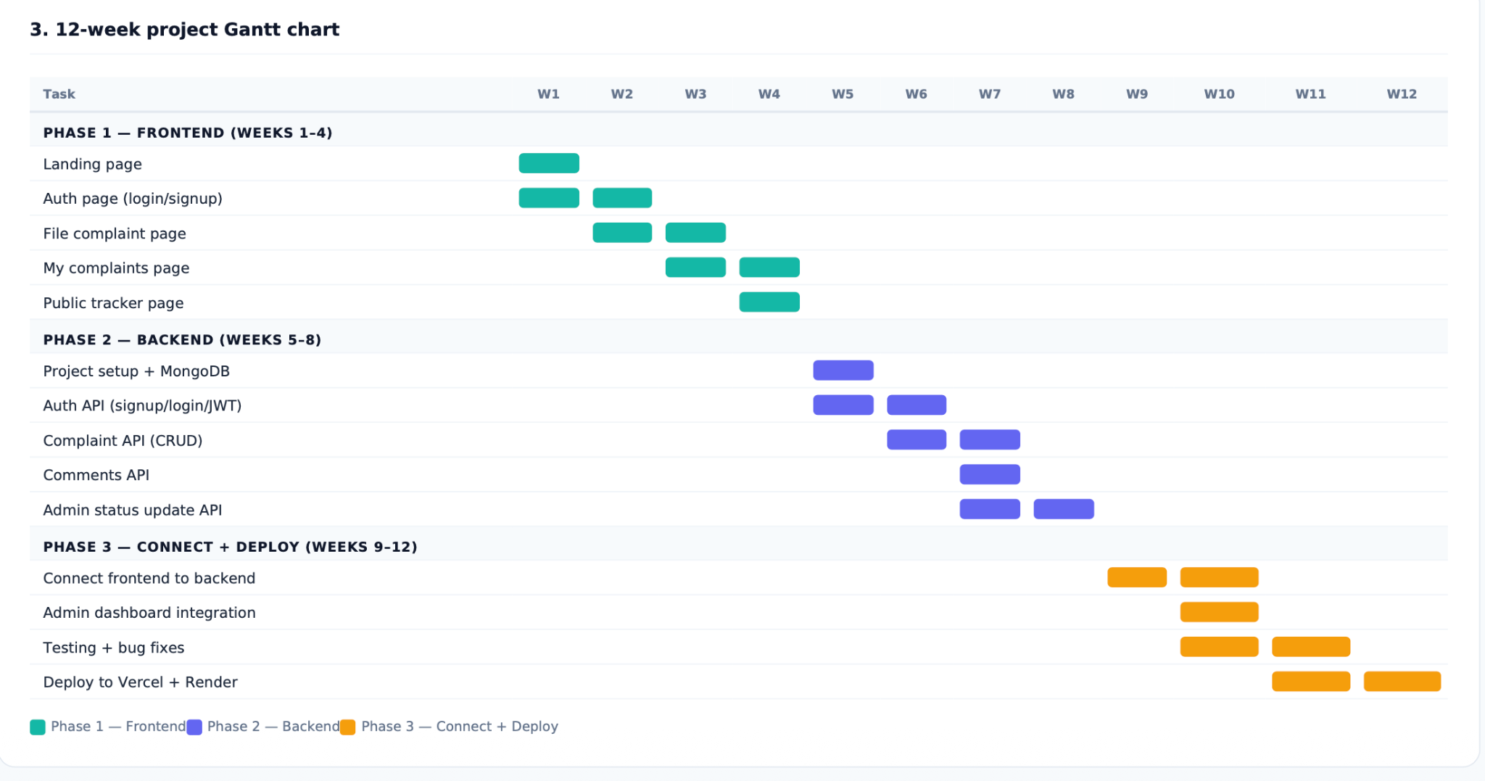
Figure 3: LeadPilot CRM 12-Week Gantt Chart covering Phase 1: Frontend, Phase 2: Backend, Phase 3: Connect & Deploy

Review of Literature

Essential Literatures Reviewed

Essential Literatures Reviewed | Themes Drawn from the Literatures
Ryan Dahl (2009). Node.js: Event-Driven Architecture. OpenJS Foundation | The event-driven, non-blocking I/O model enables real-time handling of multiple user requests simultaneously. This directly supports NagrikSetu’s live complaint updates and dashboard responsiveness.
Abadi et al. (2013). “Scalable Real-Time Communication with WebSockets.” IEEE Systems Journal. | WebSockets enable persistent two-way communication between client and server, allowing instant data transfer without repeated requests. This supports real-time complaint status updates and instant admin responses in NagrikSetu.
MongoDB Inc. (2023). Change Streams Documentation. MongoDB Manual. | Change Streams allow real-time tracking of database changes and event-driven updates. This can automatically reflect complaint status changes in dashboards without manual refresh in NagrikSetu.
MDN Web Docs (2024). WebSockets API. Mozilla. | The WebSockets API enables full-duplex communication between browser and server. It reduces latency and improves responsiveness, making it ideal for real-time tracking features in civic applications.
Fielding, R. T. (2000). Architectural Styles and the Design of Network-based Software. REST Dissertation. | REST architecture emphasizes stateless communication, but lacks built-in real-time capability. This highlights the need for hybrid REST + real-time systems like NagrikSetu.

Research Gaps

Essential Literatures Reviewed | Themes Drawn from the Literatures | Research Gaps (if any) | Remark
REST-based civic portals, traditional government service systems | Most systems rely on request–response (REST) instead of live updates | Lack of real-time communication for complaint tracking and updates | Real-time systems are needed to improve transparency and responsiveness in NagrikSetu
WebSockets, Socket.IO-based chat and notification systems | Real-time tools are mostly used for chats, not structured workflows | Absence of end-to-end real-time complaint lifecycle systems | NagrikSetu can bridge communication and workflow tracking in one system
WT authentication, RBAC models (NIST standards) | Role-based access is conceptually studied but weakly implemented | Poor enforcement of strict Admin–Citizen–Officer separation | Strong RBAC is essential for secure civic portals like NagrikSetu
E-governance dashboards and service tracking portals | Users do not get continuous updates on request status | Missing real-time status visibility (in-progress, resolved, etc.) | Live tracking improves trust and engagement in civic systems
MongoDB Change Streams, event-driven architectures | Databases are mostly queried manually instead of reacting to changes | Lack of reactive dashboards in public service applications | Event-driven DB updates can automate dashboard refresh in NagrikSetu
Monolithic e-governance architectures | Systems are not designed for high concurrent users | Poor handling of real-time load and peak traffic | Scalable backend design is necessary for modern civic portals

Key Bibliography

- Node.js Documentation (Official)
OpenJS Foundation. Node.js Documentation. https://nodejs.org/en/docs
(Runtime environment, event-driven architecture)
- Express.js Guide
Express.js Team. Express Framework Documentation. https://expressjs.com
(REST API development, middleware handling)
- MongoDB Manual
MongoDB Inc. MongoDB Documentation. https://www.mongodb.com/docs
(NoSQL schema design, indexing, aggregation)
- WT Specification (RFC 7519)
IETF. JSON Web Token Standard. https://datatracker.ietf.org/doc/html/rfc7519
(Token-based authentication and security)
- Mongoose ODM Documentation
Mongoose Team. https://mongoosejs.com/docs
(Schema modeling for MongoDB in Node.js)
- CSS Documentation (MDN Web Docs)
Mozilla. CSS Reference. https://developer.mozilla.org/en-US/docs/Web/CSS
(Styling, layouts, Flexbox, Grid, responsive design)

