**CUSTOMER ANALYSIS**

**Graph-1**

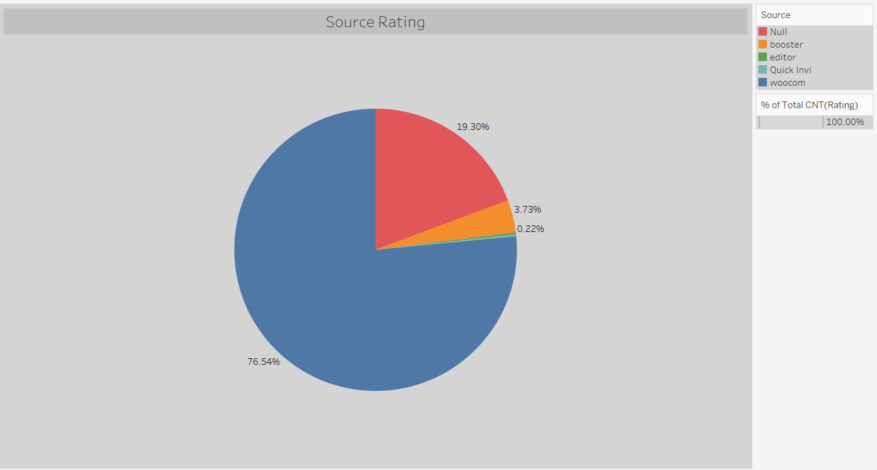

The highest rating was made from the woocommerce platform with 76.54%.

**Graph-2**

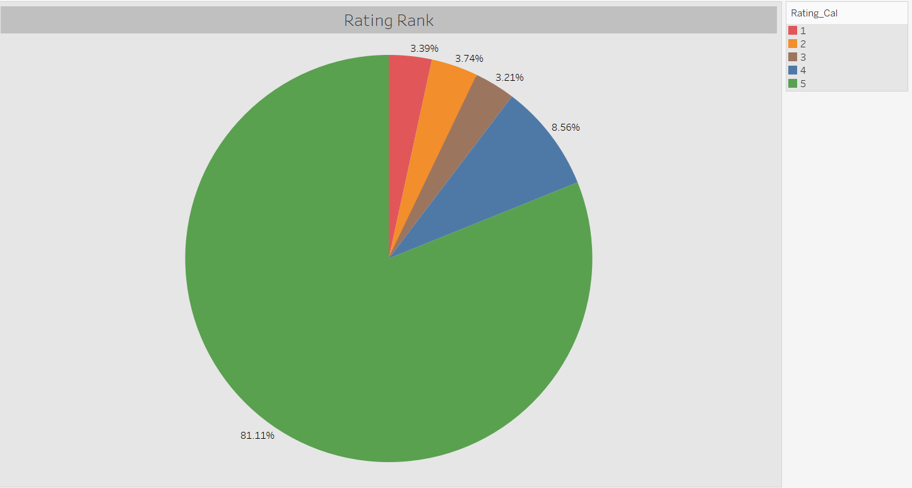

It is seen that the highest rating is made as “5” with a rate of 81.11%. At the rate of 3.39%, the lowest (1) rating was taken.

**Graph-3**

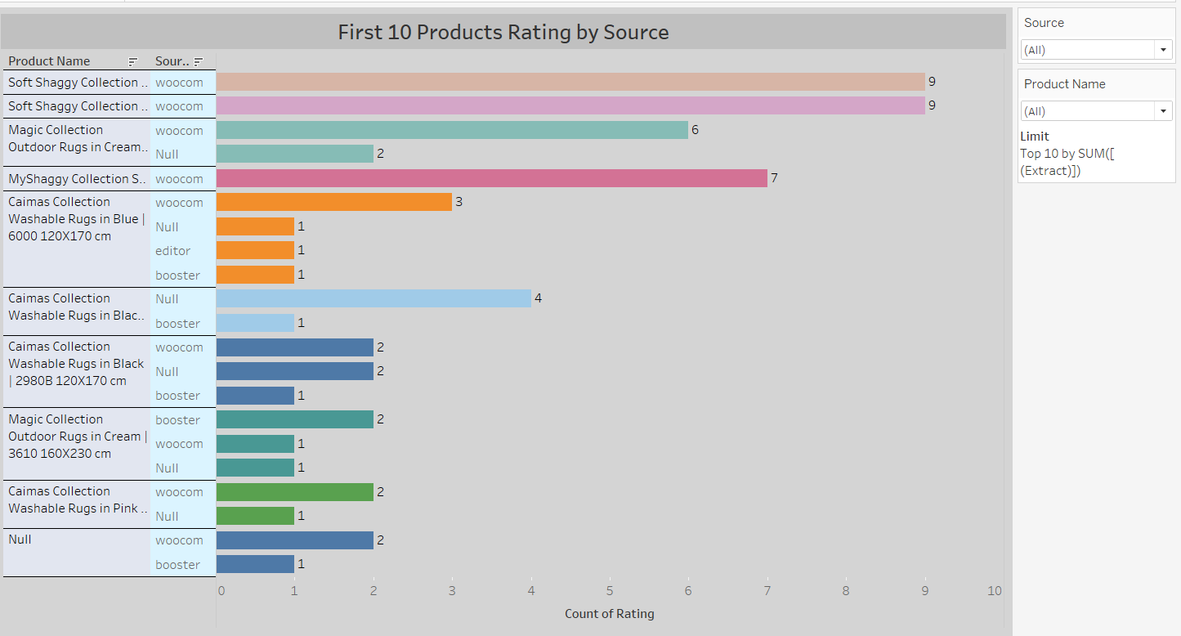

When the 10 product categories with the highest ratings are examined, it is seen that the “Soft Shaggy Collection” brand is the product with the highest rating (9) from the woocommers platform. When the whole analysis is examined, although the products with high ratings seem to be in the first place, in fact, it is seen that the products with a low rating are in the first place.

**Graph-4**

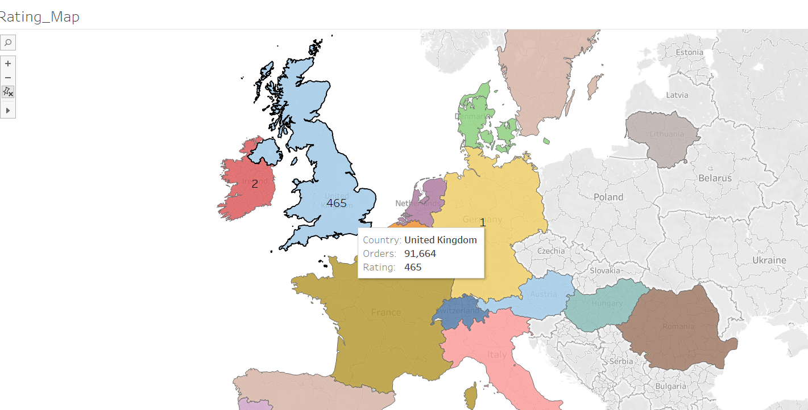

When the rating situation on the basis of countries is examined, the highest rating is seen in the UK. This is similar to the order numbers.

**Graph-5**

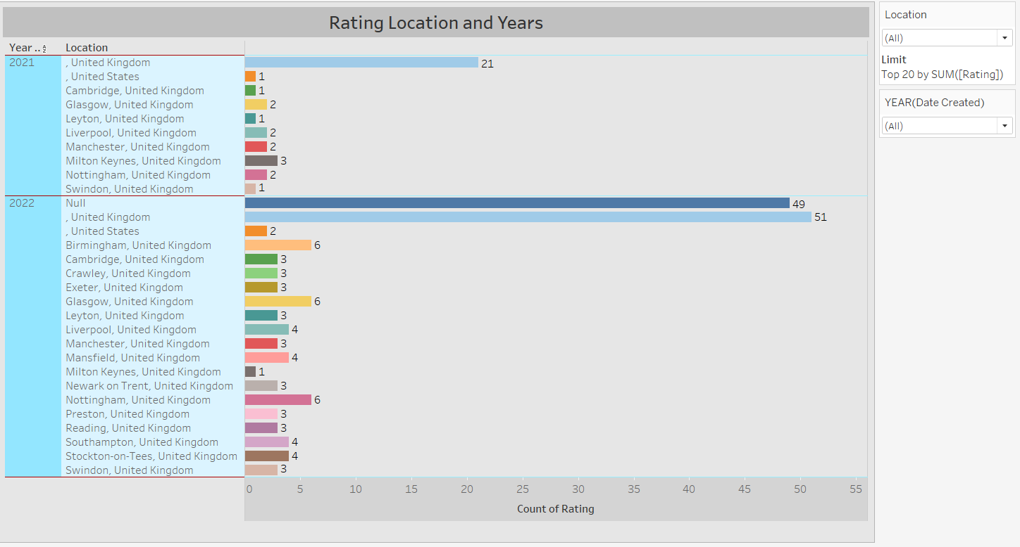

Considering the number of ratings according to years and location, it is seen that more ratings are received in 2022 than in other years. In addition, it is understood that the highest rating is received from United Kingdom (London).

**Graph-6**

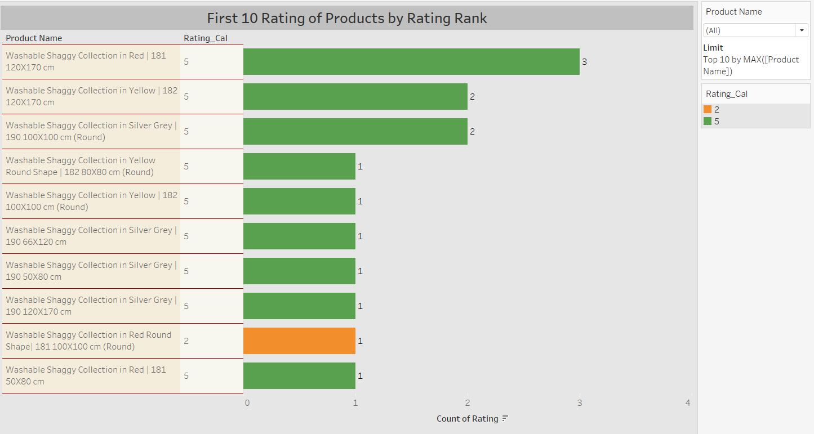

When the rating status of the first 10 products according to their rating is examined; “Washable Shaggy Collection in Red | It is seen that the 181 120X170 cm” product has 3 ratings at the 5 level and is in the first place.

Again, “Washable Shaggy Collection in Red Round Shape| 181 100X100 cm (Round)” product, on the other hand, is seen to be in the top 10 product category, despite receiving a rating of 1 at the level of 2.

Although there is a rating of 2 for the product, it is seen that the order of the product is not affected much.

**Graph-7**

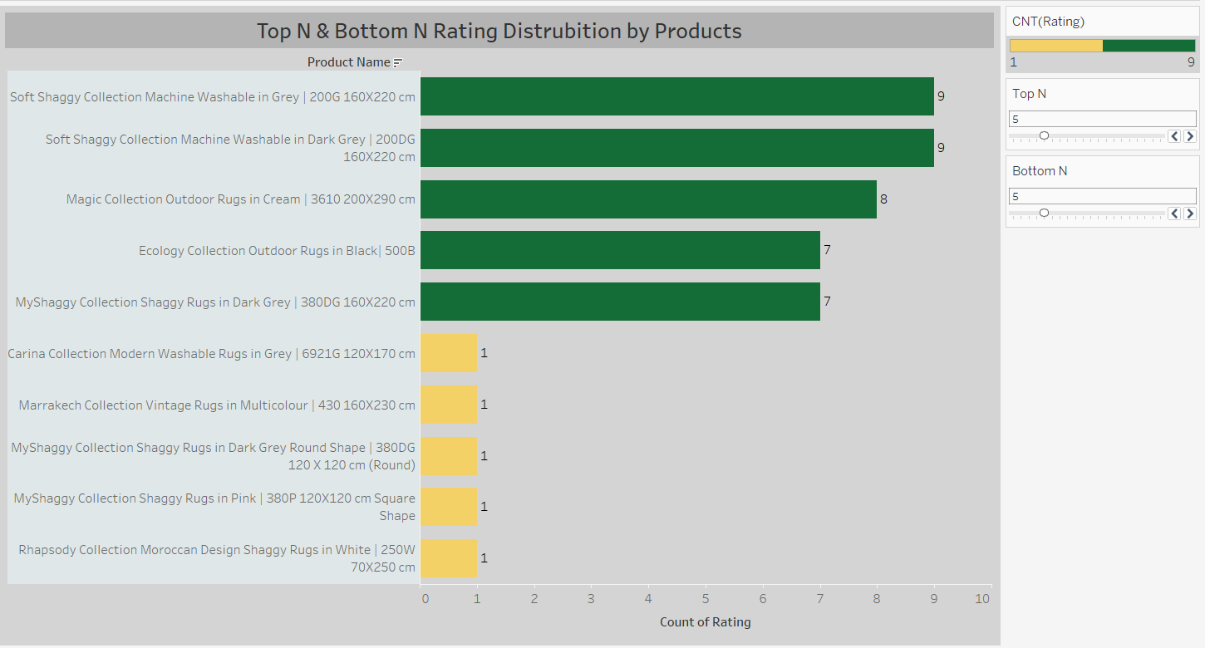

According to the rating status; when the first and last 5 products are examined, “Soft Shaggy Collection Machine Washable in Gray | 200G 160X220 cm” and “Soft Shaggy Collection Machine Washable in Dark Gray | It is seen that 200DG 160X220 cm” is the product with the highest rating, with 9 ratings.

“Rhapsody Collection Moroccan Design Shaggy Rugs in White | 250W 70X250 cm” and “MyShaggy Collection Shaggy Rugs in Pink | It is understood that 380P 120X120 cm Square Shape is the product with the least rating with 1 rating.

**Graph-8**

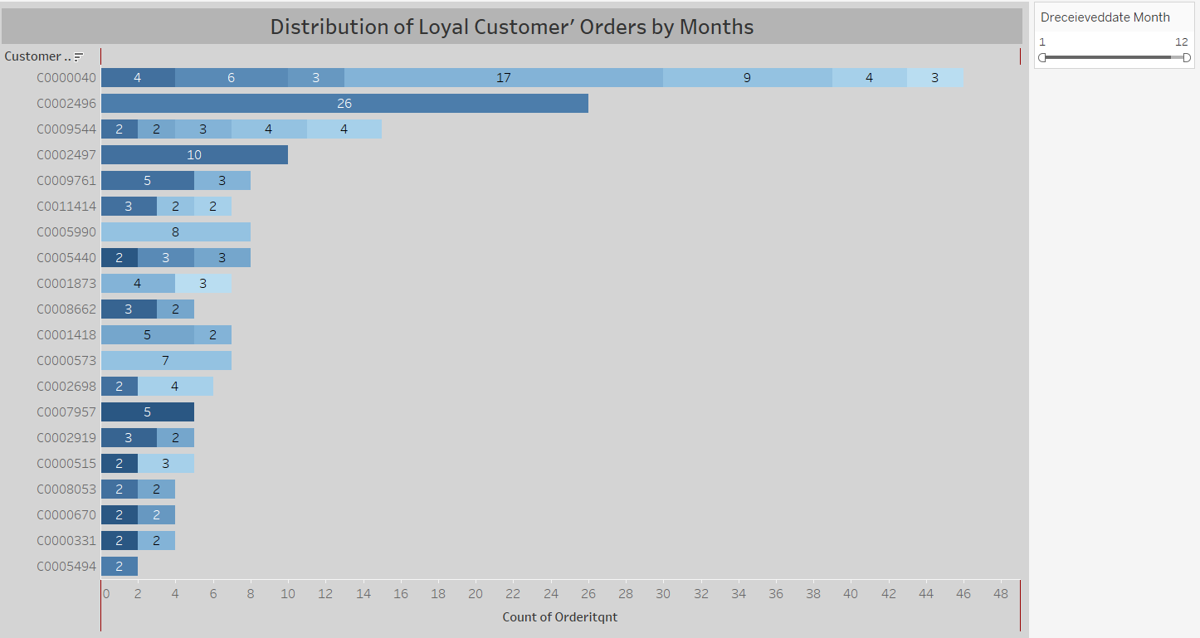

When the first 20 loyal customers are examined, it is seen that the first customer (C0000040) placed a total of 46 orders at 7 different times. It is understood that the second customer (C0002496) ordered 26 pieces at once. The reason why 1 person orders so much in a product category is not well understood.

*Amazon customers are not included in the loyal customer list.

**Graph-9**

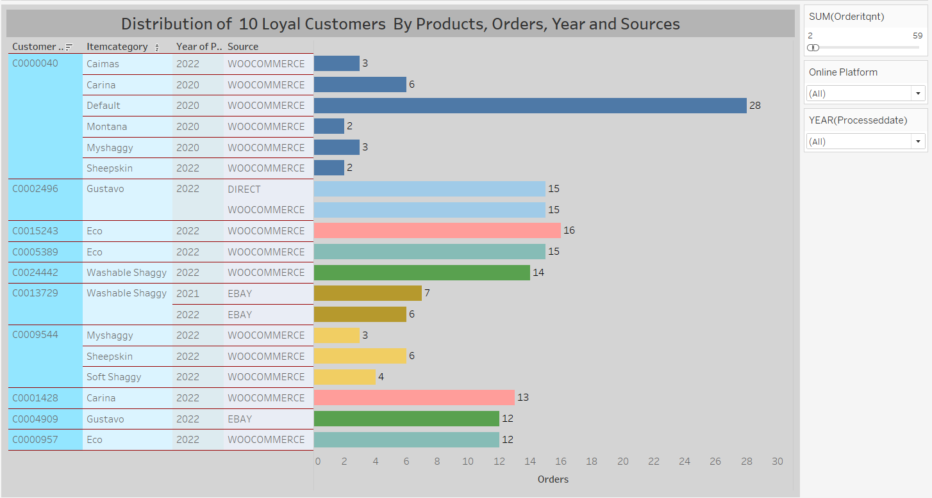

The first customer, in 2020 and 2022, using the woocommers platform; A total of 44 orders were placed in the “caimas, carina, myshaggy, montana, sheepskin and default” models. It is noteworthy here that he did not place an order in 2021. In addition, it is seen that the customer orders all these models from the same platform.

If the second customer (C0002496); It is seen that in 2022, 30 orders were placed in total from woocommerce and direct platforms.

It is understood that loyal customers place their orders from different platforms and different carpet models.

**Graph-10**

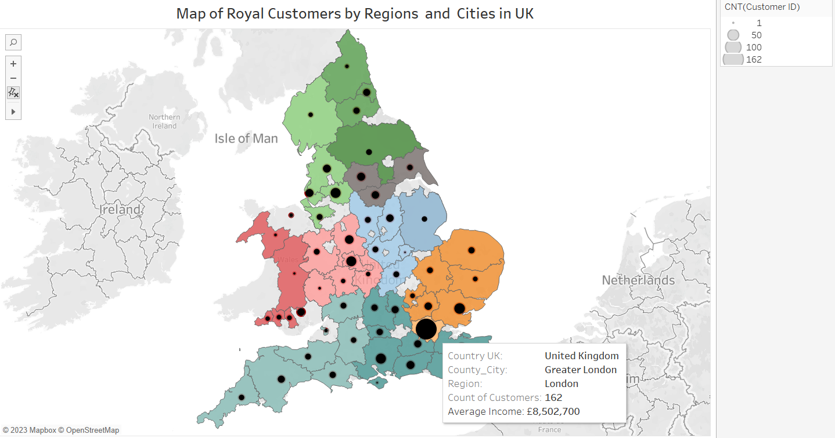

Looking at the number of loyal customers in the regions and cities on the map, it is seen that the most loyal customers are in London and then in the south east region.

In addition, when the relationship between the number of loyal customers and their average income is examined, it can be said that there is no difference.