Classification of Rugs based on Styles

In this model, we applied YOLOv5 to classify rugs based on the styles defined on the company’s website. Among them we selected 8 classes:
1-Bordered 5-Oriental
2-Doormats 6-Round
3-Faux Fur 7-Shaggy
4-Geometric 8-Striped

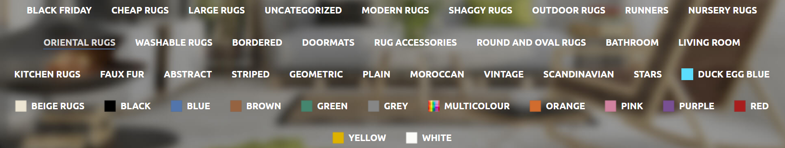
After downloading rugs from each category, they were labeled through Makesense.ai. In this model, we used 147 photos in total by separating them into the train (115) and validation (32) sets. Also, we saved a few photos and two YouTube videos to test our model.

We trained our model with 200 epochs and 8 batch sizes.
Although the overall train score is satisfactory, to receive a higher score, the model can be reset by using more samples, especially for Faux Fur and Shaggy classes.
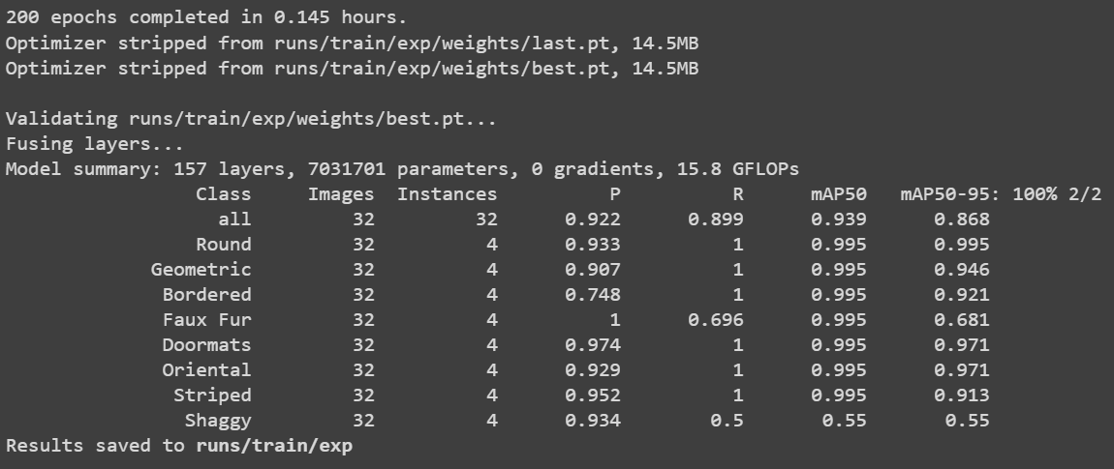

Test results are shown below:

1. Faux Fur:
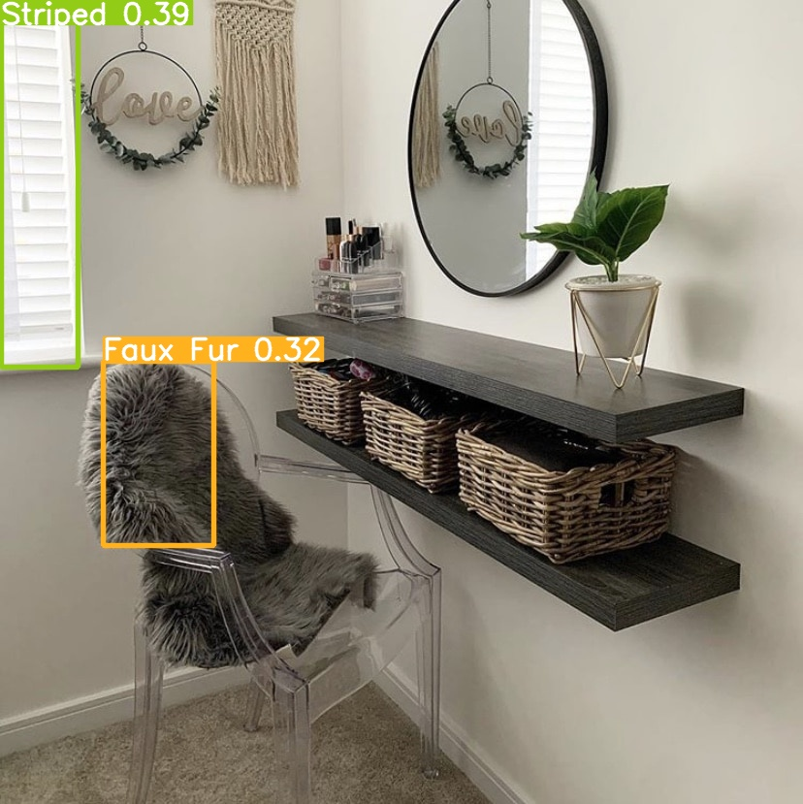

2. Geometric:
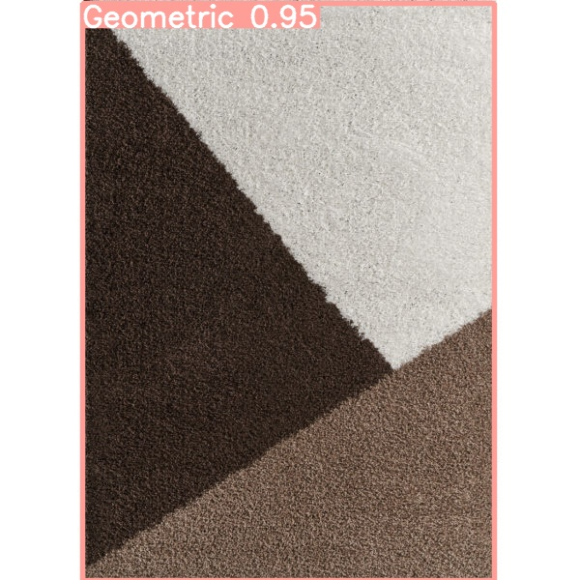

3. Doormats:

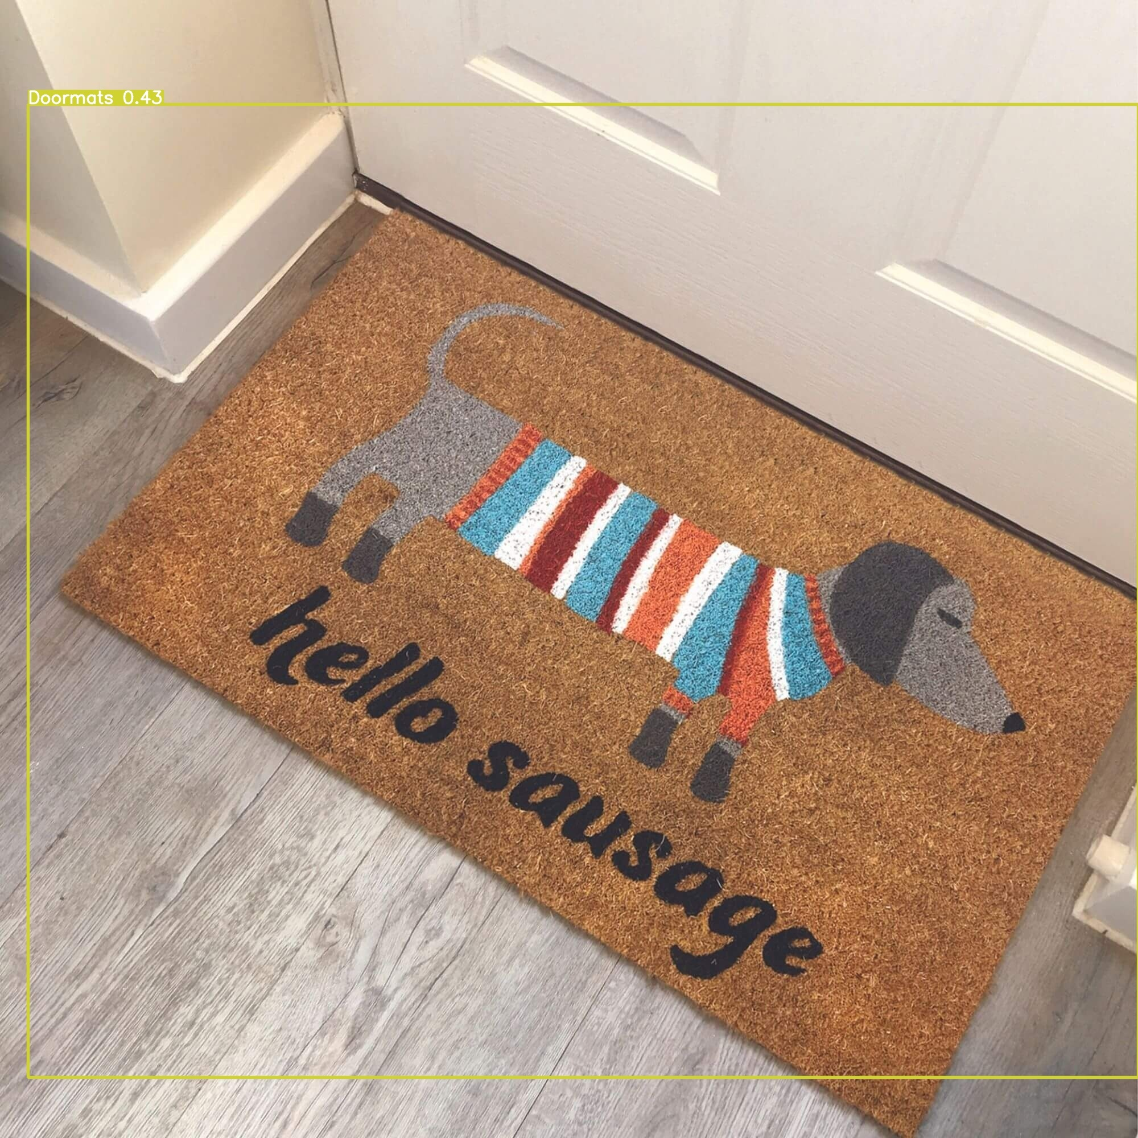

4. Oriental:
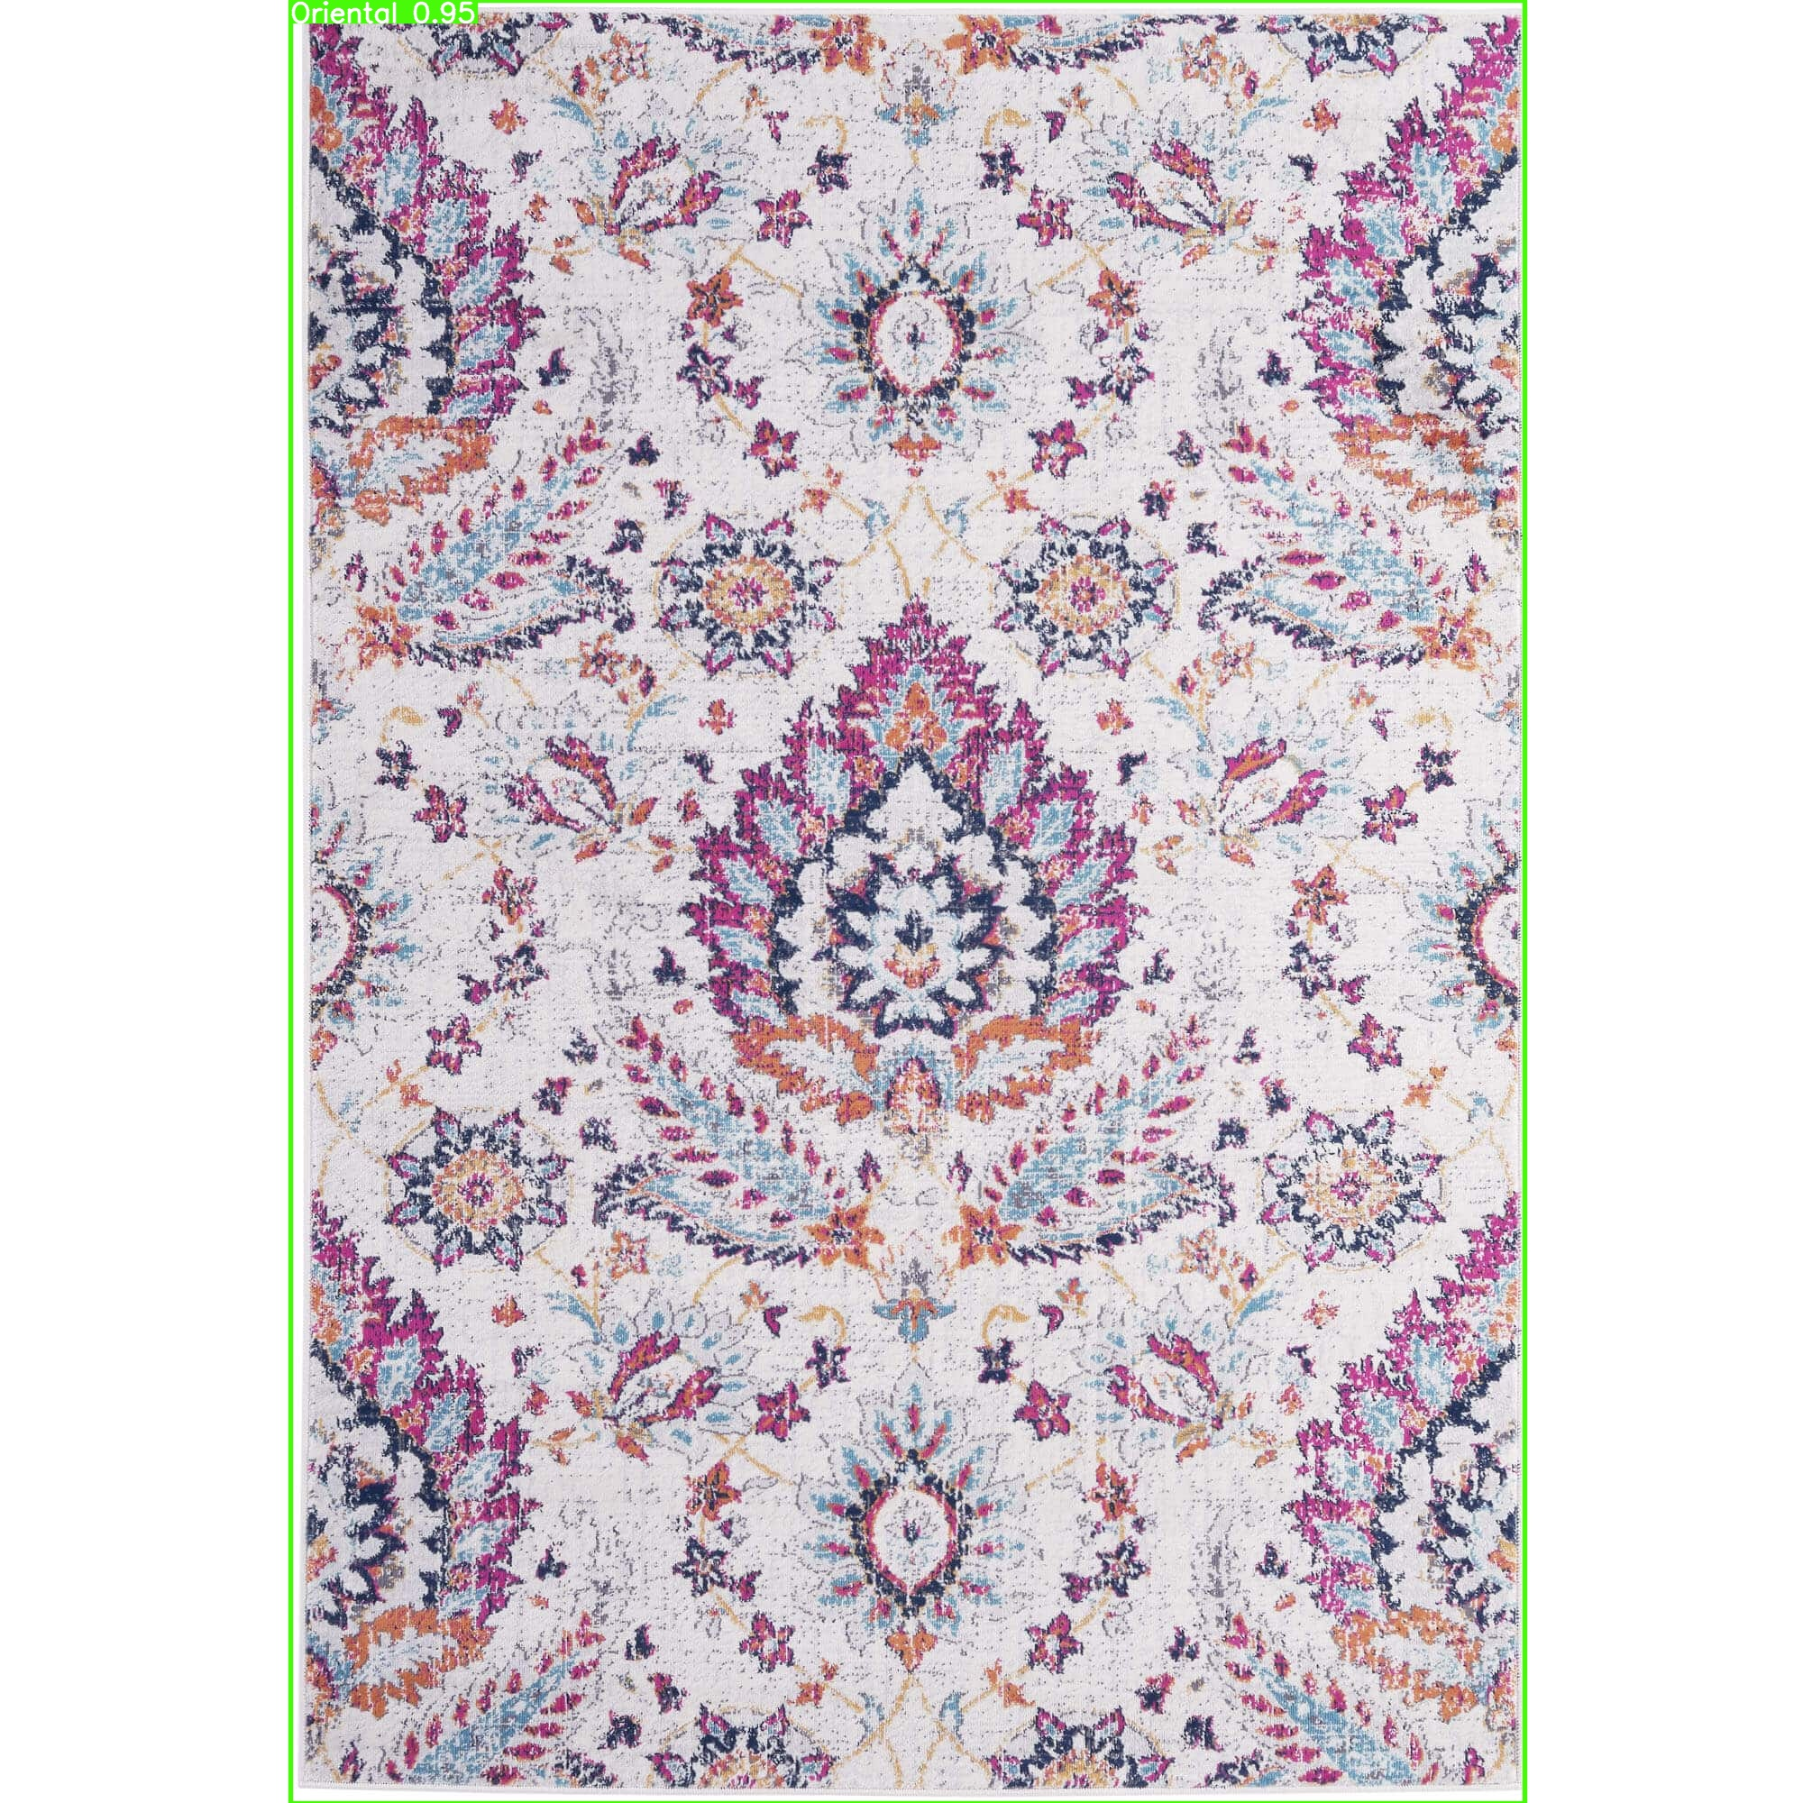

5. Round:
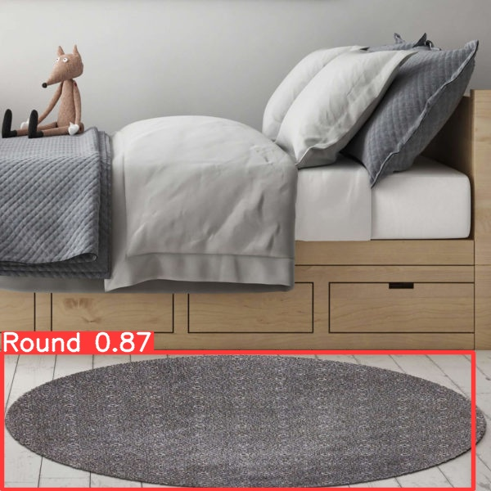

6. Shaggy:
