

INTRODUCTION TO COMPUTER ARCHITECTURE AND NETWORKING GROUP ASSIGNMENT

INTAKE : UCFF2405CT

LECTURER : Noris Ismail

DATE ASSIGNED : 28 August 2024 (Week 3)

PROPOSAL DUE DATE : 9 October 2024 (Week 9)

FINAL SUBMISSION DUE DATE :1 November 2024 (Week 12)

No. | Student Name | TP Number
 | ZHAXYLYKOV BOLAT | TP080943
 | TULKINOV JAHONGIRMIRZO | TP081072
 | ZAKHAR IUSUPOV | TP081607
 | TYULYUBAYEV TEMIRLAN | TP081509

1. SUBNET
SUBNET is a technology-driven company specializing in delivering state-of-the-art home network solutions to residential customers. Our mission is to simplify and secure home connectivity, providing an extensive range of services, including network design, hardware installation, security consulting, and troubleshooting. Our solutions prioritize optimizing network performance while ensuring robust cybersecurity, enabling customers to seamlessly access the internet across multiple devices. Beyond residential solutions, we aspire to expand into small office environments, positioning ourselves as a versatile network solutions provider for future growth.
Core Values:
- Innovation in technology
- Customer-centric support
- Commitment to security and reliability

2. Home Network Design Considerations
Designing a robust home network entails several critical factors that significantly influence its performance, scalability, and security. These factors include:
Security: Implement robust security measures to safeguard against cyber threats such as malware, ransomware, and unauthorized access. Enterprise-grade encryption protocols (e.g., WPA3) and network monitoring tools are essential to mitigate vulnerabilities.
Scalability: Plan for future expansion, particularly with the increasing adoption of IoT devices. The network should be flexible enough to accommodate new devices without compromising speed or security.
Coverage: Ensure comprehensive Wi-Fi coverage throughout the entire home, minimizing dead zones. The strategic placement of routers and access points (WAPs) is crucial in achieving optimal signal strength in all areas, including basements, attics, and outdoor spaces.
Cost: Striking a balance between performance and affordability is paramount. Utilizing cost-effective yet high-performing equipment, such as dual-band routers and mesh systems, can enhance performance without incurring substantial expenses.
User-friendliness: The system should be intuitive and user-friendly, incorporating features like parental controls, guest access, and troubleshooting capabilities through user-friendly interfaces.

3. Technology Used
To build a reliable and high-performance home network, the following technologies are essential:
Router: The central device managing traffic across the network. SUBNET uses high-performance routers with dual-band (2.4 GHz and 5 GHz) or tri-band capability for better load management.
Switches: Managed or unmanaged switches are used to connect multiple wired devices, improving wired connection speeds and network segmentation.
Cabling: Ethernet Cat 6 or Cat 7 cables provide high-speed, reliable connections for wired devices, ensuring consistent performance in areas where wireless signals may not suffice.
Wi-Fi Standards: Dual-band 2.4 GHz and 5 GHz standards are employed for flexibility. The 5 GHz band is preferable for high-speed activities like video streaming and gaming, while 2.4 GHz provides broader coverage at slower speeds.
Protocols: Key protocols include TCP/IP for communication, DHCP for dynamic IP assignment, and DNS for domain name resolution, allowing seamless device communication within the network.
Network Monitoring Tools: Tools such as SNMP (Simple Network Management Protocol) help in monitoring network performance and diagnosing issues proactively.

4. Devices
The network design is intended to support a diverse range of devices, ensuring seamless integration into the system:
Smartphones, Laptops, and Desktops: These primary devices require consistent connectivity for tasks ranging from casual browsing to intensive applications such as video conferencing.
Internet of Things (IoT) Devices: Smart home appliances (e.g., lights, thermostats, cameras, speakers) necessitate a network that prioritizes bandwidth for critical devices while maintaining low latency for real-time applications.
Printers: Wi-Fi and Ethernet-connected printers should be readily accessible from all devices within the home network.

5. Floor Plan
The floor plan is paramount for achieving optimal Wi-Fi coverage. The strategic placement of routers and WAPs is essential to minimize interference points, such as:

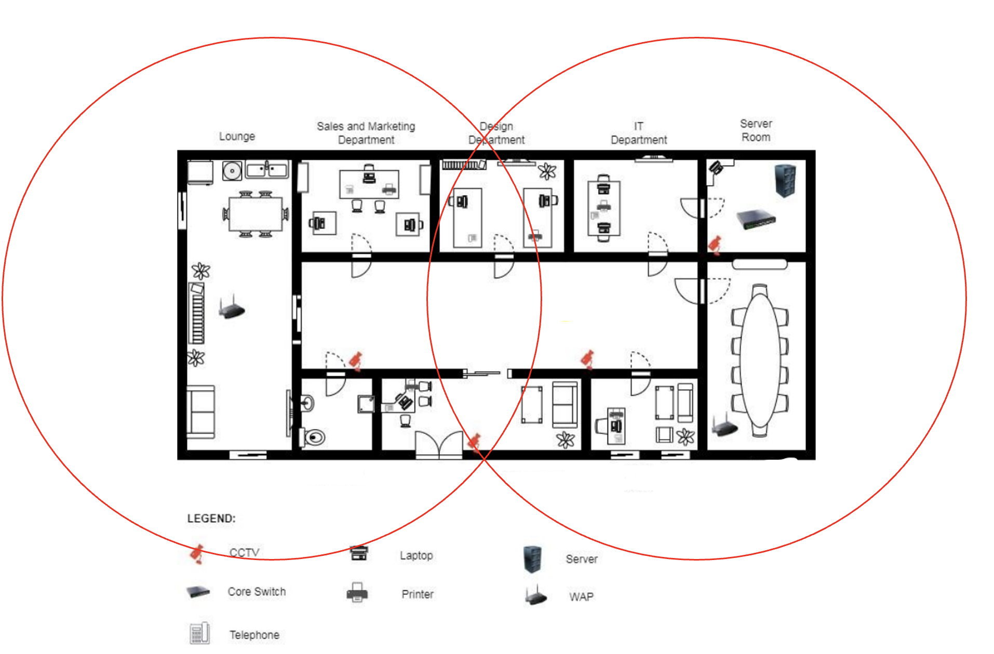
Central Locations: Routers should be centrally situated on the main floor to ensure comprehensive coverage throughout multiple floors.
Avoiding Obstructions: Refrain from positioning routers or WAPs in close proximity to substantial walls, large metallic objects, or appliances (e.g., microwaves) that can disrupt the signal.
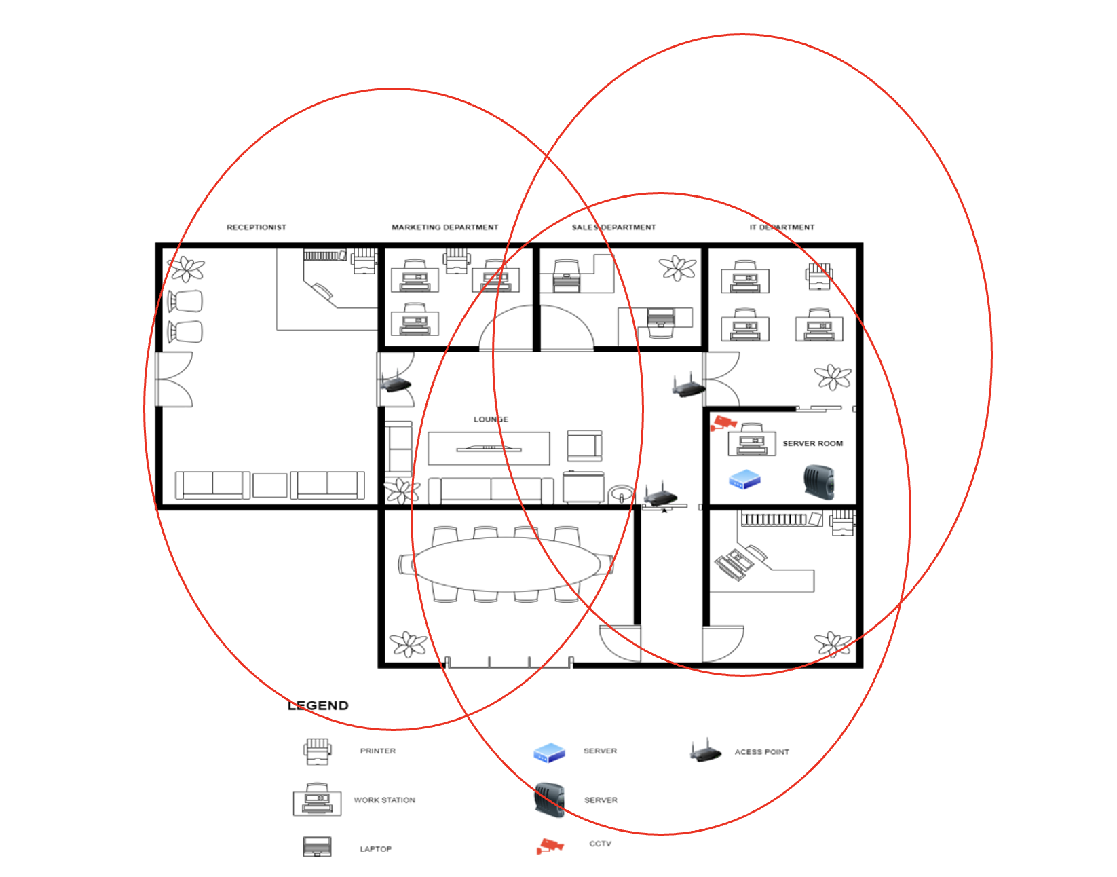
Mesh Network Consideration: For larger dwellings or buildings with intricate layouts, employing a mesh network can facilitate uniform coverage throughout all areas, including garages and outdoor spaces.

6. Network Architecture Diagram
The network architecture is meticulously designed to facilitate an uninterrupted data flow across all devices, ensuring optimal performance of both wired and wireless connections.
Central Hub: The router serves as the network’s central point, connecting devices either directly through Ethernet cables or wirelessly through Wi-Fi access points (WAPs).
Switches: Wired devices, such as desktops and gaming consoles, are connected to Ethernet switches for enhanced speed and reliability.
WAPs: Wireless devices connect to WAPs strategically placed in high-traffic areas to provide seamless wireless connectivity.

7. WAP Placement
Placing WAPs (Wireless Access Points) correctly is critical for achieving seamless Wi-Fi coverage:
High-Traffic Areas: Ensure that WAPs are placed in areas where heavy internet usage occurs, such as living rooms or home offices.
Avoiding Interference: Keep WAPs away from microwave ovens, cordless phones, and other electronics that could cause interference.
Optimal Height: Placing WAPs on ceilings or high walls can help distribute the signal more evenly.
Mesh Systems: In larger homes, implementing mesh WAPs can ensure seamless connectivity between zones, avoiding dead spots.

8. Bandwidth Requirement
To ensure the network can handle the simultaneous activities of multiple devices, the following bandwidth requirements are estimated:
HD Video Streaming: 5-10 Mbps per device for smooth streaming with no buffering.
Online Gaming: 10-15 Mbps per device for real-time gaming without lag.
General Browsing and Email: 1-2 Mbps per device for normal usage.
Video Conferencing (e.g., Zoom, Teams): 5-8 Mbps for smooth video calls.
Considering all devices, the total bandwidth requirement for 10 devices running simultaneously is around 100-150 Mbps to avoid congestion.

9. Security Attacks
Common security threats to home networks include:
Denial of Service (DoS) Attacks: Flooding the network with traffic to make services unavailable.
Man-in-the-Middle Attacks: Intercepting communications between devices on the network.
Malware Intrusions: Viruses or ransomware infecting devices, compromising personal data or network operations.
Brute-force Attacks on Passwords: Hackers attempting to guess passwords to gain unauthorized access to devices.

10. Security Mitigation Techniques
To protect the home network from potential attacks, the following security techniques should be employed:
WPA3 Encryption: Ensure that the latest Wi-Fi encryption standard (WPA3) is used to secure the network.
Firewalls: Enable firewalls on routers and individual devices to prevent unauthorized access.
Strong Passwords: Use unique, strong passwords that include a combination of uppercase letters, numbers, and special characters.
Regular Firmware Updates: Keep router and device firmware updated to patch any vulnerabilities that could be exploited by attackers.

11. Conclusion
The comprehensive home network design outlined provides a robust solution for delivering high-performance, secure, and scalable connectivity. By meticulously considering bandwidth requirements, device placement, and implementing robust security measures, the network will effectively support the evolving needs of a contemporary household, ensuring an uninterrupted and seamless digital experience for all users.

12. Workload Matrix
Task | Responsible Person | Estimated Time
Network Design | Zakhar | 3 days
Device Setup | Temirlan | 2 days
Security Implementation | Jahongirmirzo | 3 days
Testing and Monitoring | Bolat | 4 days

13. Sources
https://tig.csail.mit.edu/network-wireless/wireless-design/
https://nilesecure.com/network-design/network-scalability
https://www.garlandtechnology.com/blog/network-design-for-effective-security-and-performance-simplified
https://media.defense.gov/2023/Feb/22/2003165170/-1/-1/0/CSI_BEST_PRACTICES_FOR_SECURING_YOUR_HOME_NETWORK.PDF
https://www.blackhillsinfosec.com/home-network-design-part-2/
https://lazyadmin.nl/home-network/home-network-diagram/
https://www.kaspersky.com/resource-center/preemptive-safety/how-to-set-up-a-secure-home-network
https://www.amazon.com/Home-Network-Manual-Complete-Upgrading/dp/1735543063

