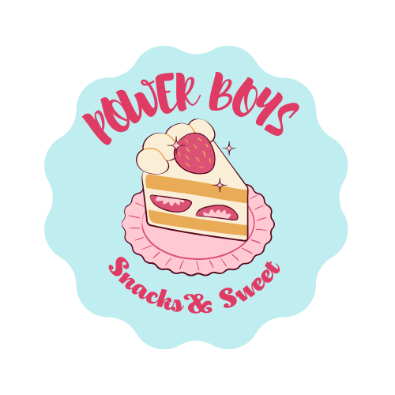Power Boys

# Business Name and Logo

Our business name is 'Power Boys'. The name was chosen to reflect the energy, enthusiasm, and strength that our team brings to the food and sweets industry. We wanted a name that captures the vibrant, fun, and dynamic nature of our products, as well as the youthful energy that defines our brand.

# Nature of the Business

Power Boys is a food and sweets business that focuses on providing a variety of delicious and creative treats. Our product range includes a mix of traditional sweets and innovative food items, all made with high-quality ingredients. We offer a selection of candies, pastries, and other sweet delights, as well as savory snacks to satisfy a wide range of customer preferences.

At Power Boys, we are committed to constantly developing new products to surprise and delight our customers. For example, at our booth, we will showcase unique food combinations that are both creative and delicious. Our aim is to stand out in the market by offering something that is not only feasible in terms of production but also highly unique and innovative, ensuring that customers are excited to try our offerings.

# Management Team

The organizational structure of our booth team is designed to ensure efficiency and smooth operations. We have clearly defined roles and responsibilities to make sure every aspect of our business is well-managed.

## Leader

Responsible for overseeing the entire operation of the booth, ensuring that everything runs smoothly, and making key decisions.

## Marketing Manager

Handles the promotion and branding of our products, ensuring that our booth attracts a wide audience.

## Finance Officer

Manages the finances, including budgeting, sales tracking, and ensuring profitability.

## Operations Manager

Responsible for managing the production and supply of our food items, ensuring that quality standards are met.

## Customer Service Representative

Ensures that all customers are attended to promptly and provides information about our products. They handle any queries or complaints.

# Management Team

## A person taking a selfie Description automatically generatedName: SHAYAN AHMED SIDDIQUI

Leader

Role: Responsible for overseeing the entire operation of the booth, ensuring that everything runs smoothly and making key decisions.

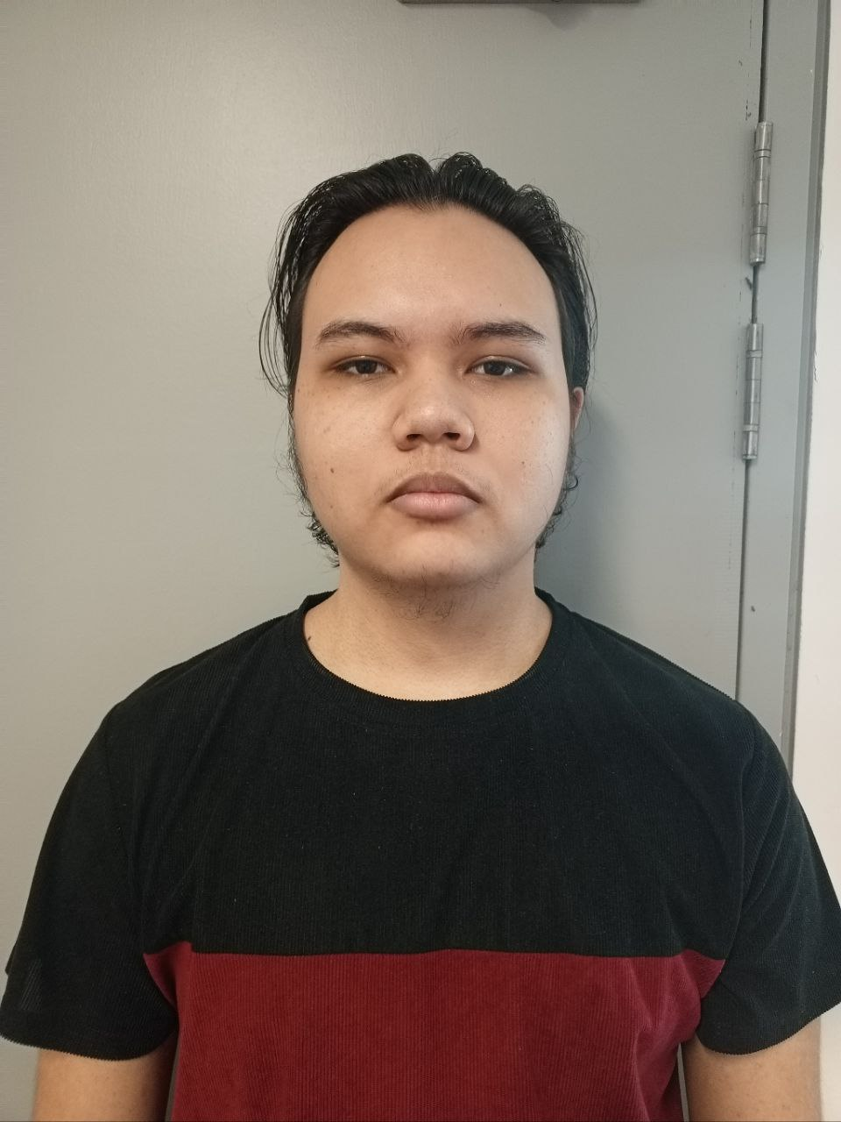

## Name: RAMON JOSE PALCONIT

Marketing Manager

Role: Handles the promotion and branding of our products, ensuring that our booth attracts a wide audience.

## A person in a suit Description automatically generatedName: TULKINOV JAHONGIRMIRZO

Finance Officer

Role: Manages finances including budgeting, sales tracking, and ensuring profitability.

## 4. Name: BOLAT

Job Title: Operations Manager

Role: Responsible for managing the production and supply of food items, ensuring that quality standards are met.

## 5. Name: RYAN

Job Title: Customer Service Representative

Role: Ensures that all customers are attended to promptly, provides information about our products, and handles queries or complaints.