Hive与mysql

检查系统是否安装了mysql 》》Rpm –qa|grep mysql

写在已经安装的 》》 rpm –e –nodeps mysql-*

Rpm –ivh mysql-server-…..

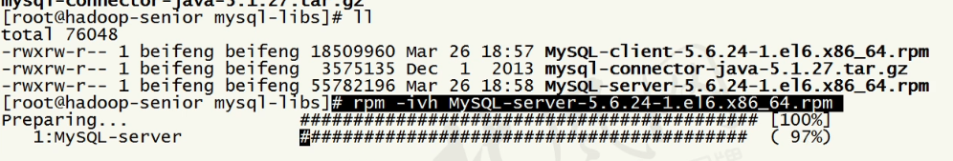

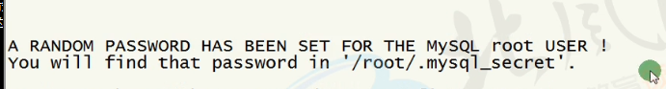

Service mysql start

安装客户端

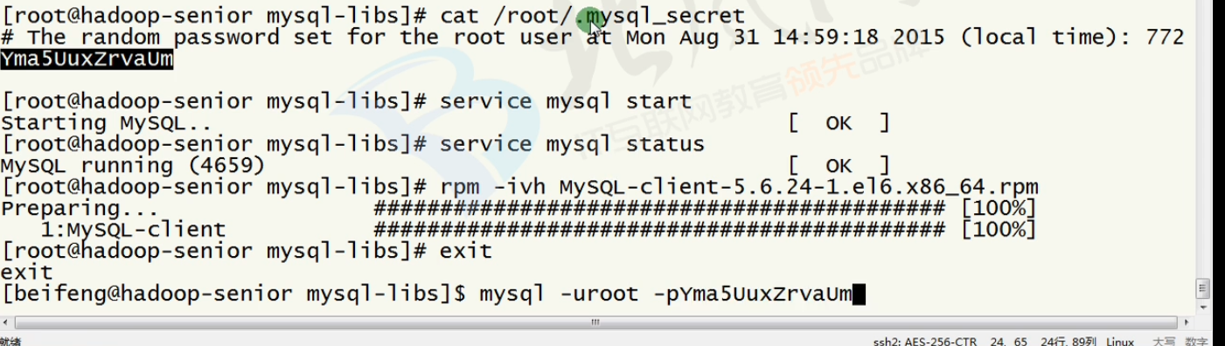

进去之后设置密码：

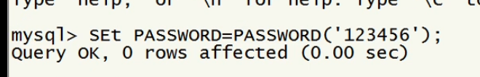

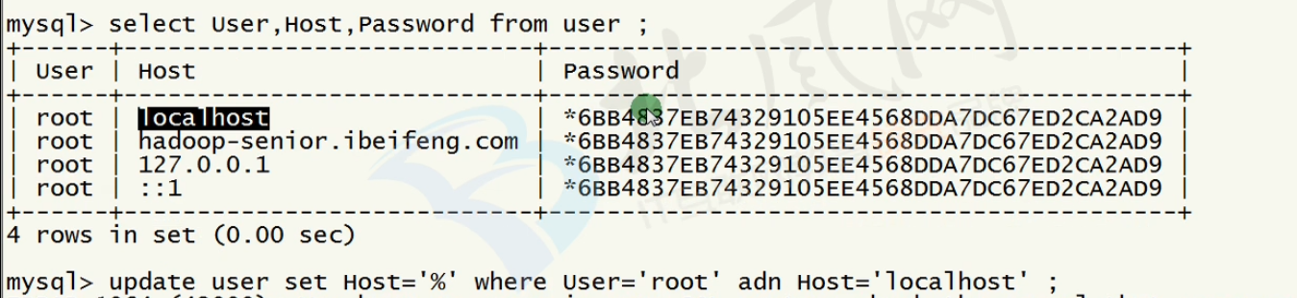

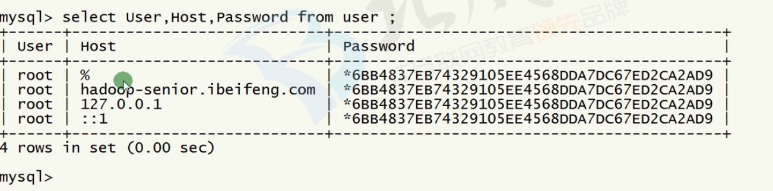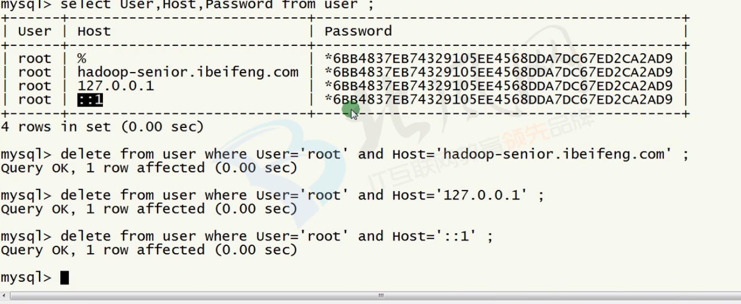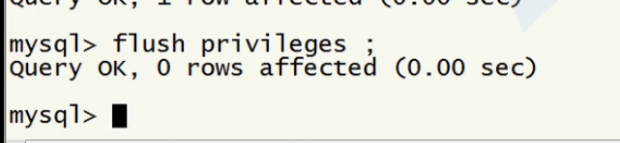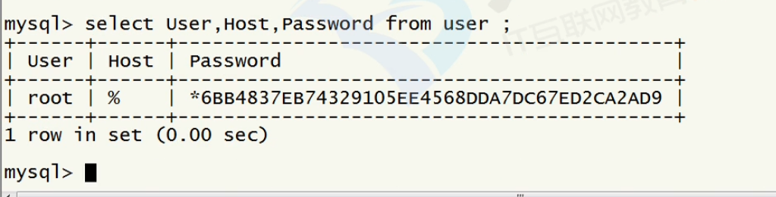

或者通过yum安装:

1、在spark2upgrade01上安装mysql。

2、使用yum安装mysql server。

yum install -y mysql-server

service mysqld start

chkconfig mysqld on

3、使用yum安装mysql connector

yum install -y mysql-connector-java

4、将mysql connector拷贝到hive的lib包中

cp /usr/share/java/mysql-connector-java-5.1.17.jar /usr/local/hive/lib

5、在mysql上创建hive元数据库，并对hive进行授权

create database if not exists hive_metadata;

grant all privileges on hive_metadata.* to 'hive'@'%' identified by 'hive';

grant all privileges on hive_metadata.* to 'hive'@'localhost' identified by 'hive';

grant all privileges on hive_metadata.* to 'hive'@'spark2upgrade01' identified by 'hive';

flush privileges;

use hive_metadata;