Kevin Cooper

Capt. Branchflower

10 Feb 14

Lab 2 Prelab

1. State transition diagram for pong_control

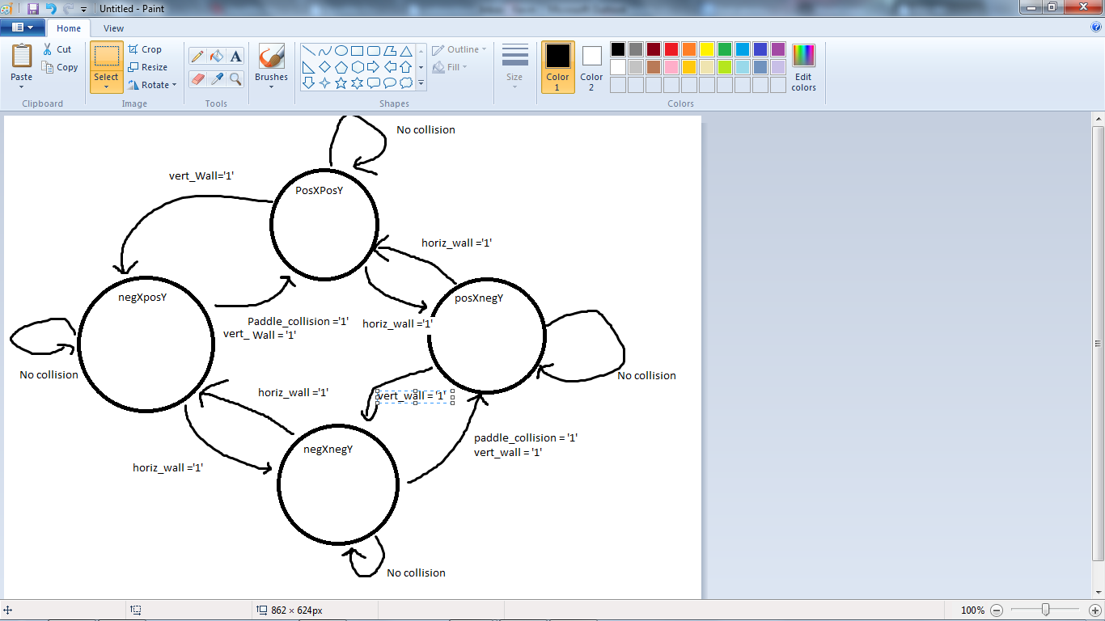

1. Implementation of bounds checking for ball
   1. Ball states – posXposY, posXnegY, negXposY, negXnegY
   2. Bounds checking
      1. ballState <= posXposY when ballX < 15 and (ballstate = negXposY) else  
          posXnegY when ballX < 15 and (ballstate = negXnegY) else  
          negXposY when ballX > 625 and (ballstate = posXposY) else  
          negXnegY when ballX > 625 and (ballstate = posXnegY) else  
          ……. Same for Y bounds
      2. has_hit_paddle <= '1' when ballX < 20 and (ballY > paddleY-10 and ballY< paddleY +10) else '0';
2. Paddle position
   1. paddleY_Next <= paddleY + 10 when "up" and paddleY+10<Height else  
       paddleY – 10 when "down" and paddleY-10>0 else  
       paddleY;
   2. process( v_completed, reset) is  
      begin  
       if (reset ='1') then  
       paddleY <= 240;  
       else  
       paddleY <= paddleY_nest;  
       end if;  
      end process;