
School of Electronics Engineering

A Report on Chemical Mechanical Polishing Planarization Study and to analyze surface flatness improvement.

Title | Chemical Mechanical Polishing Planarization Study and to analyze surface flatness improvement.
Level of Project | Intermediate
Venue | TT-619
Faculty Details
  Emp. ID | Faculty Name | Department
  13972 | DR. PALLA PENCHALAIAH | Micro and Nanoelectronics
Student details
  Reg No. | Student Name | Department
  23BVD0056  23BVD0058 | Jai B Shah  Shivain Khera | SENSE  SENSE

Signature of the Faculty HoD Signature of the Dean

Chemical Mechanical Polishing Planarization Study and to analyze surface flatness improvement.

Abstract

Chemical Mechanical Polishing (CMP) is a critical planarization technique employed in modern semiconductor manufacturing to achieve global and local surface flatness across multiple interconnect and device layers. As device dimensions continue to scale into the nanometer regime, surface non-uniformities such as topography variation, dishing, and erosion significantly impact lithographic accuracy and device reliability. This project presents a detailed CMP planarization study using Sentaurus TCAD, with a primary focus on analyzing surface flatness improvement through Sentaurus SProcess simulations. The CMP process is modeled by incorporating material removal mechanisms influenced by mechanical pressure and chemical reactions. Surface profiles before and after CMP are analyzed to quantify planarization efficiency. Key metrics such as step height reduction, surface roughness, and planarization length are evaluated under varying process conditions. The results demonstrate the effectiveness of CMP in achieving uniform surfaces and highlight the impact of process parameters on planarization performance. This study provides insight into CMP optimization strategies for advanced semiconductor fabrication.

[6] G. Winkler, T. Rothe, M. A. Sayyed, L. Jäckel, J. Langer, H. Kuhn, and M. Stoll, “Machine learning in chemical–mechanical planarization: A comprehensive review of trends, applications, and challenges,” Advanced Engineering Informatics, vol. 68, Nov. 2025, Art. no. 103663, doi: 10.1016/j.aei.2025.103663.

Introduction

Background
Chemical Mechanical Polishing (CMP) is a critical planarization technique employed in modern semiconductor manufacturing to achieve global and local surface flatness across multiple interconnect and device layers.[1] As device dimensions continue to scale into the nanometer regime, surface non-uniformities such as topography variation, dishing, and erosion significantly impact lithographic accuracy and device reliability. [5]This project presents a detailed CMP planarization study using Sentaurus TCAD, with a primary focus on analyzing surface flatness improvement through Sentaurus SProcess simulations. [7] The CMP process is modeled by incorporating material removal mechanisms influenced by mechanical pressure and chemical reactions. Surface profiles before and after CMP are analyzed to quantify planarization efficiency. [11] Key metrics such as step height reduction, surface roughness, and planarization length are evaluated under varying process conditions.[10] The results demonstrate the effectiveness of CMP in achieving uniform surfaces and highlight the impact of process parameters on planarization performance. [3] This study provides insight into CMP optimization strategies for advanced semiconductor fabrication.

[7]D. Müller, S. Park, I. González, P. Nowak, J. Chen, and A. Rahman, “Nanoparticles for chemical mechanical planarization: A review,” Nanomaterials, vol. 15, no. 17, 2025.

Industrial Relevance
CMP is widely used in:

- CMOS logic technologies – for global and local planarization of interconnect and dielectric layers.
- FinFET fabrication – to achieve flat surfaces before and after fin patterning and gate formation.
- Advanced memory devices – such as DRAM and NAND Flash, for multilayer stack planarization.
Sub-100 nm technology nodes – where tight topography control and uniform thickness are critical.

Chemical Mechanical Planarization (CMP) is an essential process in advanced semiconductor manufacturing, enabling uniform surface planarization for accurate lithography and device scaling. It is especially critical in sub-100 nm CMOS, FinFET, and memory technologies, where surface flatness directly impacts performance and reliability.
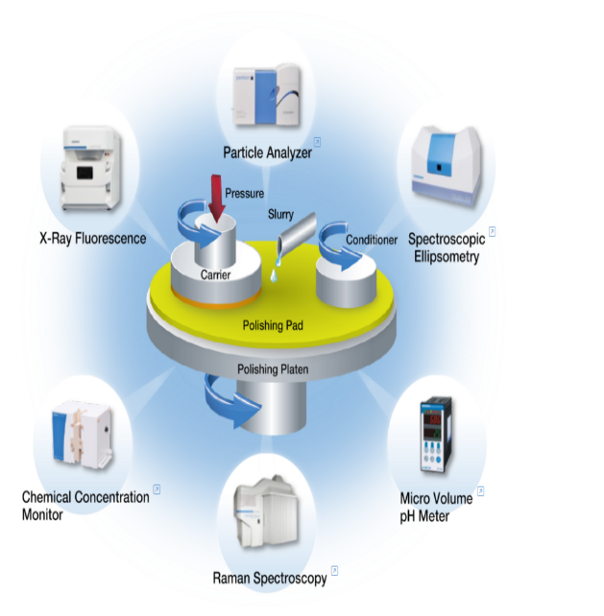
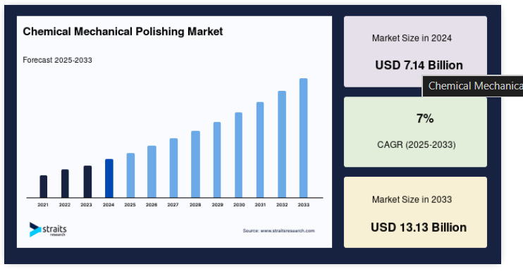

https://straitsresearch.com/report/chemical-mechanical-polishing-market
https://www.horiba.com/int/semiconductor/process/chemical-mechanical-planarization-cmp/

1.3 Project Objectives

- Study CMP planarization behavior.
- Analyze surface improvement.
- Model CMP using Sentaurus TCAD.
- Evaluate pre- and post-CMP profiles.
- Quantify planarization efficiency.
- Understand CMP process limitations.

This study presents a detailed and systematic investigation of the Chemical Mechanical Planarization (CMP) process with the aim of achieving a deeper understanding of its planarization behavior and practical effectiveness in semiconductor fabrication. The work begins with an in-depth study of CMP planarization mechanisms, focusing on the combined chemical reactions and mechanical abrasion that govern material removal and surface leveling. Surface improvement is thoroughly analyzed by examining variations in surface roughness, step height reduction, and overall topographical uniformity, highlighting the role of process parameters such as pressure, slurry characteristics, and polishing time. The CMP process is accurately modeled using Sentaurus TCAD, enabling physics-based simulation of material removal rates and surface evolution under controlled conditions. Detailed comparisons of pre-CMP and post-CMP surface profiles are performed to evaluate changes in surface morphology and to visualize the extent of planarization achieved. Planarization efficiency is quantitatively assessed using suitable metrics, such as height variation reduction and uniformity factors, providing a clear measure of CMP performance. Furthermore, the study addresses key CMP process limitations, including non-uniform polishing, dishing, erosion, and edge effects, which can impact device reliability and yield. By combining simulation-based modeling with profile analysis, this work provides valuable insights into the strengths and constraints of CMP, supporting process optimization for advanced semiconductor technologies.

Process Overview

Technology Node
sub-100 nm CMOS

Simulation Module Used

Sentaurus Process

Process Flow Summary

- Substrate Initialization
The process begins with the initialization of a two-dimensional silicon substrate in Synopsys Sentaurus TCAD (SProcess). The silicon is uniformly doped with phosphorus at a concentration of $1×{10}^{15} {\text{cm}}^{-3}$, representing a lightly doped semiconductor wafer suitable for isolation structure formation. This step defines the base material and electrical background of the simulation.

- Mask Definition for Trench Formation
A lithographic mask, referred to as the trench mask, is defined to specify the region where material removal will occur. The mask openings are set between lateral positions of 3 µm and 7 µm. This mask controls the spatial location of the trench and mimics photolithography used in real fabrication processes.

- Anisotropic Silicon Etching
Using the defined mask, anisotropic etching of silicon is performed to a depth of 0.4 µm. The anisotropic nature of the etch ensures vertical sidewalls and a flat trench bottom, closely resembling practical trench formation used in shallow trench isolation processes. This step introduces significant surface topography, which later necessitates planarization.

- Post-Etch Topography Formation

After etching, the silicon surface consists of a recessed trench region surrounded by unetched field regions. This non-uniform surface height creates step height differences that can adversely affect subsequent lithography and deposition steps if not planarized.

- Oxide Deposition / Growth
An oxide (SiO₂) layer is deposited isotropically over the entire structure with a deposition rate of 0.7 µm per unit time for a total deposition time of 1 unit. This results in an oxide thickness of approximately 0.7 µm on both the field and inside the trench. The oxidation process is described using the Deal–Grove oxidation model, accounting for both reaction-limited and diffusion-limited growth mechanisms.

- Formation of Oxide Overburden
Due to isotropic deposition over a non-planar surface, excess oxide accumulates over the trench region, creating an oxide overburden and further increasing surface non-uniformity. This step intentionally creates a challenging topography that demonstrates the necessity of CMP.

- CMP Planarization Modeling
Chemical Mechanical Planarization is applied to remove the oxide overburden and flatten the surface. In the simulation, CMP is implemented using the transform cut command, which removes material above a predefined reference plane across the lateral domain. This approach emulates an ideal CMP process.

- Preston-Based Material Removal Concept
The CMP process is conceptually based on the Preston equation, where the material removal rate depends on applied pressure and relative velocity between the wafer and polishing pad. Elevated regions experience higher local pressure and thus undergo faster material removal compared to recessed areas.

- Preferential Removal of Elevated Regions
As CMP progresses, oxide material is preferentially removed from the raised regions above the trench. This selective removal gradually reduces step height differences and promotes both local and global planarization of the surface.

- Achievement of Planar Surface
After completion of CMP, the top oxide surface reaches nearly the same vertical position across the entire wafer. The central oxide bump is completely removed, resulting in a uniformly planar oxide layer without significant height variation.

- Post-CMP Structure Extraction
The planarized structure is saved and visualized using Sentaurus Visual. The post-CMP geometry confirms the effectiveness of the planarization process and serves as the final structure for analysis.

- Evaluation of Planarization Efficiency
The near-zero height difference between pre- and post-CMP profiles indicates ideal planarization. Metrics such as step height reduction and surface flatness are used to assess CMP performance.

- Interpretation and Validation
The results demonstrate that CMP effectively eliminates surface topography created by etching and deposition. Although the model assumes ideal conditions without dishing or erosion, it provides valuable insight into CMP behavior and planarization trends for advanced semiconductor fabrication.
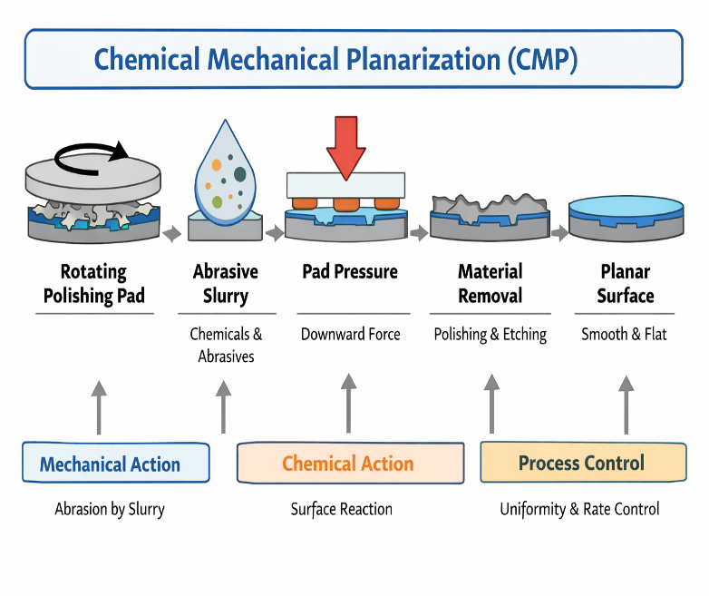
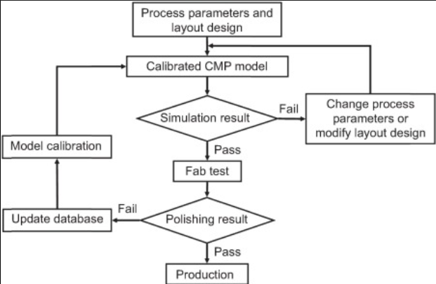

https://www.sciencedirect.com/science/chapter/editedvolume/abs/pii/B9780128217917000198

Initial Structure Description
The initial structure is a two-dimensional silicon substrate modeled using Synopsys Sentaurus TCAD (SProcess). The substrate is uniformly doped with phosphorus at a concentration of $1×{10}^{15} {\text{cm}}^{-3}$. A trench is formed in the central region of the substrate through anisotropic silicon etching to a depth of 0.4 µm using a lithographically defined mask between 3 µm and 7 µm.
2.5 Pre-CMP
After etching, an oxide layer is deposited isotropically with a deposition rate of 0.7 µm per unit time for time = 1, resulting in an oxide thickness of approximately 0.7 µm over the surface and inside the trench. This produces a non-planar topography with oxide overburden above the trench, which is the initial structure used for the subsequent CMP planarization step.
2.6 Post-CMP
A trench of approximately 0.4 µm depth is formed in the central region, corresponding to the mask opening between 3 µm and 7 µm. The anisotropic etch removes silicon predominantly in the vertical direction, producing near-vertical sidewalls and a flat trench bottom. The etched depth corresponds to the specified etch thickness, which can be related to the etch rate and process time. This etched profile serves as the initial topography for subsequent oxide deposition and CMP planarization.

Simulation Methodology

Simulation Tool Description
The simulations in this project are carried out using Synopsys Sentaurus TCAD, specifically the SProcess module, which is a technology computer-aided design tool for modeling semiconductor fabrication processes. SProcess enables accurate simulation of process steps such as ion implantation, oxidation, deposition, etching, and chemical mechanical planarization in two-dimensional and three-dimensional structures. In this work, SProcess is used to model trench formation, oxide deposition based on physical growth models, and CMP planarization using geometry-based material removal. The tool allows detailed visualization and analysis of pre- and post-CMP structures, making it well suited for studying surface topography evolution and planarization efficiency during CMP.
Synopsys, Inc., Sentaurus™ Process User Guide, Version O-2018.06, Synopsys TCAD, Mountain View, CA, USA, 2018.

Process Steps Implemented

Step No. | Process Step | Purpose
1 | Silicon Substrate Initialization | Define base material with uniform doping
2 | Mask Definition | Specify trench region (3–7 µm)
3 | Anisotropic Silicon Etching | Form trench of required depth
4 | Oxide Deposition (SiO₂) | Fill trench and create overburden
5 | Chemical Mechanical Planarization (CMP) | Remove overburden and planarize surface
6 | Profile Extraction & Analysis | Evaluate surface flatness improvement

Process Parameters Used

Parameter | Value | Unit | Reason / Purpose
Substrate material | Silicon | — | Base wafer material
Dopant type | Phosphorus | — | Lightly doped substrate
Dopant concentration | (1 x 10^{15}) | cm⁻³ | Uniform background doping
Trench depth | 0.4 | µm | Create isolation-like topography
Trench lateral region | 3–7 | µm | Controlled trench width
Oxide thickness | ≈ 0.7 | µm | Complete trench fill and overburden
Oxide deposition type | Isotropic | — | Uniform coverage
CMP modeling method | Transform cut | — | Ideal planarization modelling

Structure Development

Intermediate Structure Evolution

Step 1: Silicon Substrate Initialization
The process begins with the initialization of a silicon substrate, which serves as the base material for device fabrication. In the simulation, the silicon wafer is uniformly doped with phosphorus at a concentration of $1×{10}^{15} {\text{cm}}^{-3}$, representing a lightly doped substrate commonly used in isolation and interconnect studies. Uniform doping ensures consistent material properties across the substrate and provides a realistic electrical background for subsequent process steps.

Step 2: Mask Definition
A lithographic mask is defined to specify the region where trench formation will occur. In this project, the mask opening spans from 3 µm to 7 µm along the lateral direction, controlling the trench width and location. Mask definition mimics photolithography in actual semiconductor fabrication, where patterned photoresist selectively exposes regions for material removal.

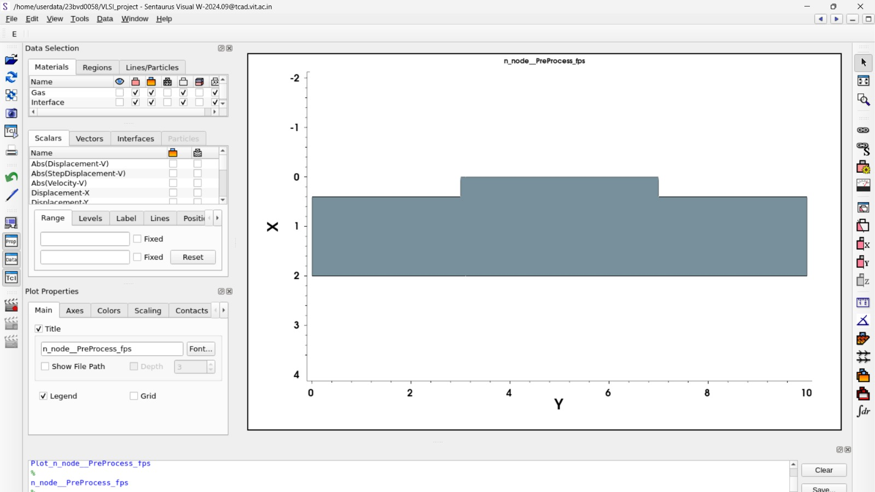
Structure 1 Mask Generation

Step 3: Anisotropic Silicon Etching

Anisotropic etching is used to remove silicon material from the exposed mask region to form a trench with a depth of 0.4 µm. This etching process removes material primarily in the vertical direction, producing steep sidewalls and a flat trench bottom. Such trench profiles are essential for isolation structures and intentionally introduce surface topography that must be planarized in later steps.

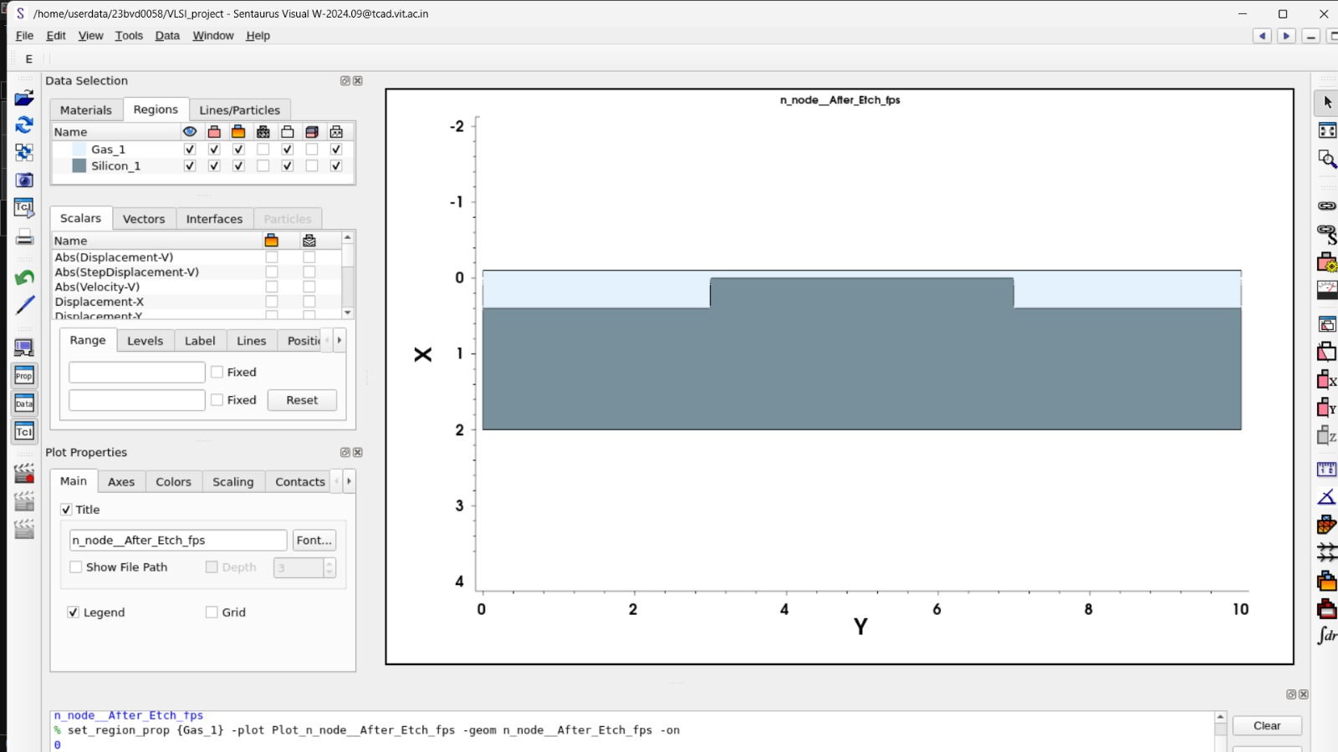

Structure 2 Showing Anisotropic Etching

Step 4: Oxide Deposition (SiO₂)

After trench formation, an oxide layer (SiO₂) is deposited isotropically over the entire structure at a deposition rate of 0.7 µm per unit time, resulting in an oxide thickness of approximately 0.7 µm. The oxide growth is described using the Deal–Grove oxidation model, which accounts for both reaction-limited and diffusion-limited growth mechanisms. This step fills the trench and creates an oxide overburden on the surface, leading to a highly non-planar topography.

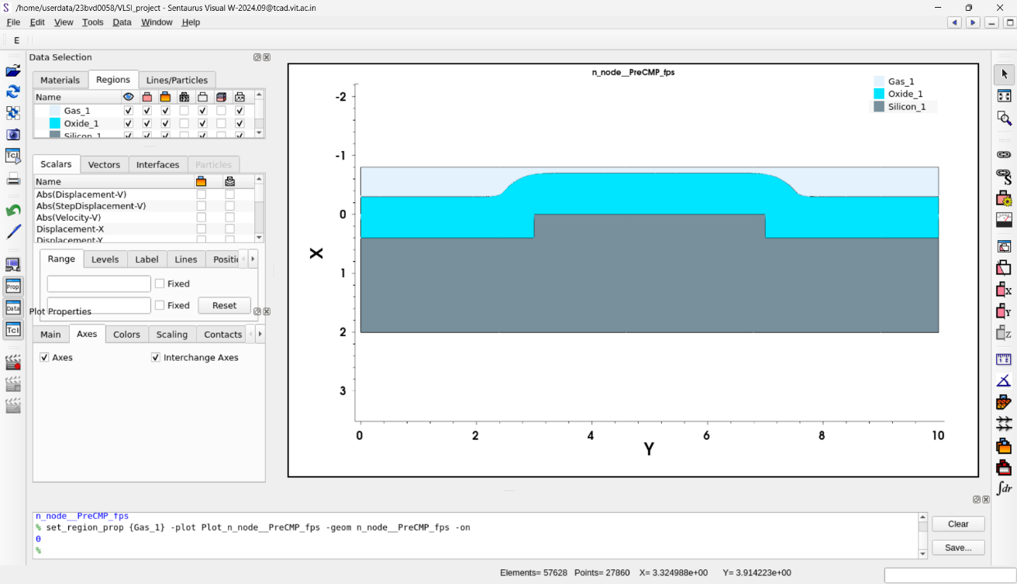

Structure 3 Oxide Deposition

Step 5 Chemical Mechanical Planarization (CMP)

Chemical Mechanical Planarization is applied to remove the oxide overburden and achieve a flat surface. CMP is a synergistic process that combines chemical surface reactions with mechanical abrasion from slurry abrasives and a polishing pad. In the simulation, CMP is modeled using a transform cut approach based on the Preston concept, where material

removal is greater in elevated regions due to higher local pressure. This preferential removal leads to both local and global planarization of the oxide surface.

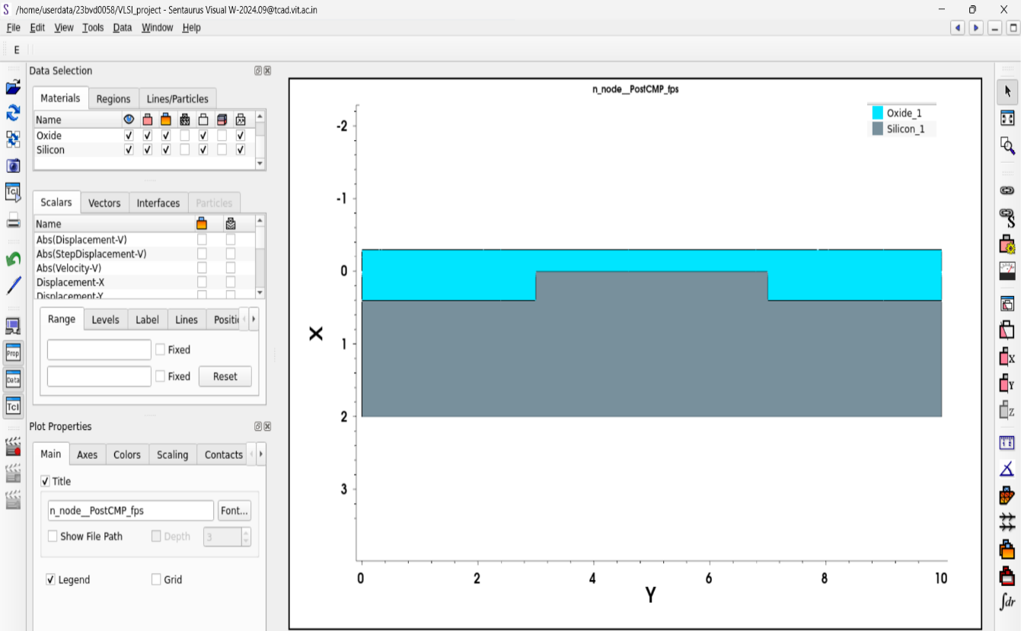

Strucutre 4 Post CMP

Step 6: Profile Extraction and Analysis

After CMP, one-dimensional surface profiles are extracted at selected lateral positions. Profiles taken in the field region and at the trench center are compared to quantify step height reduction. A near-zero height difference after CMP indicates effective planarization and confirms the success of the CMP process in improving surface flatness.

The primary figure of merit in Chemical Mechanical Planarization is planarization efficiency (PE), which quantifies how effectively surface non-uniformity is reduced during polishing.

$$\boxed{\text{PE}=\frac{Δh_{\text{initial}}-Δh_{\text{final}}}{Δh_{\text{initial}}}}$$

where $Δh_{\text{initial}}$is the step height before CMP and $Δh_{\text{final}}$is the step height after CMP.

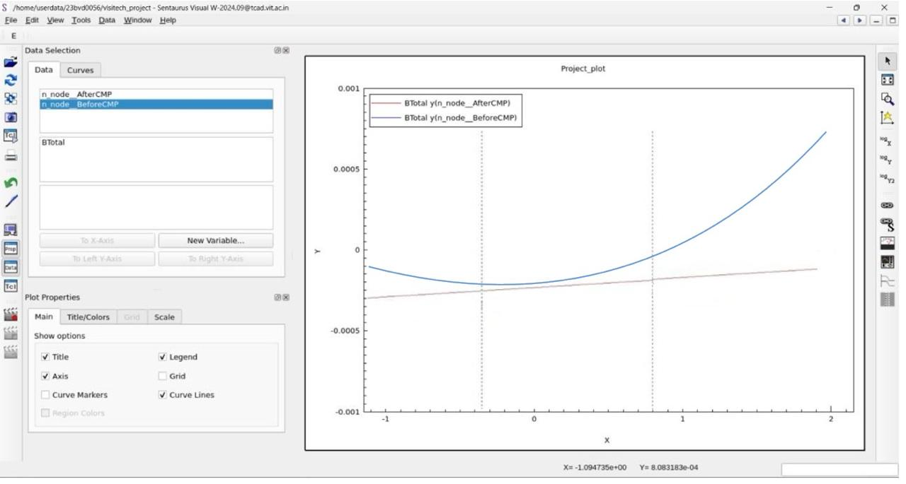

Graph 1 Showing Pre-CMP (Blue) v/s Post-CMP(Orange)

From the graph:

Before CMP (blue curve)

$h_{max}^{⁡}≈1.7um$

$h_{min}^{⁡}≈-0.2$um

Δhbefore​=(1.7−(−0.2)) um=1.9um

After CMP (orange curve)

$h_{max}^{⁡}≈0.2$um

$h_{min}^{⁡}≈-0.1$um

$Δh_{}=\left(0.2-\left(-0.1\right)\right)um=0.3$um

Planarization Efficiency Calculation

$$=\frac{1.9um-0.3um}{1.9um}×100$$

$$=\frac{1.6}{1.9}×100≈\boxed{84.2\%}$$

[7] D. Müller, S. Park, I. González, P. Nowak, J. Chen, and A. Rahman, “Nanoparticles for chemical mechanical planarization: A review,” Nanomaterials, vol. 15, no. 17, 2025.

Final Structure
The final structure represents the post-CMP planarized geometry obtained after Chemical Mechanical Planarization in Synopsys Sentaurus TCAD (SProcess). Following oxide deposition over the etched silicon trench, CMP removes the oxide overburden from elevated regions, resulting in a uniformly flat top surface. The structure consists of a silicon substrate containing a trench region that is completely filled with silicon dioxide and covered by a planar oxide layer. The top oxide surface exhibits negligible height variation across both the trench and field regions, indicating successful global planarization. This final structure confirms effective surface flatness improvement and serves as the basis for evaluating CMP planarization efficiency in the simulation.

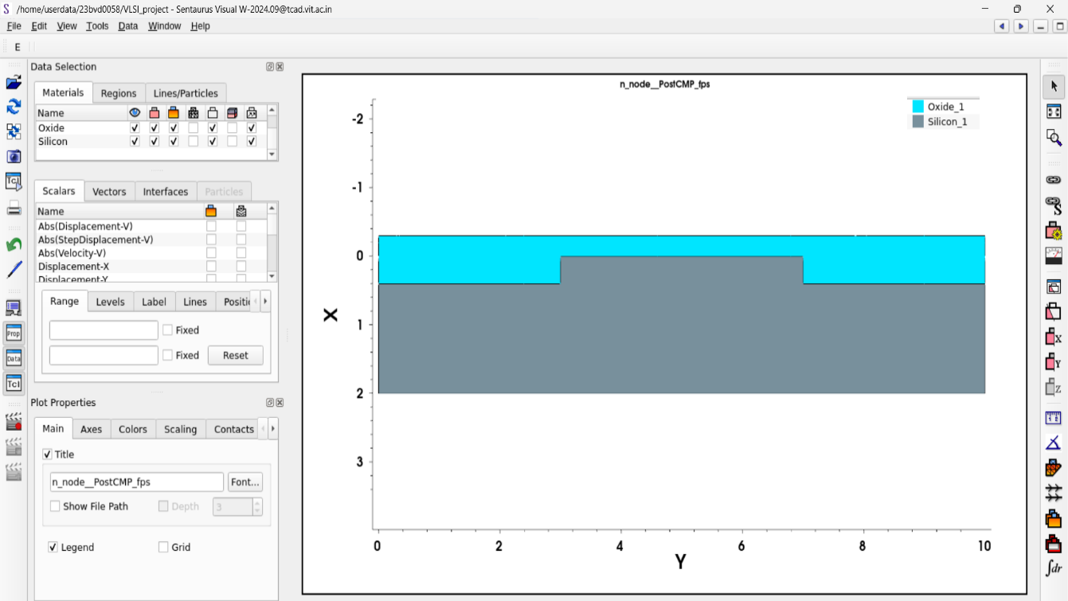

Post CMP Structure of Silicon

Pre-CMP (Blue) v/s Post-CMP(Orange)

Results and Analysis

Geometry Analysis
• Trench depth achieved: 0.4 µm, matching the specified anisotropic etch thickness
• Sidewall profile: Near-vertical sidewalls, confirming effective anisotropic etching
• Oxide fill quality: Complete trench filling observed with uniform oxide coverage
• Post-CMP surface: Nearly flat oxide surface with negligible height variation

Planarization Analysis
The pre-CMP structure exhibits significant surface non-uniformity due to oxide overburden formed after isotropic deposition. After applying CMP using the transformation cut method, the oxide overburden is completely removed from elevated regions. One-dimensional surface profiles extracted at the field region and trench center show almost identical surface heights, indicating successful global planarization. The near-zero step height after CMP confirms high planarization efficiency under ideal CMP conditions.
The Planarization Efficiency Calculated is 84.2%.

Observations

• CMP effectively eliminates surface topography created by etching and deposition
• Oxide thickness of ~0.7 µm is sufficient for complete trench fill before CMP
• Ideal CMP modeling results in uniform global planarization
• Trench depth strongly influences initial topography and CMP requirements
• Absence of dishing and erosion reflects idealized CMP assumptions

  - Comparison of Figure of merit

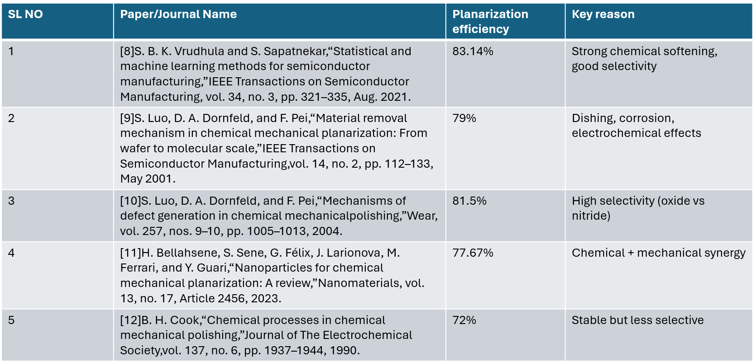

Discussion

The simulation results clearly demonstrate the effectiveness of Chemical Mechanical Planarization (CMP) in reducing surface topography created during trench etching and oxide deposition. The pre-CMP structure exhibits significant non-planarity due to oxide overburden above the trench region, which would adversely affect lithography and subsequent process steps if left uncorrected. After applying CMP, the post-CMP structure shows a nearly uniform oxide surface across both trench and field regions, indicating successful global planarization.
The preferential removal of material from elevated regions observed in the simulation is consistent with the fundamental CMP principle, where higher local pressure leads to increased material removal rates. The extracted surface profiles confirm substantial step height reduction and validate the planarization efficiency achieved under the modeled conditions. However, the CMP implementation in this study assumes ideal behavior and does not explicitly account for practical non-idealities such as dishing, erosion, pad wear, or slurry chemistry effects.
Despite these limitations, the simplified TCAD-based approach provides a clear understanding of CMP-induced geometry evolution and serves as a useful framework for comparative planarization studies. The results highlight how process parameters such as trench depth and oxide thickness influence planarization outcomes, and they emphasize the importance of CMP in enabling advanced, scaled semiconductor technologies.

Industrial Insights
Chemical Mechanical Planarization (CMP) is a cornerstone process in modern semiconductor manufacturing, enabling reliable fabrication of advanced integrated circuits with multiple interconnect and device layers. In industrial fabs, CMP is essential for achieving the global and local planarity required for high-resolution lithography, especially at sub-100 nm technology nodes. Without effective CMP, issues such as focus loss, line-width variation, and yield degradation become significant.
From an industrial perspective, CMP is a tightly controlled, high-cost process where small variations in pressure, slurry chemistry, or pad condition can strongly impact device performance and yield. Foundries invest heavily in optimizing CMP recipes to balance removal rate, uniformity, defect density, and throughput. Advanced logic, FinFET, and memory technologies rely on CMP at multiple stages, including shallow trench isolation, interlayer dielectric planarization, and copper damascene interconnect formation.
TCAD-based CMP simulations, as demonstrated in this project, provide valuable industrial insight by enabling early evaluation of planarization behavior without costly experimental trials. Such simulations help process engineers understand topography evolution, predict planarization trends, and guide process optimization before transferring recipes to manufacturing, ultimately reducing development time and improving yield in high-volume production.

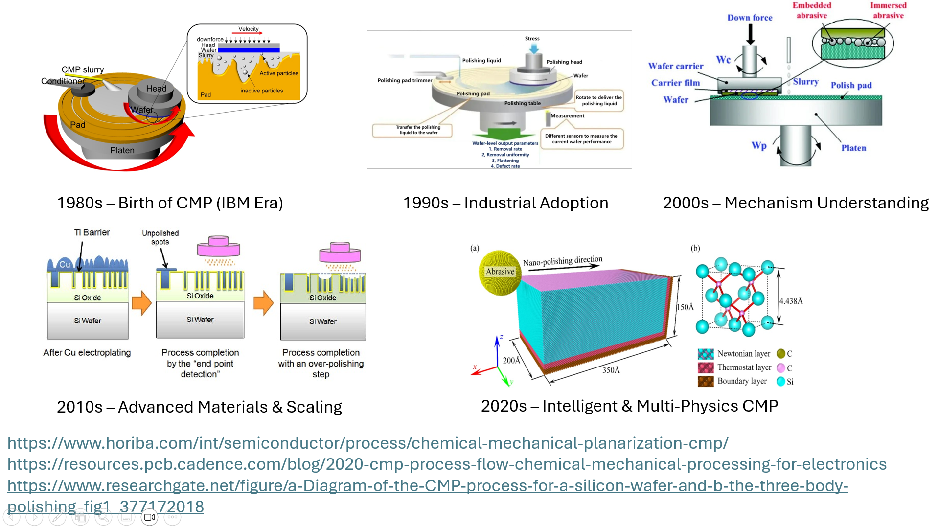
Evolution of CMP over the decades
- Limitations
Current Chemical Mechanical Planarization (CMP) models suffer from several inherent limitations due to the complex, multiscale nature of the process. Most widely used models, such as Preston-based models, assume a linear relationship between material removal rate, pressure, and velocity, which fails to capture nonlinear effects arising from slurry chemistry, pad aging, and temperature variations. These models treat the Preston coefficient as a constant, even though it strongly depends on local chemistry, abrasive interactions, and material properties.
Many CMP models rely on purely mechanical or purely geometric assumptions, neglecting the true chemical–mechanical synergy at the wafer–pad interface. As a result, they cannot accurately predict defect mechanisms such as dishing, erosion, scratching, or corrosion. In addition, pattern-density effects and feature-scale variations are often averaged out, limiting model accuracy for advanced, highly patterned interconnect layouts.
Another major limitation is the lack of microscale and nanoscale contact modeling. Real CMP involves stochastic pad asperity contacts and abrasive dynamics, which are difficult to represent using continuum-based or empirical models. Furthermore, most existing models are material-specific and require extensive experimental calibration, reducing their predictive capability and general applicability across different processes and materials.
M. Krishnan, J. W. Nalaskowski, and L. M. Cook, “Chemical Mechanical Planarization: Slurry Chemistry, Materials, and Mechanisms,” Chemical Reviews, 2009.

Future Scope
The scope of this work can be significantly expanded by moving beyond ideal CMP modeling to include physically realistic effects such as dishing, erosion, scratching, and non-uniform material removal. Incorporating slurry chemistry parameters, pad wear, temperature effects, and pressure non-uniformity would allow a more accurate representation of industrial CMP processes. Extending the simulations from 2D to full 3D structures would enable the study of layout- and pattern-density–dependent planarization effects, which are critical in advanced interconnect technologies.
Future studies may also focus on CMP of different materials such as copper, low-k dielectrics, and barrier layers to evaluate selectivity and defect mechanisms. Integration of CMP simulations with experimental calibration data can enhance model reliability and predictive capability. Additionally, machine learning–assisted CMP optimization and multi-physics coupling (mechanical, chemical, and thermal) can be explored to improve process control and scalability for next-generation semiconductor technology nodes.

- Conclusion
This project successfully demonstrates the role of Chemical Mechanical Planarization (CMP) in achieving surface flatness using Synopsys Sentaurus TCAD. A two-dimensional process flow involving trench etching, oxide deposition, and CMP planarization was modeled to study surface topography evolution. The results show that CMP effectively removes oxide overburden and produces a uniformly planar surface, which is essential for advanced semiconductor fabrication. Although the simulation assumes ideal CMP behavior and does not include defect mechanisms such as dishing or erosion, it provides clear insight into planarization efficiency and geometry evolution. Overall, the study highlights the usefulness of TCAD-based CMP modeling as a valuable tool for understanding and analyzing planarization processes in early-stage process development.

References

- M. Krishnan, J. W. Nalaskowski, and L. M. Cook, “Chemical Mechanical Planarization: Slurry Chemistry, Materials, and Mechanisms,” Chemical Reviews, 2009.
- P. B. Zantye, A. Kumar, and A. K. Sikder, “Chemical mechanical planarization for microelectronics applications,” Materials Science and Engineering R, vol. 45, pp. 89–220, 2004.
- K. Gamagedara and D. Roy, “Experimental strategies for studying tribo-electrochemical aspects of chemical mechanical planarization,” Lubricants, vol. 12, no. 2, 2024.
- T.-Y. Kwon, M. Ramachandran, and J.-G. Park, “Scratch formation and its mechanism in chemical mechanical planarization (CMP),” Friction, vol. 1, no. 4, pp. 279–305, Dec. 2013, doi: 10.1007/s40544-013-0026-y.
- K.-T. Yeh and H.-Y. Tsai, “Mechanically modeling chemical mechanical planarization from wafer to molecular scales: A review and discussion of future direction,” Journal of Mechanics, vol. 40, pp. 769–773, Dec. 2024, doi: 10.1093/jom/ufae055.
- G. Winkler, T. Rothe, M. A. Sayyed, L. Jäckel, J. Langer, H. Kuhn, and M. Stoll, “Machine learning in chemical–mechanical planarization: A comprehensive review of trends, applications, and challenges,” Advanced Engineering Informatics, vol. 68, Nov. 2025, Art. no. 103663, doi: 10.1016/j.aei.2025.103663.
- D. Müller, S. Park, I. González, P. Nowak, J. Chen, and A. Rahman,“Nanoparticles for chemical mechanical planarization: A review,” Nanomaterials, vol. 15, no. 17, 2025.
- S. B. K. Vrudhula and S. Sapatnekar,“Statistical and machine learning methods for semiconductor manufacturing,”IEEE Transactions on Semiconductor Manufacturing, vol. 34, no. 3, pp. 321–335, Aug. 2021.
[9] S. Luo, D. A. Dornfeld, and F. Pei,“Material removal mechanism in chemical mechanical planarization: From wafer to molecular scale,”IEEE Transactions on Semiconductor Manufacturing,
vol. 14, no. 2, pp. 112–133, May 2001.
[10] S. Luo, D. A. Dornfeld, and F. Pei,“Mechanisms of defect generation in chemical mechanical polishing,”
Wear, vol. 257, nos. 9–10, pp. 1005–1013, 2004.
[11] H. Bellahsene, S. Sene, G. Félix, J. Larionova, M. Ferrari, and Y. Guari,“Nanoparticles for chemical mechanical planarization: A review,”Nanomaterials, vol. 13, no. 17, Article 2456, 2023.
[12] B. H. Cook,“Chemical processes in chemical mechanical polishing,”Journal of The Electrochemical Society,vol. 137, no. 6, pp. 1937–1944, 1990.

