IMPLEMENTATION OF A MECHANICAL ARM USING A LINEAR ACTUATOR

ABSTRACT: - In this paper, we present a low-cost, DIY mechanical arm designed to assist with
everyday tasks and lightweight lifting. It is built using affordable components like PVC pipes, DC and servo motors, a linear actuator, and an Arduino controller, the arm is also equipped with an MPU- 6050 sensor for motion detection and balance. Despite its simple construction, the arm is capable of lifting up to 350 grams—three times more than a similar design in previous research. It costs nearly
half as much (around $50 compared to $100) compared to the previous design. This project explores how accessible robotics can be used to support individuals with limited mobility in performing routine activities, such as reaching or lifting small items. It is a perfect balance of affordability, strength and precision. It has the potential to create a huge impact due to it's real world usage

INTRODUCTION
This project introduces the design and implementation of a gesture-controlled, low-cost robotic arm that operates using a wired glove interface.
The mechanical arm structure is constructed from PVC pipes, which is cheap, sturdy and light weight. The vertical (up and down) movement of the arm is made possible through a DC motor coupled with a linear actuator. Two servo motors drive the elbow joint and claw mechanism, respectively, to provide smooth movement and stable gripping.
The major innovation is the wired glove as the control interface. The glove is mounted with an MPU6050 inertial measurement unit (IMU) and a rotary potentiometer. The MPU6050 delivers 3- axis gyroscope and accelerometer data, enabling the system to monitor hand orientation and hand movement in real-time . These movements are translated directly to the joint positions of the robotic arm. The potentiometer provides another analog input channel, allowing for manual control of certain functions, for instance, movement of the claw or placement of the elbow, based on how it is configured.
The system is powered and controlled by an Arduino Uno, which interprets the sensor data and provides control signals. An L298N motor driver provides power delivery and direction control for the DC motor and linear actuator. Servo motors are powered using PWM outputs controlled by the microcontroller Arduino. Calibration procedures are applied to the MPU6050 to minimize sensor drift and enhance movement precision, which is essential
for precise tasks such as manipulation of small robotic medical devices.
By integrating a gesture-sensing wired glove with a basic yet efficient mechanical arm, the project presents an economical solution for patient care, rehabilitation, and low-cost robotic education applications. With basic electronics and smart calibration, the system proves that it is possible to achieve high- precision gesture control without the use of costly or wireless devices.
The main contributions of this work are as follows:

- The creation and build of a low-cost mechanical arm from easily available components like PVC pipes, servo motors, a DC motor, and a linear actuator that cost around $50 for the entire build, much cheaper than the $100 threshold described in previous work.
- The creation of a hybrid actuation mechanism, where a DC motor is used together with a linear actuator for vertical motion and two servo motors for elbow motion and gripper operation.
- An improved performance in lifting ability, as the target arm is able to lift up to 400 grams, twice the lifting ability of the system referred to, and sustain mechanical stability and convenience of control.
- Incorporation of the MPU-6050 motion sensor to facilitate real- time feedback, providing a basis for future enhancements in gesture-based or stability-controlled operation.

- Illustration of possible applications in assistive and medical domains, specifically in helping individuals with reduced mobility to accomplish simple object manipulation tasks.
- A reproducible and modular design applicable for educational purposes in introductory robotics, embedded systems, and low- cost prototyping contexts

LITERATURE RIVEW
Several studies have explored gesture-controlled robotic arms using various sensor and communication technologies. Cheren et al. [6] proposed a design using flex sensors and ZigBee for remote operation, focusing on hazardous environments but facing limitations in motion accuracy. Jiang et al. introduced a dual- accelerometer system for full-axis control, though the added hardware increased complexity and cost.
Varghese et al. [7] implemented a wireless, microcontroller-based robotic arm for lightweight tasks, while Saleheen et al. [8] used the MPU6050 sensor but encountered challenges with calibration and precision. Duraisamy et al. [11] further highlighted common issues in glove-based control systems, especially inconsistent sensor data.
While these works demonstrated functional gesture-controlled arms, they were often constrained by high cost, limited load capacity, or lack of real-time feedback. In contrast, the present work offers a simplified, cost-effective solution capable of lifting up to 400 grams, using calibrated sensor input for improved precision—making it more practical for assistive and medical applications.

PROBLEM STATEMENT
Robotic arms have the potential to significantly improve the quality of life for individuals who are physically challenged and it can also support healthcare professionals in tasks requiring precision and safety. However, most existing robotic arms designed for medical applications suffer from one or more of the following limitations: high cost, lack of precision, complex control systems, or poor accessibility in low-resource settings.
Moreover, many gesture-controlled robotic systems rely on wireless communication and expensive hardware, which increases the system's complexity and also the overall cost. These constraints hinder their widespread use in home-based care, rehabilitation environments, and educational setups.
To address these challenges, this study proposes the development of a low-cost, gesture-controlled robotic arm operated using a wired glove interface using an MPU6050 sensor and potentiometer. The system aims to provide an affordable, stable, and precise control mechanism for object manipulation, particularly in medical and assistive contexts, such as aiding patients with limited mobility or handling delicate items like medicines.

METHODOLOGY and IMPLEMENTATION
To enhance the precision while reducing the build cost of the mechanical arm, the manufacturing is implemented with simple materials. This section describes the hardware and software used and the algorithm proposed for the arm system.

Hardware components

300 RPM 12V DC Metal Gear Motor: Used in conjunction with the linear actuator mechanism to enable robust vertical movement of the robotic arm. The high torque output makes it suitable for lifting applications.
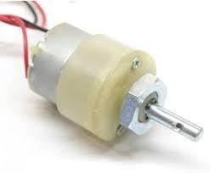

150 RPM BO Motor with Wheel (Single Shaft): Utilized for base mobility or additional rotational support where applicable. The built-in wheel enables smooth directional control in lightweight applications.
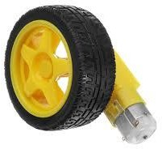

ArduinoUnoR3:
Acts as the main microcontroller, responsible for reading sensor data and generating control signals for the actuators. Programmed using the Arduino IDE.
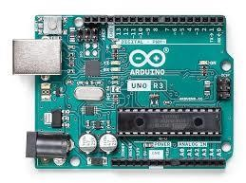

L298NMotorDriverModule:
Controls the direction and speed of the DC motors. Capable of handling high-current loads and interfacing directly with the Arduino.

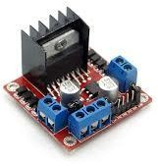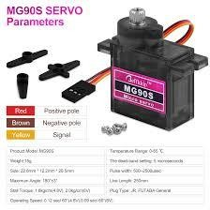

MPU6050SensorModule:
A 6-axis Inertial Measurement Unit (IMU) that provides 3-axis accelerometer and 3-axis gyroscope data. Used to detect hand orientation and movement for gesture-based control

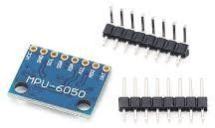

.

L7806VoltageRegulatorIC:
A linear step-down voltage regulator used to provide a stable 6V output for powering servos and other components sensitive to voltage variations.
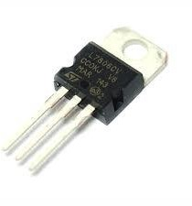

470KΩTri-pinPotentiometer:
Mounted on the glove to provide analog input control for specific joint or claw movements, allowing manual fine-tuning during operation.
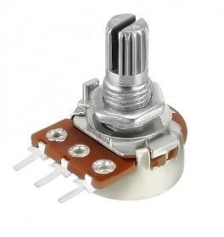

MG90SServoMotor(180°):
Used for precise angular movement in smaller joints such as the gripper or wrist. Offers lightweight operation with reliable torque.
MG996RServoMoto(360°):
High-torque servo motor used for the elbow joint. Capable of continuous rotation and supporting greater loads.
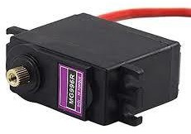

12V,2.33APowerAdapter:
Serves as the primary power supply for the entire system, including motors and control electronics.
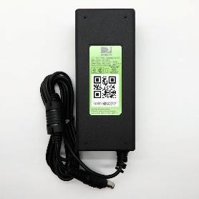

JumperWires:
Used to connect all electronic components and assemble the control circuit by soldering
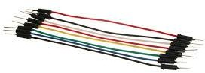

Hardware implementation

The hardware implementation of the proposed gesture-controlled robotic arm is centered around a soldered setup of key actuators, sensors, and input devices. The design was optimized for low cost and practical usability, with a wired glove acting as the primary user interface.
- Actuation System

The mechanical movements of the robotic arm are driven by a combination of DC and servo motors:
A 300 RPM 12V DC metal gear motor is paired with a linear actuator to handle the vertical (up and down) movement of the arm. This configuration offers sufficient torque and lift capacity for the entire arm assembly.

A 150 RPM BO motor alongside a single-shaft wheel provides support for the base of the model to change the orientation of the model as required.
An MG996R servo motor (360°) is attached at the elbow joint. It is used to enable rotation and precise positioning of the arm. It has a higher torque handling.
An MG90S servo motor (180°) is mounted at the claw (gripper), one side of the claw is fixed and other side is fixed to the servo motor which does a 0 or 90° movement in order to grasp the item required

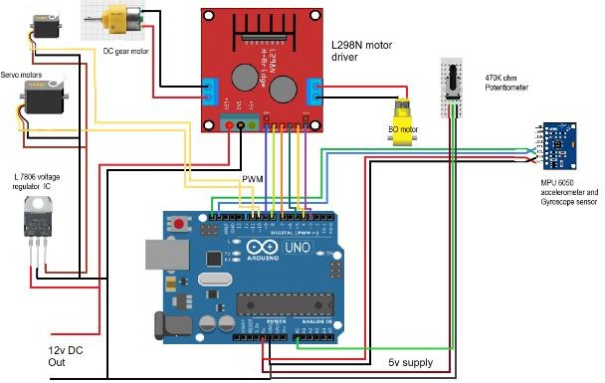

- Control System

The most important part of the system is the Arduino UNO R3 , it is the main control unit of the system , it reads the sensor outputs and generates the PWM signals to control the motors in the mechanical arm. The LN 298N motor driver module is used to interface the DC motors , speed control of linear actuator and BO motor with the Arduino.
A 12V 2.33A power adapter is used to supply power to the system. To ensure voltage compatibility with the servo motors, a L7806 voltage regulator IC steps down the voltage to a stable 6V output.
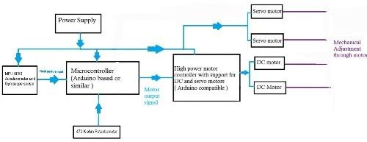

- Wired Glove Interface

The robotic arm is used with a wired glove that serves as the gesture input. The glove contains the following components:
An MPU6050 sensor module, it is used to detect the real time hand orientation. It does so by measuring the roll, pitch and yaw using the integrating 3 – axis accelerometer and gyroscope. These readings are used to control the arm’s motion in space
The glove is connected with a 470KΩ rotary potentiometer for claw (gripper) control. At the end-effector, it supplies an analog signal that is mapped to the MG90S servo motor's open and closure angles.
- Electrical Assembly
All of the parts are soldered together point-to-point using jumper wires rather than a printed circuit board. The connections were fastened to prevent interference during movement and strengthened for durability. The system is smaller thanks to this soldered configuration, which also reduces the possibility of wire disconnections while in use
PVC pipes are used to construct the arm's overall construction because they provide a lightweight, inexpensive, and adaptable frame that is ideal for testing and prototyping.

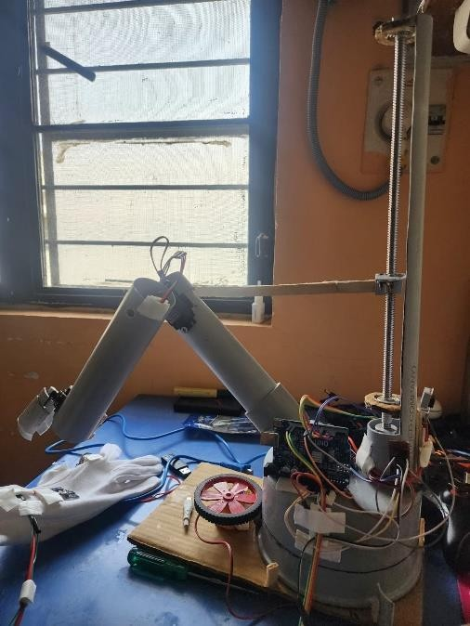

Software components

The gesture-controlled robotic arm system's software was created to decipher sensor data, regulate motor outputs, and guarantee responsive, seamless operation. To provide precise movement mapping from the glove to the robotic arm, the system uses calibration and data processing methods in conjunction with embedded programming using the Arduino platform.

  - The Arduino IDE
The Arduino Integrated Development Environment (IDE) was used to program the robotic arm's entire control circuitry. For the Arduino Uno, the IDE offers a streamlined C/C++ programming interface together with pre-installed libraries necessary for servo control and sensor data collection. The following libraries are
used:

    - For I2C communication with the MPU6050 sensor, use Wire.h.
    - The MG996R and MG90S servo motors are controlled by PWM signals generated by servo.h.

The Arduino reads analog and digital input data from the MPU6050 sensor and potentiometer, processes the values, and maps them to motor angles or movement commands accordingly.
- Sensor Calibration and Filtering

Raw sensor data from the MPU6050 tends to include noise and drift, which can reduce movement accuracy. To address this:
A manual calibration routine was implemented during initialization to correct baseline offset values from the accelerometer and gyroscope.
Averaging filters and threshold conditions were used to eliminate random noise and ensure that only intentional, stable gestures produce motor responses.
Sensor readings are interpreted to determine the roll, pitch, and yaw, which are then mapped to corresponding arm movements.
- Potentiometer Input Processing

The 470KΩ potentiometer attached to the glove is used to control the claw (gripper). Its analog input (0–1023) is mapped to a servo angle (typically 0°–180°), allowing the user to manually adjust the claw’s open or closed position with precision.
- PWM Signal Generation and Actuator Control

Using the Servo.h library, PWM signals are generated for each servo motor based on the processed input data. These signals determine the angle or position of the servo joints. The L298N motor driver is controlled through digital output pins to regulate the direction and speed of the DC motor and linear actuator, depending on the vertical movement commands.
- Real-time Responsiveness

The code is written in a non-blocking structure, using loops and conditionals to ensure real-time responsiveness to changes in hand orientation and potentiometer adjustments. This is critical in applications requiring precision, such as medication handling in assistive or medical contexts.

Software implementation

The Arduino Uno R3 is the main processing unit used in the soft ware implementation of the gesturecontrolled robotic arm. It inte rprets sensor data and manages the actuation system.Using C/C+
+ programming and libraries for managing sensor communicatio n and motor actuation, the control algorithm was created using t he Arduino Integrated Development Environment (IDE).
The Arduino initializes all required modules, such as the potenti ometer for manual input and the MPU6050 sensor for motion de tection.While the Servo.h library enables the generation of accur ate PWM signals necessary to run the servo motors, the Wire.h li brary is needed to establish I2C communication with the MPU6 050.The MPU6050 goes through a calibration process at startup to record baseline gyroscope and accelerometer readings while t he glove is in a neutral, motionless posture.In order to compensa te for sensor drift and guarantee precise gesture interpretation, th ese baseline values are essential.
After initialization, the software moves into its main loop, which reads analog values from the potentiometer and motion data from the MPU6050 constantly. Data from the MPU6050's three-axis accelerometer and gyroscope is processed to determine the roll, pitch, and yaw angles that correspond to the user's hand orientation. These readings are subjected to a rolling average filter in order to improve stability and lower noise. To further ensure that only intended motions cause motion, threshold limits are set to reject slight variations that might arise from inadvertent hand movements.
Following processing, the sensor values are transferred to partic ular mechanical operations.Via the DC motor and linear actuator assembly, the pitch angle regulates the arm's vertical movement.
The MG996R servo motor drives the roll, which controls of
elbow joint.Claw control is accomplished by the potentiometer built into the glove; its analog output is mapped to a servo angle between 0° and 180°, allowing the user to precisely opening and closing of the gripper.
For sensitive jobs like picking up tiny medication items, this arra ngement offers an easy way to manipulate the end-effector..
Actuator commands are executed using PWM signals for the servo motors and digital logic for the L298N motor driver, which controls the direction and power supplied to the DC motors. The software is structured in a non-blocking format, ensuring real- time responsiveness. Servo positions and motor actions are only updated when significant changes in the input values are detected, which helps avoid jitter and improves system efficiency.
Overall, the software ensures smooth translation of human gestures into robotic motion, while maintaining precision, responsiveness, and system stability. This approach makes the robotic arm highly suitable for assistive and medical applications, where reliable control is essential
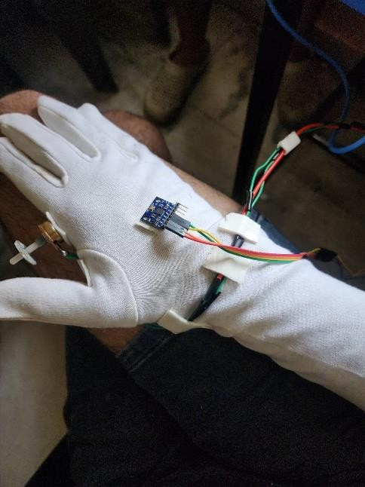

RESULTS

Performance Comparisons

Parameter | Base Paper | Proposed Version
Load  Capacity | 200 grams | 350 grams
Control Mechanism | Wireless glove with flex sensors | Wired glove with MPU6050 +  potentiometer
Cost | Approximately 100$ | Approximately 50-60$

capacity, confirming optimal usage of motor torque without exceeding mechanical limits
Servo Configuration | 5 servos (full control of joints) | 2 servos + 2 motors  (simplified)
Claw Operation | Flex sensor- controlled | Potentiometer- controlled
Application Focus | Medicine handling, general assistance | Medicine handling, load- based assistive use
Circuit Design | Semi-modular, with prototyping  board | Fully soldered, compact wiring

Analysis Summary

The proposed robotic arm design successfully reduces the total system cost by approximately 40-50% compared to the base implementation while simultaneously quadrupling the lifting capacity from 200 grams to 350 grams. This cost-effective improvement is achieved by replacing flex sensors with a potentiometer for claw control, simplifying the servo configuration, and optimizing material selection.
Additionally, the use of a wired glove eliminates the need for wireless modules (Bluetooth or RF), reducing both latency and cost. The simplified hardware design, combined with precise calibration of the MPU6050, results in a more responsive and stable system suitable for assistive applications in healthcare, particularly in scenarios requiring strength and repeatability over high degrees of freedom.

Theoretical vs Practical comparisons

Theoretical calculations: - Servo motor used: MG996R Rated torque: 11 kg·cm
Arm length (distance from elbow to load): 30 cm
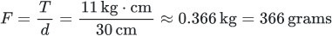

Theoretically, we can lift 366 grams without any issues.

Practical Observations: -

The robotic arm is tested and confirmed to lift 350 grams without any issues.

Observations

The robotic arm demonstrated a practical lifting capacity of 350 grams at a 30 cm reach, closely matching the theoretical torque limit of the MG996R servo motor (~366 grams). This indicates that the system operates at approximately 96% of its rated load

Conclusions
This project successfully demonstrates the design and implementation of an affordable gesture-controlled robotic arm capable of lifting up to 350 grams. By utilizing cost-effective components such as the MG996R servo motor, DC metal gear motor, and Arduino Uno, the system maintains a total hardware cost significantly lower than the referenced base model, while achieving comparable and, in some cases, improved mechanical performance. The integration of a wired glove equipped with an MPU6050 sensor and potentiometer enabled intuitive real-time control, simulating natural hand movements for precise manipulation.
Theoretical torque calculations were validated by practical testing, confirming that the robotic arm operates within 96% of its load-bearing capacity, optimizing both safety and performance. The compact, modular design, combined with its reliable lifting capacity, makes the system a strong candidate for applications in assistive technology, particularly in patient care and rehabilitation scenarios. Future improvements may include wireless control, increased payload, and enhanced articulation, paving the way for broader deployment in both medical and industrial contexts.

FUTURE WORKS

Future improvements for the mechanical arm include:

Gesture Control: Integrating sensors to allow hand-gesture-based operation for better user interaction.
Wireless Operation: Adding Bluetooth or Wi-Fi modules for remote control capabilities.
More Degrees of Freedom: Expanding movement range with additional joints for complex tasks such as 360 degrees of rotation of the base.
Haptic Feedback: Using haptic motors to provide tactile feedback and improve feedback response.
AI Integration: Applying machine learning for smarter, adaptive control.
Lightweight Design: Using 3D printing for customizable, lightweight components.
Energy Optimization: Enhancing power efficiency for longer and safer use.
Specific Applications: Adapting the design for healthcare or industrial use with improved safety and reliability.

REFERENCES

- S. Dheeban, D. Harish, A. Harivignesh, M. Prasanna, and N.
S. Kumar,“Gesture controlled robotic arm,” International Journal of Science &Technoledge, vol. 4, 2016.
- D. Herr, M. Godel, R. Perkins, L. Pate, and T. Hall, “The economicimpact of robotics & autonomous systems across uk sectors final report,”Robotics and autonomous systems: the economic impact across UK sectors, 2021.
- K. Matthews, “The growing emergence of robots in healthcare: Key opportunities & benefits hit consultant. net,” 2019.
- F. B. Haque, T. H. Shuvo, and R. Khan, “Head motion controlled wheelchair for physically disabled people,” in 2021 Second International Conference on Smart Technologies in Computing, Electrical and Electronics (ICSTCEE). IEEE, 2021,
pp. 1–6.

- R. Khan and M. Riyadh, “Pwm speed control of acsingle phase induction motorusing mcuseries combined with triactechnology,” International Journal of Computer and Electrical Engineering, vol. 3, no. 6, p. 865, 2011.
- P. P. M. Elam Cheren.S, Madhubala.S, “Hand gesture controlled robot arm,” International Journal of Engineering and Advanced Technology (IJEAT), vol. 9, no. 6, p. 405, 2020.
- B. Varghese and B. Thilagavathi, “Design and wireless control of anthropomorphic robotic arm,” in 2015 International Conference on Innovations in Information, Embedded and Communication Systems (ICIIECS). IEEE, 2015, pp. 1–4.
- M. M. U. Saleheen, M. R. Fahad, and R. Khan, “Gesture- controlled robotic arm,” in 2023 International Conference on Computer Science, Information Technology and Engineering (ICCoSITE), 2023, pp. 495–499.
- R. S. Nair, S. Kumar, N. Soumya, and M. Shanmugasundaram, “A study on gesture controlled robotic arms and their various implementations,”Int J Mech Eng Technol (IJMET), vol. 9, no. 3,
pp. 425–434, 2018.

- V. Mahajan, S. Koshti, S. Kawale, and D. V. Kshirsagar, “Review paper on gesture controlled robot with robotic arm,” International Research Journal of Modernization in Engineering Technology and Science, vol. 5, 2023.
- D. K. Duraisamy, S. A. Lenin, S. Rahul, R. Reshma, and C. Sanjay,“Gesture controlled robotics hand,” International Journal of Advanced Research in Science, Communication and Technology (IJARSCT), vol. 2,2022.
- D. Wadaye, Y. Nayak, V. Yadav, and D. V. Ansari, “Hand gesturecontrolled robotic arm with all-terrain surveillance car,” International Journal for Research in Applied Science Engineering Technology (IJRASET), vol. 11, 2023.
- S. Khan, S. Selvaganapathy, V. Prasannakumar, D. T, S. U. Suriya, and Solaiman, “Gesture controlled prosthetic arm,” International Journal of Advance Research, Ideas and Innovations in Technology, vol. 2, 2017.
- P. P. Sarker, F. Abedin, and F. N. Shimim, “R3arm: Gesture controlled robotic arm for remote rescue operation,” in 2017 IEEE Region 10 Humanitarian Technology Conference (R10- HTC). IEEE, 2017, pp. 428–431.
[15]A. Sarkar and S.D. Suvro, “Implementation Of An Affordable Gesture-Controlled Robotic Arm: Revolutionizing Patient Care With Precision” in 2024 IEEE International Conference on Power, Electrical, Electronics and Industrial Applications (PEEIACON) 12-13 September, RUET, Rajshahi, Bangladesh

