# Advanced Neural Network Architectures for Sequential Recommendation

## Group-12 Results & Analysis

1. Aamleen Ahmed
2. Ishaan Marwah
3. Jai Singh
4. Madhava Krishna
5. Sejal Kardam

# LIGHT GCN MODEL

The paper aims to simplify the design of GCN to make it more concise and appropriate for a recommendation.

The proposed model, called LightGCN, uses a basic method called neighborhood aggregation to learn about users and items. It does this by looking at how users and items are connected in a graph and making a weighted average of their embeddings.

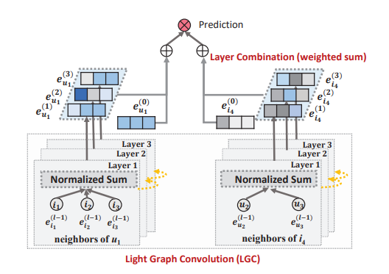

**An Illustration of Light GCN Model**

1. **Movielens Dataset(100 K)**

Parameters: Number of Iterations: 1000, Epochs: 10, K=10

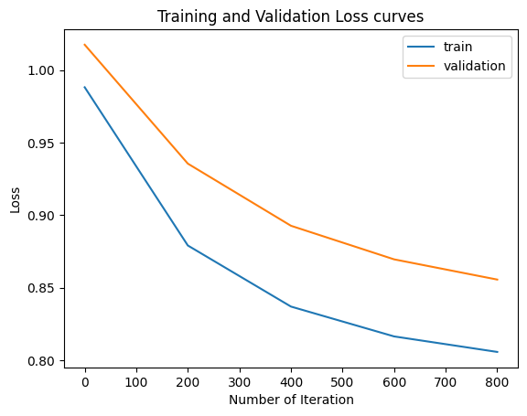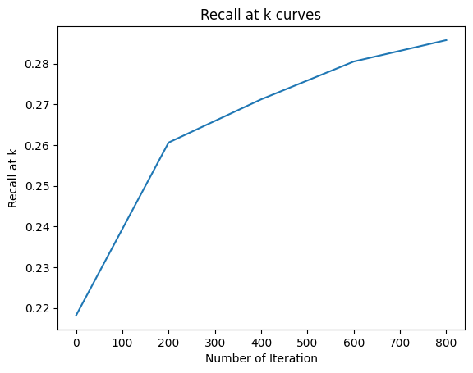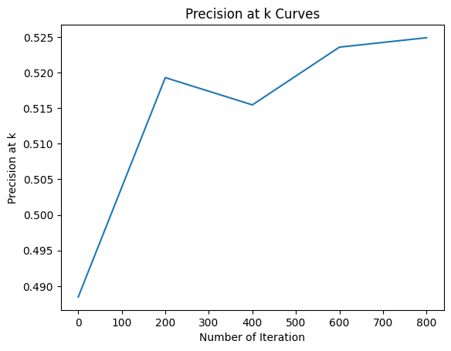

Recall at K = 0.30392 and Precision at K = 0.51476

Parameters: Number of Iteration:500, Epochs: 10, K=10

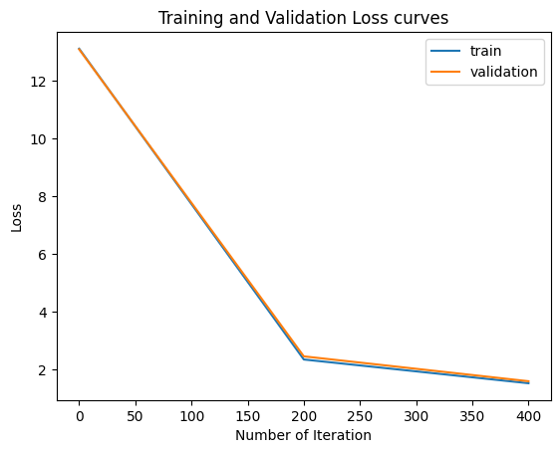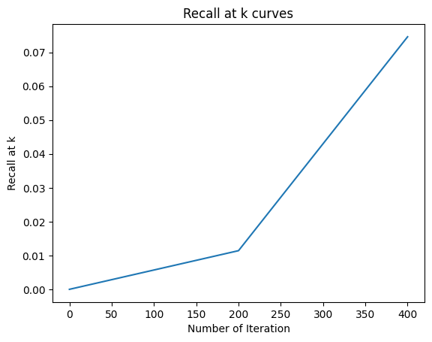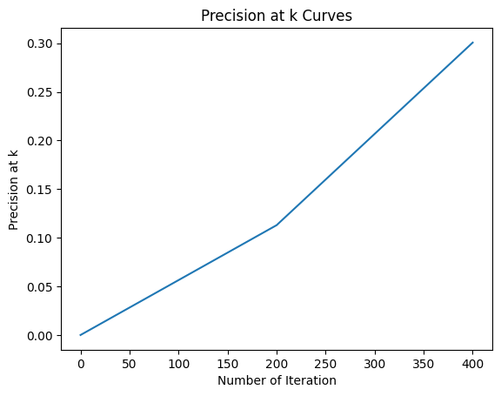

Recall at K=0.08509 and Precision at k=0.31086

Parameters: Number of Iterations: 600, Epochs: 10, K=10

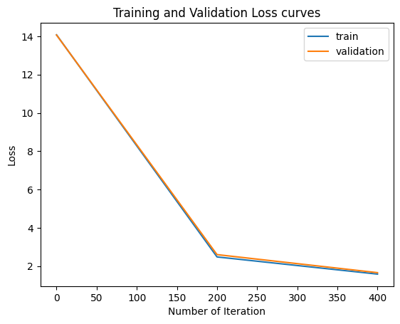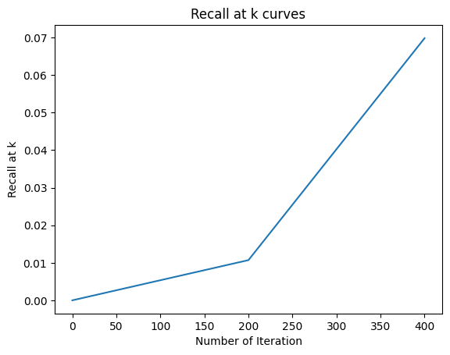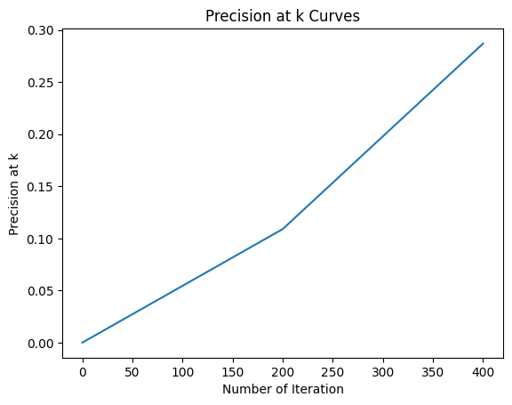

Recall at K=0.10052 and Precision at K=0.33419

Parameters: Number of Iterations: 700, Epochs: 10, K=10

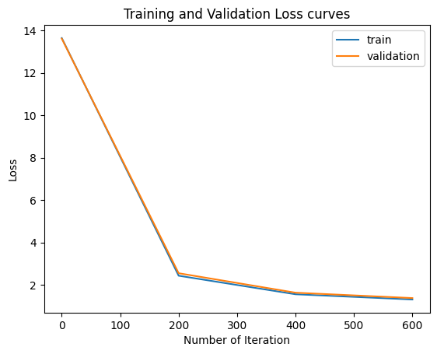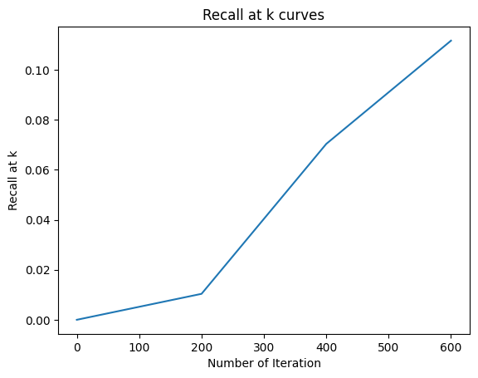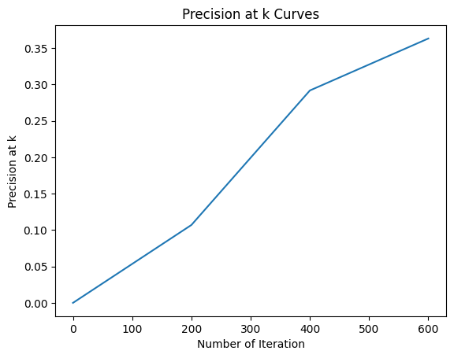

Recall at K=0.1198 and Precision at K=0.35972

Parameters: Number of Iteration: 800, Epochs: 10, K=10

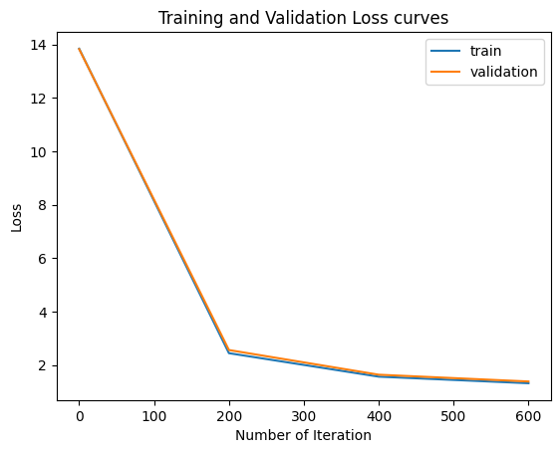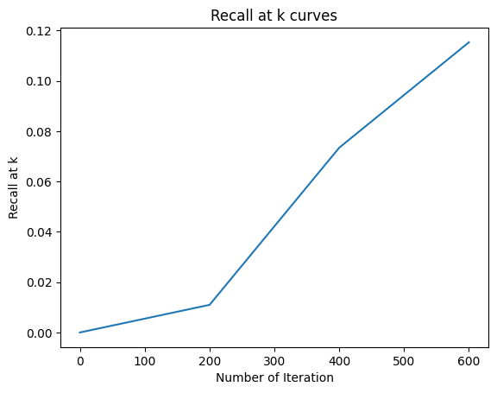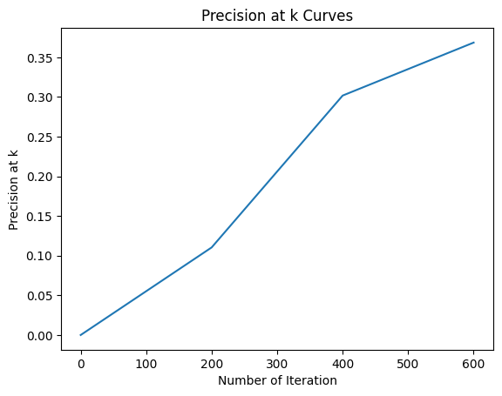

Recall at K=0.13726 and Precision at K=0.38427

Parameters: Number of Iteration = 900, Epochs = 10,K=10

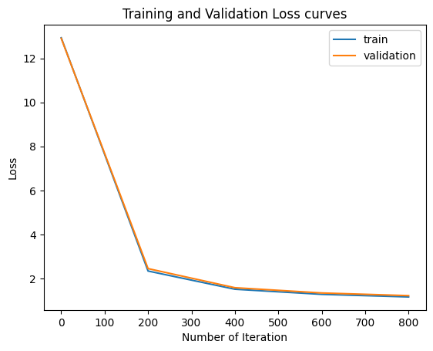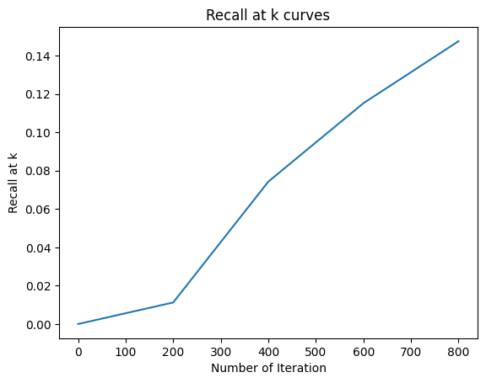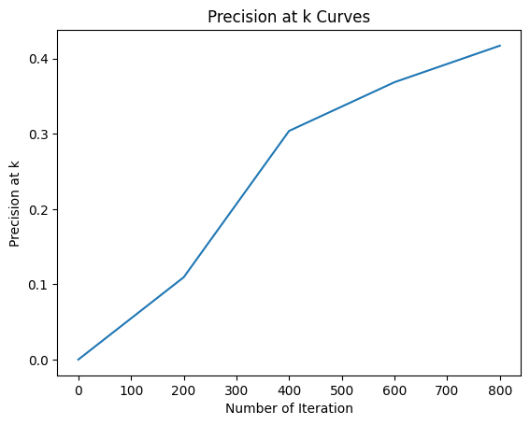

Recall at K=0.1517 and Precision at K=0.39381

1. **Amazon Book Reading Dataset**

Parameters: Number of Iteration= 500, Epochs=10,K=10

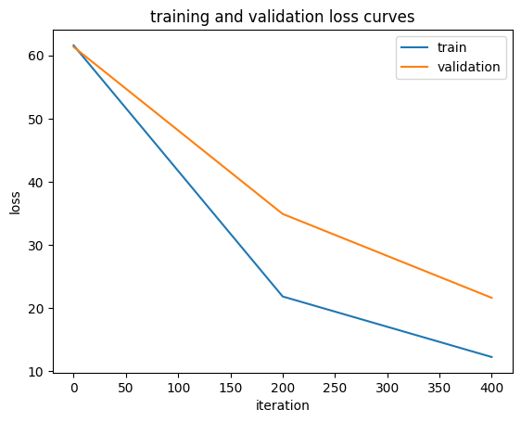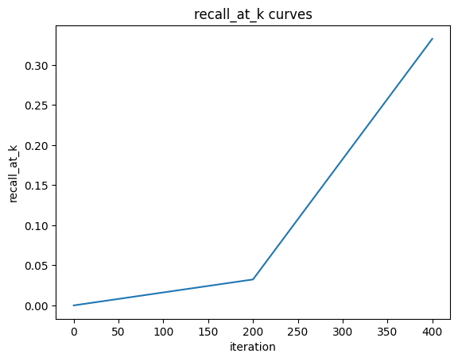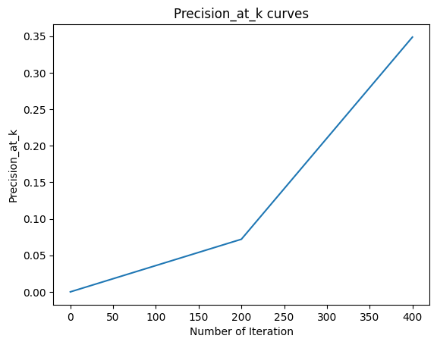

Recall at K=0.40337 and Precision at K=0.40639

Parameters: Number of Iteration = 600, Epochs = 10,K=10

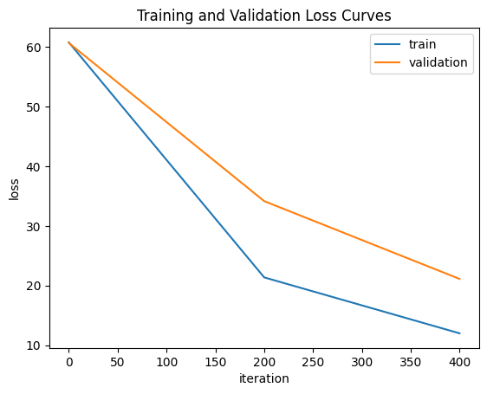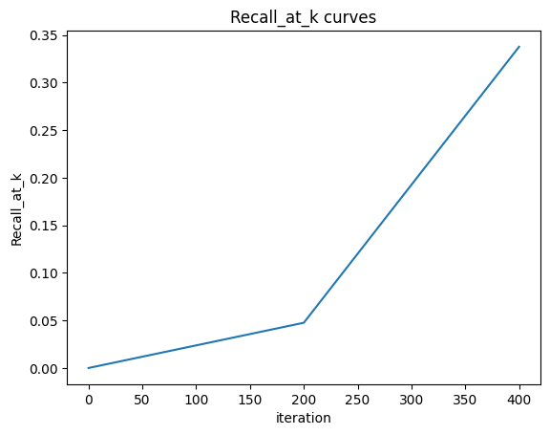

Recall at K=0.45246 and Precision at K=0.45584

Parameters: Numbers of Iteration=700, Epochs = 100, K=10

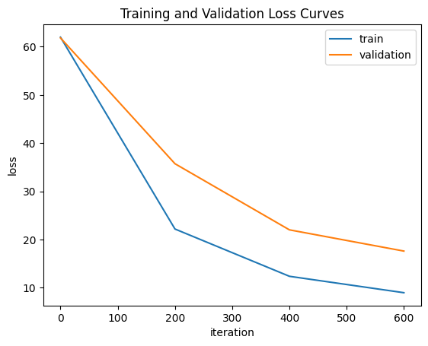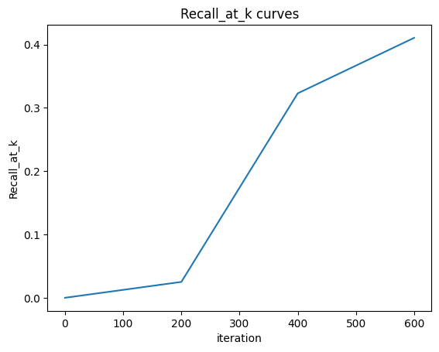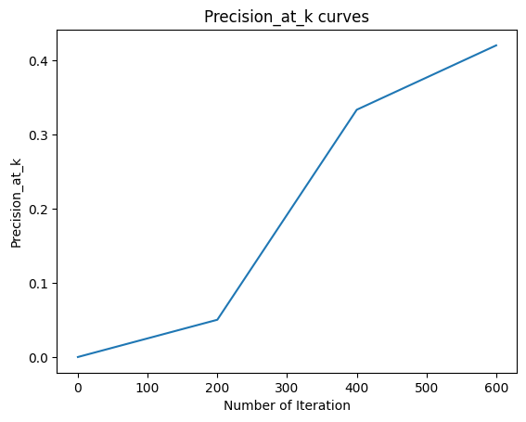

Recall at K=0.4759 and Precision at K=0.47782

Parameters Number of Iteration = 800 , Epochs = 10,K=10

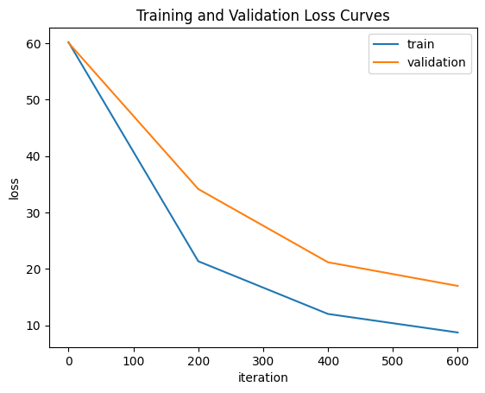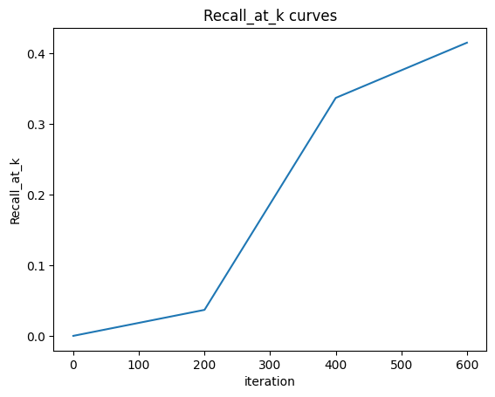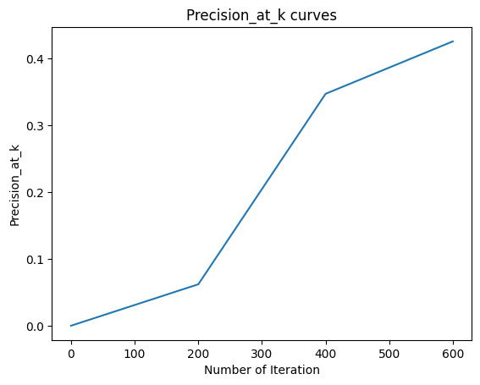

Recall at K=0.51766 and Precision at K=0.51518

Parameters: Number of Iteration = 900, Epoch = 10,K=10

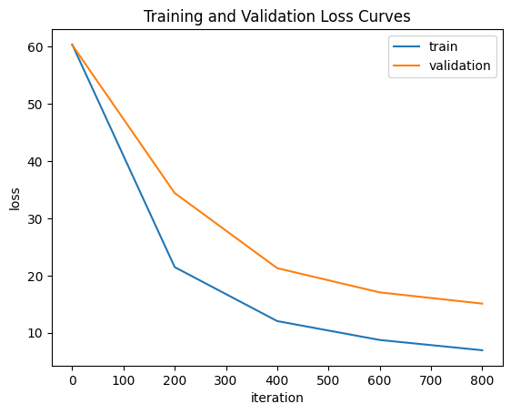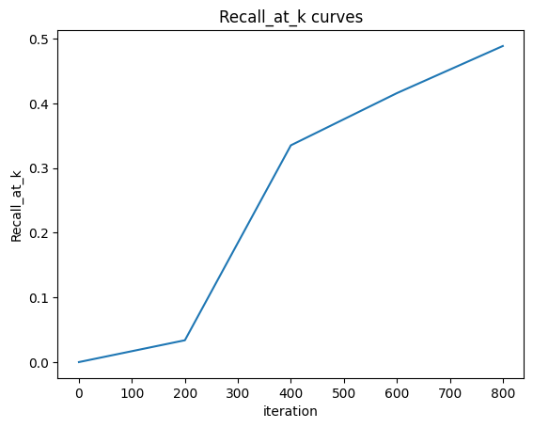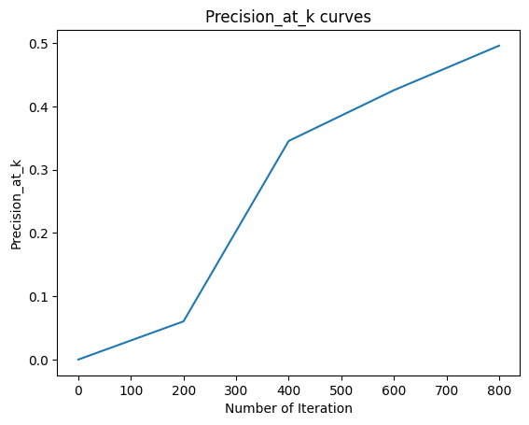  Recall at K=0.54401 and Precision at K=0.54145.

Parameters: Number of Iteration = 1000, Epochs = 10, K=10

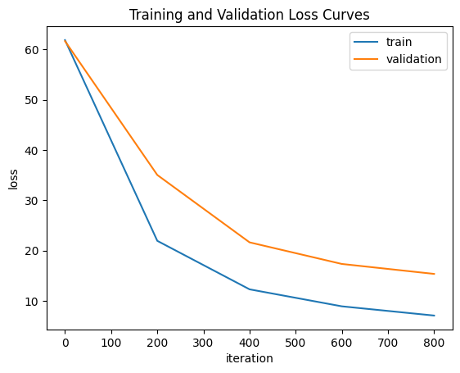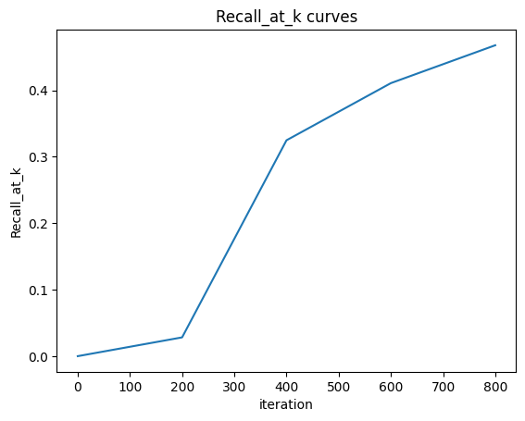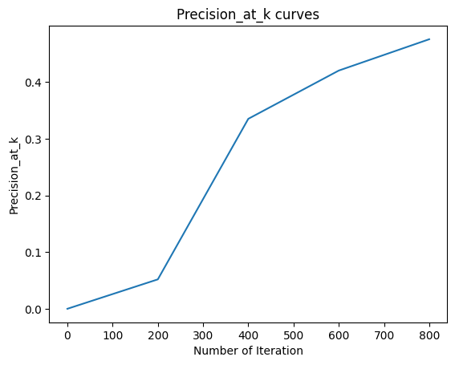

Recall at k=0.54623 and Precision at K=0.54375

**(3) Learning from the sets of Items 2019**

Parameters: Number of Iteration=500, Epochs = 10, K=10

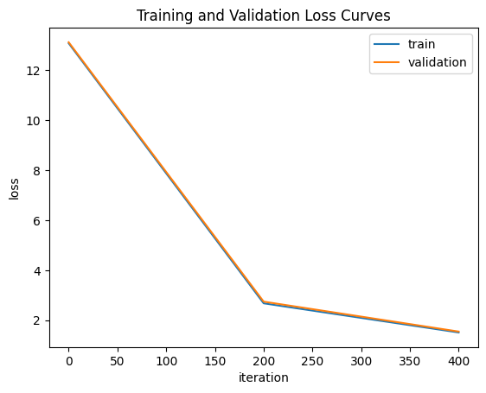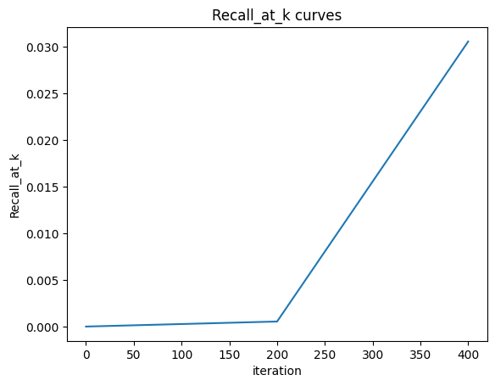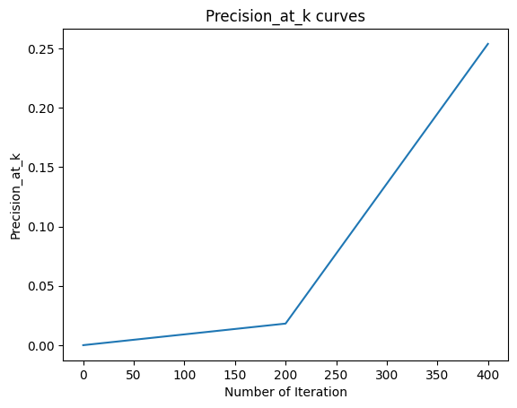

Recall at K=0.04748 Precision at K=0.29479

Parameters: Number of Iteration = 600, Epoch = 10, K= 10

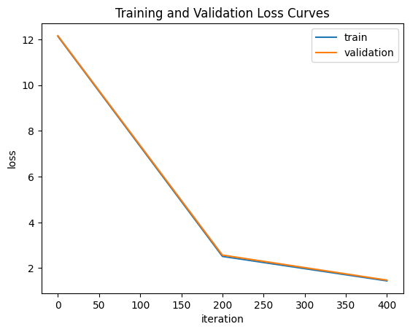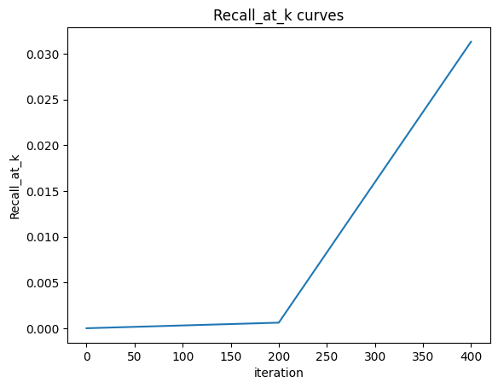 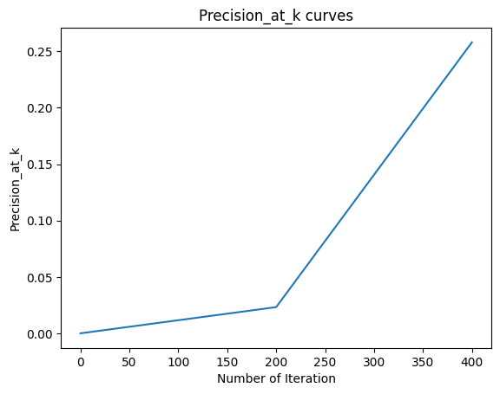

Recall at K=0.06567 Precision at K=0.34745

Parameters: Number of Iteration = 700, Epochs = 10, K=10

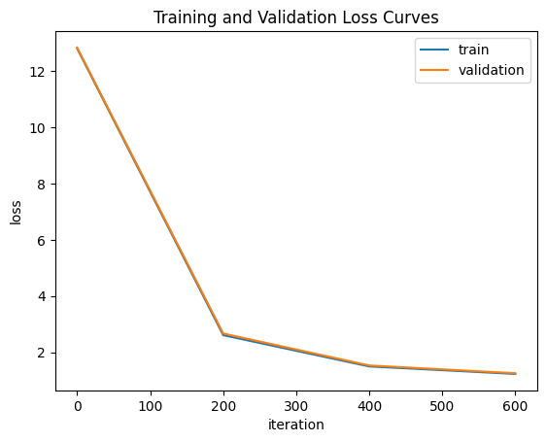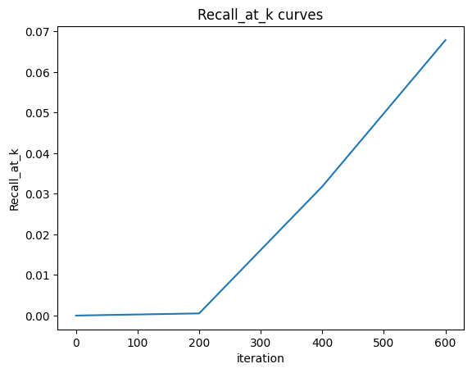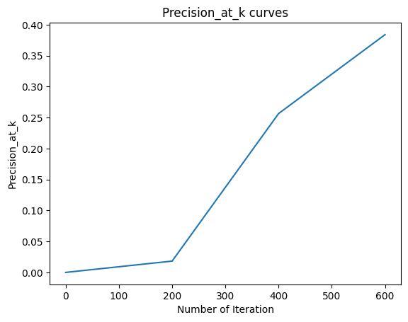recall_at_k 0.08052, precision_at_k 0.38234

Parameters: Number of Iteration=800, Epochs = 10,k=10

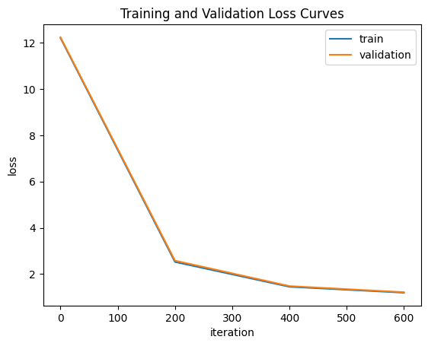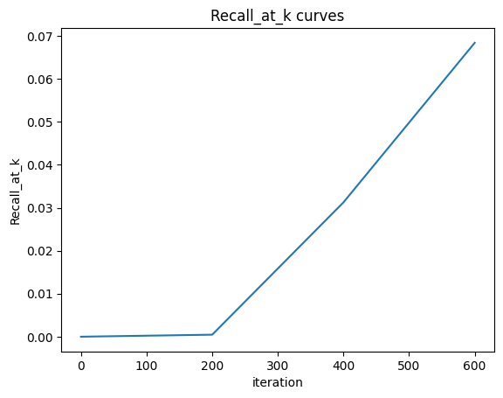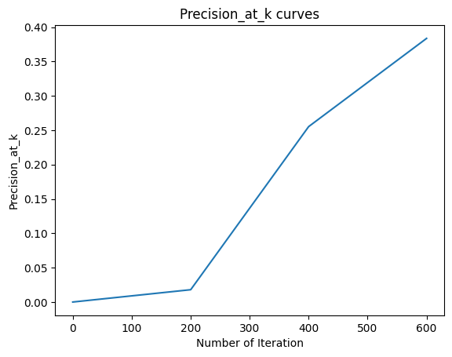

recall_at_k 0.09661, precision_at_k 0.4168

Parameters: Number of Iteration = 900, Epochs = 10, K=10

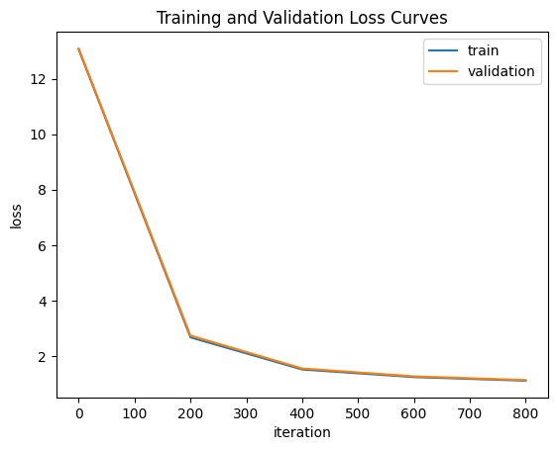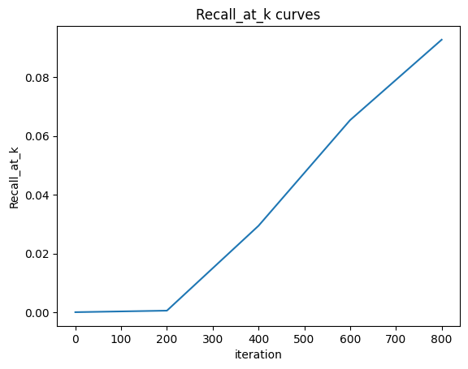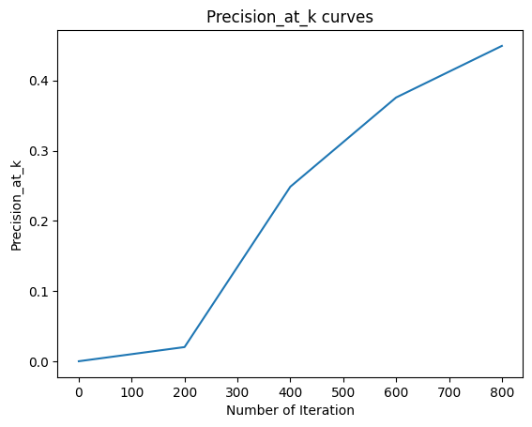

recall_at_k 0.10525, precision_at_k 0.42954

Parameters: Number of Iteration = 1000, Epochs = 10, K=10

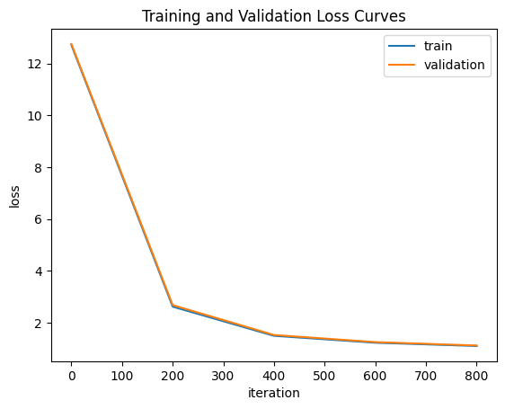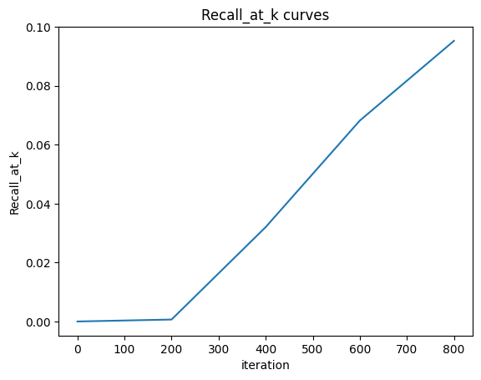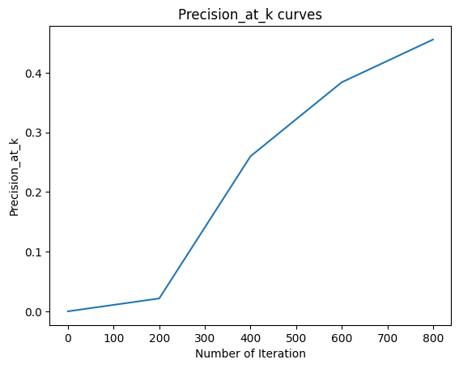

recall_at_k 0.12016, precision_at_k 0.4511

**(4)Personality dataset**

Parameters: Number of Iteration=500, Epochs=10, K=10

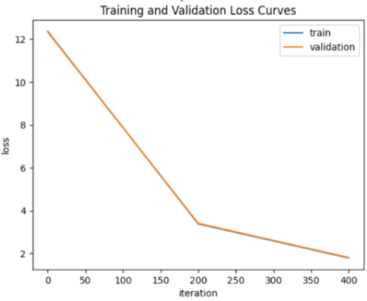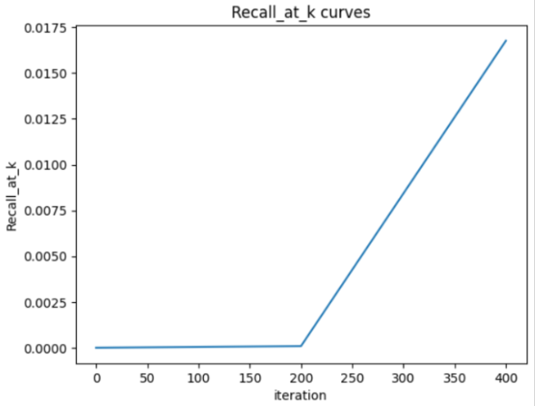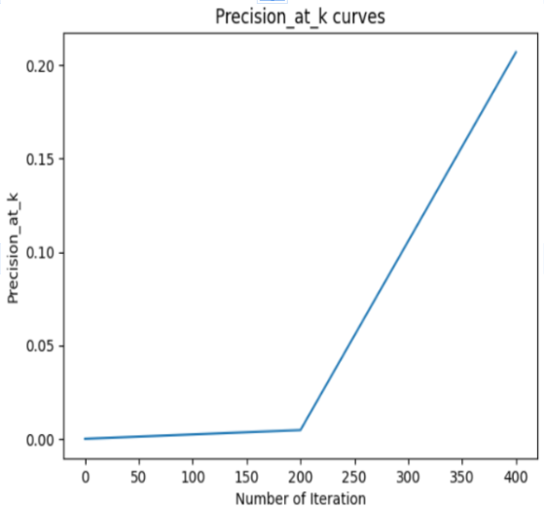

Recall at K=0.03357 and Precision at K = 0.25467

Parameters: Number of Iteration = 600, EPOCHS = 10, K = 10

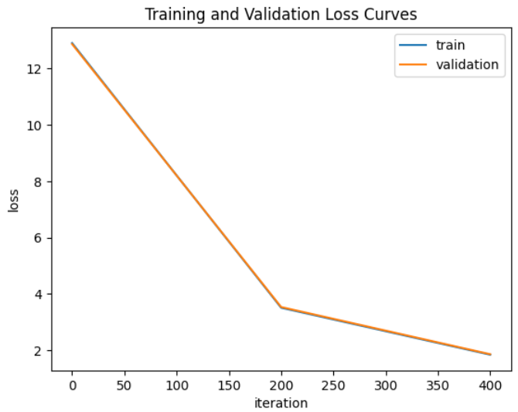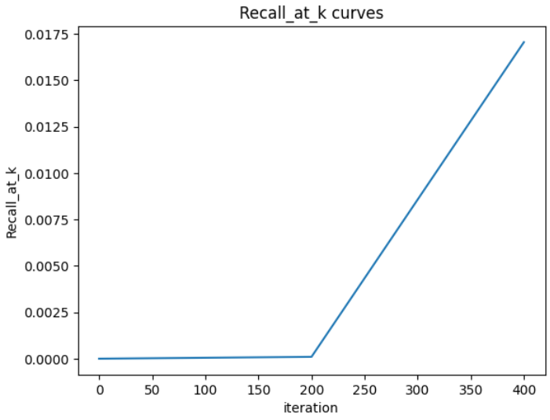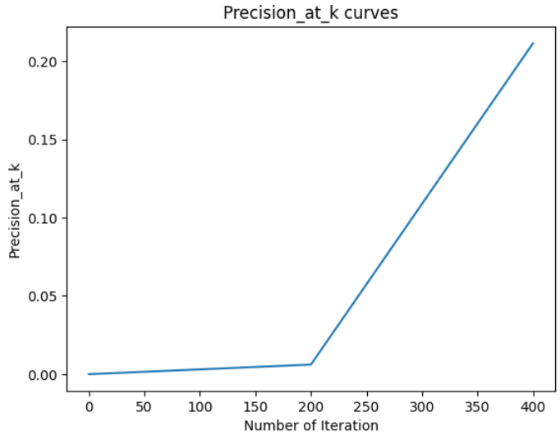

Recall at K = 0.04958 and Precision at K=0.30712

Parameters: Number of Iteration = 700, EPOCHS = 10, K = 10

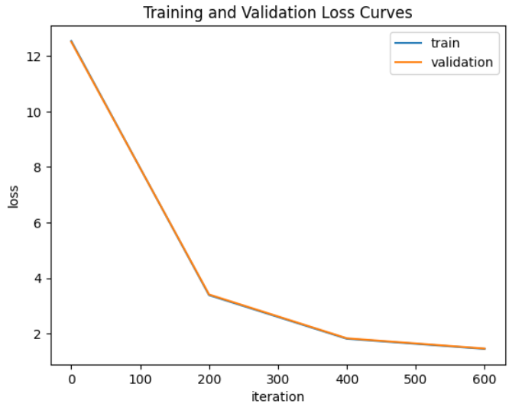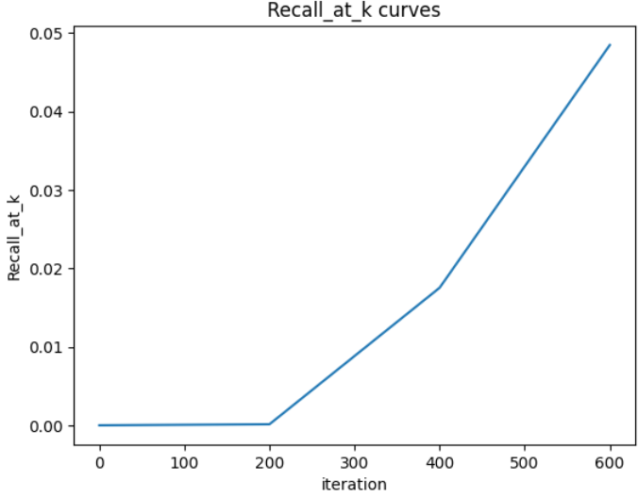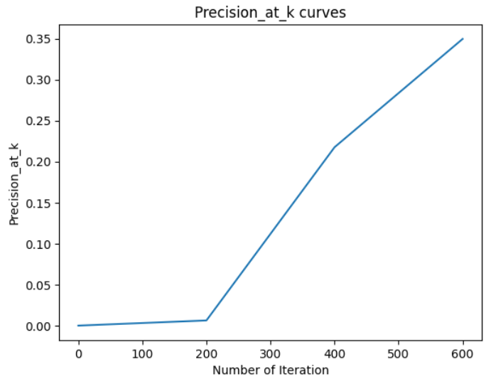

Recall at K = 0.06309 and Precision at K=0.34817

Parameters: Number of Iteration = 800, EPOCHS = 10, K = 10

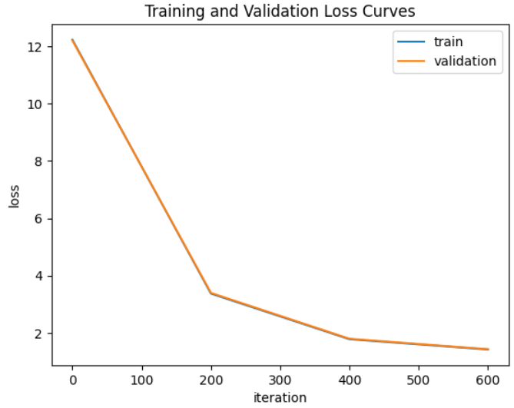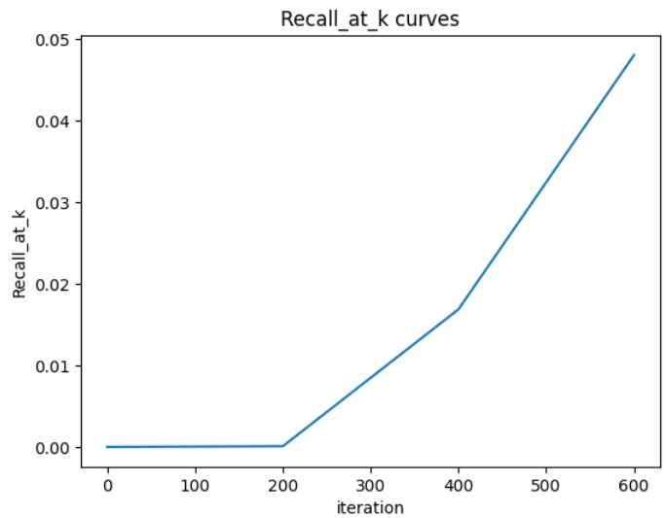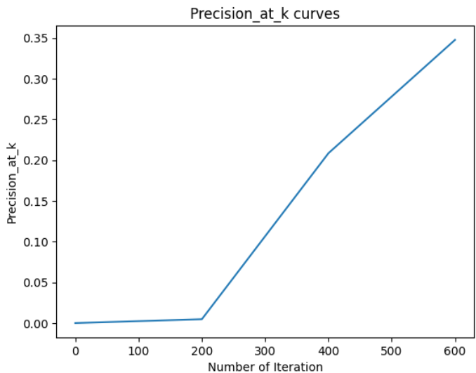

Recall at K = 0.07741 and Precision at K = 0.38285

Parameters: Number of Iteration = 900, EPOCHS = 10, K = 10

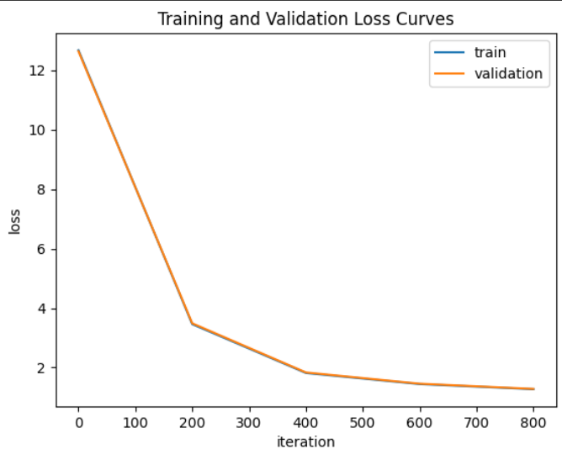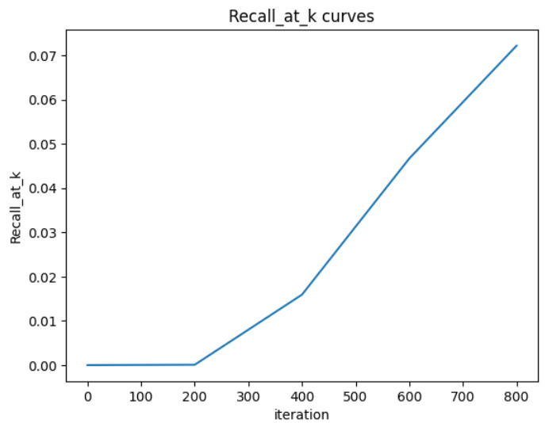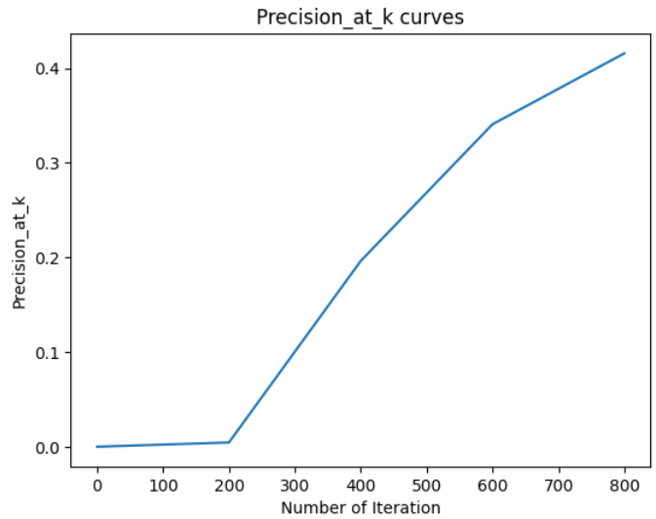

Recall at K = 0.08716 and Precision at K = 0.40228

Parameters: Number of Iteration = 1000, EPOCHS = 10, K = 10

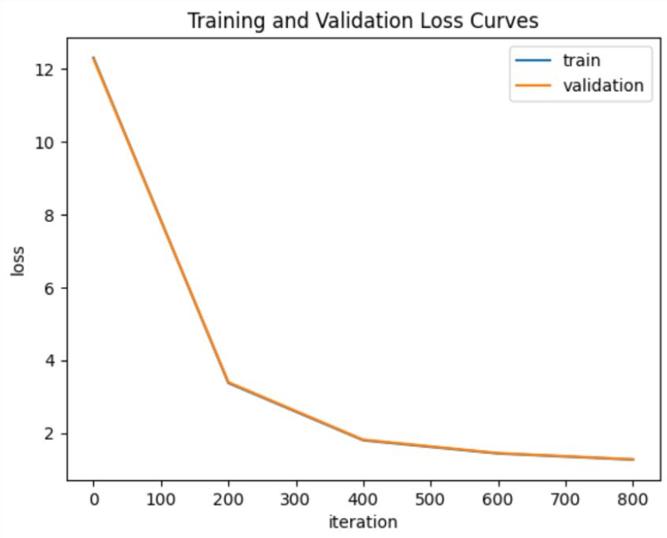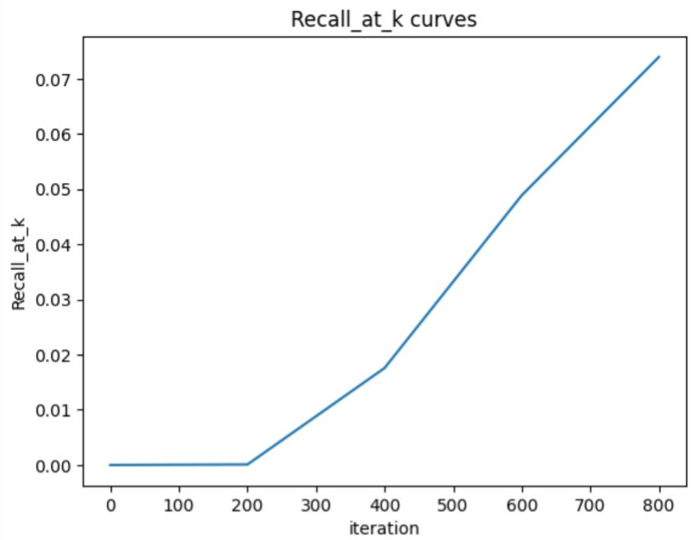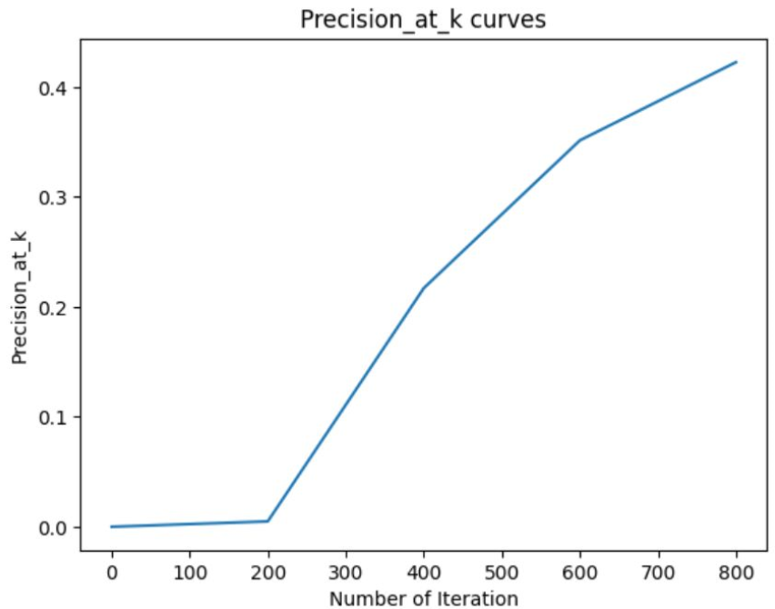

Recall at K = 0.1002 and Precision at K = 0.43562

# Personalized Top-N Sequential Recommendation via Convolutional Sequence Embedding

# 

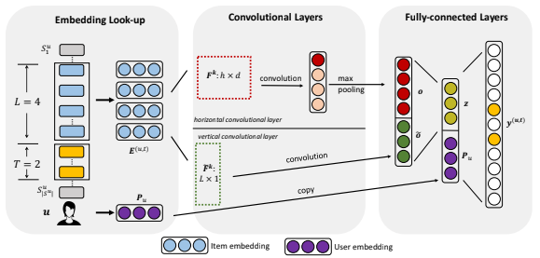

The paper proposes a personalized top-N sequential recommendation method that models each user as a sequence of items interacted in the past and aims to predict top-N ranked items that a user will likely interact in the "near future". This paper proposes a Convolutional Sequence Embedding Recommendation Model (Caser) to address this requirement. Caser embeds a sequence of recent items into an image and learns sequential patterns as local features of the image using convolutional iterations. Experiments on public data sets demonstrated that Caser consistently outperforms state-of-the-art sequential recommendation methods on a variety of common evaluation metrics.to embed sequential user-item interactions into a low-dimensional vector space.

We evaluated the proposed method on several real-world datasets and found that it replicated the author's recommendation methods in terms of accuracy and efficiency.

We further tested on other datasets, apart from paper as follows:

### **MovieLens 10M:**

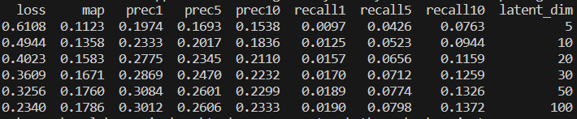

### **Learning from sets of items 2019:**

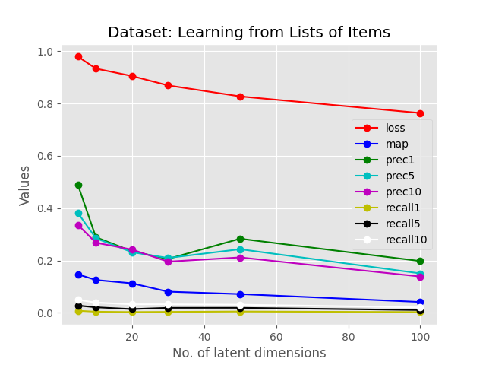

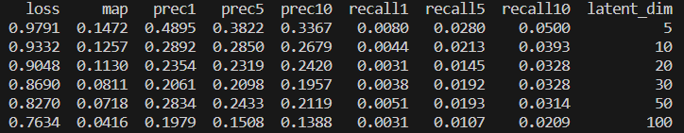

### **Personality 2018:**

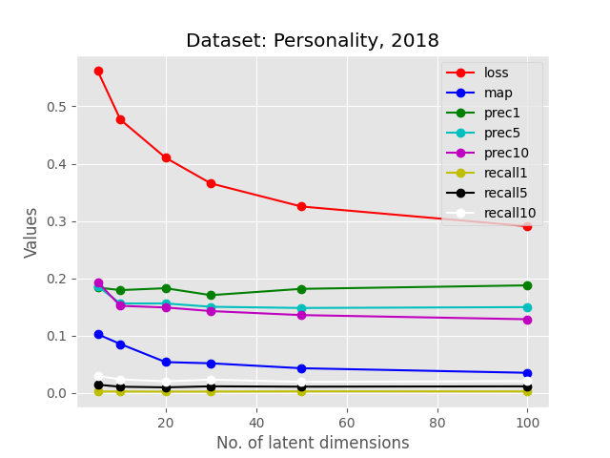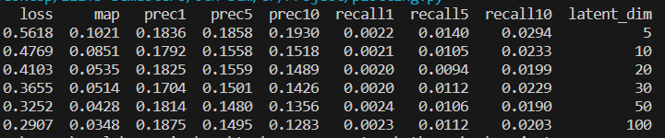

# 

# SHAN: Sequential Recommender System based on Hierarchical Attention Network

* Model for sequential predictions taking the user’s long and short-term interests into account.
* Uses a hierarchical attention mechanism to construct the user’s latent factor vector.
* Employs a latent-factor model for calculating preferences.

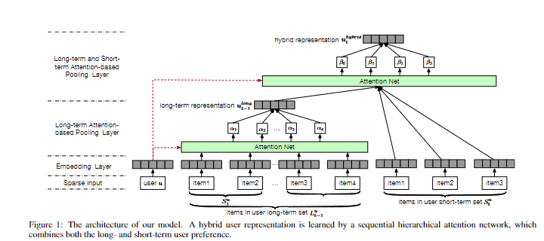

(source: SHAN by Ying et al.)

## Approach:

1. Embed user and item label-encoded representations into vectors.
2. Used an attention mechanism at the lower levels for long-term sequential data.
3. Used an independent attention mechanism at upper level for short-term sequential data.
4. Weighted combination of the two representations to capture the entire user-representation.
5. Latent factor model : take a matrix product of net user-representation with item representations to get preference of the user.

The ReLU activation function was used as the activation for the attention layers.

### Loss Function:

1. The loss function optimisation involved sampling for a random item and maximising the log-sigmoid value of the difference between the target preference and the random item’s preference:  
   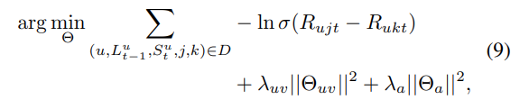  
   Here, *Rujt* and *Rukr* denote the target’s preference and the random item’s preference, σ is the sigmoid activation function, λ’s are the regularisation parameters for the weights 𝚯 for the embeddings and the attention-layers.
2. To prevent overfitting, early-stopping was done.

### Data preprocessing:

We dropped users and items having less than 20 appearances in the entire dataset and constructed sequences having a minimum size of 11 items.

**Note:** This differs from the vanilla implementation of the paper, wherein they shortlist the last 9-months’ data for creating the models. This reduced the training examples and increased the number of users and items considered for evaluation.

The data splits for training, validation and testing were done created in 7:1:2 ratio selected in a random fashion.

The period of time chosen was 1 day (1440 minutes).

## Results:

### Gowalla dataset:

Note: the dataset used for training and validation were larger than what they used in the paper. The deviations could have happened due to the differences in sizes of the datasets and training examples.

There were 9,908 users and 41,012 items in the dataset.

The train-test-val splits are as follows:

1. Train: 10,808 sequences
2. Val: 349 sequences
3. Test: 1,525 sequences

The splits were done randomly.

Early stopping was used to prevent overfitting and the best model was saved. The last entry of the sequence was used as a target, as per the paper.

| Latent Dimensions | Precision@1 | Precision@5 | Precision@10 | Recall@1 | Recall@5 | Recall@10 |
| --- | --- | --- | --- | --- | --- | --- |
| 5 | 0.00197 | 0.00079 | 0.00092 | 0.00036 | 0.00077 | 0.00155 |
| 10 | 0.01836 | 0.01023 | 0.00682 | 0.00348 | 0.00965 | 0.01306 |
| 20 | 0.1082 | 0.03948 | 0.02459 | 0.02327 | 0.04088 | 0.04984 |
| 50 | 0.44984 | 0.12472 | 0.06807 | 0.08858 | 0.12032 | 0.13117 |
| 75 | 0.44393 | 0.14911 | 0.08 | 0.08826 | 0.14209 | 0.15189 |
| 100 | 0.41639 | 0.14046 | 0.07482 | 0.08212 | 0.13366 | 0.14157 |

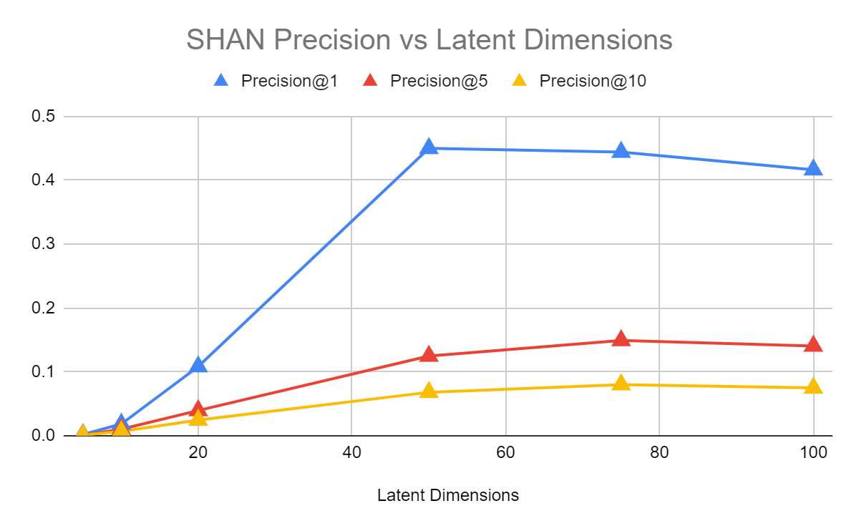

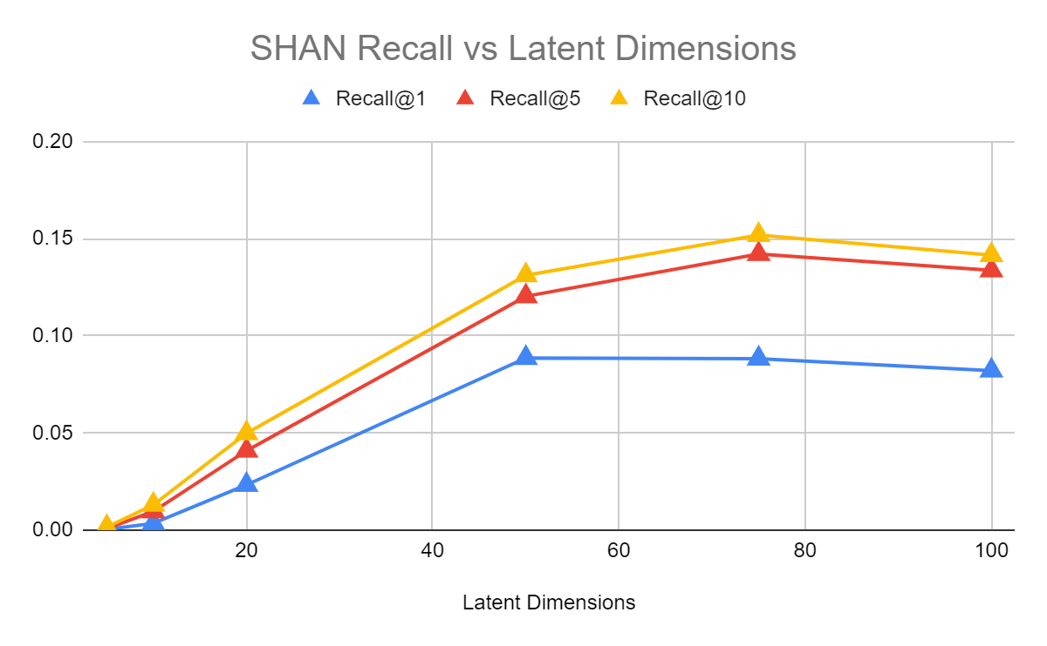

### Amazon Books dataset:

There were 6,109 users, 64,754 items.

The train-test-val splits are as follows:

1. Train: 6,747 sequences
2. Val: 32 sequences
3. Test: 164 sequences

| Latent Dimensions | Precision@1 | Precision@5 | Precision@10 | Recall@1 | Recall@5 | Recall@10 |
| --- | --- | --- | --- | --- | --- | --- |
| 5 | 0 | 0 | 0 | 0 | 0 | 0 |
| 10 | 0 | 0 | 0 | 0 | 0 | 0 |
| 20 | 0 | 0 | 0.00061 | 0 | 0 | 0.00061 |
| 50 | 0 | 0 | 0 | 0 | 0 | 0 |
| 75 | 0 | 0 | 0 | 0 | 0 | 0 |
| 100 | 0 | 0 | 0 | 0 | 0 | 0 |

The SHAN model was unable to produce good results on the Amazon-Books dataset. This could be a result of the less number of sequences used for training which prevented the model from learning relevant representations for prediction.

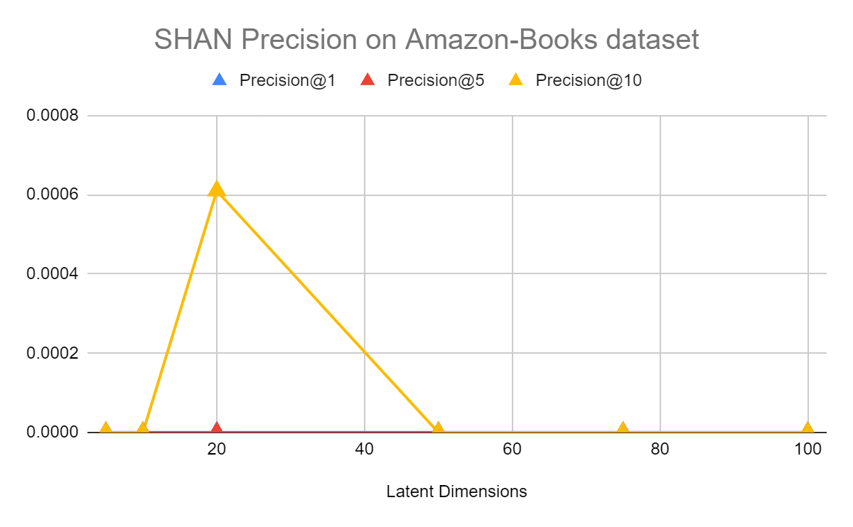

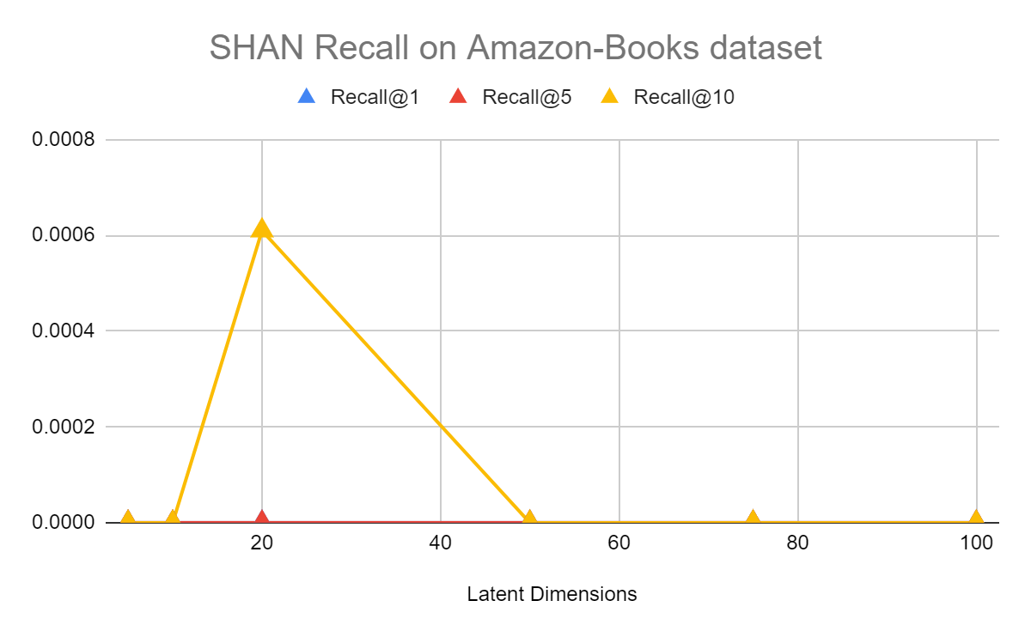

### MovieLens20M dataset:

There were 101,196 users, 9,630 items.

The train-test-val splits are as follows:

1. Train: 101,700 sequences
2. Val: 351 sequences
3. Test: 4,143 sequences

| Latent Dimensions | Precision@1 | Precision@5 | Precision@10 | Recall@1 | Recall@5 | Recall@10 |
| --- | --- | --- | --- | --- | --- | --- |
| 5 | 0 | 0.00048 | 0.0006 | 0 | 0.00024 | 0.00024 |
| 10 | 0.00217 | 0.00135 | 0.00101 | 0.00022 | 0.00068 | 0.00101 |
| 20 | 0.00024 | 0.00039 | 0.00056 | 2.00E-05 | 0.00019 | 0.00056 |
| 50 | 0.00024 | 0.00092 | 0.00072 | 2.00E-05 | 0.00046 | 0.00072 |
| 75 | 0 | 0.00087 | 0.0008 | 0 | 0.00043 | 0.0008 |
| 100 | 0 | 0.00034 | 0.00056 | 0 | 0.00017 | 0.00056 |

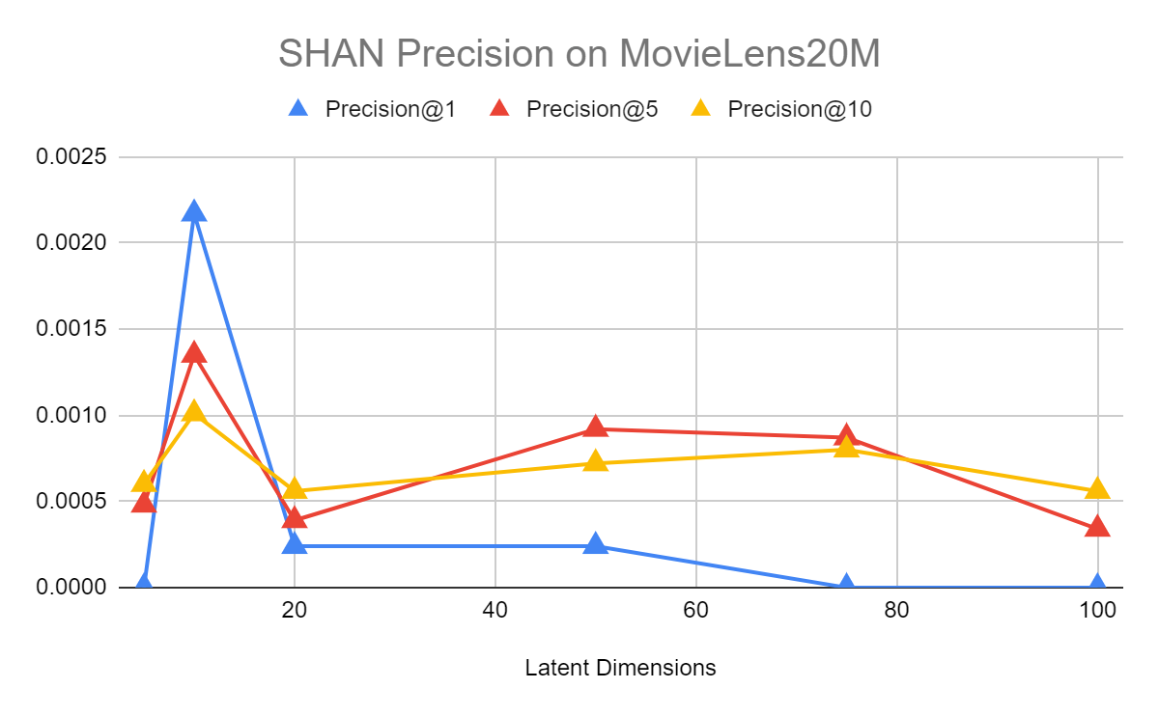  
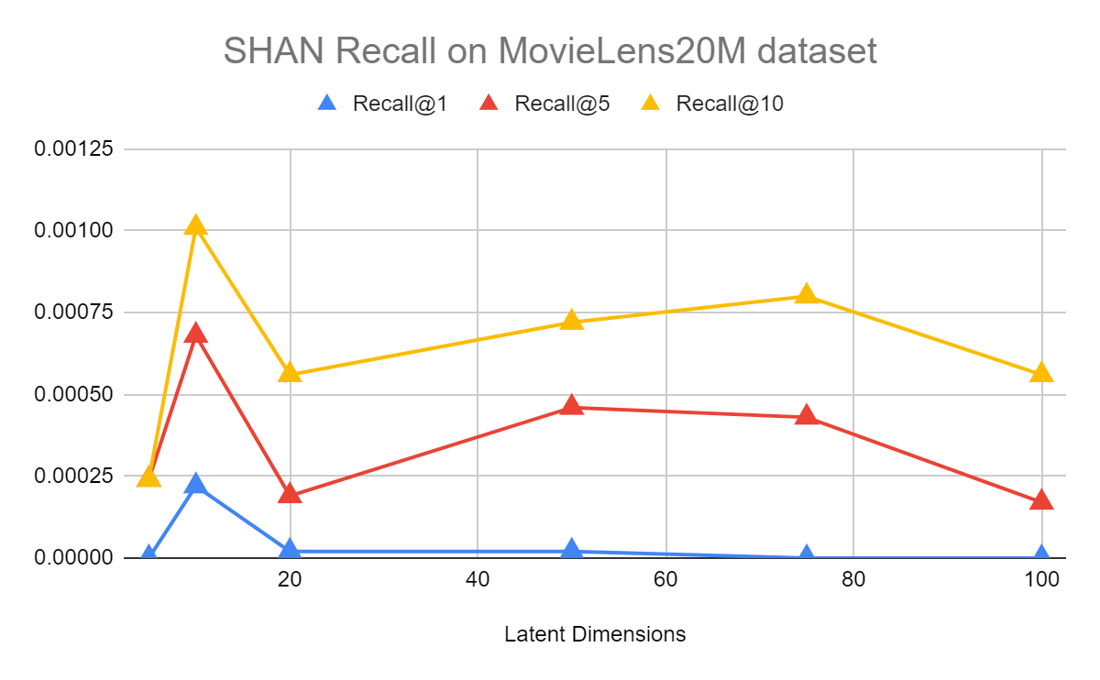

Conclusion:

1. We observe that the SHAN model performs poorly on Amazon-Books and the Gowalla dataset.