**AI-Job-Market-Disruption Analysis**

**Monthly Layoff Trends Reveal Year-End AI Disruption Surge:**

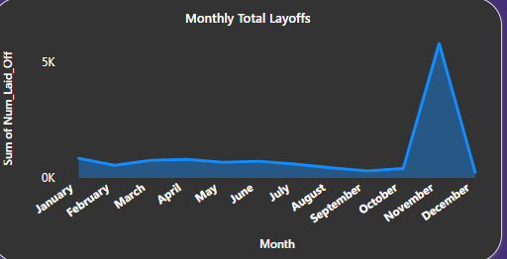

**Insight**

* **Sharp layoff spike in November** indicates **AI-driven restructuring** and **year-end strategic workforce shifts**.
* Stable layoffs across other months suggest **targeted disruptions**, not constant downsizing.

**Recommendations**

* **Pre-Q4 planning:** Encourage companies to assess AI impact by **Q3** to avoid sudden layoffs.
* **Upskilling focus:** Prioritize **AI transition training** in high-risk industries.
* **Predictive tracking:** Use the **Disruption Index** and **Layoff Efficiency** to forecast future layoff zones.
* **Responsible AI use:** Promote AI that **augments** rather than replaces human roles.

**Industry-Wise Layoff Impact Highlights AI-Vulnerable Sectors:**

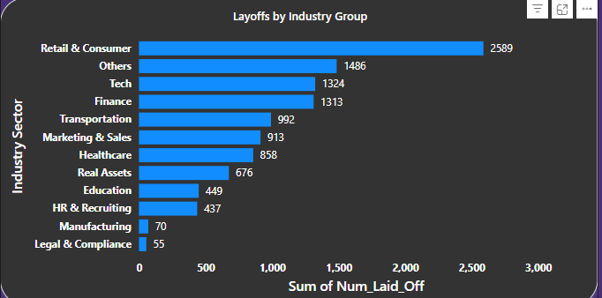

**Insight**

* **Retail & Consumer**, **Tech**, and **Finance** are the **top three most affected sectors**.
* These industries are **highly AI-disruptable**, indicating early automation or structural shifts due to digital transformation.
* **HR, Education, and Manufacturing** show lower layoff volumes but may be in early AI adoption phases.

**Recommendations**

* **Focus upskilling programs** in Retail and Tech to soften the AI disruption impact.
* **Support financial sector automation transitions** with hybrid role training.
* Use this data to **prioritize AI impact assessments** by industry for strategic workforce planning.
* **Monitor lagging industries** (e.g., Manufacturing) for emerging layoff trends as AI adoption spreads.

**Geographic Disparities in AI-Driven Layoffs Led by the U.S:**

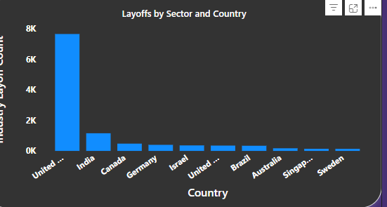

**Insight**

* The **United States** dominates the layoff landscape by a large margin, with **India** trailing as a distant second.
* This concentration suggests the **U.S. is experiencing the deepest workforce restructuring**, likely driven by aggressive **AI adoption in tech and corporate sectors**.
* Other countries like **Canada, Germany, and Israel** show emerging disruption, but on a smaller scale.

**Recommendations**

* **Prioritize AI disruption tracking** and workforce reskilling strategies in the **U.S. and India**, where the impact is most pronounced.
* Encourage **AI governance frameworks** in highly affected regions to balance innovation with employment stability.
* **Monitor emerging patterns** in smaller economies (e.g., Germany, Israel) for proactive policy and HR interventions.
* Use this geographic trend to **guide global workforce planning, AI deployment strategies, and regional policy dialogues.**

**High AI Exposure in Finance, Tech, and Marketing Sectors**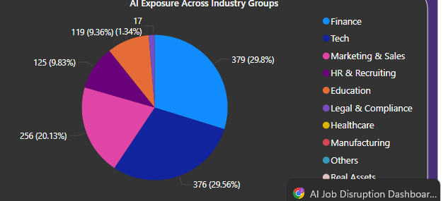

**Insight**

* **Finance (29.8%)** and **Tech (29.56%)** sectors show the **highest AI exposure**, collectively accounting for nearly **60%** of all AI-sensitive layoffs.
* This indicates these industries are the **primary frontiers of AI-driven disruption**, likely due to automation in financial operations, software development, and support services.
* **Marketing & Sales (20.1%)** also appears significantly impacted, suggesting increased use of AI tools for content, customer interaction, and analytics.

**Recommendations**

* **Urgent reskilling initiatives** are needed in **Finance and Tech**, focusing on AI augmentation roles (e.g., AI auditing, prompt engineering, data ethics).
* **Marketing departments** should shift from execution-heavy roles to **AI strategy and oversight**.
* Companies in high-exposure sectors should implement **change management frameworks** and workforce transition plans to retain talent during AI adoption phases.
* Stakeholders should use this data to **prioritize investments in AI training programs**, particularly in the top 3 sectors identified.

**Layoff Severity Concentrated in Retail, Finance, and Tech**

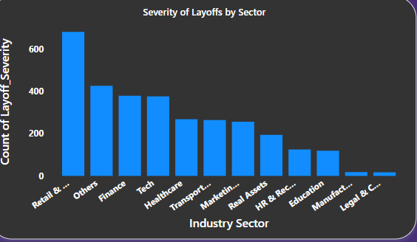

**Insight**

* The **Retail & Consumer sector** experienced the **highest severity of layoffs**, followed by **Others**, **Finance**, and **Tech**.
* These sectors show a **concentration of high-impact layoffs**, likely affecting larger portions of the workforce per incident.
* Sectors like **Legal & Compliance**, **Manufacturing**, and **Education** reported relatively **low severity**, indicating either fewer layoffs or less disruptive downsizing events.

**Recommendations**

* **Retail & Consumer** companies should urgently explore **automation transition plans** and **employee reallocation strategies**, as they face both volume and intensity in workforce restructuring.
* **Finance and Tech** leaders must integrate **AI change management protocols** to prevent operational risks tied to workforce gaps post-layoff.
* Policymakers should consider **sector-specific intervention plans**, targeting upskilling and support where severity is highest.
* Encourage **early-stage monitoring** in emerging sectors before severity escalates—this supports a **proactive rather than reactive** workforce strategy.

**U.S. Leads in AI-Dependent Companies, Revealing Global Risk Gaps**

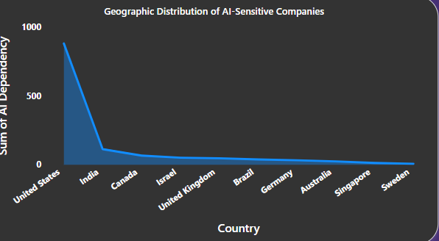

**🌍 Insight**

* The **United States overwhelmingly leads** in the number of AI-sensitive companies, indicating **deep AI integration** in business operations.
* Countries like **India**, **Canada**, **Israel**, and the **UK** follow, but with significantly lower AI dependency.
* The sharp drop after the U.S. reflects a **geographical concentration of AI exposure**, highlighting potential regional vulnerabilities in employment due to AI adoption.

**Recommendations**

* **U.S. policymakers and industry leaders** must prepare for **large-scale AI-induced workforce transitions**, emphasizing reskilling, automation audits, and ethical AI deployment.
* Emerging markets such as **India and Israel** should proactively **balance AI growth with workforce adaptation**, investing in training and labor protection.
* Use this insight to design **country-specific AI disruption readiness frameworks**, ensuring tailored strategies based on AI sensitivity levels.
* Consider a **drill-through slicer** by region or funding stage in your dashboard for more localized action planning.

**Company Stage Breakdown Shows Mid-to-Late Startups Under Pressure**

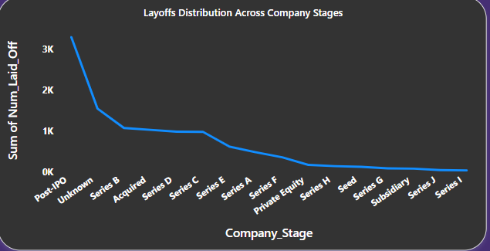

**Insight**

* **Post-IPO companies** faced the **highest number of layoffs**, suggesting that even mature, publicly traded firms are not immune to AI-driven restructuring.
* Startups in **Series B, D, and E stages** show notable layoff counts, indicating **mid-to-late-stage startups** may struggle to balance growth and AI transformation.
* **Seed and early-stage startups** (Seed, Series A, Series G-I) saw fewer layoffs, likely due to smaller teams and higher adaptability.

**Recommendations**

* Investors and VCs should **closely monitor Series B–E startups** for risk signals, especially where AI replaces traditional roles.
* **Post-IPO companies** need robust **AI change management frameworks**, blending innovation with workforce sustainability.
* In your dashboard, include a **startup stage filter** with color-coded risk levels to help users pinpoint where interventions (like upskilling or automation audits) are most needed.

**Mature Companies Face the Most Layoffs Based on Maturity Level**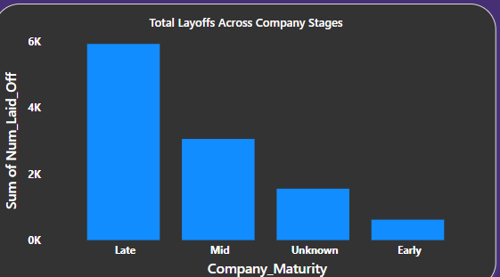

* **Late-stage companies** must implement **AI workforce transformation strategies**, including reskilling and ethical automation frameworks to balance innovation and employment.
* **Mid-stage companies** should undergo **AI-readiness and vulnerability assessments** to avoid reactive layoffs and ensure sustainable scaling.
* **Early-stage companies** offer a model for **AI-native organizational design**

**Conclusion:**

This analysis reveals a clear pattern: AI disruption is not uniform—it varies sharply by industry, geography, funding stage, and company maturity. Late-stage and post-IPO companies are facing the brunt of layoffs, driven by pressure to scale AI adoption, reduce costs, and restructure teams. Industries like Finance, Tech, and Retail are experiencing the most severe impact, while emerging economies like India are beginning to show signs of disruption.

The dashboard offers a multi-dimensional view of AI’s effect on global employment, empowering stakeholders to take action. It highlights not just where layoffs are happening, but why—and what strategic interventions (like upskilling, AI governance, or transition planning) are most effective.

By integrating metrics such as Layoff Severity, AI Sensitivity, Disruption Index, and Company Maturity Risk, this dashboard becomes a strategic tool for:

* Policymakers to draft workforce resilience plans
* Investors and VCs to assess startup risk exposure
* HR leaders to design AI-transition roadmaps
* Companies to forecast and mitigate disruption

As AI adoption accelerates globally, proactive, data-driven workforce planning is no longer optional—it is essential.