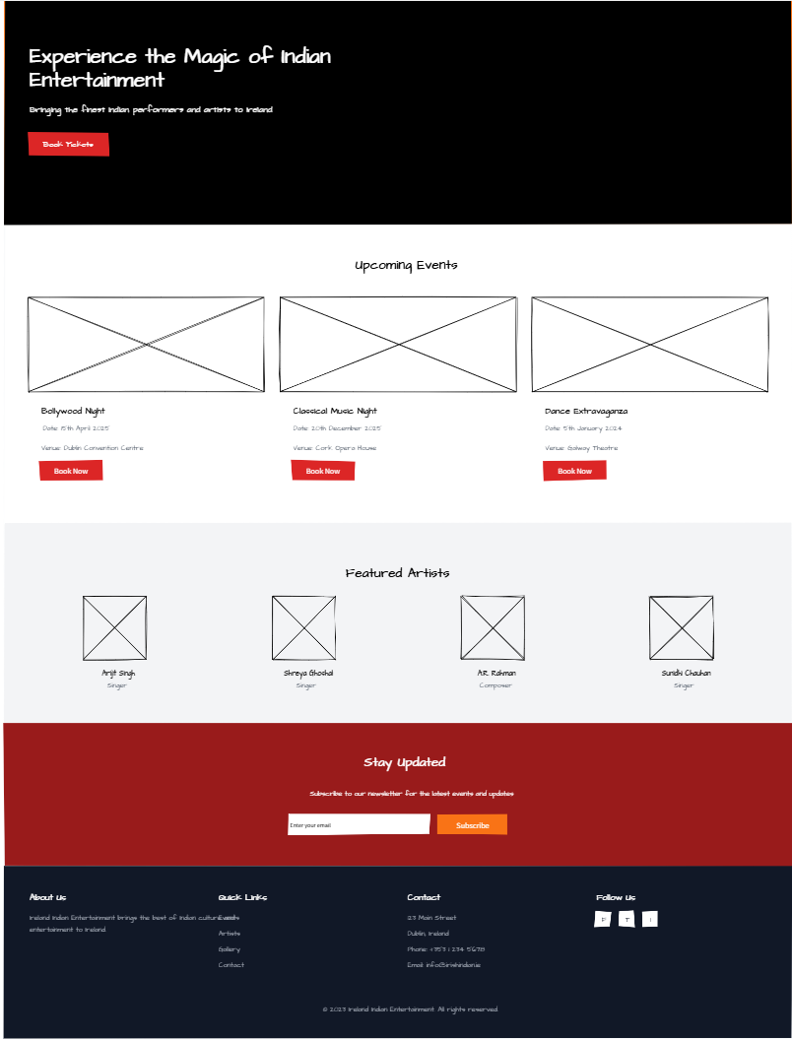

Mock Website obtained from mockflow.com

