This project is meant to convert an arbitrary json to XML, as per the instructions given.For Instructions kindly refer the Instructions.doc

Refer the below Screenshot to know the Project Structure.

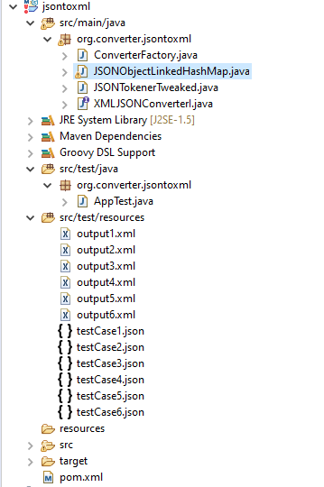

This Project comes with JUNIT test case implementation.

To Build the Project via Eclipse, Kindly refer the below screenshots.

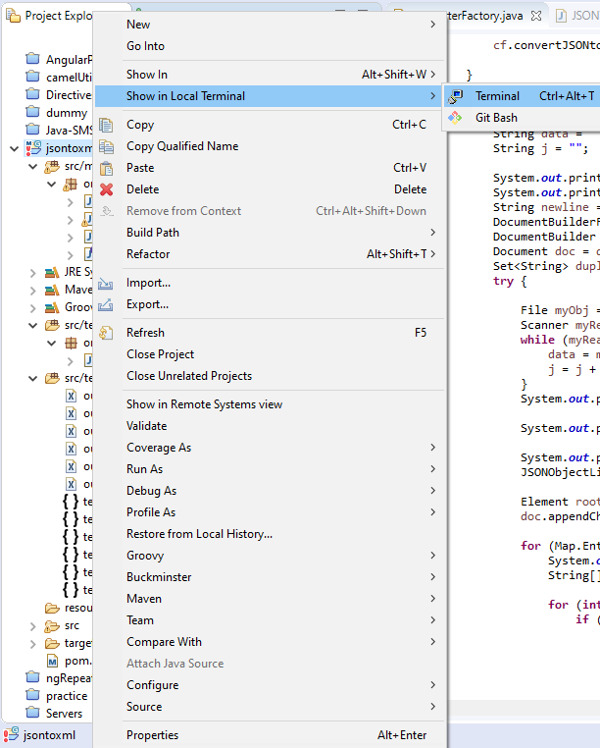

Command to build the project : mvn clean install

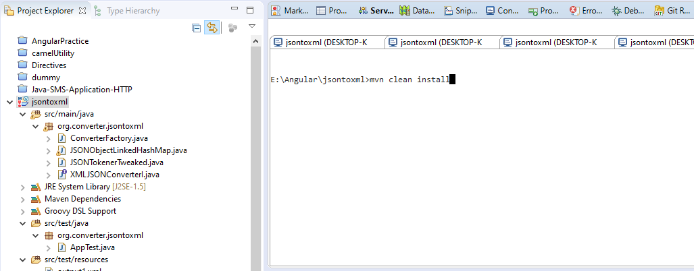

After Successful build, a jar file will be created under target folder within this project.

Kindly refer the file Name **jsontoxml-0.0.1-SNAPSHOT-jar-with-dependencies.jar**

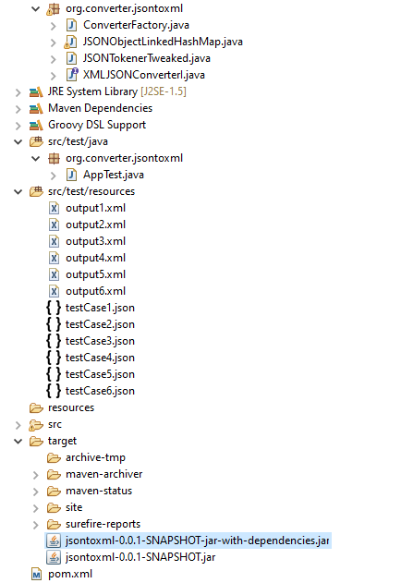

To run the jar kindly follow the below steps.

Step1: Navigate to the project root Folder, Open Command Prompt

Step 2: kindly give the below command to run the jar file. Input and Output file location must be given to run the jar file.

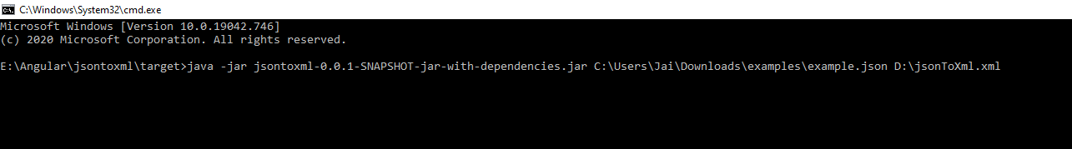

Step 3: Open the specified output file  
  
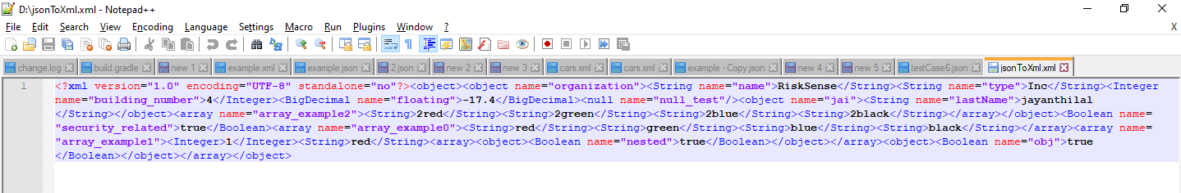

U can format the above XML file using any online XML formatter on google.

Junit Test Cases

Step 1: To run the Junit test cases, kindly use the AppTest.java file from test folder as shown in the below screenshot.

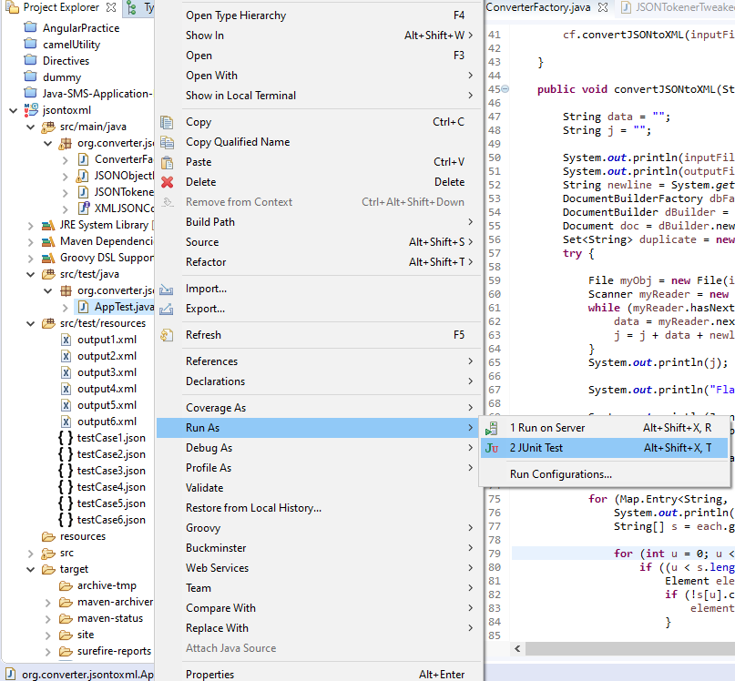

Under src/test/resources folder one can find the input and output file for test cases.

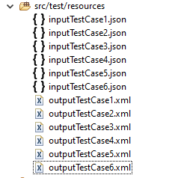

To take a report on Test cases, kindly execute the below command from Project root directory.

mvn clean install test surefire-report:report -Dmaven.test.failure.ignore=true

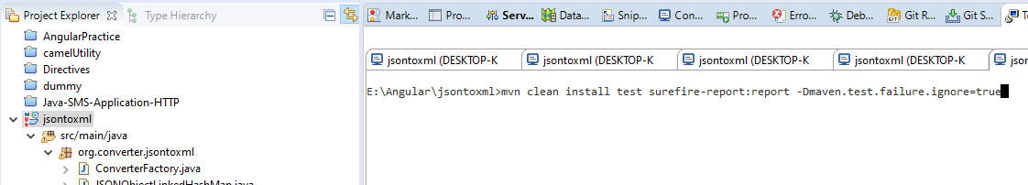

To get the test case report Navigate to **target/site** folder, open **the surefire-report.html** file

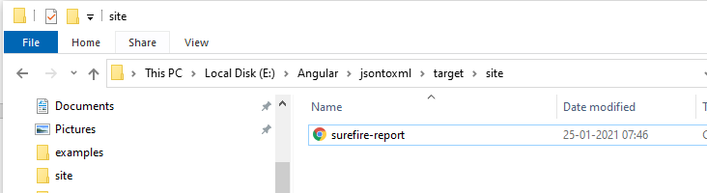

One can see the project test case report as shown in the screenshot.

