**APPLICATION TO GOOGLE PAGE RANK**

**History:**

Developed by Google’s founders, Larry Page and Sergey Brin, who were graduate students at Stanford University when the foundational ideas of Google developed. Google ranks webpages according to the percentage of time one would end up at each web on a random walk through the web.

**Concept:**

**PageRank** (**PR**) is an algorithm used by Google Search to rank web pages in their search engine results. PageRank is a way of measuring the importance of website pages. According to Google:

PageRank works by counting the number and quality of links to a page to determine a rough estimate of how important the website is. The underlying assumption is that more important websites are likely to receive more links from other websites.

Currently, PageRank is not the only algorithm used by Google to order search results, but it is the first algorithm that was used by the company, and it is the best known. As of September 24, 2019, PageRank and all associated patents are expired.

**Steps:**

1. Assign each page an initial rank of 1/N.
2. Creating a transition matrix (H).
3. Successively update the rank by no. of every page that links to it divided by the number of links emanating from the referring page.
4. The sum of all the columns of the transition matrix must be equal to 1.
5. Using the formula: PR(t+1) =H*PR(t), start iterations.
6. We can do any number of iterations till we get a stabilized value. But it will be mentioned in the question for how many iterations you need to do.
7. The node/web page with higher value will have the highest page Rank.

**Solved example:**

**Question 1:**

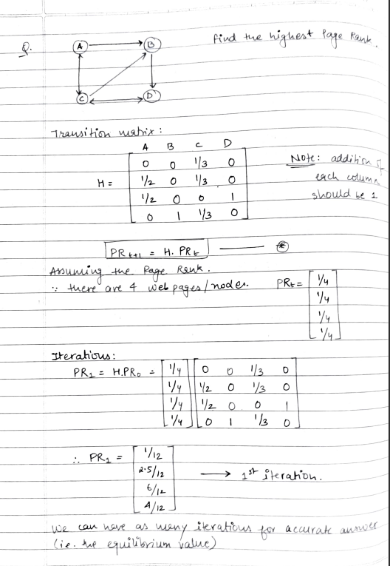

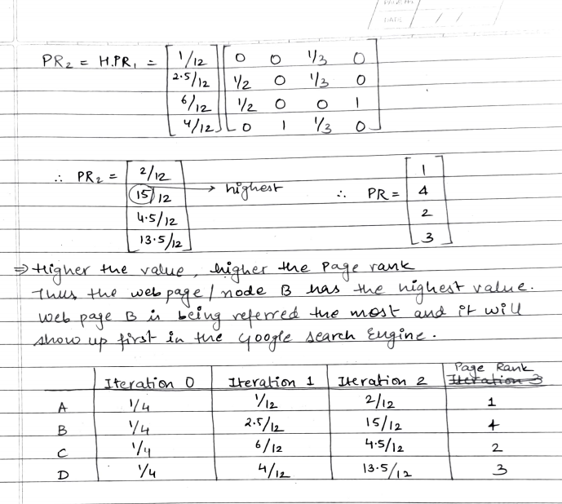

**Question 2:**

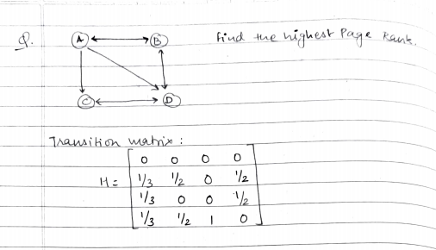

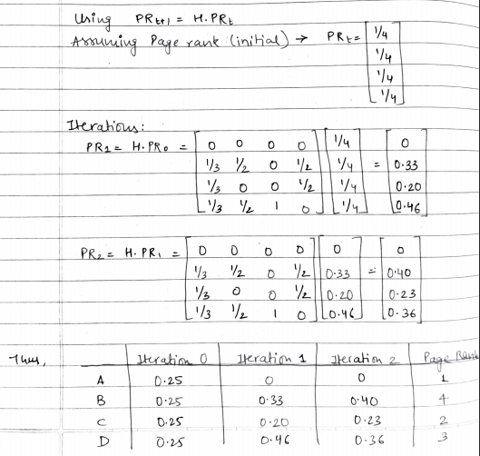

**Question 3:**

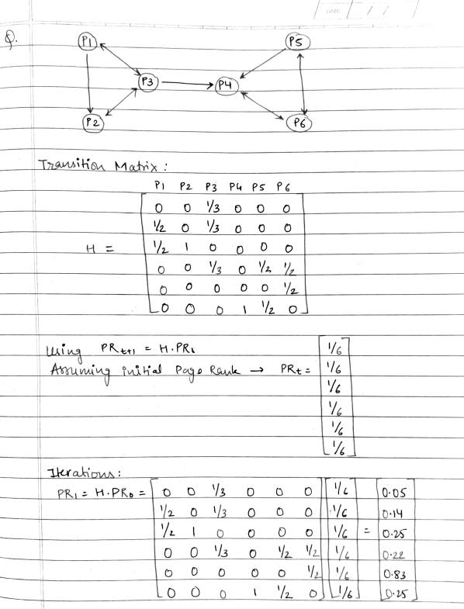

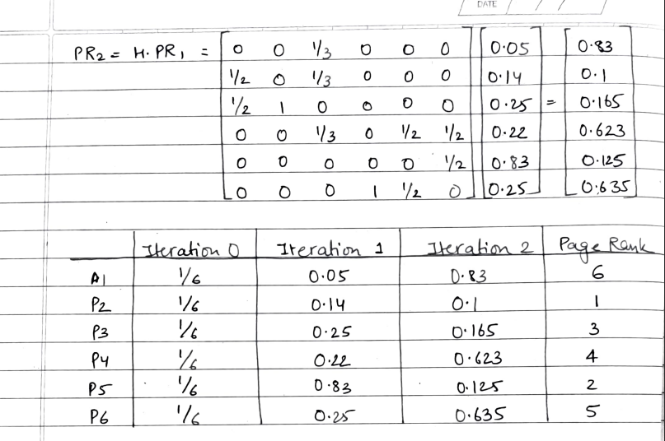

**Application:**

PageRank has been used to rank spaces or streets to predict how many people (pedestrians or vehicles) come to the individual spaces or streets. In lexical semantics it has been used to perform Word Sense Disambiguation, Semantic similarity, and also to automatically rank WordNet synsets according to how strongly they possess a given semantic property, such as positivity or negativity.

In sport the PageRank algorithm has been used to rank the performance of: teams in the National Football League (NFL) in the USA; individual soccer players; and athletes in the Diamond League.

Neuroscience: using fMRI scans to generate a network where the nodes are vowels on the fMRI scan and edges on the nodes represent that the voxels are strongly time correlated and a version of PageRank designed for undirected graphs, neuroscientists were able to identify parts of the brain that change together as subjects aged.

**Significance:**

The fundamental idea behind PageRank is the notion that each hyperlink is a recommendation, an endorsement of one page for another. Thus, the World Wide Web is a giant recommendation system where webpages vote for other pages by linking to them.

The idea behind Google's PageRank is to let a random surfer take a random walk on the Web's graph and then observe the frequency with which he visits each page. More important (i.e., more frequently visited) pages appear at the top of the results page for a query to the Google search engine.