**SPAN**

Definition:

The linear span of a set S of vectors, is the smallest linear subspace that contains the set. It can be characterized either as the intersection of all linear subspaces that contain S, or as the set of linear combinations of elements of S. The linear span of a set of vectors is therefore a vector space.

Concept:

* Given a vector space V over a field K, the span of a set S of vectors is defined to be the intersection W of all subspaces of V that contain S. W is referred to as the subspace spanned by S, or by the vectors in S.
* Conversely, S is called a spanning set of W, and we say that S spans W.
* Alternatively, the span of S may be defined as the set of all finite linear combinations of elements of S.
* In particular, if S is a finite subset of V, then the span of S is the set of all linear combinations of the elements of S.
* Let V be a vector space and let S = {v1, v2, ... , vn) be a subset of V. We say that S spans V if every vector v in V can be written as a linear combination of vectors in S.

Geometrical Interpretation:

* If V is the vector space and S is set of vectors such as S={v1, v2,..., vr}.
* The set of linear combinations of vectors (v1,v2...,vr) is called span of S is denoted as L(s) or Span(s) or Span(v1, v2,...,vr).
* Span(s) is given as {k1v1+k2v2+...+krvr}.
* k1,k2,...,kr are scalars.

Significance:

* If v is non zero vector in R2 with initial point at the origin then the set of all scalar multiples of v span the line determined by v.
* It means, if v is the vector OP, then the vector formed by any value of k, along the line OP can be expressed in the multiple of v. It is said v spans the space of vector OP.

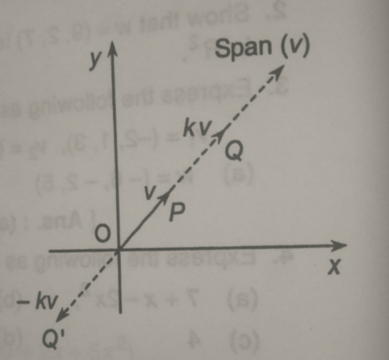

* If v1 and v2 are two non colinear vectors with initial points at the origin in R2 , then any vector in the plane can be expressed as k1v1+k2v2.
* v1 and v2 are said to be not colinear span of the plane R2.

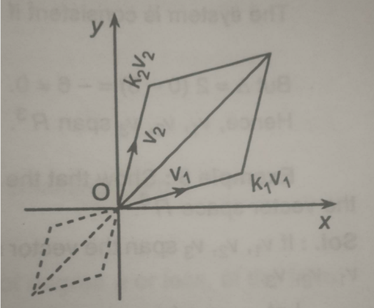

Applications in real life:

* Span can be used to find or locate the coordinates in vector space.
* It can be used to check which linear combinations are satisfied by the points of the vector space.
* To check linear dependency of the vectors.

Examples with solution and Procedure:

