COS80020 - Creating Data Driven Mobile Applications

D Sketch – Jai Lafferty 101610772

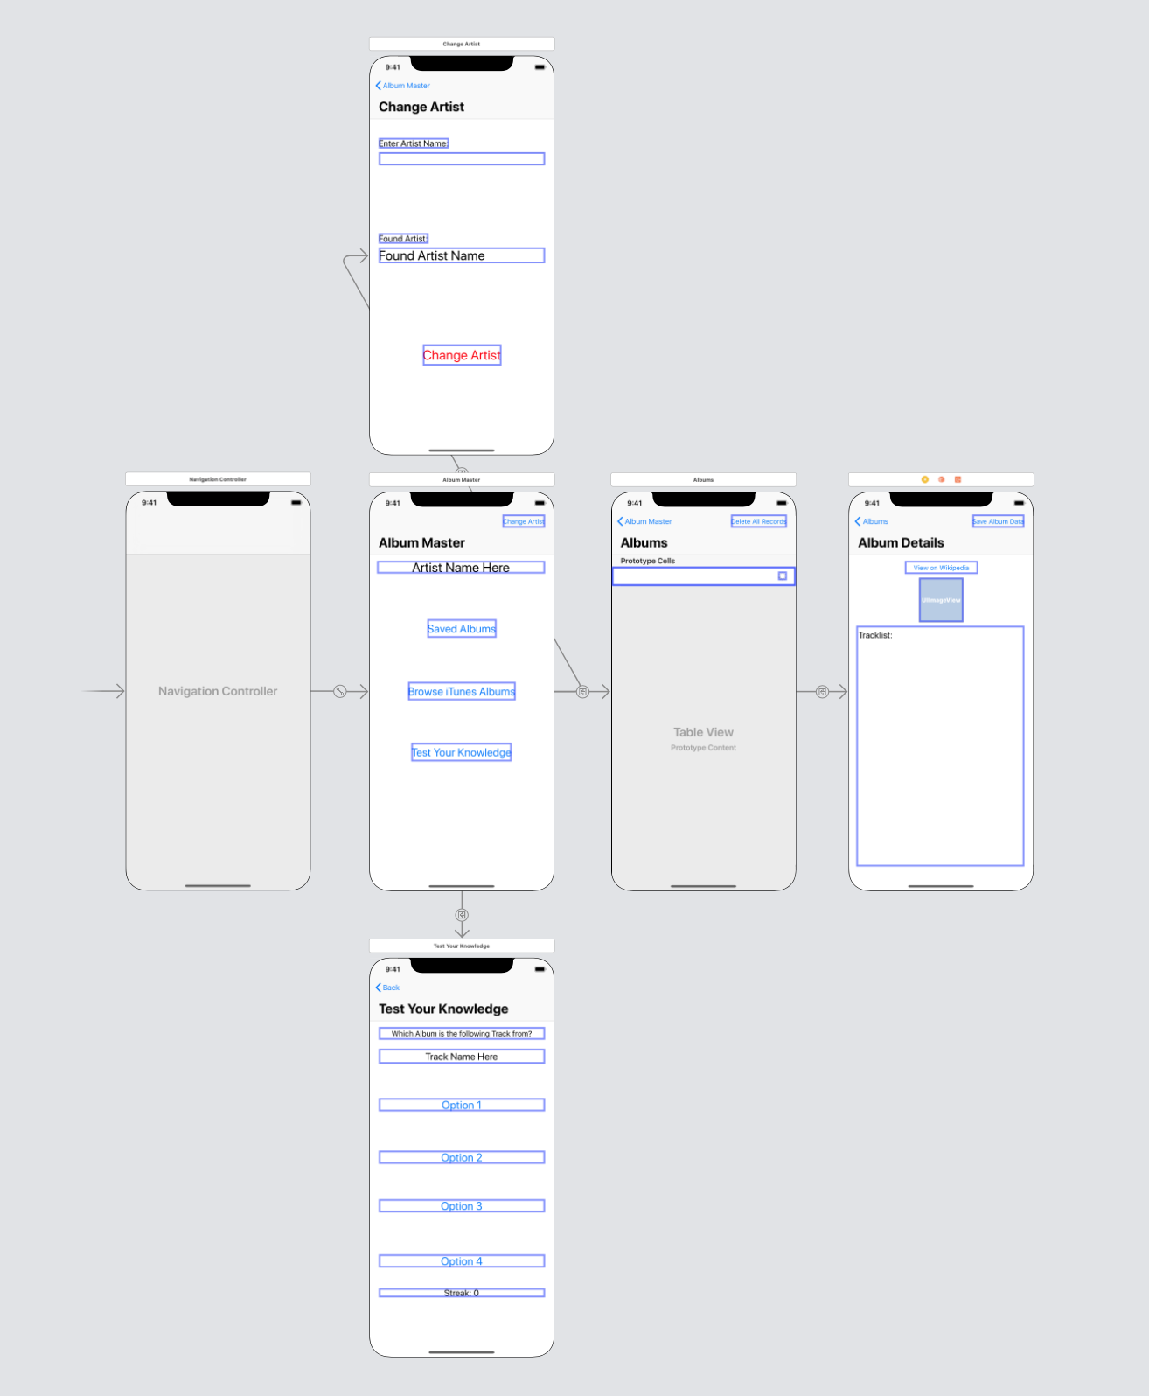

My app is comprised of 5 different screens:

* Menu
* Albums Table
* Album Detail
* Album Quiz
* Change Artist

**Menu**

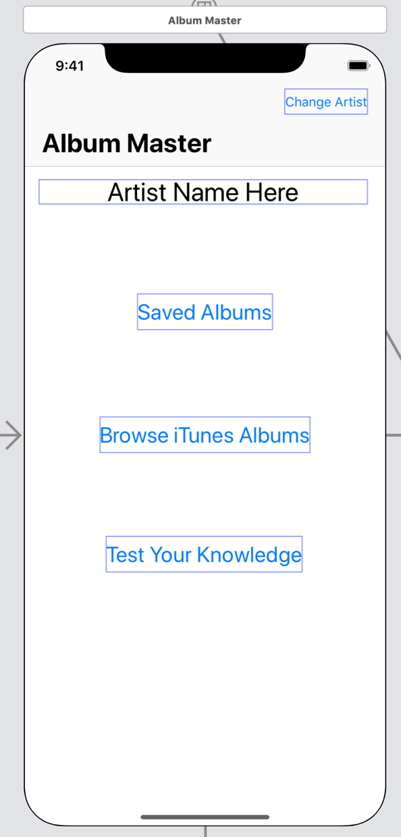

Menu is as it sounds, a few buttons on the main screen taking you to whichever place you wish to go

**Albums Table**

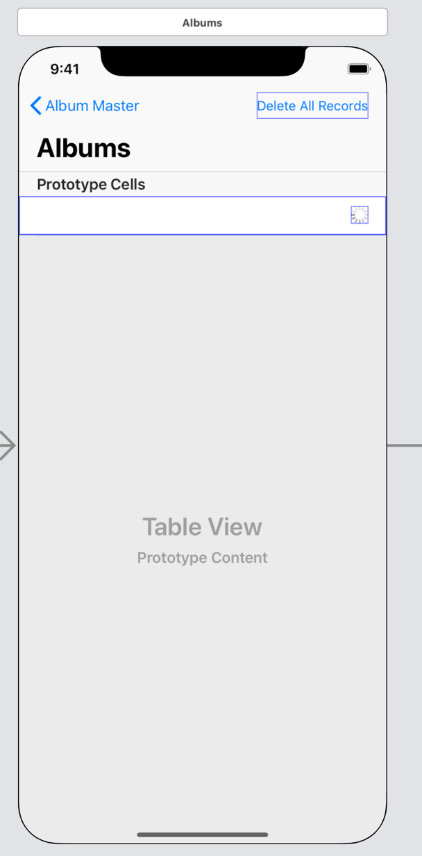

This table displays both saved or fetched albums based on which menu item was selected. In the case of an online fetch an activity indicator is present in the relevant clicked cell in order to provide feedback that a task is being complete. The Delete All Records button is only present should the albums be loaded from Core Data, this provides the user the option of wiping the database and starting fresh. Note an alert appears asking whether the user really means to wipe the database.

**Album Details**

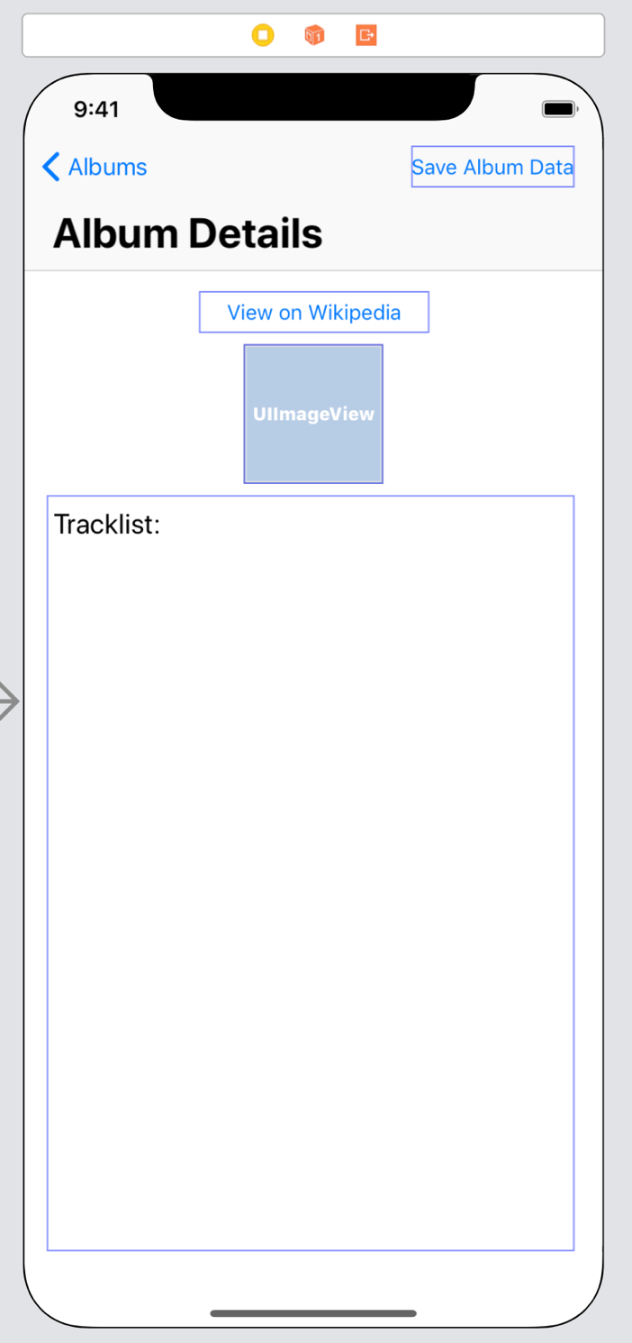

This screen displays the tracklist and the artwork for the selected Album. A button is present to take the user to the relevant Wikipedia page as well as a button to save the album to storage, this button is disabled on save.

**Quiz**

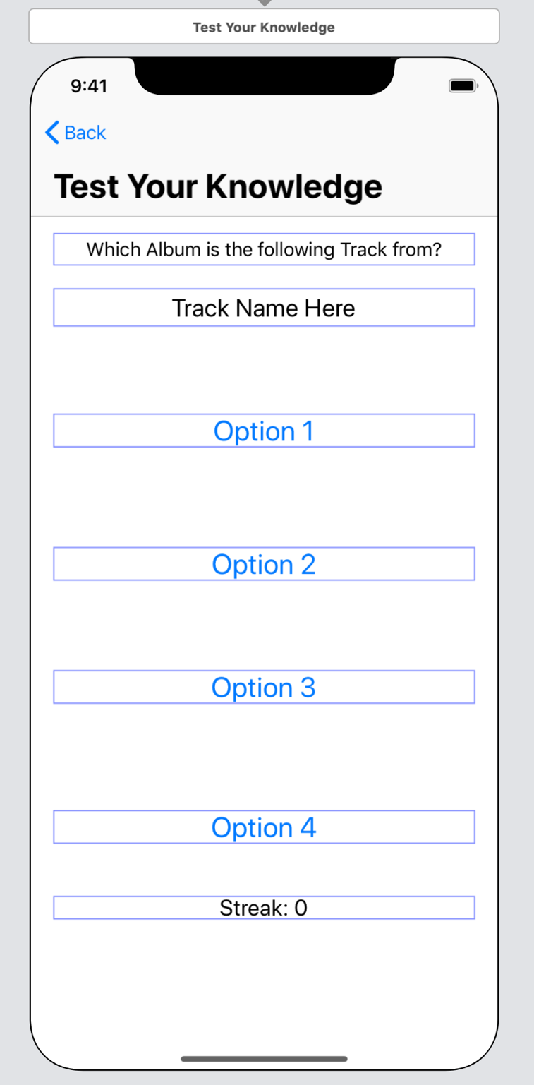

This screen is a simple multiple-choice quiz asking the user which album the given track is from. Should the user get the answer correct the streak value increases until a wrong answer is given.

**Change Artist**

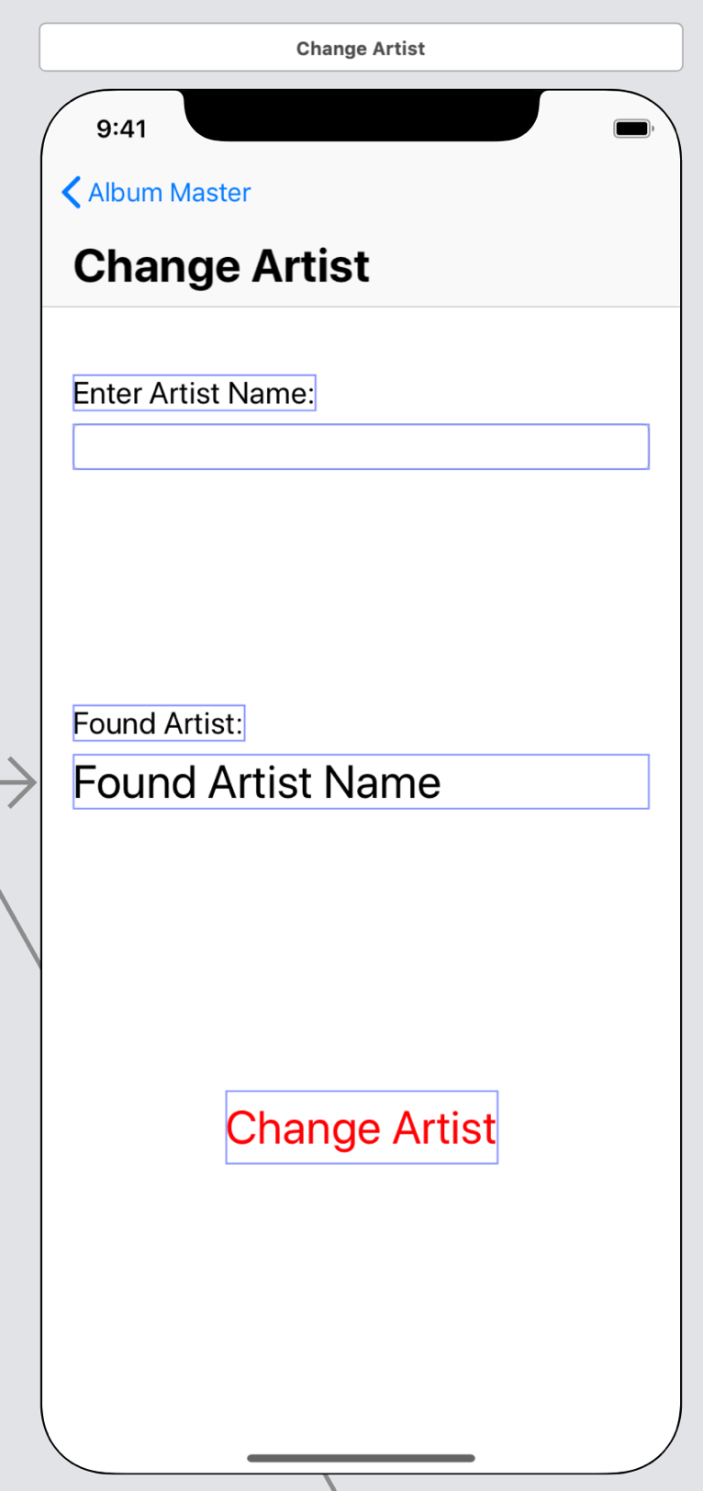

This app is to help users become an expert in a particular artist’s work. Hence they need the ability to select which artist they are going to be studying. The textbox allows the user to search an artist, which in turn searches the iTunes API for the most relevant artist before prompting the user to change to this new artist. Should they change, the database is wiped as albums from another artist are obviously not from the newly selected artist.