**Normalization Assignment:**

**1.**

|  |  |  |  |  |
| --- | --- | --- | --- | --- |
| salutation | First name | Member_id | Address | Movies_rented |
| Mr. | Ram | 2 | New Delhi | Matrix, clash of Titan |
| Ms. | Sita | 7 | Pune | Home Alone-I, Home Alone -II |

**After Normalization:**

1. Name : Member_id, First name.
2. Salutation : Member_id, Salutation.
3. Address : Member_id, Address.
4. Movies : Member_id, Movies_rented.

**2.**

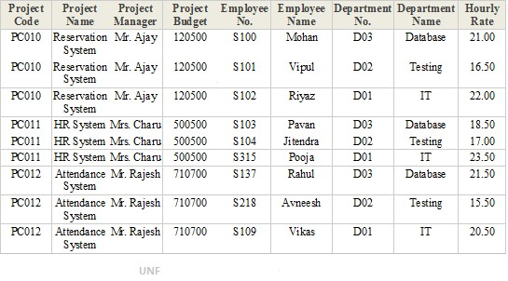

**After normalization the second table will look as follows:**

1. Project: Project Code, Project Name
2. Budget: Project Code, Project Budget
3. Manager: Project Code, Project Manager
4. Employee: Employee No, Employee Name
5. Department: Department No, Department Name
6. Project_Details: Project Code, Employee no, Department no, Hourly rate.