**Factors to Consider as A result of Analysis of Feedback Survey**

So far, a total of 18 users completed this short questionnaire regarding our web application idea. The results mostly conclude that the platform would be used by members of society and help to solve a real-world issue.

**Question 1**

* When asked which platform people would currently use if in need of finding housemates, 100% of users selected social media. This strongly indicates that there is currently a gap in the market for a functional or popular house share finding application.
* One user selected both Social Media and Website/Application, suggesting they would be inclined to use both platforms. Our aim is to make our platform more engaging and easier to use than house share pages on social media.

**Question 2**

* This question was interpreted incorrectly by 4 users, as it was only supposed to be answered by users who selected Website/Application.
* The person who selected Website/Application suggested that they would use a platform called Spare Room. This platform will be reviewed by the group and the positive and negative aspects of its features and user interface considered in order to improve our own housemate finding platform.

**Question 3**

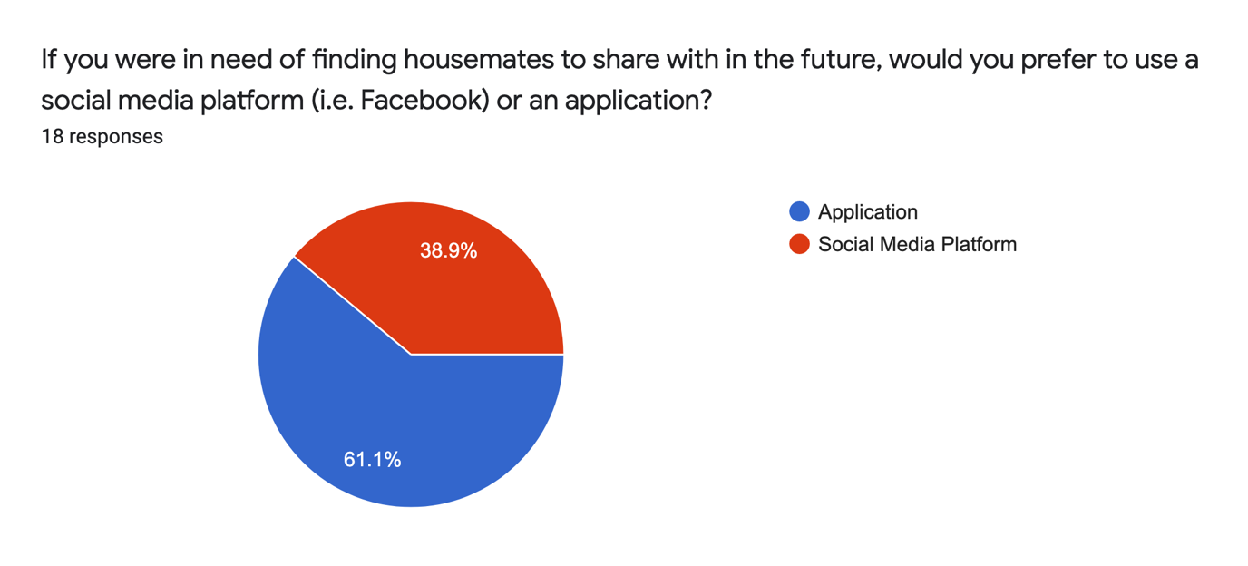

* When asked which platform users would prefer to use in the future, 61.1% of users opted for an Application. This is a fairly strong indication that our web application would be a popular platform for those in need of finding a housemate and thus most likely be a viable alternative to the current social media monopoly on housemate finding.

**Question 4**

* 27.8% of users said that Gender was one of the most important factors to consider when finding a housemate. This figure is lower than the group expected and therefore we may decide to put less significance on the matching of genders on our platform.
* 88.9% of users said that Age was an important factor when finding a housemate. This figure is very high and so is definitely something that should be a significant factor included in our matching algorithm.
* 50% of users said Budget was an important factor. This suggests it is definitely a relevant criterion to include but may be tricky to implement into the matching algorithm without the use of budget constraint values. Therefore, the group may decide to offer several budget constraint options in the profile setup, which can be selected by the user.
* 94.4% of users said that Lifestyle was one of the most important factors. In fact, this was voted as generally the most popular criteria for finding a housemate, with only one person not selecting it. This feedback strongly suggests that lifestyle choices should be included in profile setup and either displayed on users’ bio pages or included in the matching algorithm if possible.
* 0% of users said that University Course was an important factor whilst choosing a housemate. This figure is much lower than expected seeing as the group has now decided the web app will be targeted at Bristol students. Perhaps we will make this field optional in the profile setup.
* 55% of users said that Interests and Hobbies was an important factor. This is similar to lifestyle, but since hobbies may vary significantly, we will probably just display these on the user’s bio page so that other users can view them.
* 0% of users said that Religion was an important factor. Based on this feedback we may decide as a group to completely scrap this criterion from the options, or at least make it an optional field.

Evaluation of Criteria Feedback

The feedback on matching criteria has definitely provided useful information for deciding which factors are most significant for the matching of different users. However, it is important to consider the demographic of the people the survey was distributed to. Since most of the people who filled out this form were friends of our age who have graduated from university, it is natural that they would no longer consider options such as University Course to be of importance. Furthermore, these users are mostly all of the same age and from similar backgrounds. Perhaps for some more robust feedback and data the survey would need to be distributed to different demographics of students, such as first years and groups in sixth form. Results may vary significantly depending on the target audience.

**Question 5**

* This question was not particularly helpful. It only received two responses, both of which were already listed in the previous question. However, it does suggest that we have already considered most of the important criteria for finding a housemate in the previous question

**Question 6**

* 72.2% of users said that they preferred the swiping animation such as on an app like Tinder, rather than a like and dislike button similar to the dating app Hinge. This may be a technical challenge as our application is a website rather than a mobile app.
* However, as the groups JavaScript skills improve over the unit, we may be able to implement some kind of animations when the like and dislike buttons are clicked on.

**Question 7**

* When asked if users would recommend a Tinder like housemate finding application to a friend in need of a housemate in the future, the results were very promising.
* With 55.6% of users saying they would Absolutely recommend this platform to a friend in need and 44.4% saying they would be Very Likely to, this indicated that our idea would be a popular choice for users and would be solving a real-life problem.
* However, as previously discussed, this survey was completed by a limited demographic of people that the group know personally. Therefore, these users may be more inclined to give biased positive feedback. In the future it would be good to get feedback from a wider demographic to provide more conclusive data, but that has been challenging currently due to the COVID-19 pandemic.