**Adding UCanAccess jar files to the Eclipse project**

1. Download the project package from Canvas.
2. Unzip the project and UCanAccess files on your desktop. To unzip the project, right-click on the file and select Extract All.

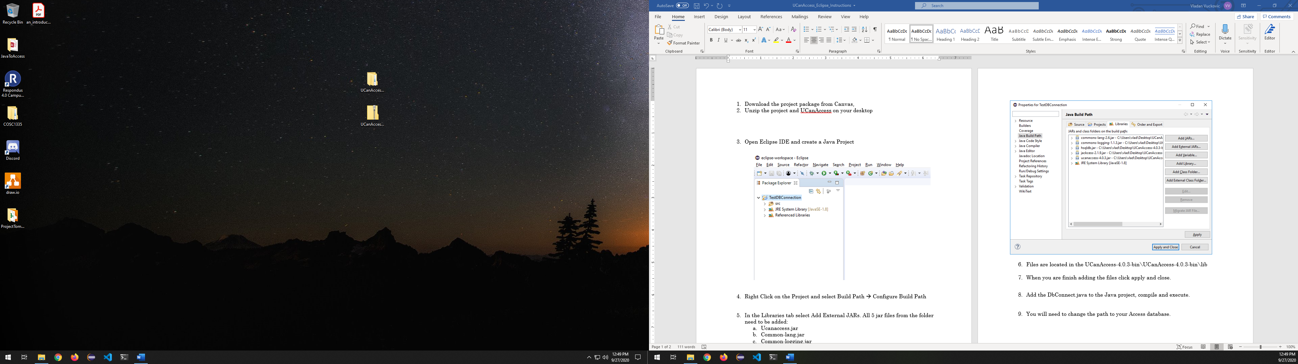

1. Open Eclipse IDE and create a Java Project

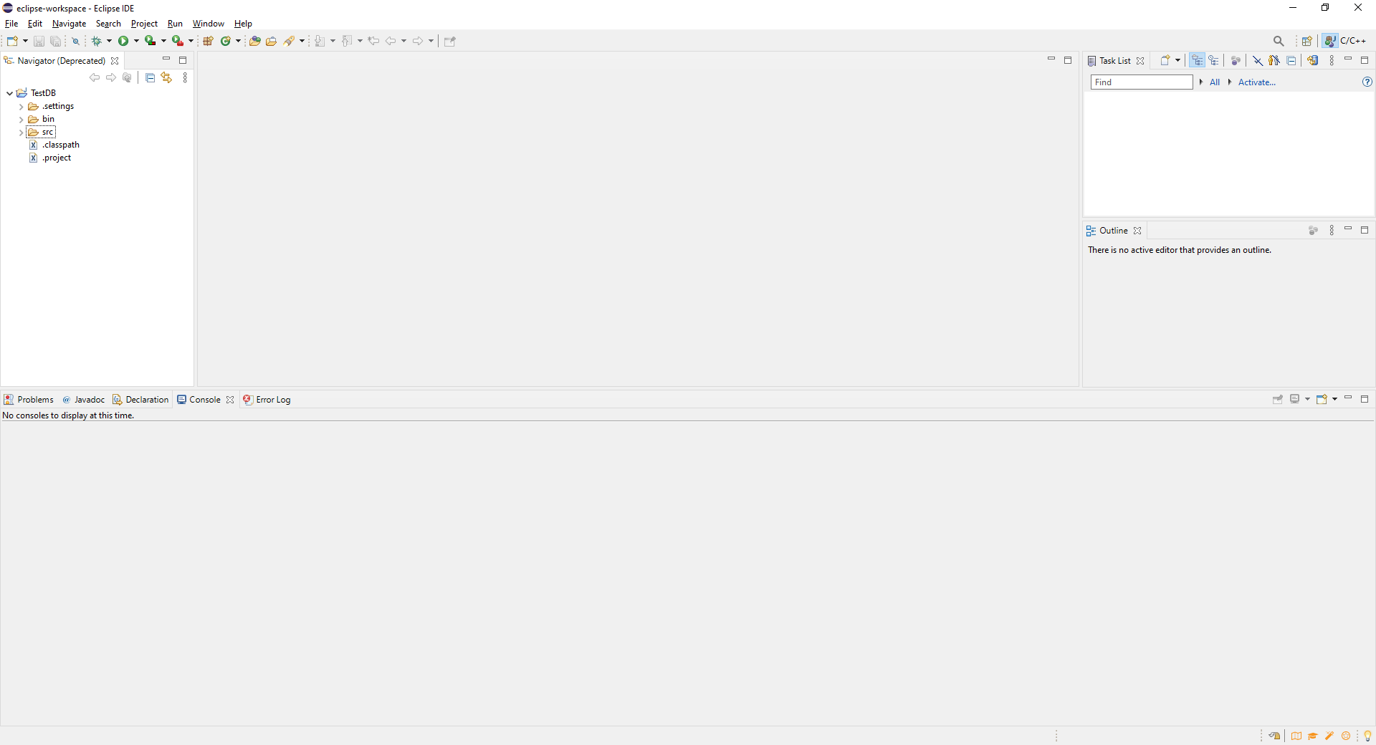

1. Right-click on the project and select Properties.
2. In properties, select Java Build.
3. In the Libraries tab, select Add External JARs. Add all six jar files from the folder:
   1. Ucanaccess.jar
   2. Ucanload.jar
   3. Common-lang.jar
   4. Common-logging.jar
   5. Hsqlbd.jar
   6. Jackcess.jar
4. Files are in:
   * \UCanAccess-5.0.0-bin\UCanAccess-5.0.0-bin\lib
   * \UCanAccess-5.0.0-bin\UCanAccess-5.0.0-bin\loader
   * \UCanAccess-5.0.0-bin\UCanAccess-5.0.0-bin

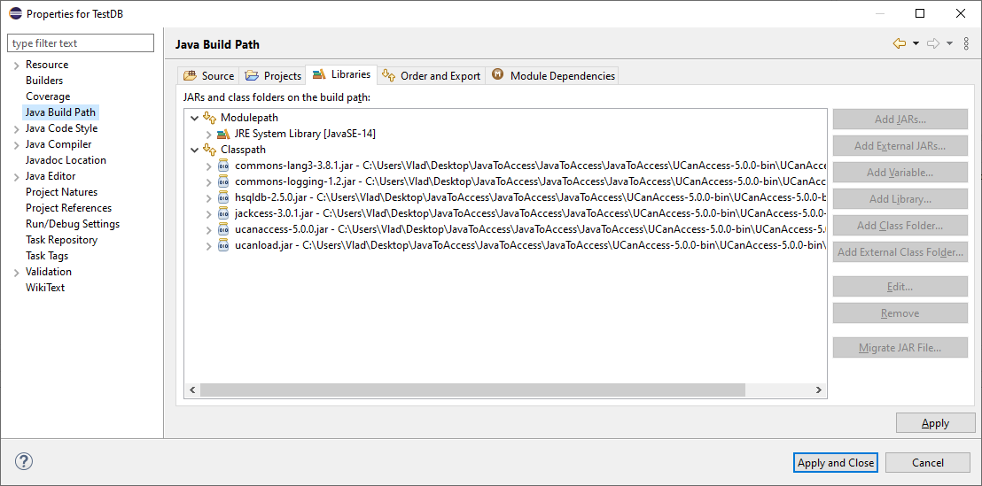

1. When you are done adding the files, click apply and close.
2. Add the DbConnect.java file to the Java project, compile and execute. Be sure to change the path to your access database in the code.