AVERERA PROBLEM STATEMENT REPORT
  - July 27, 2025

PROBLEM STATEMENT 1

Circuit Design and Component Connections
Components used here are Arduino Uno, DC Motor with encoder in it, 2 P-MOS of model IRF9Z34N, 2 N-MOS of model IRLZ44N, 2 NPN transistors of model 2N2219, 2 ACS712ELCTR-20A-T current sensors, 1 three-way switch of model SW-ROT-3, a potentiometer (POT-HG), resistors of resistances 220 ohms & 10k ohms. I have used power terminals and ground terminals, and also voltage probes to check for HIGH and LOW of encoder pins.
For N-MOS, IRLZ44N was good choice as it turns ON with 5V applied over gate, thus enabling easier direct connections from Arduino pins from digitalWrite(). In IRF9Z34N as we had power supply of 48V, thus to prevent flow of higher voltage from its gate we use NPN transistor which also enables to maintain voltage at the pins and connections we want, and helps us in directly using a pull-down resistor connecting gate to source. As the pull-down resistor when connected to gate to source of N-MOS had no issues, due to the source being grounded, needed no protection to use a transistor in N-MOS gates connection. Also, the MOSFETs used have a maximum voltage of 55V, thus good to handle 48V motor and sources in P-MOS.
The H-Bridge is made by joining motor’s each terminal to drains of one P-MOS and N-MOS on one side, and other terminal to drains of other side’s P-MOS and P-MOS. The ACS712ELCTR-20A-T sensors, which are based on Hall Effect, are being used in series, as they were available in both proteus and KiCAD, to each drain connections of P-MOS & N-MOS, with its IP+ and IP- connected in such a way that current flows through it in through IP+ and IP-. Now, the VCC is given 5V power supply, and GND is grounded, while VIOUT is attached to analog pins A1, A2 of Arduino. It’s used to check whether the current flow doesn’t exceed the limit, which was cross checked using current probes.
The DC motor used here has a position encoder within it, which I found in proteus, and when checked using oscilloscope it was found the outer pins of the three on top are encoder A & B pins, while middle pin was found out to be ground, thus been grounded. Where encoder pins are connected to Arduino digital pins 2 and 3.
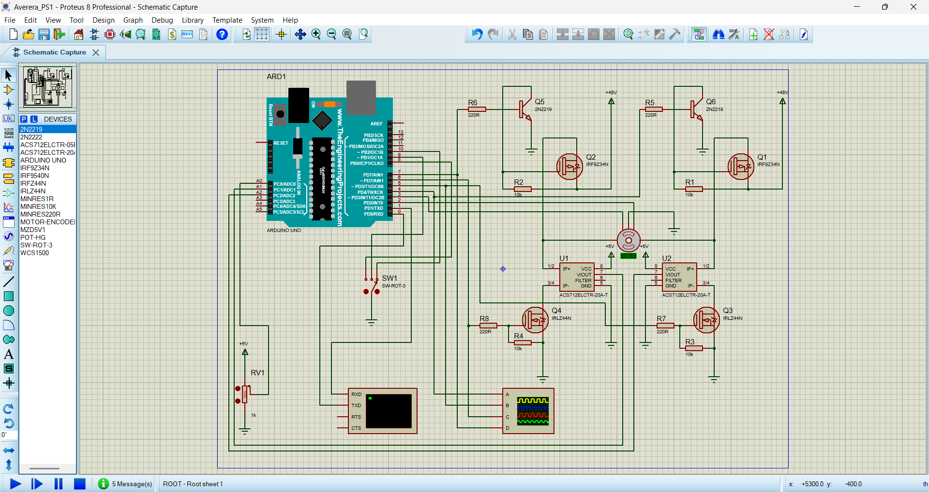
To control speed I used a potentiometer, where it’s given a 5V power supply, and another pin grounded. And the wiper (middle) pin is connected to analog pin A0 of Arduino to read the input voltage from potentiometer.
For the display of angle and waveforms of gate signals, serial monitor (virtual terminal) and oscilloscope is also used.

Explanation of Concept Used
MOSFETs are used in a H-Bridge to change polarity of the motor thus switching the direction. An N-MOS (here IRLZ44N) turns ON when gate voltage is greater than source voltage (here 0V, as grounded), with an optimum difference of 5V. So, when given a HIGH from Arduino it turns ON and allows current flow, and opposite when made LOW. Similarly, but opposite way, a P-MOS (IRF9Z34N) works, where it turns ON when gate voltage is smaller than source voltage (here 48V), with an optimum difference of 10V. Where N-MOS is generally used in the low-side of bridge and P-MOS in the high-side.
For finding the direction through encoders of motor, we must know the concept that the pulsating waves from encoder A leads the encoder B by 90° this says that the motor rotates clockwise, while if encoder B pulse leads with 90° the encoder A pulse, then the motor is rotating in anticlockwise direction.
Attached image is of anticlockwise case: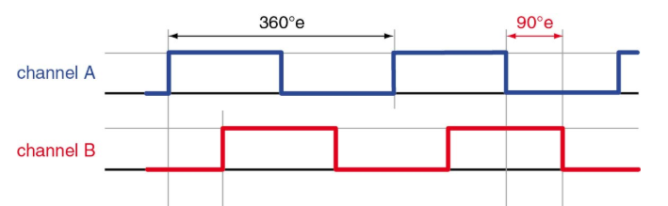
Now, for finding the right limit of threshold current through I measured using current probes when run with highest speed/RPM by potentiometer, which I found it be something near to 1.99A and fluctuating a bit with maximum below 2.5A, so decided to fix 2.5A to be threshold value. Now in the ACS712ELCTR-20A-T sensor, for 0A the VOUT gives 2.5V and has a sensitivity of 100 mV/A, thus the desired output voltage would be VIOUT = 2.5 + (2.5*0.1) = 2.75, which mapped to 0 to 5V to 0 to 1023, gives approximate reading at analog pins A1, A2 as 563.

Explanation about Arduino Code
I have used #define to name the pins used here, the names of pins can be referred from Arduino file. I have declared variables pos for counting the pulses as counter for encoder, threshold = 563, now it would keep count of time whenever it reaches interval = 200 the code to check shoot through would activate using if condition at every 200ms, if found exceeding it runs function shutDown() which would turn OFF all the MOSFETs. Now, we declare variable pot which would keep reading of potentiometer.
In setup, I set the pin modes of all pins as OUTPUT for gate pins, INPUT for encoder pins A & B, and INPUT_PULLUP for switch pins to turn clockwise, anticlockwise and to stop. Also, I have used pinToChnageInterrupt() to keep counting the number of pulses whenever A pulse rises, whether in clockwise or anticlockwise determined by digitalRead() of encoder B pin under interrupt function, and thus pos either added or subtracted.
In loop, I run if condition for checking shoot through every 200ms, but thus is little rare to happen as all MOSFETs are immediately turned OFF and ON only when bool shootThrough is FALSE. Next, pot is mapped from 0-1023 to PWM range 0-255. And then again, we use if and else if to run digitalWrite() and analogWrite() to turn ON and OFF the certain MOSFETs to run clockwise or anticlockwise or to stop that is, to shutDown(). I didn’t join the gates of diagonal MOSFETs as when done so, the PWM would be sent to both P-MOS and N-MOS, but in general the PWM is sent to N-MOS to control motor’s speed, but also another issue in that setup was that the change in potentiometer’s input given would no longer be linear with the motor’s RPM, whereas in the connections right now the RPM’s approximately linear with potentiometer’s input, like on 100% I get 180 RPM, while on 50% I get near to 88.4 RPM (near to the expectation of 90 RPM), but in previous discussed case the RPM at 50% would come way below 88, thus making it nonlinear, thus I had chosen to make use of most pins instead of joining, so that it would be linear making it helpful for next question mapping the speeds too.
Using serial monitor, I print out the angle calculated as pos*15.0, because my motor’s properties show 24 PPR, thus each pulse covers here 360/24=15 degrees. So, the angle would be pos*15.0. And the oscilloscope shows the gate signals waveforms connected to gates of all four MSOFETs. Here, I didn’t make the angles to start again from 0 after 360, instead they may go to higher positive or negative numbers based on how much time they have been revolving so that we may have an idea of number revolutions completed by then.

Note: Whenever I print out my angles they don’t come faster as compared to my motor in the starting few seconds of my simulation but later becomes more accurate, may be due to CPU excessive load error or something else, because of which I don’t get precise angle measurements despite of correct calculation at starting or sometimes in between, which I even tried to fix it but couldn’t understand the reason which is holding me back to get precise angles, for example 90 degrees feels if its nearer to 110 degrees, thus allow this small inaccuracy in my simulation.

