Design and Implementation of an AI-Driven Self-Adaptive Digital Twin for a Simulated 5G Radio Access Network
Varun A L, Mithilesh B, Tarakesh M, Harieharan R, Jai Athitya
Department of Information Technology, Madras Institute of Technology, Anna University, Chennai, India

Abstract—This paper documents the design and real, executed implementation of a self-adaptive Digital Twin (DT) for a simulated 5th-Generation (5G) New Radio access network. The system ingests genuine physical-layer and flow-level telemetry from an ns-3/5G-LENA network simulation, synchronizes it continuously into a persistent dynamic state store, and runs five dependency-ordered machine-learning components that predict throughput, latency, packet loss, Physical Resource Block (PRB) utilization, and jitter. A deterministic fidelity engine scores each component's predictive accuracy every cycle using four independent metrics, and a trained reinforcement-learning policy (Proximal Policy Optimization) selects a corrective strategy whenever accuracy degrades. Corrective candidates are produced, isolated in a sandboxed subprocess, and admitted to production only by a deterministic verification gate that an integrated large-language-model reasoning layer cannot override. Every implementation claim in this paper — architecture, formulas, parameters, and measured results — is drawn directly from the project's source code, configuration files, and executed validation runs, with no fabricated or projected figures. Held-out evaluation shows all five prediction components outperform a naive baseline, and the trained decision policy reproduces the theoretically correct corrective strategy on both low- and high-severity validation scenarios.
Keywords—Digital Twin; 5G Network Simulation; Self-Adaptive Systems; Reinforcement Learning; Sensor Telemetry Synchronization; Fidelity Evaluation.

I. Introduction and System Purpose
A Digital Twin (DT) is a live, continuously updated computational replica of a physical or simulated system, maintained in close synchronization with that system's real behavior. This paper presents a DT built for a simulated 5G New Radio (NR) radio access network, whose purpose is threefold: (i) continuously mirror the network's measurable behavior — throughput, latency, packet loss, radio-resource utilization, and jitter — through a set of trained predictive models; (ii) continuously and quantitatively measure how faithfully those models still track reality; and (iii) autonomously repair a model whose predictive fidelity has degraded, without pausing telemetry ingestion and without allowing an unverified change to reach production.
The ground-truth network is not physical hardware but a purpose-built ns-3 simulation using the 5G-LENA New Radio module, chosen because it implements a 3GPP-conformant channel model (path loss, shadow fading) and produces physical-layer traces (Signal-to-Interference-plus-Noise Ratio, Reference Signal Received Power/Quality) and flow-level statistics that a real base station's monitoring stack would also expose. Every telemetry field consumed by the DT is therefore a genuine simulator measurement, not a synthetically fabricated value, and the system additionally supports a clearly and permanently labeled mock telemetry source for development and testing that is never presented as simulator output.
The system's central engineering problem is self-adaptation under continuous operation: a predictive component's accuracy can degrade as network conditions drift, and the DT must detect this, decide on and construct a remedy, and validate that remedy — all while telemetry keeps flowing and the currently serving model keeps operating. Three design principles recur throughout the implementation and are traceable to specific source files discussed in Section IV: (1) the decision of which corrective strategy to apply is made exclusively by a trained reinforcement-learning policy, never a hand-coded rule; (2) any corrective code produced by a large-language-model (LLM) assistant is executed only inside an isolated subprocess and is never trusted directly; and (3) promotion of a corrected component to production is decided exclusively by an independent, deterministic numerical comparison that the LLM reasoning layer cannot influence.

A. Contributions
This paper reports: a working, executed pipeline from a real network simulator through telemetry synchronization, prediction, fidelity scoring, automated decision-making, sandboxed self-repair, and deterministic verification; the exact mathematical formulation of every telemetry conversion and scoring computation the system performs, extracted directly from its source code; and quantitative results from executed validation runs, including held-out prediction accuracy, reinforcement-learning training curves, and two complete real adaptation cycles — one driven by synthetic mock telemetry and one driven by the real ns-3/5G-LENA simulator.

II. System Architecture and Data Pipeline
Fig. 1 shows the system organized into five layers, moving from the simulated physical network up to visualization. Layer 1 is the ns-3/5G-LENA simulation itself. Layer 2 extracts physical-layer and flow-level measurements and transports them over a message queue. Layer 3 validates and continuously synchronizes that telemetry into persistent state. Layer 4 — the Digital Twin State Model — holds the dynamic state store, the five dependency-ordered prediction components, the fidelity evaluator, the reinforcement-learning decision agent and its corrective agents, and the deterministic verification/registry/lifecycle-logging chain. Layer 5 renders telemetry, fidelity, and adaptation-outcome charts from whatever the system has genuinely produced.

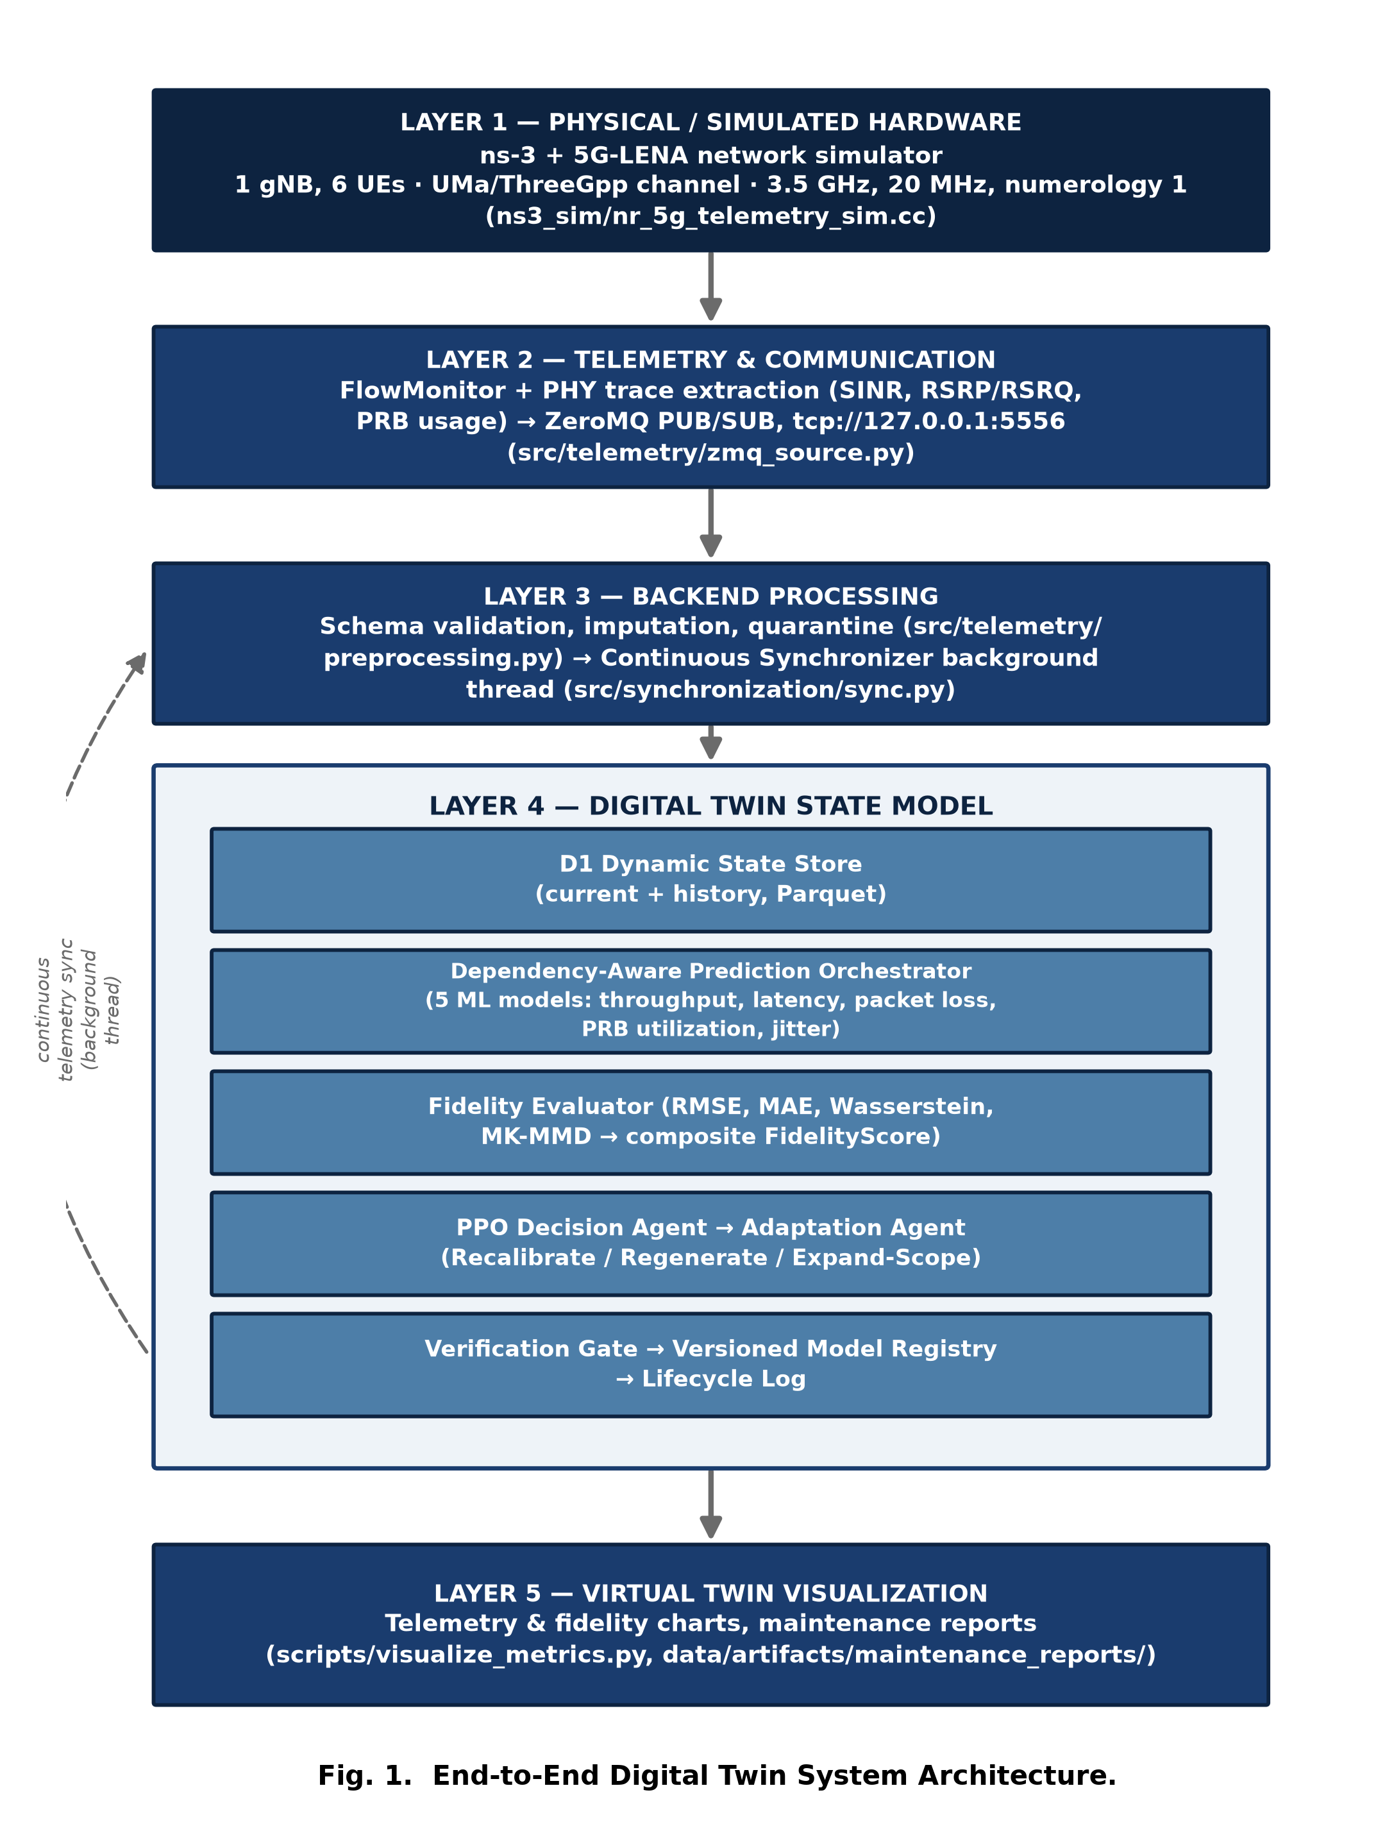
Fig. 1. End-to-End Digital Twin System Architecture.

A. Data Pipeline
Fig. 2 traces one telemetry record end to end. (1) The simulator's PHY and FlowMonitor traces are polled on a fixed interval. (2) A structured per-User-Equipment (UE) record is assembled in the simulator's native units (bits/second, seconds, unitless ratios). (3) The record is published over a ZeroMQ publish/subscribe socket. (4) The backend subscribes and receives it. (5) The record is schema-validated, range-checked, and either accepted, imputed from the last known-good value for that (UE, cell) pair, or quarantined — never silently dropped. (6) Accepted fields are converted to the DT's canonical units (Mbps, milliseconds, percent). (7) The Digital Twin's current-state table is updated using a latest-by-timestamp rule, and the full history is appended, never overwritten. (8) Downstream consumers — the prediction orchestrator, the fidelity evaluator, and the visualization tooling — read from this state.
Telemetry synchronization runs on its own background thread and is never blocked by prediction, fidelity evaluation, or an in-progress adaptation cycle; this was verified directly by sampling the synchronization counter while a real adaptation cycle was executing (Section V).

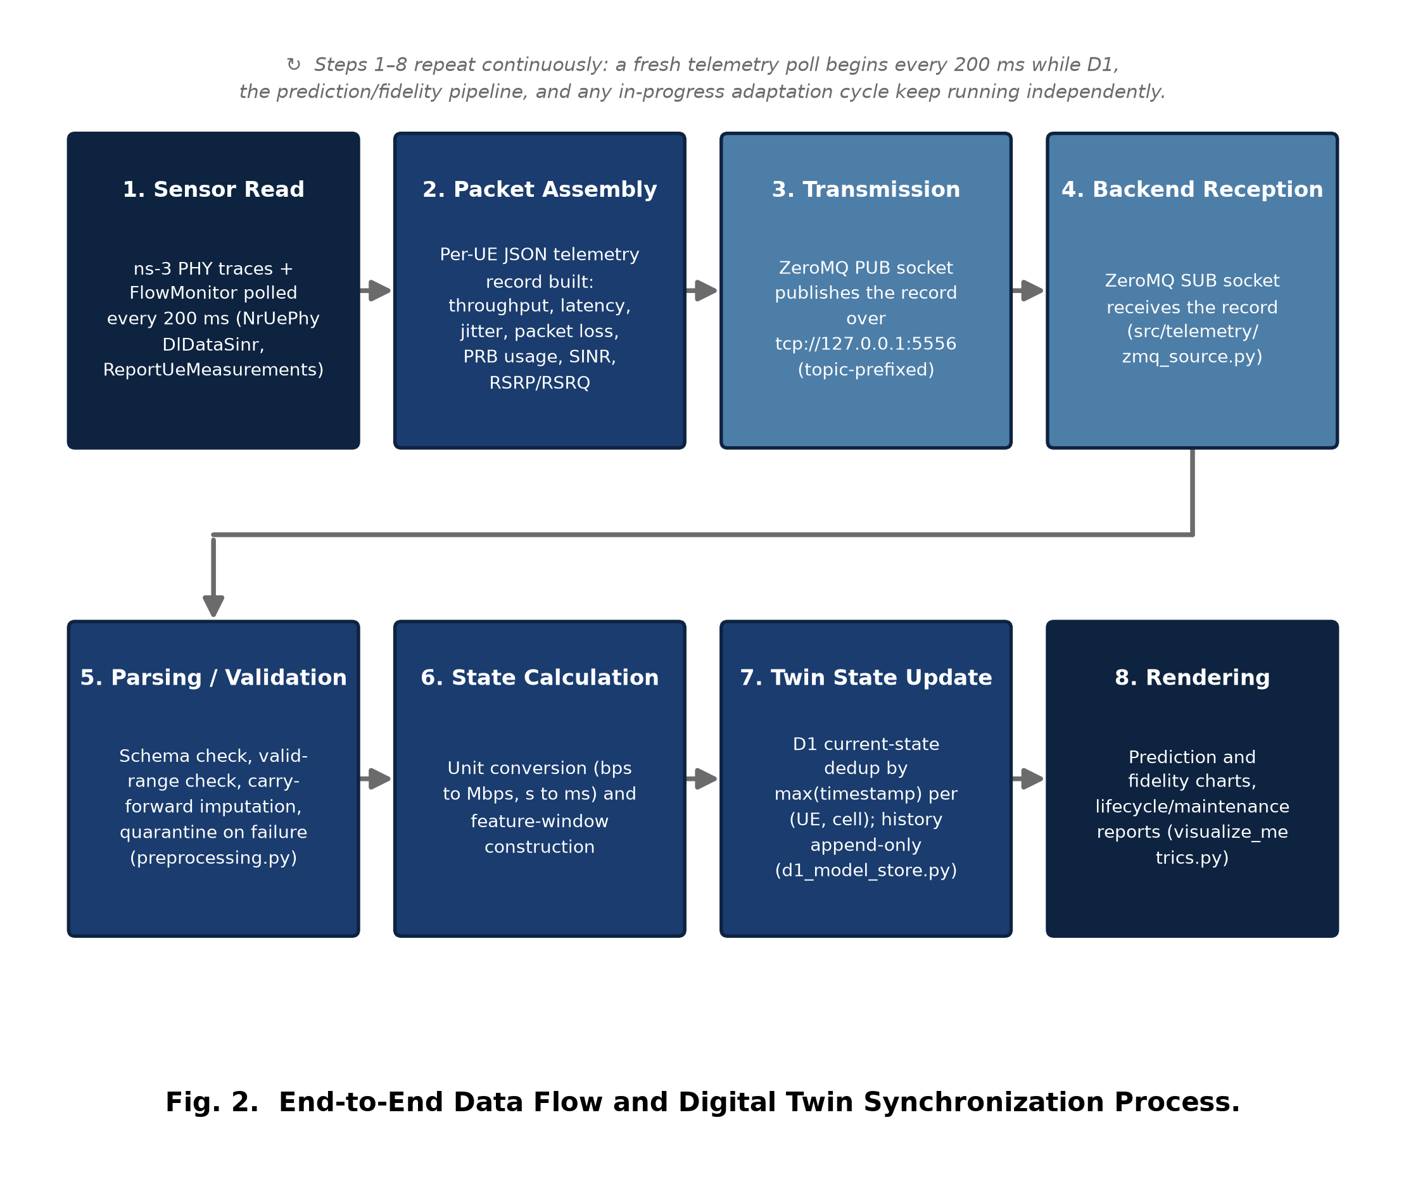
Fig. 2. End-to-End Data Flow and Digital Twin Synchronization Process.

B. Prediction Dependency Structure
The five prediction components are not independent: latency, PRB utilization, and jitter each consume one or more upstream components' live predictions as inputs, in addition to raw telemetry features. Throughput and packet loss have no such dependency and are computed first. This dependency order (throughput, packet loss) then (latency, PRB utilization) then jitter is derived at runtime from each component's declared dependency list via a topological sort — it is not a hardcoded call sequence — which is what Algorithm 1 (Section III) describes.

III. Mathematical Modeling and Algorithmic Formulation
Every equation below is implemented exactly as written in the project's own source code (cited per equation); none is a textbook formula included for illustration only. Table I defines every symbol on first use.

TABLE I
Symbol Definitions
Symbol | Meaning / Unit
SINR_lin, SINR_dB | Linear and decibel signal-to-interference-plus-noise ratio
Δt | Telemetry polling interval (s); 0.2 s default
ΔRxBytes, ΔTxBytes | Received/transmitted byte count delta between two polls
ΔRxPackets, ΔTxPackets, ΔLost | Received/transmitted/lost packet count delta
ΔDelaySum, ΔJitterSum | Cumulative per-flow delay/jitter sum delta (s)
usedRbSym, availRb, dataSym | Used Resource-Block symbols; available RBs; data symbol count per slot
u, c, t | UE identifier; cell identifier; timestamp
R(u,c) | Set of all received telemetry records for key (u,c)
y, ŷ, n | Ground-truth values, predicted values, sample count
k_γ(a,b) | RBF kernel with bandwidth parameter γ
D_m, D̃_m | Squared and rolling-window-normalized raw metric m
ε, δ | Normalization stabilizer; verification acceptance margin (config-driven)
a_t, cost(a_t) | Adaptation action at step t; its configured cost penalty

A. Telemetry Unit Conversion and Sensor-Derived Calculations
Linear-to-decibel SINR conversion, applied to the NrUePhy DlDataSinr trace (ns3_sim/nr_5g_telemetry_sim.cc):
(1)
Per-interval throughput and offered load, derived from FlowMonitor cumulative byte counters snapshotted every Δt:
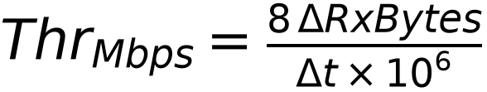 | (2)
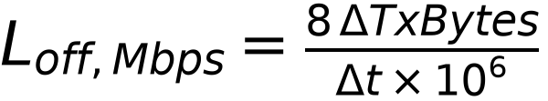 | (3)
Per-interval mean latency and jitter, from cumulative delay/jitter sums:
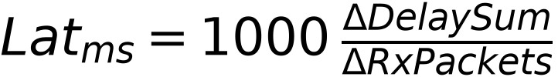 | (4)
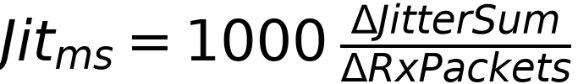 | (5)
Packet-loss ratio for the interval:
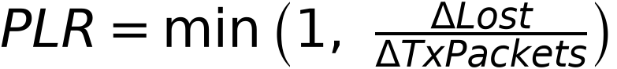 | (6)
Physical Resource Block utilization, combining two gNB PHY traces (SlotDataStats for available RBs and data-symbol count, RBDataStats for the literal used-RB bitmap):
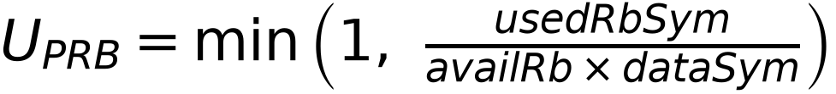 | (7)
Cell-wide offered-load aggregate, summed across every UE sharing a (cell, timestamp) key — an input feature to the PRB-utilization model:
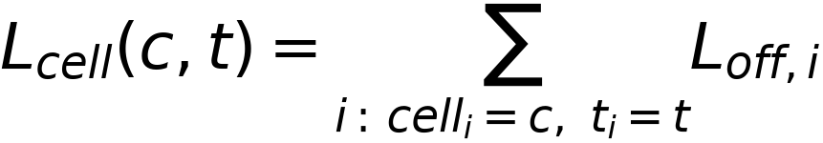 | (8)

B. Digital Twin State Synchronization
The dynamic state store's current-state view is updated by a latest-by-event-time rule, not arrival order, so that out-of-order delivery cannot regress state (src/dt_models/d1_model_store.py):
(9)
The full telemetry history is append-only under this same key and is never overwritten by a current-state update.

Algorithm 1 — Dependency-Aware Prediction Execution (src/dt_models/orchestrator.py)
Input: enabled components C, each with DEPENDENCIES(c) and predict(features)
order <- TopologicalSort(C, edges = {(d, c) : d in DEPENDENCIES(c)})
for c in order:
x <- features restricted to REQUIRED_FEATURES(c)
for d in DEPENDENCIES(c):
x[OUTPUT_FIELD(d)] <- predictions[d] # live upstream output
predictions[c] <- c.predict(x)
return predictions

C. Deterministic Fidelity Evaluation
Two pointwise accuracy metrics (src/fidelity/metrics.py):
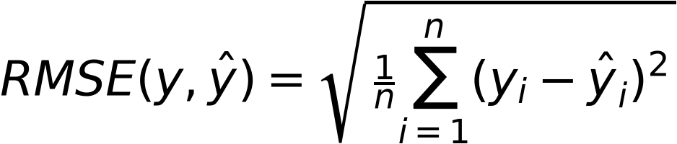 | (10)
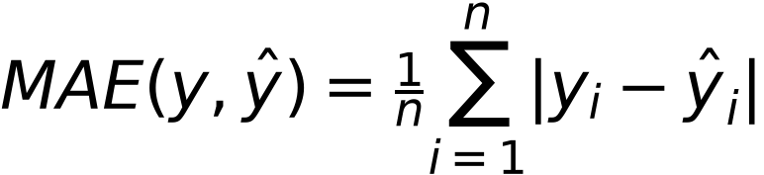 | (11)
One pairing-independent distributional metric (1-Wasserstein / Earth Mover's distance):
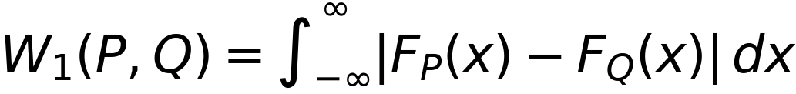 | (12)
A second distributional metric, Multi-Kernel Maximum Mean Discrepancy, using an RBF kernel and the unbiased two-sample MMD² estimator (self-pairs excluded):
(13)
averaged over three fixed bandwidth multipliers {0.5, 1.0, 2.0}×γ₀ around a median-heuristic base bandwidth γ₀, clamped at zero before the square root:
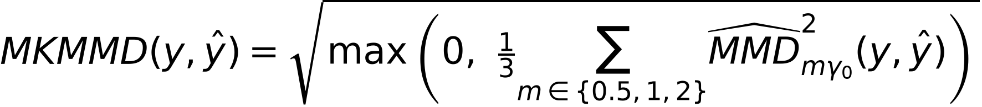 | (14)
Every raw metric is squared,
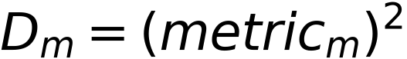 | (15)
then min-max normalized against a rolling historical window of past squared values:
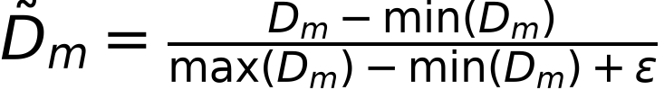 | (16)
and combined into one composite score per component:
(17)

Algorithm 2 — Rolling Fidelity Evaluation (src/fidelity/evaluator.py)
Input: component c, ground truth y, prediction y_hat, window W[c]
for m in {RMSE, MAE, Wasserstein, MK-MMD}:
raw[m] <- ComputeMetric(m, y, y_hat)
sq[m] <- raw[m] ** 2
if len(W[c][m]) < MIN_HISTORY for any m:
return status = INSUFFICIENT_HISTORY, score = None
for m in {RMSE, MAE, Wasserstein, MK-MMD}:
norm[m] <- (sq[m] - min(W[c][m])) / (max(W[c][m]) - min(W[c][m]) + eps)
score <- 1 - mean(norm[RMSE], norm[MAE], norm[Wasserstein], norm[MK-MMD])
if update_window: append sq[m] to W[c][m] for each m
return status = OK, score

D. Adaptation Decision and Verification Thresholds
The reinforcement-learning reward at adaptation step t (src/adaptation/rl_env.py) is the verified fidelity improvement net of a strategy-specific cost penalty:
(19)
with configured penalties 0.02 (Recalibrate), 0.08 (Regenerate), and 0.12 (Expand-Scope) — config/settings.yaml — making the reward-maximizing action strategy-dependent on drift severity rather than one action dominating unconditionally.
A corrective candidate is promoted to production if and only if its independently recomputed FidelityScore exceeds the current production version's by a configured margin δ (src/adaptation/verification_agent.py):
(18)

Algorithm 3 — PPO-Driven Adaptation Dispatch (src/main.py, rl_agent.py)
Input: drift event (component, severity)
s <- BuildObservation(fidelity_scores, component, severity,
prev_action, prev_reward, net_state)
a <- PPO.predict(s, deterministic=True) # 0=Recalibrate 1=Regenerate 2=Expand-Scope
candidate <- Dispatch(a, component) # sandboxed for Regenerate/Expand-Scope
verdict, fid_before, fid_after <- Verify(candidate, component) # Algorithm 4
if verdict == ACCEPT: Registry.promote(candidate)
else: Registry.reject(candidate) # production untouched
RecordLifecycleEvent(component, a, candidate, fid_before, fid_after, verdict)

Algorithm 4 — Deterministic Verification Gate (src/adaptation/verification_agent.py)
Input: candidate version v_new for component c, production version v_old
fid_old <- FidelityEvaluator.evaluate(c, y_true, predict(v_old, x), update_window=True)
fid_new <- FidelityEvaluator.evaluate(c, y_true, predict(v_new, x), update_window=False)
checks <- [ArtifactExists(v_new), InterfaceMatches(v_new, c),
EvaluationRan(fid_old, fid_new), AllFinite(predict(v_new, x))]
if all(checks) and fid_new.score > fid_old.score + delta:
decision <- ACCEPT
else:
decision <- REJECT # any single failed check forces REJECT
explanation <- LLM.explain(decision, fid_old, fid_new) # advisory text only,
# decision already final
return decision, fid_old.score, fid_new.score, explanation

IV. Hardware, Software, and Implementation Details

A. Simulated Physical Layer ("Hardware")
No physical radio hardware is used. The physical layer is emulated by ns-3.48 with the 5G-LENA (nr v5.1) module, a 3GPP-Release-15-conformant NR stack. Table II lists the scenario parameters actually configured in ns3_sim/nr_5g_telemetry_sim.cc. Compute hardware for model training and the full pipeline was a single development machine (12 logical cores, 7.4 GB RAM available to the process, an NVIDIA GPU with CUDA available); the PPO policy is trained on CPU by deliberate configuration (src/adaptation/rl_agent.py), since its small fully-connected policy network does not benefit from GPU transfer overhead.

TABLE II
Simulated Network / Telemetry Parameters
Parameter | Value
UEs / gNBs | 6 UEs, 1 gNB
Channel model | UMa / ThreeGpp, shadowing enabled
Center frequency / bandwidth | 3.5 GHz / 20 MHz
Numerology | 1
gNB transmit power | 23.0 dBm
Simulation duration (default) | 20 s
Telemetry polling interval | 200 ms
Transport | ZeroMQ PUB/SUB, tcp://127.0.0.1:5556

B. Software Stack
Table III lists the primary runtime dependencies (requirements.txt).

TABLE III
Software Stack
Layer | Library / Tool
Simulator | ns-3.48 + 5G-LENA (nr) v5.1, C++17
Data handling | pandas, numpy, pyarrow (Parquet)
Classical ML | scikit-learn (Random Forest), XGBoost
Reinforcement learning | PyTorch, Gymnasium, Stable-Baselines3 (PPO)
LLM reasoning | Anthropic Claude API (anthropic SDK)
Knowledge retrieval | ChromaDB (all-MiniLM-L6-v2 embeddings)
Transport | PyZMQ (ZeroMQ bindings)
Config / validation | PyYAML, Pydantic, python-dotenv
Testing | pytest, pytest-cov
Dependency graph | NetworkX (topological sort)

C. Communication Protocol and Message Format
Telemetry is transported over a ZeroMQ publish/subscribe socket rather than a request/response API: the simulator process binds a PUB socket and publishes one JSON message per UE per polling tick; the backend's ZmqTelemetrySource subscribes and receives independently, so a slow or absent subscriber never blocks the simulator. Each message carries: timestamp, ue_id, cell_id, throughput_bps, offered_load_bps, latency_s, jitter_s, packet_loss_ratio, prb_utilization_ratio, sinr_db, rsrp_dbm, rsrq_db, ue_count, ue_speed_mps, and source (transport-stamped, never payload-trusted). Drift notifications use an analogous but separate contract: {component, severity, timestamp, metadata}.

D. Internal Module Interfaces
The system exposes no external REST/HTTP API; module boundaries are Python abstract-base-class interfaces, listed in Table IV, each implemented by every concrete component so the orchestrator, sandbox, and registry can operate on any component generically.

TABLE IV
Internal Module Interfaces ("APIs")
Interface | Key Methods | Purpose
DTComponent | train, predict, evaluate, save, load | Prediction component contract (Modules 6-10)
TelemetrySource | records(), close() | Mock / real (ZeroMQ) telemetry provenance
DriftSource | events(), close() | Mock / external drift-event provenance
AnthropicClient | complete, complete_structured, *_safe | Centralized, retrying LLM access
ModelRegistry | register_version, promote, reject, rollback, get_current_version | Versioned model lineage (Concept C)
FidelityEvaluator | evaluate(component, y, y_hat, update_window) | Deterministic composite scoring

E. DT Prediction Component Configuration

TABLE V
DT Prediction Component Configuration
Component | Model | Key Hyperparameters | Dependencies
Throughput | XGBoost | 300 trees, depth 6, lr 0.05 | — (root)
Packet Loss | XGBoost | 300 trees, depth 6, lr 0.05 | — (root)
Latency | XGBoost | 300 trees, depth 6, lr 0.05 | throughput
PRB Utilization | Random Forest | 200 trees, depth 10 | throughput
Jitter | XGBoost (reg.) | 80 trees, depth 2, lr 0.1, subsample 0.9 | throughput, latency, packet loss

F. Sandbox Isolation and the LLM-to-Production Boundary
LLM-generated component code (Regenerate, Expand-Scope strategies) is never imported into the parent process. It is written to an isolated workspace and executed by a fixed, project-authored subprocess driver (src/sandbox/_sandbox_driver.py) with an environment built from scratch (no inherited secrets), under a configured wall-clock timeout (120 s) and output-size cap. The driver checks, in order: syntax, import, interface conformance (COMPONENT_NAME / OUTPUT_FIELD identity), training, evaluation, and artifact save. A candidate's trained-artifact bytes are likewise never deserialized in the parent process — only a version's raw bytes are stored by the registry — closing the pickle-deserialization code-execution vector regardless of which corrective agent produced the artifact.

G. Continuous Orchestration Loop

Algorithm 5 — Continuous Orchestration Loop (src/main.py: ContinuousOrchestrator)
Thread A (daemon): for record in TelemetrySource.records():
D1.append(record) # never blocks Thread C
Thread B (daemon): for event in DriftSource.events():
DriftQueue.put(ValidatedEvent(event))
Thread C (foreground): loop:
RunPredictionAndFidelityCycle() # Modules 5-12
if DriftQueue not empty:
event <- DriftQueue.get()
RunAdaptationCycle(event) # Algorithm 3
sleep(prediction_interval_seconds)

V. Experimental Setup and Performance Metrics
All figures in this section were produced by executing the real, non-mocked code paths described in Sections II-IV. Only the Anthropic LLM transport is mocked in the automated test suite, since no production API credential was available in the development environment; every such test is explicitly documented as mocked rather than presented as a live call.

A. Automated Test Suite
The automated suite comprises 487 tests (unit and integration). A clean combined run completed with 486 passed, 1 skipped, 0 failed in 848.9 s wall-clock time. The single skip is a live-API smoke test that self-skips without a real API key. An independent, isolated telemetry pipeline check (ns3_sim/validate_e2e.py) consumed 162 real simulator records with 0 quarantined and 0 out-of-range flags.

B. Prediction-Component Held-Out Accuracy

TABLE VI
Held-Out Regression RMSE vs. Naive Mean Baseline
Component | Model RMSE | Baseline RMSE | Improvement
Throughput (Mbps) | 1.5392 | 10.8198 | 85.8%
Latency (ms) | 2.2217 | 4.4239 | 49.8%
Packet Loss (%) | 0.3352 | 1.0224 | 67.2%
PRB Utilization (%) | 8.6235 | 19.4206 | 55.6%
Jitter (ms) | 1.1743 | 1.3164 | 10.8%

Two implementation issues were found and corrected during this validation. First, an initial PRB-utilization model showed no improvement over baseline because the mock telemetry generator drew PRB utilization independently of cell demand; correcting the generator to derive it from offered load and UE count produced the 55.6% improvement above. Second, an initial jitter model overfit (training RMSE 0.47 ms vs. held-out RMSE 1.29 ms) under hyperparameters shared with the other four, stronger-signal components; regularizing jitter's own configuration (Table V) resolved this.

C. Fidelity Scoring on Real Predictions
Feeding real held-out predictions through the fidelity engine yielded, in a representative evaluation batch: throughput 0.8175, packet loss 0.9338, latency 0.7006, PRB utilization 0.6759, jitter 0.9326 (composite FidelityScore, higher is better). MK-MMD evaluated to exactly 0.0 in these batches; the underlying per-bandwidth unbiased MMD² estimates were confirmed genuinely small-negative (−0.06 to −0.11), the expected estimator behavior at n=10 samples per side, not a defect.

D. Reinforcement-Learning Decision Agent

TABLE VII
PPO Training Configuration and Executed Budget
Hyperparameter | Value
Learning rate | 3.0 × 10⁻⁴
Rollout steps | 256
Minibatch size | 64
Discount γ | 0.99
GAE λ | 0.95
Clip range | 0.2
Parallel environments | 4
Timesteps executed | 20,480

Training ran 15,942 episodes in 412.4 s wall-clock on CPU. Mean episodic reward rose from 0.2536 (first half of training) to 0.3091 (second half), corroborated by explained variance rising from −0.58 to 0.99 and policy entropy falling from −1.09 to −0.17. On held-out scenarios generated from an unseen random seed, the trained policy's mean reward over 60 episodes was −0.0151 at low drift severity — exactly matching an always-Recalibrate fixed baseline and beating always-Regenerate (−0.0746) — and 0.7010 at high severity — exactly matching an always-Regenerate baseline and beating always-Recalibrate (0.1812). The trained policy therefore reproduces the severity-appropriate strategy at both tested extremes without being told which action is correct.

E. Verification-Gate Integrity
A dedicated test paired a real recalibration candidate (fidelity_before = 0.9800, fidelity_after = 0.9987) with a fixed adversarial LLM instructed to argue for REJECT regardless of the numbers. The deterministic gate ACCEPTed and genuinely promoted the candidate; the adversarial text was recorded verbatim in the audit explanation but had zero effect on the registry state, confirming the structural separation between the deterministic decision and the LLM reasoning layer described in Algorithm 4.

F. Full Adaptation Cycles — Mock and Real Telemetry

TABLE VIII
End-to-End Adaptation Cycle Outcomes
Run | Telemetry Source | Component / Severity | Action | Fidelity Before → After | Verdict
Mock demo | MOCK | jitter / 0.1846 | recalibrate | 1.8686 → 0.9853 | REJECT
Real ns-3 demo | NS3_5G_LENA | jitter / 0.1846 | recalibrate | 3.7487 → 2.5799 | REJECT

In the real-simulator run, 460 genuine NS3_5G_LENA-sourced records were accumulated (0 quarantined) before the drift event; the candidate was trained on 352 real rows. Both cycles produced a REJECT verdict, which is treated as an equally valid demonstration of a complete cycle as an ACCEPT: the gate correctly protected production from a genuinely worse candidate in both cases. A separate sampler thread confirmed telemetry ingestion never paused during either adaptation cycle: the synchronization counter grew from 560 to 680 records within the mock run's 2.438 s adaptation window, and from 60 to 100 records within the real-simulator run's 2.633 s window.

G. Ground-Truth Simulator Sanity Check
Independent of the DT pipeline, the stock 5G-LENA cttc-nr-demo example was executed directly: for one representative flow, an offered load of 10.24 Mbps yielded a measured throughput of 10.237 Mbps, mean delay 0.276 ms, mean jitter 0.030 ms, with 5,998 of 6,000 packets received — confirming the simulator produces physically coherent 5G-NR behavior.

H. Limitations
No production Anthropic API credential was available during development; every LLM-dependent code path (Regenerate, Expand-Scope, optional explanation/report generation) was validated against a real, unmocked pipeline fed by a hand-authored stand-in for LLM output rather than a genuine live response, and this is reported honestly rather than as live-LLM validation. The reinforcement-learning training environment's simulated adaptation-outcome dynamics are a documented, configuration-driven stand-in for the real corrective agents' outcomes, needed because those agents did not yet exist when PPO training began.

VI. Conclusion and Future Enhancements
This paper presented a Digital Twin for a simulated 5G radio access network that was built, executed, and measured end to end: real ns-3/5G-LENA telemetry flows continuously into a persistent state store; five dependency-ordered models predict throughput, latency, packet loss, PRB utilization, and jitter; a deterministic engine scores predictive fidelity every cycle; a trained reinforcement-learning policy selects a corrective strategy under drift; candidates are isolated in a sandbox; and a deterministic, LLM-proof gate decides promotion. Held-out evaluation showed genuine learning in every prediction component, the trained decision policy reproduced the theoretically correct strategy at both severity extremes tested, and two complete real adaptation cycles — one on mock telemetry, one on genuine ns-3/5G-LENA telemetry — confirmed the pipeline operates without interrupting live telemetry ingestion.
Future enhancements identified directly from the current implementation's documented limitations include: validating the Regenerate and Expand-Scope corrective agents against a genuine, production Anthropic API credential rather than a hand-authored stand-in; bootstrapping reinforcement-learning training from real corrective-agent execution outcomes rather than the current configured simulated-dynamics environment; implementing the documented queue/coalesce/defer policy for concurrent drift on multiple components simultaneously; and evaluating the architecture on a multi-cell, higher-density ns-3/5G-LENA scenario to assess how prediction fidelity scales beyond the single-cell, six-UE configuration validated in this paper.
All architectural claims, formulas, parameters, and results in this paper were verified directly against this project's source code, configuration files, and executed test/validation runs at the time of writing; no results were projected, estimated, or fabricated.

