

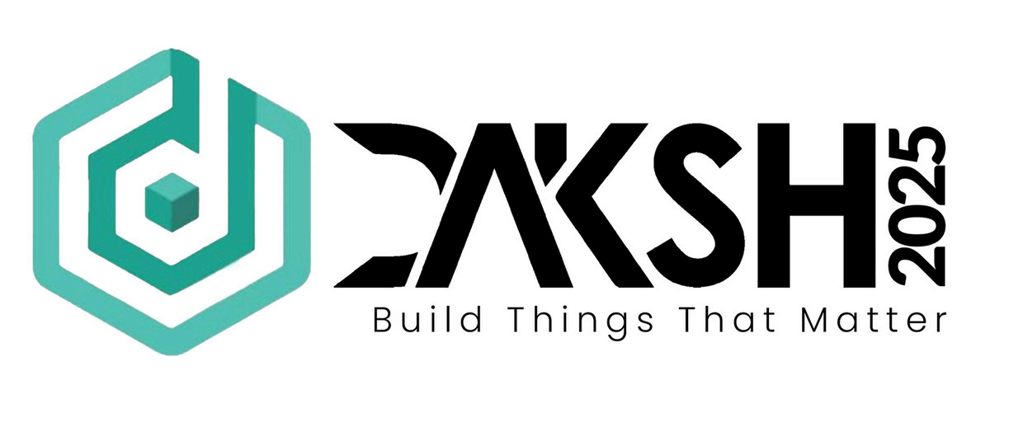

AI-Powered Assistant for

Chartered Accountants

Title of the Proposed Solution : AI-Driven Efficiency Tool for Chartered Accountants

Team Name: Dot and Dash  
Theme Chosen: **AI for Management & Business**

**Details of Team :**

Team Representative - Jaiadithya A

Other Members - Kiran Soorya R S

**Problem Statement & Need Analysis :**

**Challenges Faced by CAs:**

* *Repetitive and time-consuming tasks* like bookkeeping, reconciliations, and tax filings reduce productivity and limit focus on high-value activities like strategic advisory services.
* *Frequent updates in tax laws* and accounting standards increase complexity, leading to higher risks of errors and penalties.
* *Growing financial data volumes* make manual audits and fraud detection inefficient and error-prone.
* *Demand-Supply Gap* : India has only 1.5 lakh active CAs serving a rapidly growing economy projected to require 30 lakh CAs by 2047, highlighting the need for efficiency-enhancing tools.
* *Need for AI-Driven Solutions :* Automating routine tasks, ensuring compliance accuracy, and providing predictive insights can significantly improve efficiency.

Leveraging machine learning, natural language processing (NLP), and robotic process automation (RPA) can help CAs handle larger workloads, improve reporting accuracy, and adapt to India's economic growth.

**Existing Solutions and Their Limitations :**

**Current Tools:**

* Tools like *QuickBooks* and *Tally* streamline bookkeeping but lack advanced AI-driven automation for complex tasks like fraud detection or predictive analytics.
* Platforms like *TaxDome* and *Docy*t automate document management but are expensive and not fully adapted to Indian-specific tax laws or ICAI guidelines.

**Limitations:**

* Many tools are not scalable for large datasets or complex financial scenarios.
* Dependence on high-quality input data can lead to inaccuracies if data is incomplete or erroneous.
* Integration challenges with legacy systems, high costs, data privacy concerns, and the need for skilled personnel hinder adoption.

**Opportunity:**

There is a clear need for an affordable, adaptable solution tailored to Indian regulations that bridges these gaps while enhancing productivity for Chartered Accountants.

**Description of the Proposed AI-Driven Solution :**

The proposed solution is an AI-powered assistant tailored for Chartered Accountants (CAs) to enhance efficiency, accuracy, and productivity. It addresses inefficiencies in routine tasks, compliance management, and financial analysis by leveraging advanced AI technologies.

**Key Features:**

* *Automation of Repetitive Tasks:* Uses Robotic Process Automation (RPA) to automate bookkeeping, invoice processing, reconciliations, and tax filings.
* *Fraud Detection & Predictive Analytics:* Employs Machine Learning (ML) to detect anomalies in financial transactions, identify fraud risks, and forecast cash flows.
* *Regulatory Compliance:* Utilizes Natural Language Processing (NLP) to process unstructured data (emails, contracts) and ensure adherence to Indian-specific tax laws like GST.
* *Real-Time Insights:* Provides a user-friendly dashboard with real-time financial insights and automated compliance checks.
* *Seamless Integration:* Integrates with existing accounting software like Tally or QuickBooks for smooth adoption.

**Expected Outcomes & Benefits:**

* 50% reduction in time spent on routine tasks.
* Enhanced accuracy in financial reporting and compliance.
* Improved decision-making through predictive insights.
* Scalability to handle larger workloads efficiently.

This solution bridges the gaps in existing tools by being cost-effective, adaptable to Indian regulations, and easy to integrate with current workflows, empowering CAs to focus on strategic advisory roles.

**Technical Approach :**

The proposed AI-driven solution for Chartered Accountants (CAs) will leverage cutting-edge technologies to automate workflows, enhance accuracy, and provide actionable insights. Below is the technical approach to building and implementing the solution:

**1. Core Technologies**

* *Robotic Process Automation (RPA):* Automates repetitive tasks such as bookkeeping, invoice processing, and reconciliations to reduce manual effort.
* *Machine Learning (ML):*Detects anomalies in financial transactions, predicts cash flows, and identifies fraud patterns using historical data.
* *Natural Language Processing (NLP):*Processes unstructured data like contracts, emails, and tax laws to ensure compliance and streamline documentation.
* *Optical Character Recognition (OCR):* Extracts data from invoices, receipts, and bank statements for automated categorization and reconciliation.

**2. Integration with Existing Systems**

* Seamless integration with popular accounting software like Tally, QuickBooks, and ERP platforms such as NetSuite to ensure smooth adoption without disrupting current workflows.
* APIs will be used to connect with external tools like TaxDome, Zoho Books, or ICAI-recognized platforms such as Assure AI for features like tax compliance and audit automation.

**3. Data Management**

* Data Cleaning & Preprocessing: Ensures high-quality input data for accurate predictions and compliance checks.
* *Cloud-Based Storage*: Enables real-time collaboration and secure data access from anywhere.

**4. User Interface (UI)**

* A *user-friendly dashboard* will be designed to provide:
* Real-time financial insights.
* Automated compliance alerts tailored to Indian tax laws (e.g., GST).
* Predictive analytics for business planning.

**5. Development Tools**

* *Free tools like ChatGPT for NLP-based automation* of reports and queries.
* Open-source frameworks such as *TensorFlow Lite* for building ML models.
* Affordable platforms like *Wave or free plans of Zoho Books* for small-scale automation.

**6. Implementation Steps**

* *Identify Automation Opportunities*: Map repetitive accounting tasks that can be automated.
* *Develop AI Models*: Train ML algorithms using historical financial data for fraud detection and forecasting.
* *Build Integrations*: Use APIs to connect with existing accounting tools.
* *Test & Optimize:* Conduct iterative testing to refine algorithms and ensure accuracy.
* *Deploy & Monitor*: Launch the tool on a cloud platform for scalability, with regular updates based on user feedback.

This approach ensures a robust, cost-effective AI tool tailored to the needs of CAs while addressing inefficiencies in current workflows.

**Implementation :**

**How the solution will be developed and deployed**?  
The tool will be developed as a web-based platform with cloud integration for real-time collaboration. Deployment will involve hosting on cloud services like AWS or Azure.

**Resource requirements** (hardware/software):

* Hardware: Cloud servers for hosting; local systems for testing.
* Software: Python libraries (TensorFlow, Scikit-learn), APIs for integration with accounting software.

**Challenges and possible risk**s :

* Ensuring data privacy and compliance with regulations like GDPR or India’s Data Protection Bill.
* Adoption resistance from traditional accounting firms unfamiliar with AI tools.

**Future Scope & Scalability :**

**Advanced AI Capabilities:**

* Incorporate *Explainable AI* (XAI) to improve transparency in auditing and compliance processes, ensuring clear explanations of AI-driven decisions for regulatory requirements.
* Integrate *Predictive Analytics for advanced financial forecasting*, helping businesses make informed decisions about investments, budgeting, and risk management.
* Leverage Natural Language Processing (NLP) for better understanding of complex accounting language and automated regulatory updates.

**Integration with Emerging Technologies:**

* Combine *AI with Blockchain* for secure, transparent financial record-keeping and fraud prevention.
* Use Generative AI to automate financial reporting, competitor analysis, and personalized client communications.

**Personalized Financial Services:**

* Develop tailored solutions for small businesses, startups, and large enterprises by scaling AI models to meet specific needs.
* Enhance customer relationship management (CRM) by analyzing client data for cross-selling, upselling, and retention strategies.

**How the Solution Can Be Scaled for a Larger Impact :**

* Cloud-Based Deployment :Host the solution on scalable cloud platforms like AWS or Azure to handle increasing data volumes and users across geographies.
* Modular Architecture:Build a modular system that allows users to adopt features incrementally, such as starting with bookkeeping automation and later adding predictive analytics or fraud detection.
* Cross-Industry Applications : Expand beyond Chartered Accountants to industries like banking, insurance, and corporate finance where similar financial workflows exist.
* Partnerships with Accounting Bodies : Collaborate with ICAI or other global accounting organizations to promote adoption and ensure the tool aligns with professional standards.
* Cost-Effective Solutions for SMEs : Offer tiered pricing models to make the solution affordable for small and medium-sized enterprises (SMEs), enabling widespread use.
* Continuous Learning Models : Implement machine learning pipelines that improve accuracy over time by learning from new data inputs across various industries.

By focusing on these improvements and scaling strategies, the solution can have a transformative impact on the accounting profession, empowering Chartered Accountants to handle larger workloads efficiently while delivering higher-quality services.

**Conclusion :**

The proposed AI-powered assistant addresses critical inefficiencies faced by Chartered Accountants by automating routine tasks while enhancing accuracy and decision-making capabilities. This tool has the potential to revolutionize the profession by enabling CAs to focus on high-value activities like strategic advisory services.

**References :**

1. "The Rise of Artificial Intelligence in Chartered Accountancy," HSCO LLP, November 2024.
2. "11 Best AI Accounting Software and Tools for 2025," Netgain, December 2024.
3. "Accounting and AI: How AI & ML Impact Finance Teams," Airbase, January 2025.
4. "AI Integration in CA Firms: ICAI Survey Analysis," Taxscan, 2024.
5. "Case Studies: AI in Financial Management," NanoSchool.
6. "AI in Accounting and Auditing: Use Cases, Benefits, and Implementation," Fullestop.
7. "AI Agents in Auditing: Redefining Chartered Accountants Compliance," Akira.ai, December 2024.