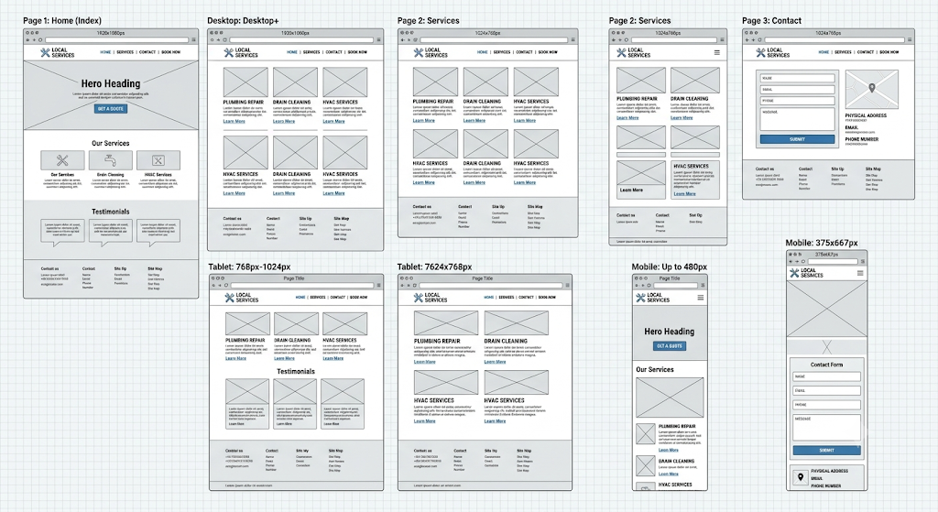
Wireframe-jd-plumbers
desktop, tablet and mobile versions.

