1. 立即数寻址：addi, andi, sll, srl.

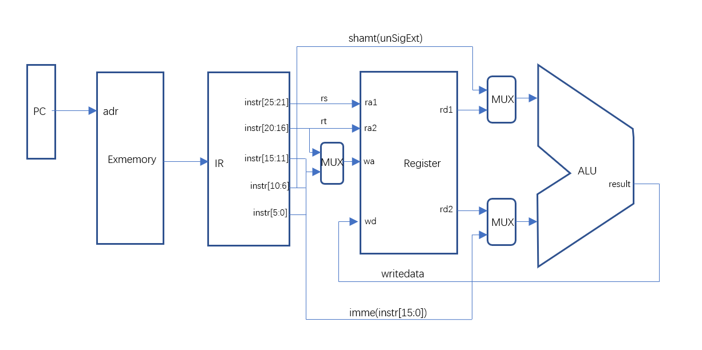

1. PC相对寻址：beq, bne.

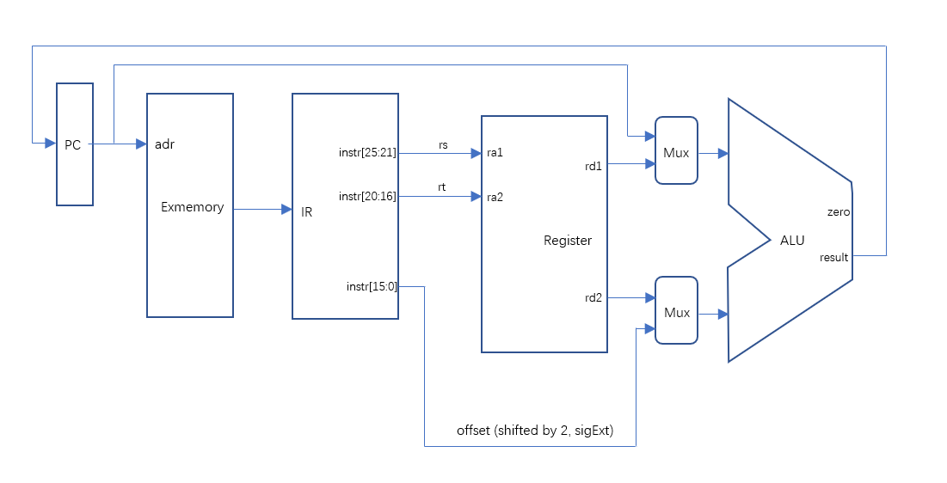

1. 寄存器寻址：add, and, or, sub, jr.

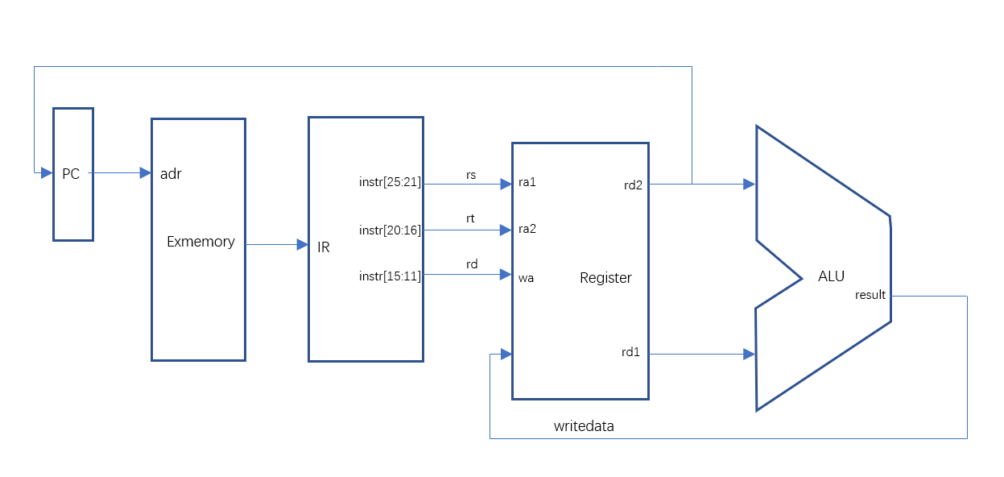

1. 基址寻址：lw, sw.

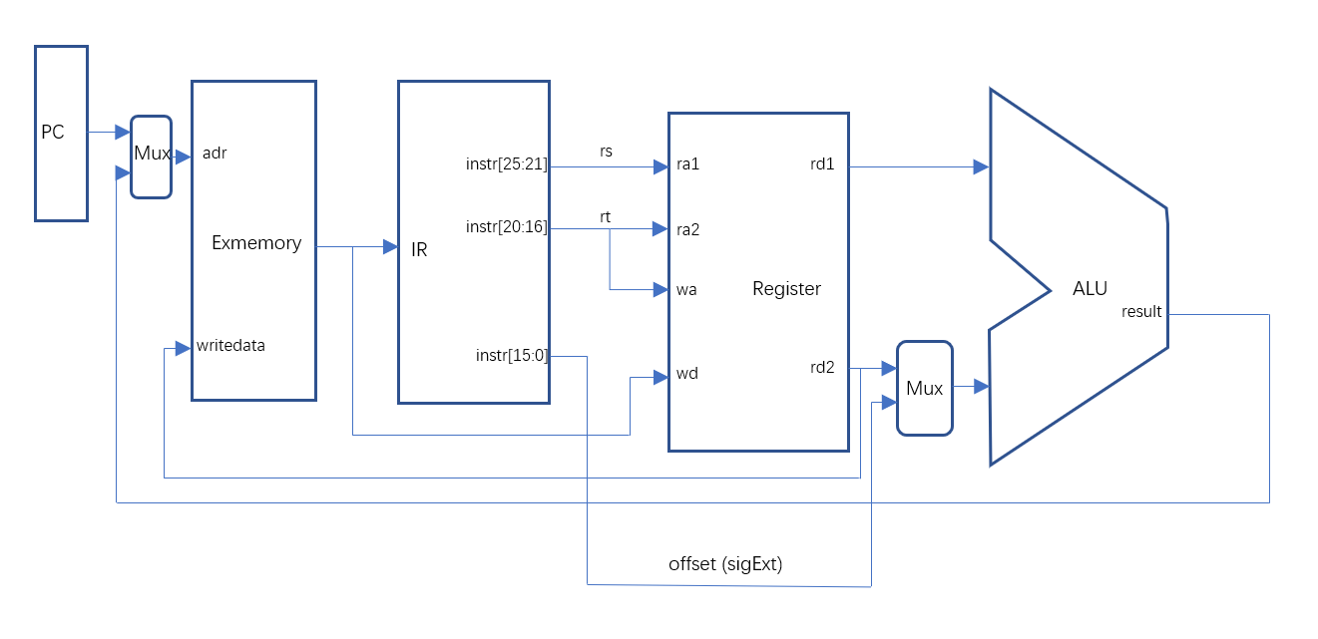

1. 类直接寻址：j, jal.

