Sql script generated using vertabelo.

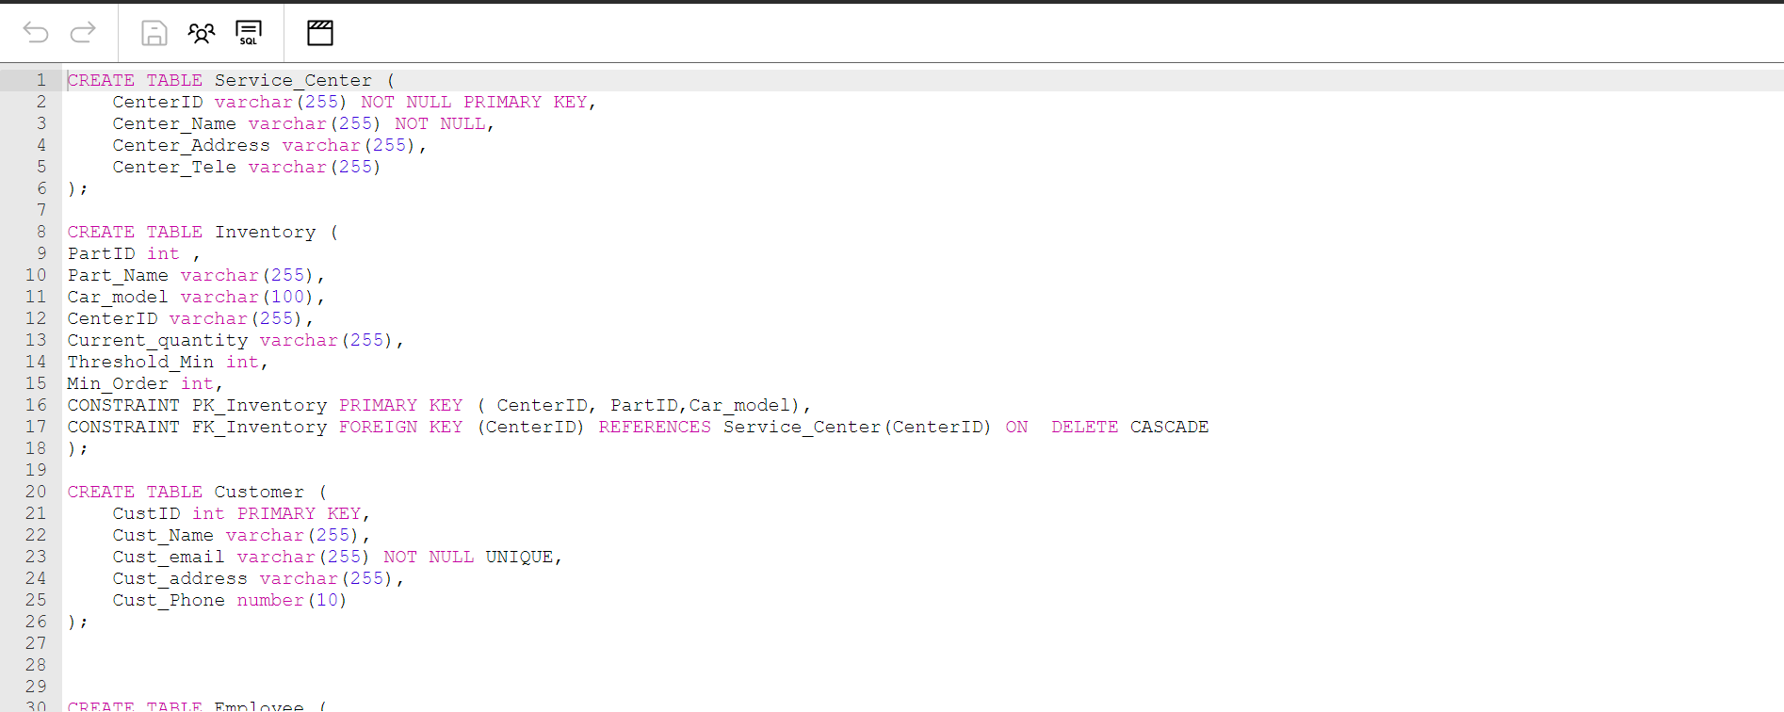

Executing all create statements in mssql and the screenshot of the result shared below.

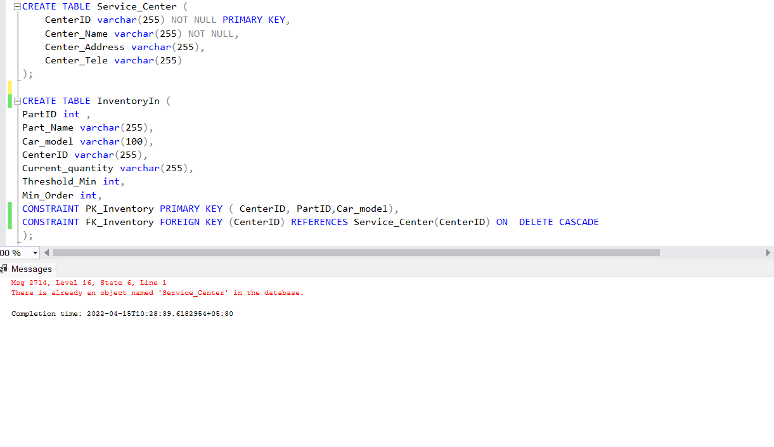

Insert Queries.

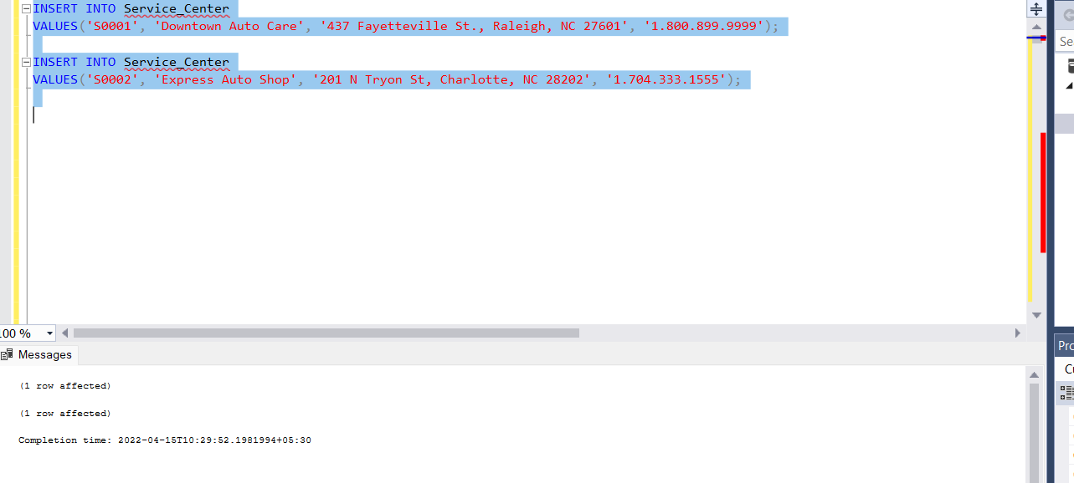

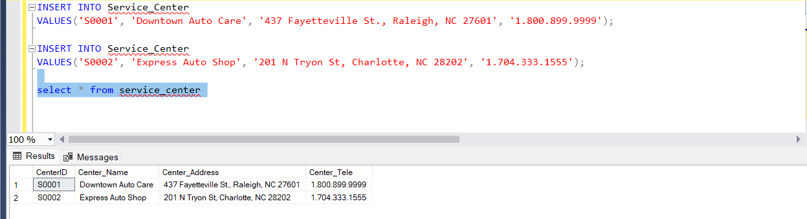

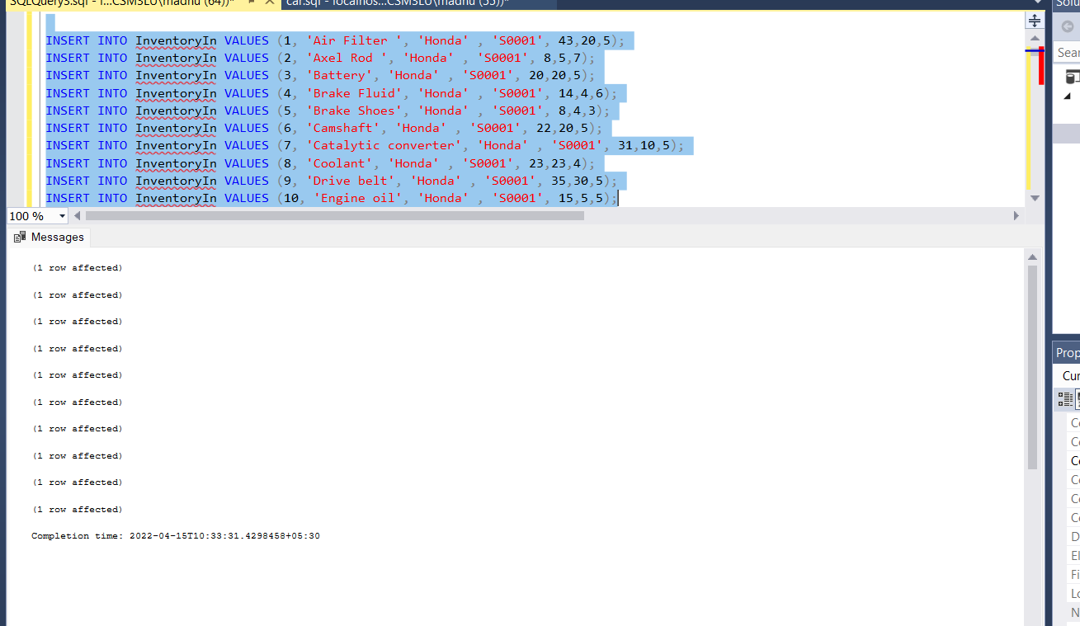

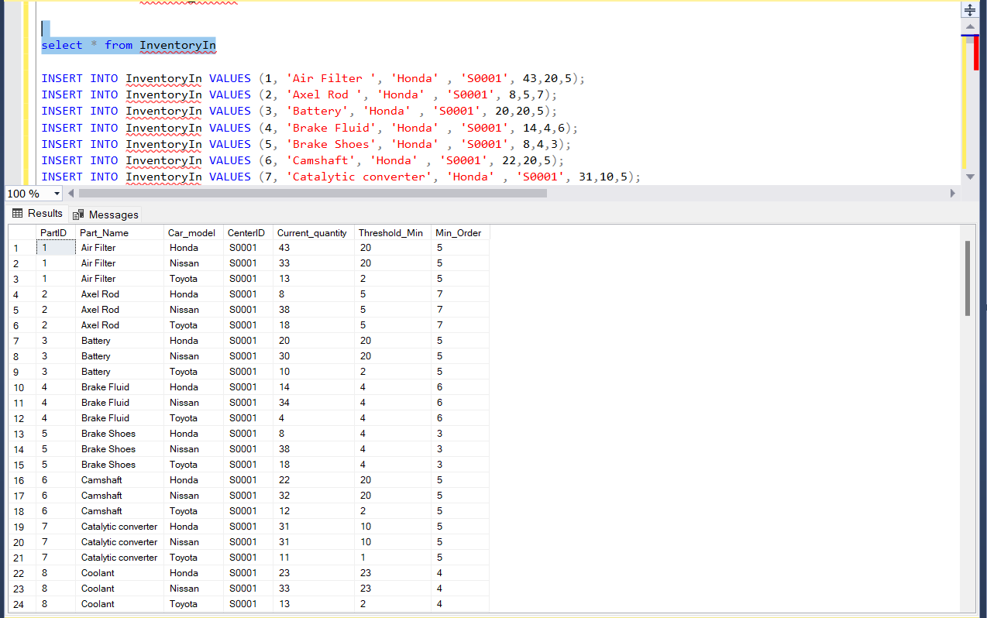

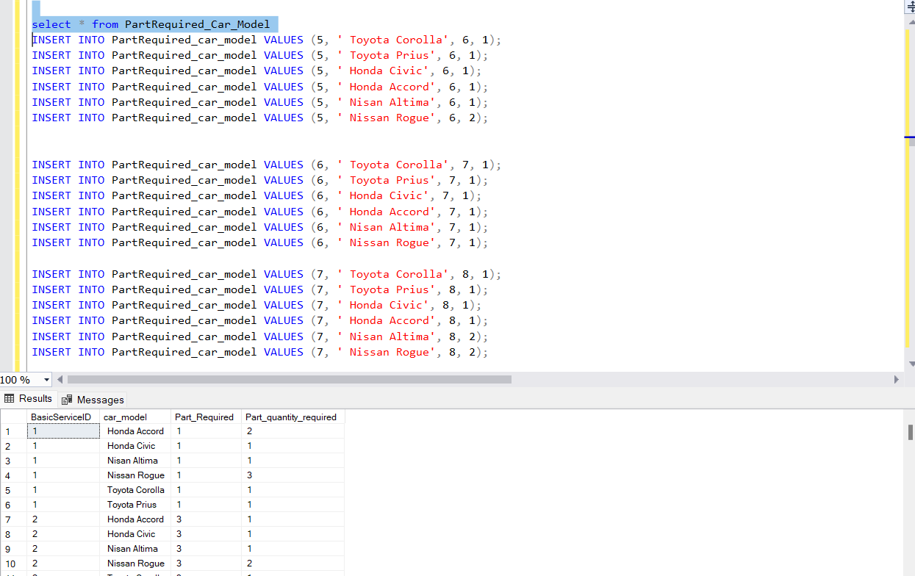

Join Queries:

SELECT Cu.CustID, Cu.Cust_Name, Cu.Cust_email, Cu.Cust_address, Cu.Cust_Phone, C.LicensePlateID, C.Car_Type, C.Date_Purchase,

C.Last_Mileage, C.Type_Recent_Service, C.Date_Recent_Service

FROM Customer Cu, Cars C, GoesTo G

WHERE

Cust_email ='ethanhunt@gmail.com' AND Cu.CustID = G.CustID AND G.LicensePlateID = C.LicensePlateID

