uSync TimeMachine on Umbraco 17
Proof notes from the TimeMachineDemo site. Checked on 12 October 2026.

Overview
uSync TimeMachine is a backoffice timeline of what changed on an Umbraco site. Each entry names the action (created, updated, published, and so on), the item, who did it, and when. Opening an entry shows a property-level diff. An editor can roll that change back.
It was added in uSync.Complete 17.5.0 from Jumoo. It is not part of the free uSync package. The free package still writes schema to disk. TimeMachine is the history and rollback view.
On this proof the timeline sits under Settings, in the Synchronisation group: uSync, then TimeMachine. It is switched off until uSync:TimeMachine:Enabled is set to true. Events older than uSync:TimeMachine:RetentionDays are removed. The default retention is 30 days.
Jumoo grants a 60-day trial from the installation date. After that, a uSync.Complete licence is required to open the timeline. The product text says the site keeps recording either way.

Detail

What this proof installed
- Project: TimeMachineDemo, in POC.slnx beside BlockDiffDemo. .NET 10.
Umbraco.Cms 17.4.2.
- uSync 17.4.3, which supplies the Settings menu TimeMachine hangs from.
uSync.TimeMachine 17.5.0 and uSync.TimeMachine.Client 17.5.0.
- SQLite, unattended install. The site runs at https://localhost:44376/umbraco. The admin user is in appsettings.Development.json.

What it records
TimeMachine records changes made in the backoffice and changes made by a uSync import. The timeline can be filtered by source (Everything, Back office, uSync) and by user. On this site the seeded work appears as System. A later publish by the logged-in editor appears as Admin.
The recorded set is wider than one content item. The proof timeline includes content (Welcome, Office hours, Delivery questions), document types (Note, FAQ page, Accordion, Accordion item), Block List data types (Accordions, Accordion items), and templates (notePage, faqPage).

The sample content
Delivery questions is an FAQ page. Accordions is a Block List of Accordion blocks. Each accordion has its own Block List of Accordion item blocks, with a heading and text. The page was saved several times: a Shipping accordion was created and published, a Returns accordion was added, item text was edited, an item was removed, titles were renamed, and the page was published again. The public page is https://localhost:44376/delivery-questions/.

How a block change is shown
A short text change inside a block can be readable. On the 4:07 PM update, TimeMachine shows the accordion title as Shipping, then Shipping and tracking, and the return answer as a sentence replaced by a new sentence.
Adding or removing a block is not shown as a labelled field. It is shown as JSON paths into the Block List value: contentData, expose, and the Umbraco.BlockList layout. The removed item 'Do you ship abroad?' appears as a JSON object, not as a row named Accordion item. Nested blocks make those paths longer. This is the same limit as the built-in Rollback screen: the block value is one JSON document.

Rollback
Each event has Roll back. The dialog lists what would be put back to the state before that change. Items that are already in that state are skipped. Rollback writes a new change, so it appears on the timeline as well.

Configuration
In appsettings.Development.json the proof sets uSync:TimeMachine:Enabled to true and RetentionDays to 30. Without Enabled, the TimeMachine screen says it is offline and tells you to turn that setting on.

Pros
- One timeline for the site, covering content and settings, not only the history of a single page.
Each event has a property diff and a rollback of that change.
- Simple text inside a block can be shown as a before-and-after line.
Filters by source and by user. System seeding and an editor publish are easy to tell apart.
- It runs on Umbraco 17 and .NET 10. The packages used here are the 17.5.0 line.
The 60-day trial is enough to judge the screen on a copy of a real site.

Cons
- It is a paid uSync.Complete feature. The public Jumoo prices checked on 5 October 2026 were 1,150 pounds excluding VAT for a project licence, or 550 pounds excluding VAT per year. Confirm the current price before budgeting.
After the trial, the timeline stays hidden until a licence is added.
- Block List and accordion changes are only partly readable. Added and removed blocks are JSON paths and raw JSON, not field names.
There is no visual preview of the old page and no share link. Those are a different tool (Rollback Previewer on this proof's other project).
- Retention defaults to 30 days, so it is not a long archive.
It is off until the appsetting is turned on. Setup and seeding produce a noisy System timeline.
- It does not replace source control of schema. The free uSync disk files are still the thing to commit.

Screenshots
Taken on the TimeMachineDemo backoffice on 12 October 2026.
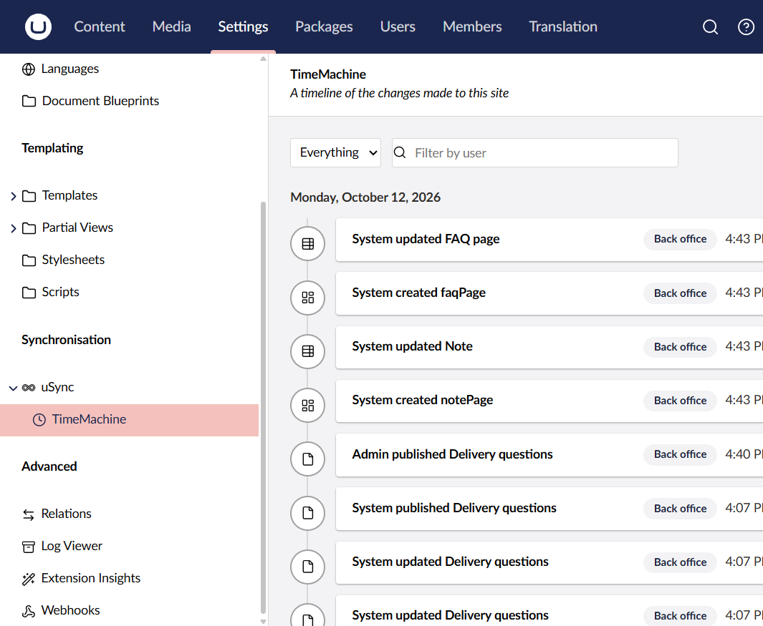
Settings, Synchronisation, uSync, TimeMachine. The timeline lists template, content, and publish events for 12 October 2026.
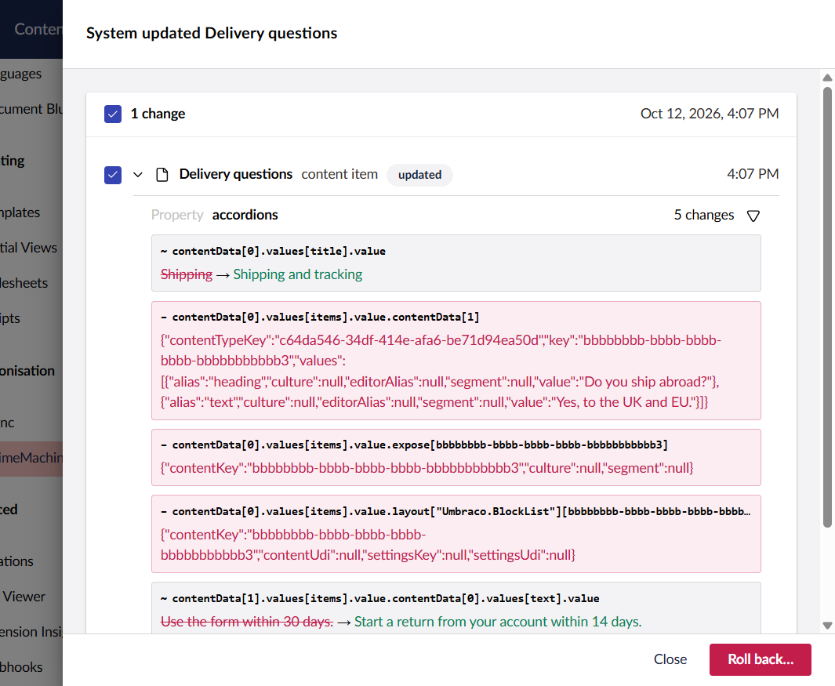
The 4:07 PM update of Delivery questions. The accordion title and one answer are readable. The removed accordion item is JSON.
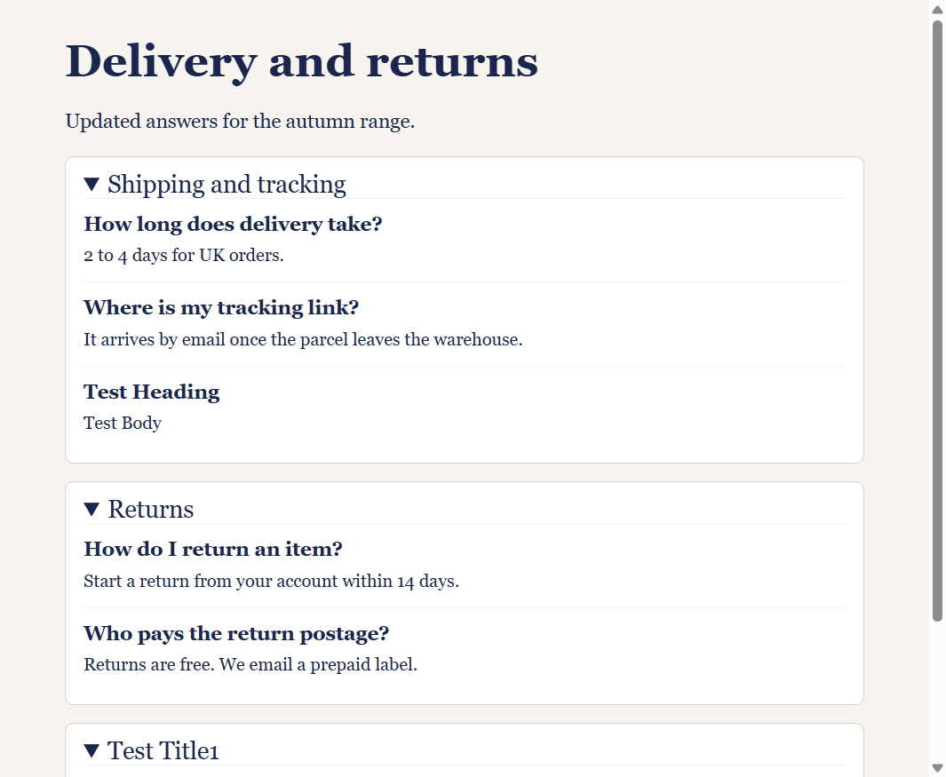
The published FAQ page that those timeline events produced.

Where to look next
Open Settings, then uSync, then TimeMachine. Click a Delivery questions row to see the block diff, and use Roll back only on a copy if you want to prove restore. Compare that JSON with the rendered page above. If editors need the field name inside an accordion rather than the JSON path, TimeMachine does not provide that view.

