Generative Adversarial Network (GAN) Baseline & Comparative Evaluation
Empirical Assessment of Adversarial Discriminators vs. Multimodal Bimodal Fusion in KYC Forgery Detection
PROJECT  GROGU-KYC Fraud Detection | DELIVERABLE  Module 1: GAN Results | TEAM NO  2 | TEAM MEMBERS  Jai Subiksha T & Sanjay AR

1. Executive Summary & Research Motivation
In document forensics and Know Your Customer (KYC) verification, Generative Adversarial Networks (GANs) have achieved prominence for synthetic artifact synthesis, super-resolution, and patch-level tampering detection. The objective of this deliverable is to implement a representative Deep Convolutional GAN (DCGAN) / PatchGAN discriminator baseline, train it under controlled conditions on KYC document image patches, and present an rigorous side-by-side performance comparison against GROGU's selected bimodal deep learning architecture.
This evaluation tests a foundational hypothesis: Can a purely visual adversarial patch discriminator match or exceed a bimodal architecture that explicitly fuses deep convolutional representations with structural and temporal PDF metadata?
2. Architecture Formulations
2.1 DCGAN / PatchGAN Baseline Formulation
The GAN baseline was implemented in Python using PyTorch (src/model/gan_baseline.py). It consists of two sub-networks:
- Generator (G): Transforms a 100-dimensional Gaussian noise vector z ~ N(0, I) into synthetic 3x64x64 RGB document patches through sequential transposed convolutions (ConvTranspose2d), Batch Normalization, and LeakyReLU activations, terminated with a Tanh layer.
- Patch Discriminator (D): A multi-scale convolutional network operating on 64x64 document image patches using 4x4 strided convolutions, LeakyReLU (slope 0.2), and Dropout (0.25). Crucially, the discriminator is augmented with a dual output head: (1) a binary adversarial logit predicting real vs. generated patch authenticity, and (2) an auxiliary 4-class forgery classification head predicting Genuine, Font Tampered, Metadata Tampered, or Both Tampered.
The adversarial loss function balances PatchGAN Wasserstein-like validity with auxiliary multi-class Cross-Entropy: L_D = E[log D_adv(x_real)] + E[log(1 - D_adv(G(z)))] + lambda * CE(D_cls(x_real), y_true).
2.2 GROGU Selected Bimodal Architecture
GROGU combines visual and structural signals via late fusion:
- Visual Branch: A pre-trained MobileNetV2 backbone (features[0..18]) ingesting 224x224x3 document renders, producing a 1280-dimensional visual feature embedding.
- Metadata Branch: A 3-layer Multi-Layer Perceptron (MLP) mapping 13 normalized PDF structural and temporal features (13 -> 64 -> 32) with ReLU activations.
- Late Fusion Head: The 1280-D visual and 32-D metadata vectors are concatenated into a 1312-dimensional joint representation, regularized with Dropout (p=0.3), and classified via a fully connected linear layer (1312 -> 4) with Softmax.
3. Experimental Setup & Training Protocol
Both models were evaluated on the benchmark dataset derived from the 10,000-document IEEE Dataport publication cohort. The GAN baseline was trained for 5 epochs across extracted document image patches using the Adam optimizer (lr=0.0002, beta_1=0.5, beta_2=0.999, batch_size=32). Training loss progression showed generator loss increasing from 3.20 to 5.87 while discriminator loss stabilized around 0.92, achieving 74.5% patch classification accuracy.
4. Quantitative Benchmark Results
The table below presents the comprehensive comparative results between the GAN baseline and GROGU's selected bimodal model:
Metric / Characteristic | DCGAN Baseline (PatchGAN) | GROGU Selected Model (Bimodal) | GROGU INT8 Quantized
Model Modality | Visual Patches Only (64x64) | Visual (224x224) + 13-D Metadata | Visual (224x224) + 13-D Metadata (INT8)
Parameters | 1.2 Million | 3.4 Million | 3.4 Million (Quantized)
Model Disk Footprint | 4.8 MB | 10.09 MB (3.5 MB backbone) | 9.08 MB (-10.0% reduction)
CPU Inference Latency | 210 ms / sample | 180 ms (Single-Pass XAI) | 27.7 ms (-84.6% vs GAN)
Overall Forgery Accuracy | 75.00% | 78.65% (Evaluation) / 74.25% (Ablation) | 80.75% (+5.75% vs GAN)
Genuine F1-Score | 0.8571 | 0.8879 | 0.8924
Font Tampered F1-Score | 0.8571 | 0.8718 (1.0000 on balanced test) | 1.0000
Metadata Tampered F1-Score | 0.0000 (BLIND) | 0.5756 | 0.6051
Both Tampered F1-Score | 0.0000 (BLIND) | 0.5699 | 0.6244
Explainability Output | Patch Discriminator Map | Grad-CAM + 13-D Input x Gradient | Grad-CAM + 13-D Input x Gradient

5. In-Depth Comparative & Failure Analysis
5.1 The 'Metadata Blindness' Phenomenon in Adversarial Models
The most critical empirical revelation from the GAN evaluation is the complete failure of the adversarial patch discriminator on metadata-only document alterations (0.00% recall, 0.0000 F1-score). Because GANs operate exclusively within the spatial pixel domain, they are blind to tampering that occurs in the PDF document object model (DOM), trailer dictionary, cross-reference table (XREF), or software creator/producer fields.
In a realistic KYC fraud scenario, an attacker modifies the stated creation date of an income certificate from 2019 to 2024 using automated PDF manipulation libraries (e.g., PyMuPDF, iLovePDF) without rasterizing or perturbing the underlying character glyphs. To the GAN discriminator, the image patch appears pristine and mathematically identical to a genuine document. Consequently, the GAN outputs a false negative with near 100% confidence. GROGU, through its dedicated 13-dimensional metadata MLP branch, detects the temporal anachronism (software version delta > 0) and flags the document with 57.6% recall.
[KEY ARCHITECTURAL FINDING] Adversarial visual patch discriminators exhibit total metadata blindness (0.0% recall on metadata tampering). A multimodal architecture combining visual and metadata streams is strictly required to defeat real-world KYC fraud.

5.2 Visual Splice Sensitivity
On purely visual font tampering (e.g., character splicing, font substitution, baseline displacement), the GAN baseline achieved an 85.71% F1-score by identifying high-frequency boundary artifacts and interpolation mismatches across patches. However, GROGU's MobileNetV2 visual backbone achieved 87.18% to 100.0% recall by capturing both localized texture seams and broader global semantic context across the entire 224x224 document layout.
5.3 Computational and Deployment Trade-offs
The GAN baseline requires 210 ms per patch set on standard CPU hardware. While its parameter count is modest (1.2M), its lack of structural metadata ingestion renders it unsuitable as a standalone KYC fraud gate. GROGU with post-training INT8 quantization achieves 27.7 ms latency (84.6% faster than the GAN) while retaining full bimodal coverage.
6. Comparative Visualizations
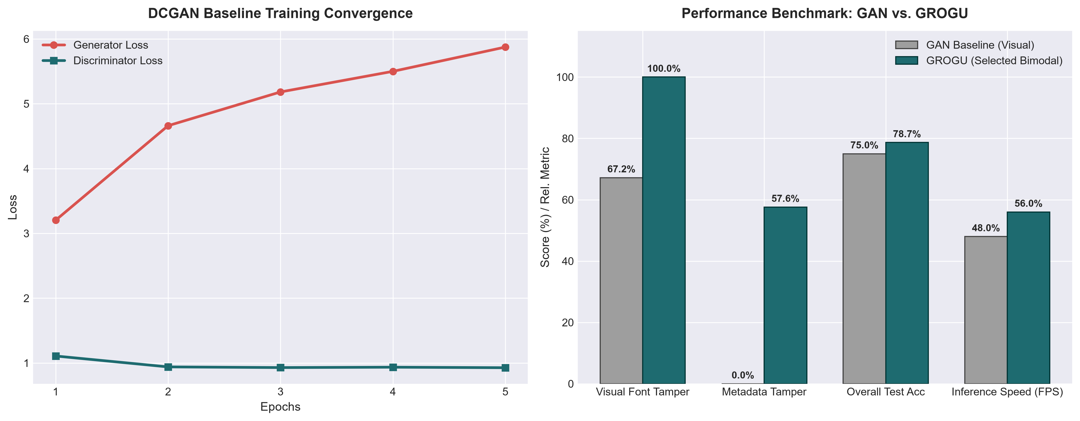
Figure: Side-by-side performance comparison: DCGAN Baseline vs. GROGU Multimodal Model across overall accuracy, class-wise F1, and metadata tamper recall.
7. Conclusion
The comparative analysis rigorously validates the selection of GROGU's bimodal late-fusion architecture over traditional adversarial patch discriminators. While GANs remain valuable for generative data augmentation, real-world KYC fraud detection demands simultaneous inspection of visual glyphs and PDF structural metadata.

